Os Assingment 1

Problem 1: Read the instructions carefully and answer accordingly. If there is any need to insert some data then do that as well. a) Navigate and List: a. Start by navigating to your home directory and list its contents. Then, move into a directory named "LinuxAssignment" if it exists; otherwise, create it. 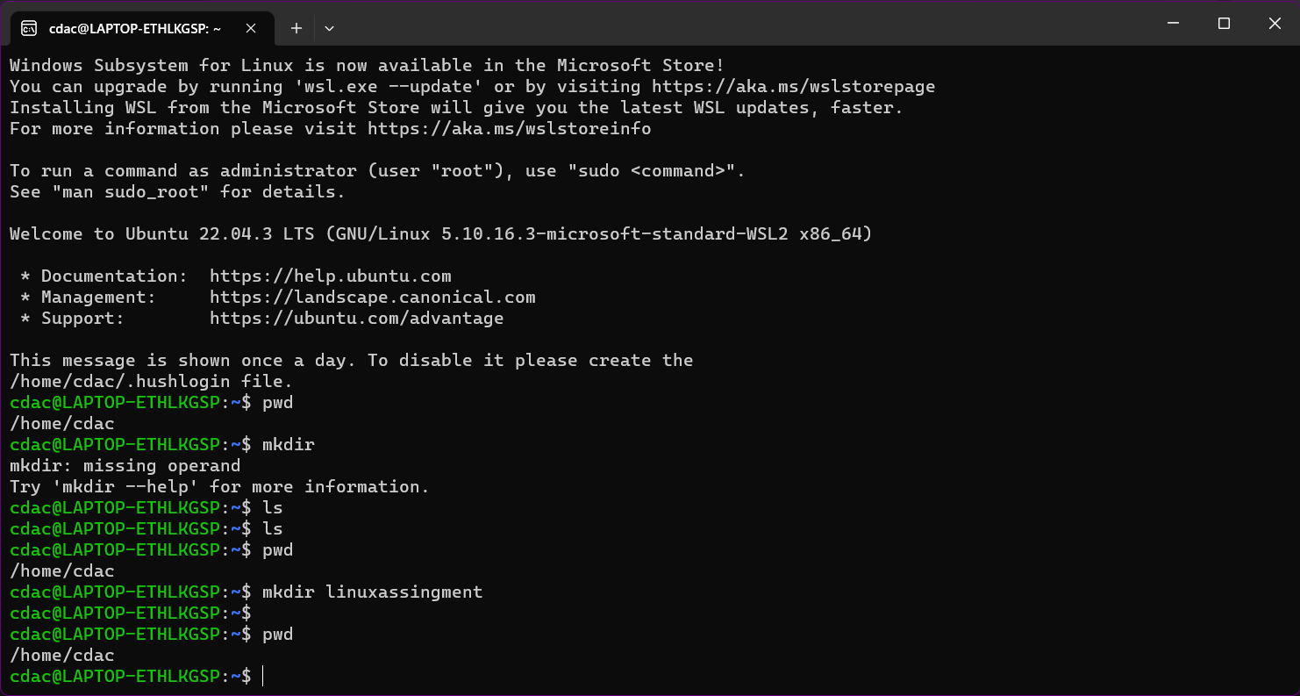

b) File Management: a. Inside the "LinuxAssignment" directory, create a new file named "file1.txt". Display its contents 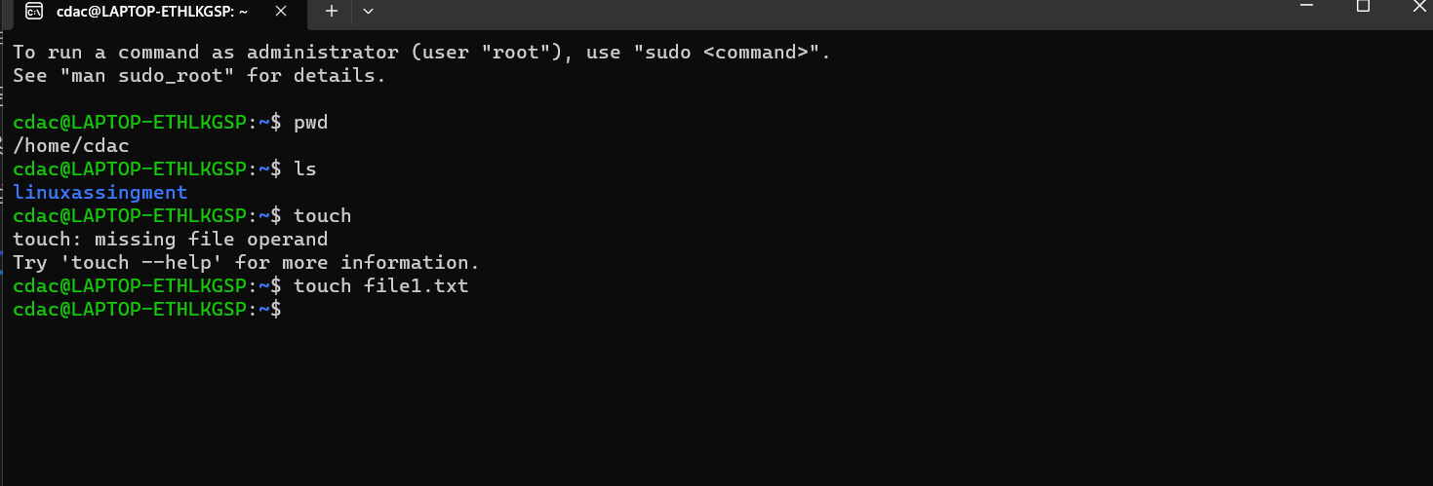C)Directory Management: a. Create a new directory named "docs" inside the"LinuxAssignment"directory 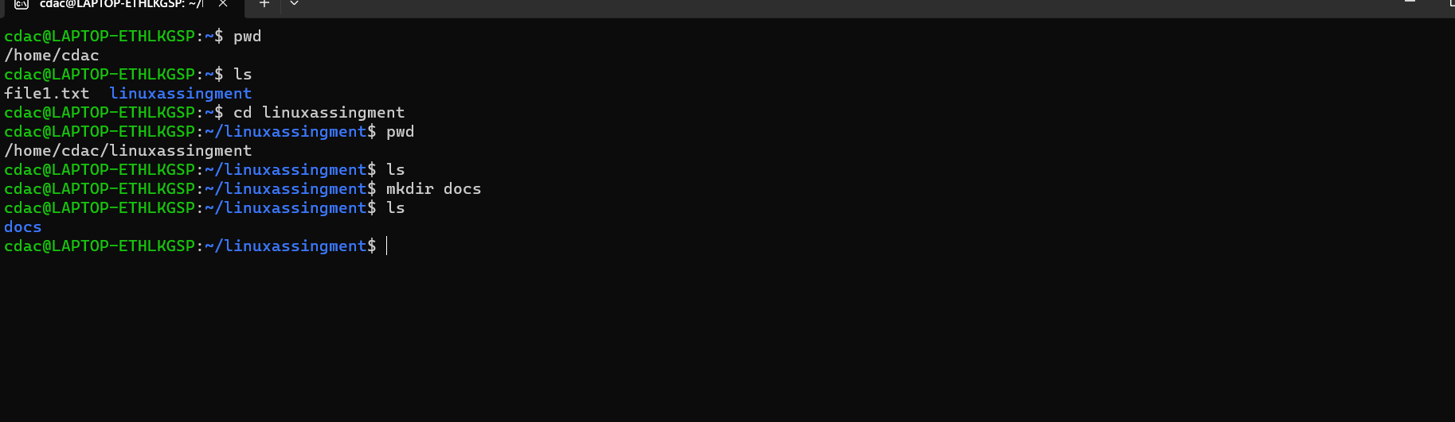

d) Copy and Move Files: a. Copy the "file1.txt" file into the "docs" directory and rename it to "file2.txt".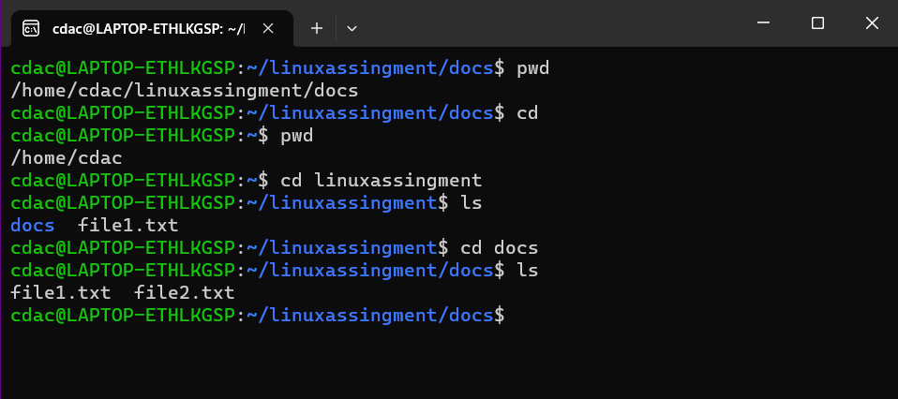

e) Permissions and Ownership: a. Change the permissions of "file2.txt" to allow read, write, and execute permissions for the owner and only read permissions for others. Then, change the owner of "file2.txt" to the current user.

