Documentation provides a step-by-step guide to deploying a highly available WordPress website on Amazon EC2, Amazon RDS, Application Load Balancer (ALB), Amazon Route 53, and AWS Certificate Manager (ACM).

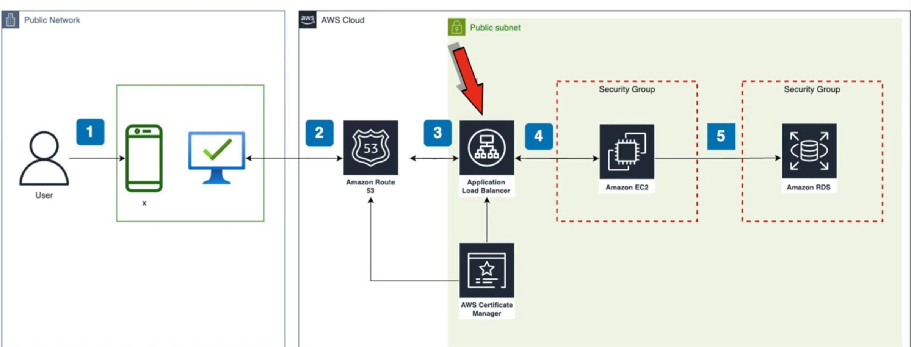

Architecture Overview:

Amazon EC2: Hosts the web application (WordPress).

Amazon RDS: Manages the MySQL database.

Application Load Balancer (ALB): Distributes traffic to multiple EC2 instances.

Amazon Route 53: Manages the domain and DNS routing.

AWS Certificate Manager (ACM): Provides a free SSL certificate for HTTPS.

Step by step process:

1.Connect to each EC2 instance via SSH:

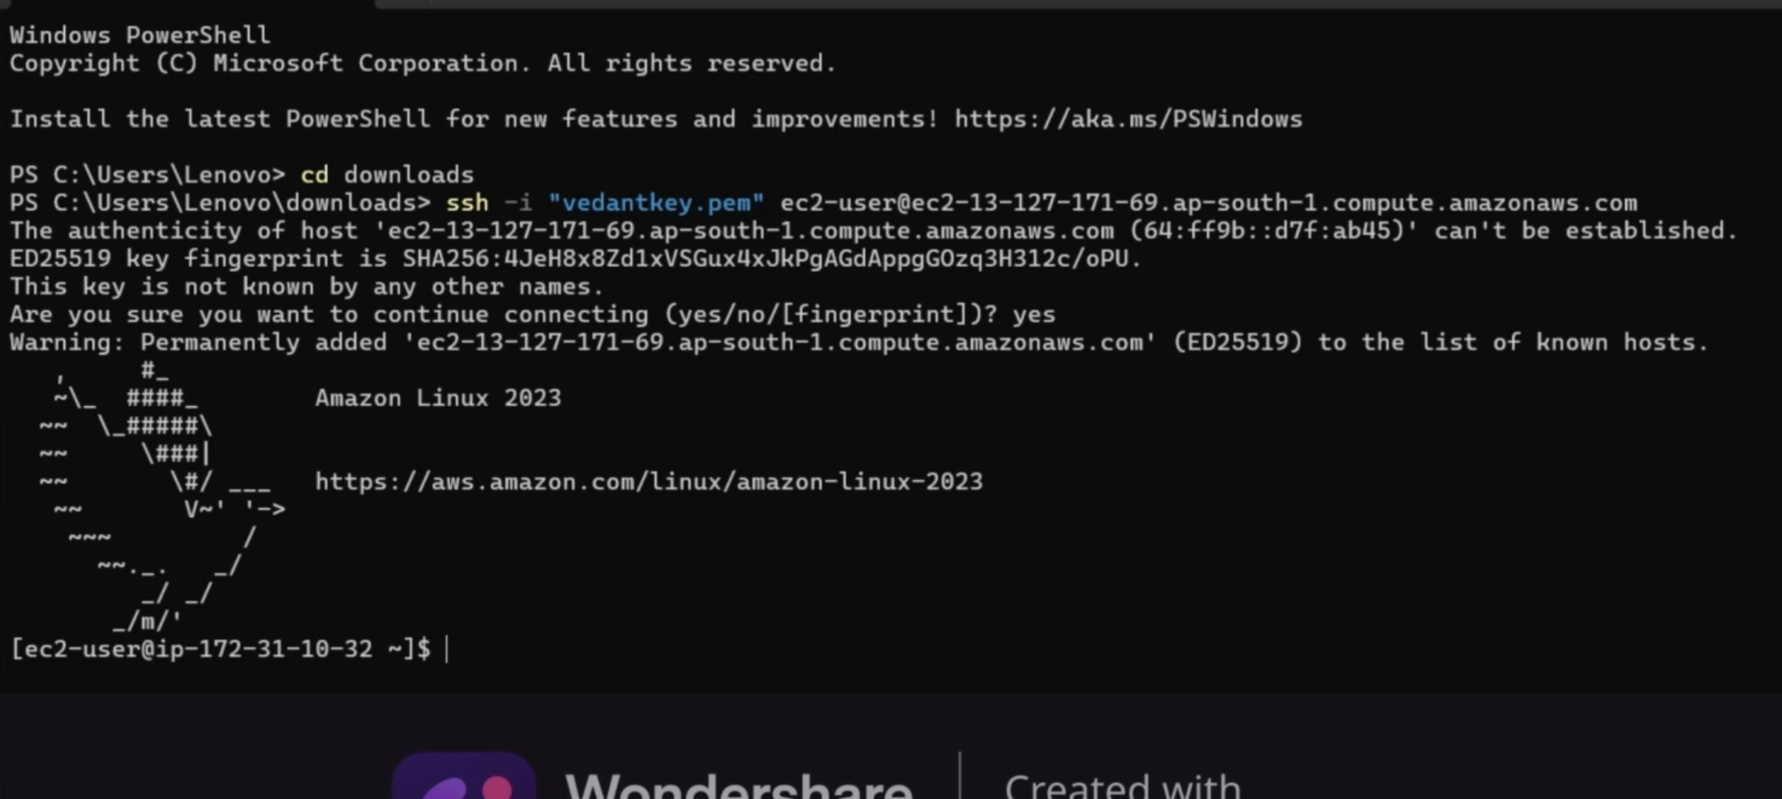

2.Update Your System&Install Apache, PHP, and MariaDB

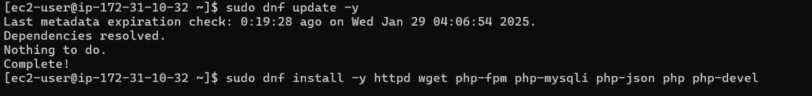

3.To check the MariaDB version:



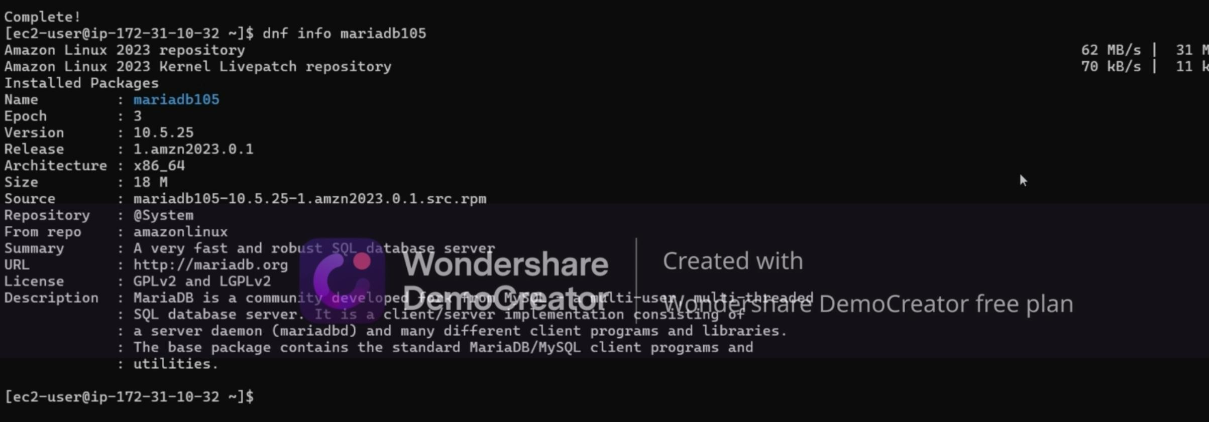

4.Start and Configure Apache RTR ,

5.Verify if Apache is enabled,

6.Add your user (ec2-user) to the Apache group,

7.Then, log out and log back in again to refresh your groups.

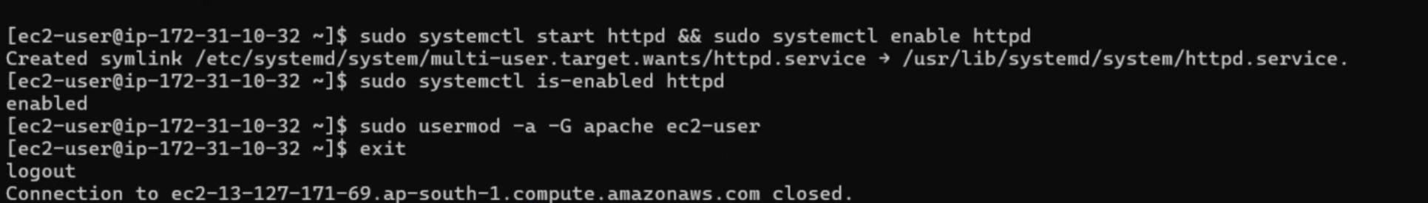

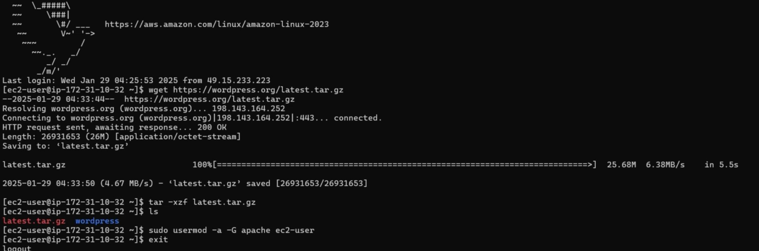

8.Copy WordPress to html:



9.Configure WordPress:

10.Copy the WordPress sample configuration file and edit it with your database details.

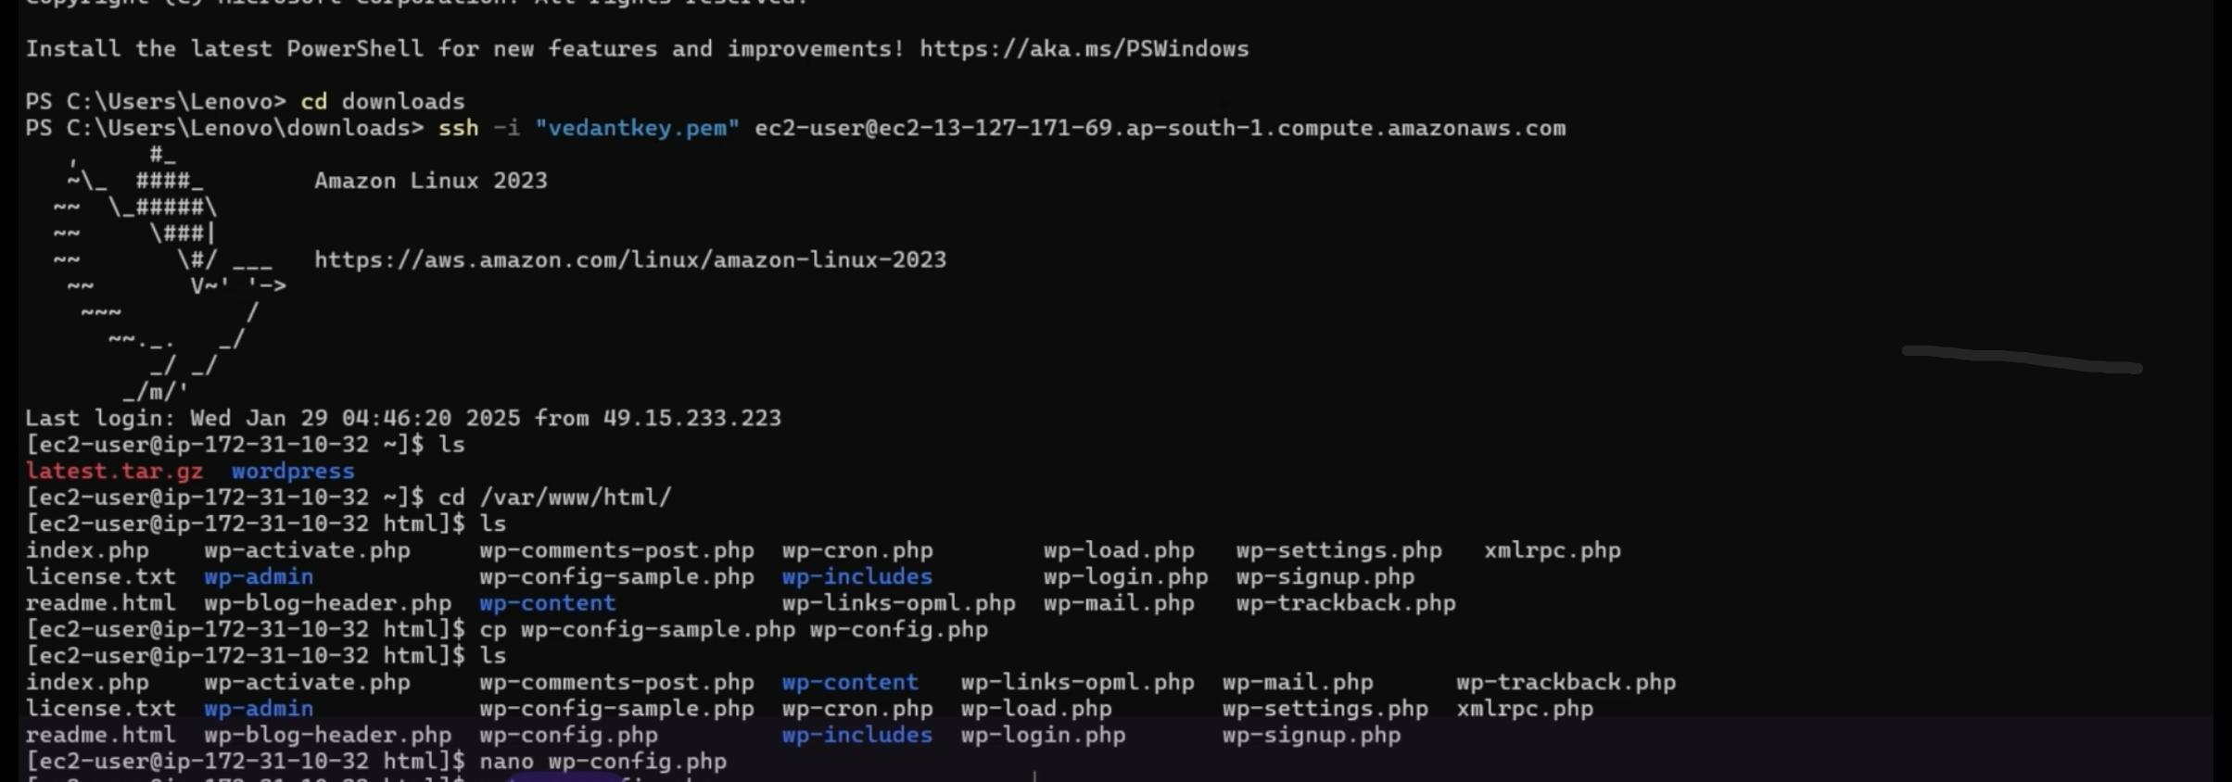

11.Update the database name, user, and password in the wp-config.php file.

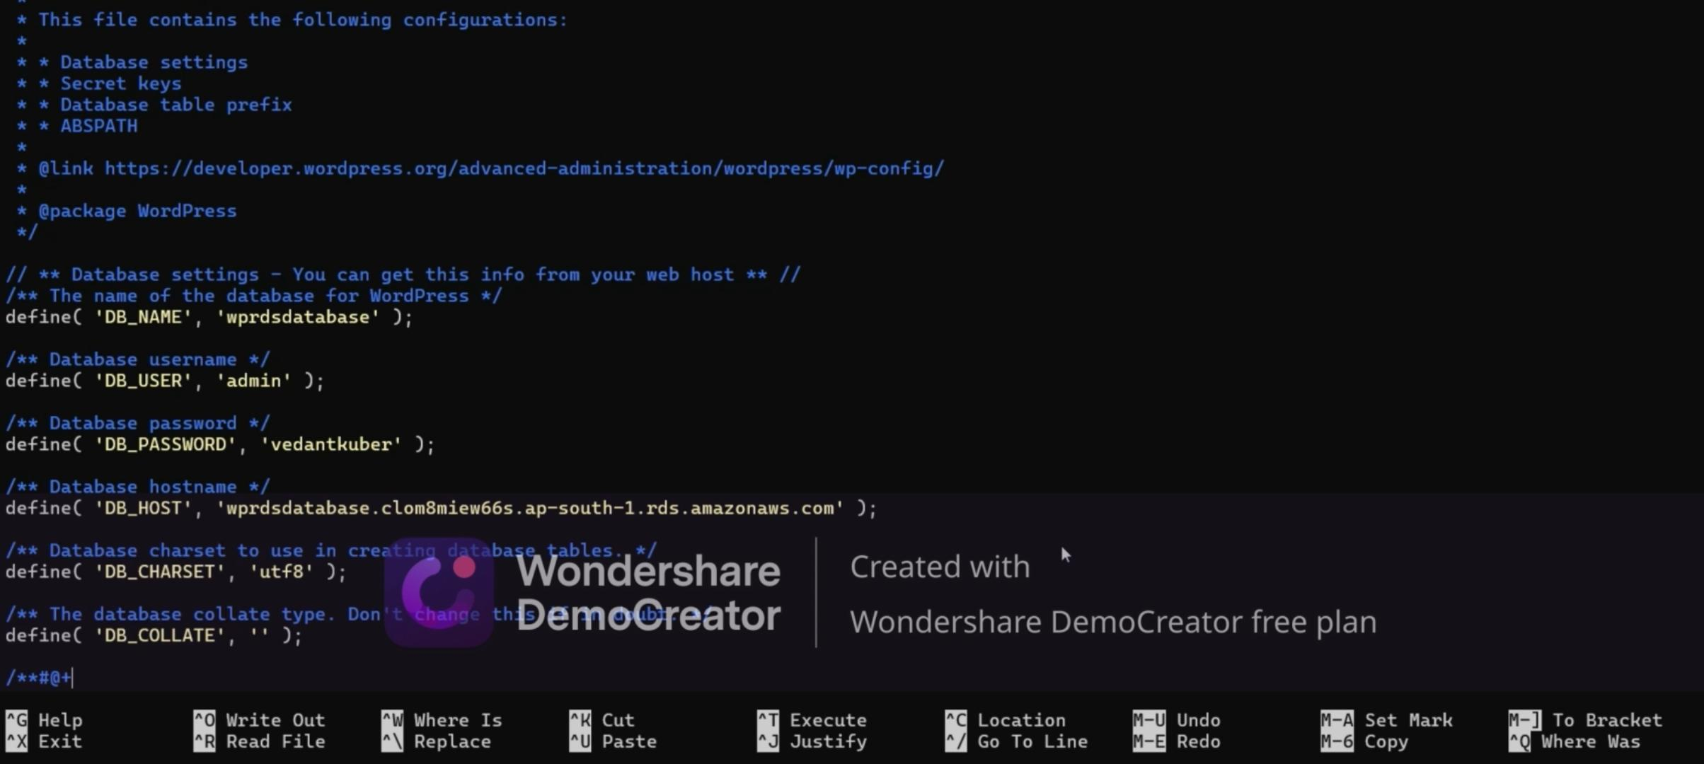

12.Cat command use for check wp-config.php

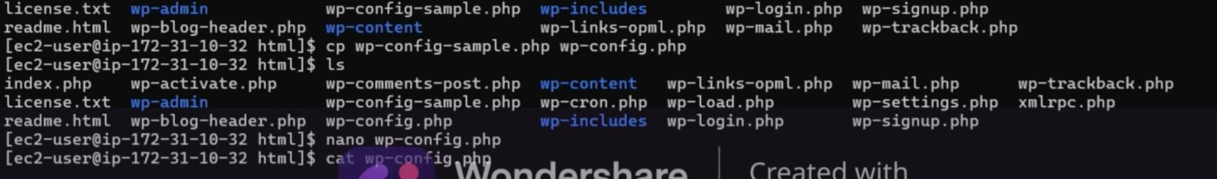

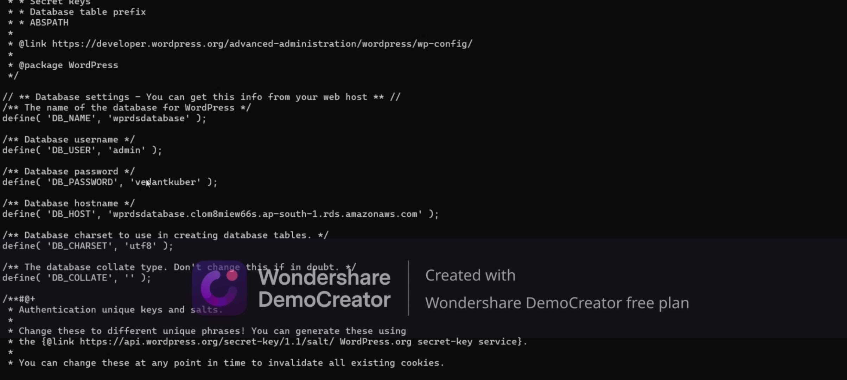

13.Configure Apache:

14.Before finalizing the installation, you may need to adjust the Apache configuration.



15.Change the AllowOverride None line in the above section to read AllowOverride All.

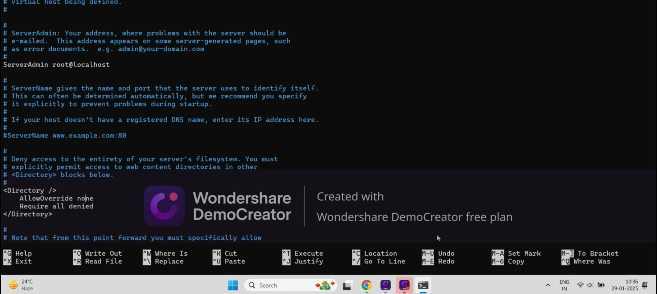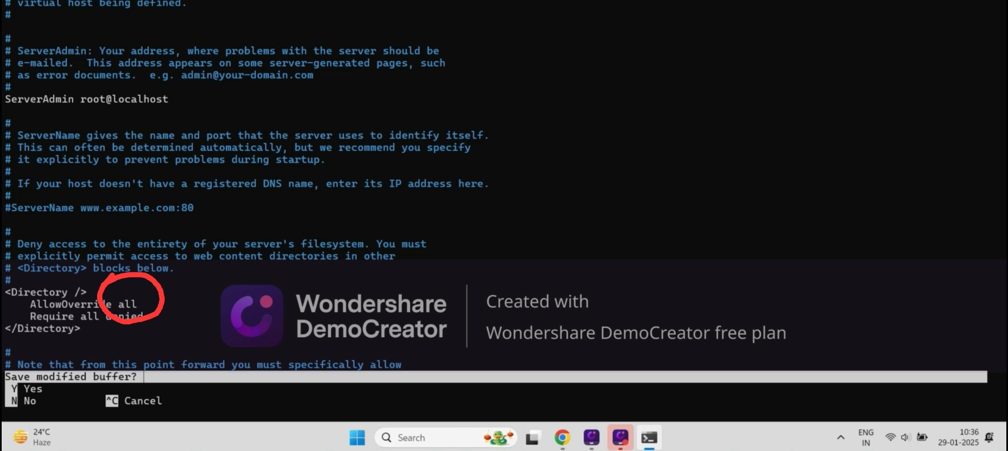

16.Restart Apache to apply the changes:

