**Assignment 2b**

**Name :** Kaushik Nitin Naik

**Class :** TE11

**Roll No :** 33342

**Title :** Create Docker Container Environment.

**Install using the repository**

Before you install Docker Engine for the first time on a new host machine, you need to set up the Docker repository. Afterward, you can install and update Docker from the repository.

**Step 1 :**Update the apt package index and install packages to allow apt to use a repository over HTTPS:

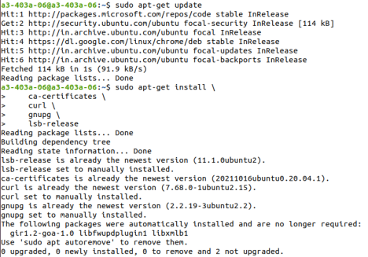

**Step 2 :** Add Docker’s official GPG key:

**Step 3 :** Use the following command to set up the repository:

**Step 4 :** Install Docker Engine.

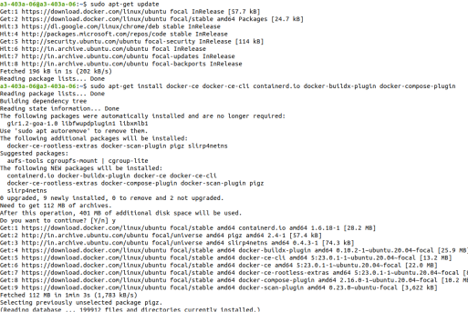

**Step 5 :** Verify that the Docker Engine installation is successful by running the hello-world image:

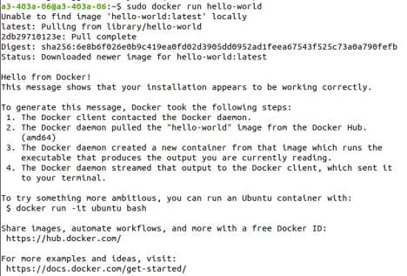

**Containerize an application**

