1. SELECT COUNT(\*) from Orders WHERE ShipperID = 1

Answer: 54  


1. SELECT LastName, Count(\*) AS NumberOfOrders

FROM Orders

JOIN Employees

ON Orders.EmployeeID = Employees.EmployeeID

GROUP BY LastName

ORDER BY NumberOfOrders DESC

LIMIT 1

Answer:   
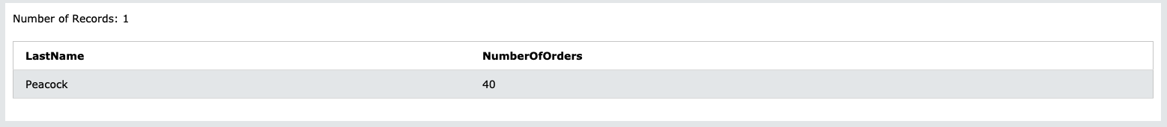

1. SELECT Products.ProductName,

SUM(OrderDetails.Quantity) AS "total"

FROM Orders

JOIN Customers

ON Customers.CustomerID = Orders.CustomerID

JOIN OrderDetails

ON OrderDetails.OrderID = Orders.OrderID

JOIN Products

ON Products.ProductID = OrderDetails.ProductID

WHERE Customers.Country = 'Germany'

GROUP BY OrderDetails.ProductID

ORDER BY total DESC

LIMIT 1

Answer:   
