Earthquake Report for Haiti on 2021-08-14 20:20:4

# Hazard Description

On August 14, 2021, at approximately 16:20 local time, a magnitude 5.8 earthquake, with a depth of 12.04 km, struck 12 km North-Northeast of of Chardonnière, Haiti. The coordinate of epicenter of the earthquake was 18.3711°N, 74.0992°W.

Extensive diversity and complexity of tectonic regimes characterizes the perimeter   
of the Caribbean plate, involving no fewer than four major plates (North America,   
South America, Nazca, and Cocos). Inclined zones of deep earthquakes   
(Wadati-Benioff zones), ocean trenches, and arcs of volcanoes clearly indicate   
subduction of oceanic lithosphere along the Central American and Atlantic Ocean   
margins of the Caribbean plate, while crustal seismicity in Guatemala, northern   
Venezuela, and the Cayman Ridge and Cayman Trench indicate transform fault   
and pull-apart basin tectonics.  
  
Along the northern margin of the Caribbean plate, the North America plate moves   
westwards with respect to the Caribbean plate at a velocity of approximately 20   
mm/yr. Motion is accommodated along several major transform faults that extend   
eastward from Isla de Roatan to Haiti, including the Swan Island Fault and the   
Oriente Fault. These faults represent the southern and northern boundaries of the   
Cayman Trench. Further east, from the Dominican Republic to the Island of Barbuda,   
relative motion between the North America plate and the Caribbean plate becomes   
increasingly complex and is partially accommodated by nearly arc-parallel subduction   
of the North America plate beneath the Caribbean plate. This results in the formation   
of the deep Puerto Rico Trench and a zone of intermediate focus earthquakes   
(70-300 km depth) within the subducted slab. Although the Puerto Rico subduction   
zone is thought to be capable of generating a megathrust earthquake, there have   
been no such events in the past century. The last probable interplate (thrust fault)   
event here occurred on May 2, 1787 and was widely felt throughout the island with   
documented destruction across the entire northern coast, including Arecibo and San   
Juan. Since 1900, the two largest earthquakes to occur in this region were the   
August 4, 1946 M8.0 Samana earthquake in northeastern Hispaniola and the July 29,   
1943 M7.6 Mona Passage earthquake, both of which were shallow thrust fault earthquakes.   
A significant portion of the motion between the North America plate and the Caribbean   
plate in this region is accommodated by a series of left-lateral strike-slip faults that bisect   
the island of Hispaniola, notably the Septentrional Fault in the north and the   
Enriquillo-Plantain Garden Fault in the south. Activity adjacent to the Enriquillo-Plantain   
Garden Fault system is best documented by the devastating January 12, 2010 M7.0 Haiti   
strike-slip earthquake, its associated aftershocks and a comparable earthquake in 1770.  
  
Moving east and south, the plate boundary curves around Puerto Rico and the northern   
Lesser Antilles where the plate motion vector of the Caribbean plate relative to the North   
and South America plates is less oblique, resulting in active island-arc tectonics. Here, the   
North and South America plates subduct towards the west beneath the Caribbean plate   
along the Lesser Antilles Trench at rates of approximately 20 mm/yr. As a result of this   
subduction, there exists both intermediate focus earthquakes within the subducted plates   
and a chain of active volcanoes along the island arc. Although the Lesser Antilles is   
considered one of the most seismically active regions in the Caribbean, few of these events   
have been greater than M7.0 over the past century. The island of Guadeloupe was the site   
of one of the largest megathrust earthquakes to occur in this region on February 8, 1843,   
with a suggested magnitude greater than 8.0. The largest recent intermediate-depth   
earthquake to occur along the Lesser Antilles arc was the November 29, 2007 M7.4   
Martinique earthquake northwest of Fort-De-France.  
  
The southern Caribbean plate boundary with the South America plate strikes east-west   
across Trinidad and western Venezuela at a relative rate of approximately 20 mm/yr.   
This boundary is characterized by major transform faults, including the Central Range   
Fault and the Boconó-San Sebastian-El Pilar Faults, and shallow seismicity. Since 1900,   
the largest earthquakes to occur in this region were the October 29, 1900 M7.7 Caracas   
earthquake, and the July 29, 1967 M6.5 earthquake near this same region. Further to   
the west, a broad zone of compressive deformation trends southwestward across western   
Venezuela and central Colombia. The plate boundary is not well defined across northwestern   
South America, but deformation transitions from being dominated by Caribbean/South America   
convergence in the east to Nazca/South America convergence in the west. The transition zone   
between subduction on the eastern and western margins of the Caribbean plate is   
characterized by diffuse seismicity involving low- to intermediate-magnitude (M<6.0)   
earthquakes of shallow to intermediate depth.  
  
The plate boundary offshore of Colombia is also characterized by convergence, where the Nazca   
plate subducts beneath South America towards the east at a rate of approximately 65 mm/yr.   
The January 31, 1906 M8.5 earthquake occurred on the shallowly dipping megathrust interface   
of this plate boundary segment. Along the western coast of Central America, the Cocos plate   
subducts towards the east beneath the Caribbean plate at the Middle America Trench.   
Convergence rates vary between 72-81 mm/yr, decreasing towards the north. This subduction   
results in relatively high rates of seismicity and a chain of numerous active volcanoes;   
intermediate-focus earthquakes occur within the subducted Cocos plate to depths of nearly 300 km.   
Since 1900, there have been many moderately sized intermediate-depth earthquakes in this region,   
including the September 7, 1915 M7.4 El Salvador and the October 5, 1950 M7.8 Costa Rica events.  
  
The boundary between the Cocos and Nazca plates is characterized by a series of north-south trending   
transform faults and east-west trending spreading centers. The largest and most seismically active of   
these transform boundaries is the Panama Fracture Zone. The Panama Fracture Zone terminates in the   
south at the Galapagos rift zone and in the north at the Middle America trench, where it forms part of   
the Cocos-Nazca-Caribbean triple junction. Earthquakes along the Panama Fracture Zone are generally   
shallow, low- to intermediate in magnitude (M<7.2) and are characteristically right-lateral strike-slip   
faulting earthquakes. Since 1900, the largest earthquake to occur along the Panama Fracture Zone was   
the July 26, 1962 M7.2 earthquake.  
  
References for the Panama Fracture Zone:  
  
Molnar, P., and Sykes, L. R., 1969, Tectonics of the Caribbean and Middle America   
Regions from Focal Mechanisms and Seismicity: Geological Society of America Bulletin,   
v. 80, p. 1639-1684.  
  
   
More information on regional seismicity and tectonics

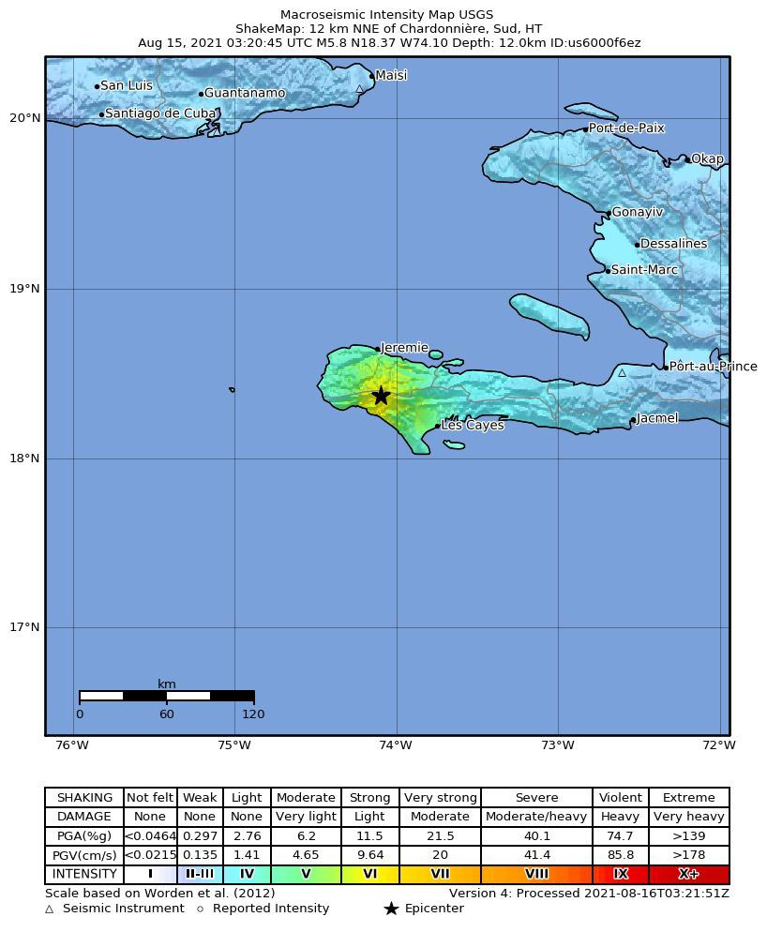

# Buildings

# Infrastructure

# Resilience

LES CAYES, Aug 18 (Reuters) - Days before a powerful earthquake struck, Rosemond Clermont paid the $1,554 rent on the office of his construction business in southern Haiti for the rest of the year.  
  
Economic losses were expected to be smaller than $1 million with a probability of 8%.

