Earthquake Report for Haiti on 2021-08-14

# Hazard Description

On August 14, 2021, at approximately 1:29 local time, a magnitude 7.2 earthquake, with a depth of 10.0 km, struck 1 km Northwest of of Nippes, Haiti. The coordinate of epicenter of the earthquake was 18.4167°N, 73.4804°W.

Extensive diversity and complexity of tectonic regimes characterizes the perimeter   
of the Caribbean plate, involving no fewer than four major plates (North America,   
South America, Nazca, and Cocos). Inclined zones of deep earthquakes (Wadati-Benioff zones), ocean trenches, and arcs of volcanoes clearly indicate subduction of oceanic lithosphere along the Central American and Atlantic Ocean margins of the Caribbean plate, while crustal seismicity in Guatemala, northern Venezuela, and the Cayman Ridge and Cayman Trench indicate transform fault and pull-apart basin tectonics.  
  
Along the northern margin of the Caribbean plate, the North America plate moves westwards with respect to the Caribbean plate at a velocity of approximately 20 mm/yr. Motion is accommodated along several major transform faults that extend eastward from Isla de Roatan to Haiti, including the Swan Island Fault and the Oriente Fault. These faults represent the southern and northern boundaries of the Cayman Trench. Further east, from the Dominican Republic to the Island of Barbuda, relative motion between the North America plate and the Caribbean plate becomes increasingly complex and is partially accommodated by nearly arc-parallel subduction of the North America plate beneath the Caribbean plate. This results in the formation of the deep Puerto Rico Trench and a zone of intermediate focus earthquakes (70-300 km depth) within the subducted slab. Although the Puerto Rico subduction zone is thought to be capable of generating a megathrust earthquake, there have been no such events in the past century. The last probable interplate (thrust fault) event here occurred on May 2, 1787 and was widely felt throughout the island with documented destruction across the entire northern coast, including Arecibo and San Juan. Since 1900, the two largest earthquakes to occur in this region were the August 4, 1946 M8.0 Samana earthquake in northeastern Hispaniola and the July 29, 1943 M7.6 Mona Passage earthquake, both of which were shallow thrust fault earthquakes.

A significant portion of the motion between the North America plate and the Caribbean plate in this region is accommodated by a series of left-lateral strike-slip faults that bisect   
the island of Hispaniola, notably the Septentrional Fault in the north and the Enriquillo-Plantain Garden Fault in the south. Activity adjacent to the Enriquillo-Plantain Garden Fault system is best documented by the devastating January 12, 2010 M7.0 Haiti strike-slip earthquake, its associated aftershocks and a comparable earthquake in 1770.  
  
Moving east and south, the plate boundary curves around Puerto Rico and the northern Lesser Antilles where the plate motion vector of the Caribbean plate relative to the North   
and South America plates is less oblique, resulting in active island-arc tectonics. Here, the North and South America plates subduct towards the west beneath the Caribbean plate along the Lesser Antilles Trench at rates of approximately 20 mm/yr. As a result of this   
subduction, there exists both intermediate focus earthquakes within the subducted plates   
and a chain of active volcanoes along the island arc. Although the Lesser Antilles is considered one of the most seismically active regions in the Caribbean, few of these events   
have been greater than M7.0 over the past century. The island of Guadeloupe was the site   
of one of the largest megathrust earthquakes to occur in this region on February 8, 1843,   
with a suggested magnitude greater than 8.0. The largest recent intermediate-depth earthquake to occur along the Lesser Antilles arc was the November 29, 2007 M7.4   
Martinique earthquake northwest of Fort-De-France.  
  
The southern Caribbean plate boundary with the South America plate strikes east-west   
across Trinidad and western Venezuela at a relative rate of approximately 20 mm/yr.   
This boundary is characterized by major transform faults, including the Central Range   
Fault and the Boconó-San Sebastian-El Pilar Faults, and shallow seismicity. Since 1900,   
the largest earthquakes to occur in this region were the October 29, 1900 M7.7 Caracas   
earthquake, and the July 29, 1967 M6.5 earthquake near this same region. Further to the west, a broad zone of compressive deformation trends southwestward across western Venezuela and central Colombia. The plate boundary is not well defined across northwestern South America, but deformation transitions from being dominated by Caribbean/South America convergence in the east to Nazca/South America convergence in the west. The transition zone between subduction on the eastern and western margins of the Caribbean plate is characterized by diffuse seismicity involving low- to intermediate-magnitude (M<6.0) earthquakes of shallow to intermediate depth.  
  
The plate boundary offshore of Colombia is also characterized by convergence, where the Nazca plate subducts beneath South America towards the east at a rate of approximately 65 mm/yr. The January 31, 1906 M8.5 earthquake occurred on the shallowly dipping megathrust interface of this plate boundary segment. Along the western coast of Central America, the Cocos plate subducts towards the east beneath the Caribbean plate at the Middle America Trench. Convergence rates vary between 72-81 mm/yr, decreasing towards the north. This subduction results in relatively high rates of seismicity and a chain of numerous active volcanoes; intermediate-focus earthquakes occur within the subducted Cocos plate to depths of nearly 300 km. Since 1900, there have been many moderately sized intermediate-depth earthquakes in this region, including the September 7, 1915 M7.4 El Salvador and the October 5, 1950 M7.8 Costa Rica events.  
  
The boundary between the Cocos and Nazca plates is characterized by a series of north-south trending transform faults and east-west trending spreading centers. The largest and most seismically active of these transform boundaries is the Panama Fracture Zone. The Panama Fracture Zone terminates in the south at the Galapagos rift zone and in the north at the Middle America trench, where it forms part of the Cocos-Nazca-Caribbean triple junction. Earthquakes along the Panama Fracture Zone are generally shallow, low- to intermediate in magnitude (M<7.2) and are characteristically right-lateral strike-slip faulting earthquakes. Since 1900, the largest earthquake to occur along the Panama Fracture Zone was the July 26, 1962 M7.2 earthquake.  
  
**References for the Panama Fracture Zone:**  
  
Molnar, P., and Sykes, L. R., 1969, Tectonics of the Caribbean and Middle America   
Regions from Focal Mechanisms and Seismicity: Geological Society of America Bulletin,   
v. 80, p. 1639-1684.

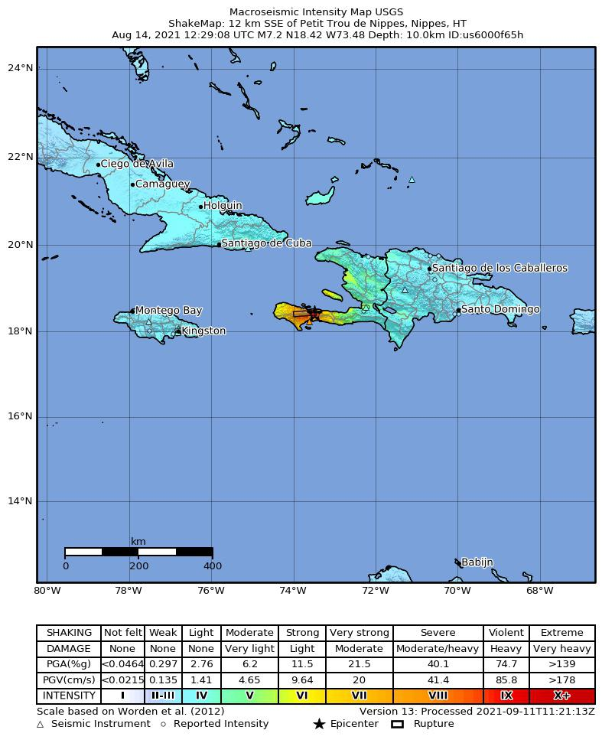

# Buildings

On Saturday morning, the investment vanished when his small shop collapsed along with hundreds of other buildings in his home town as the coastal city of Les Cayes began crumbling. His mother Seralia Dejoit had been attending a voodoo ceremony in the house when the quake struck. Residents say an estimated 20 lives were lost in the building in the tight-knit rural community inland from the city of Les Cayes. A soldier cleans debris from a house after a 7.2 magnitude earthquake in Les Cayes, Haiti August 15, 2021. In difficult-to-reach villages many houses were fragile and built on slopes vulnerable to landslides, said Alix Percinthe, from the ActionAid charity. Before the quake, farmer Michel Pierre had tended 15 goats and cultivated yams, potatoes, corn, and banana trees. The calamity brought back memories for Dorcy of the 2010 quake, which he survived by fleeing the collapsing three-story building he was inside in Port-au-Prince. Elsewhere in the village, some people dug graves to prepare for funerals, while other residents worked to remove a massive heap of rubble in efforts to find the remains of loved ones. In Nan Konsey, the earth's convulsions tore open the village's cement cisterns used to store drinking water and triggered landslides that interred residents' modest subsistence farms. Churches, hotels, hospitals and schools were badly damaged or destroyed, while the walls of a prison were rent open by the violent shudders that convulsed Haiti. At the Paroisse Saint-Joseph de Simon Roman Catholic church on the outskirts of Les Cayes, a southwestern city that bore the brunt of the quake, about 200 worshipers gathered early for the first Sunday Mass since the disaster. Now she lay under a white sheet on the floor. Outside another Catholic church overlooking the main park in Les Cayes, dozens of worshipers gathered for Sunday Mass in the yard adjacent to the damaged cathedral. "Since the earthquake, I keep thinking the ground is trembling, that it's happening again." With so many dead, residents decided to bury victims of the church collapse in a mass grave in a nearby cemetery, said Prenor Lefleur, who helped move the bodies and dig the hole. Architecture studio TYPE has converted the dilapidated Redhill Barn in Devon, England, into a house that retains its 200-year-old stone … A soldier cleans debris from a house after a 7.2 magnitude earthquake in Les Cayes, Haiti August 15, 2021. The 26-year-old deceased woman, herself a mother of two, had been crushed by debris during the magnitude 7.2 quake. Dozens of businesses ranging from hotels, restaurants to corner shops in downtown Les Cayes and surrounding areas suffered a similar fate, with premises either badly damaged or flattened. Clermont's family has been spending nights in the car since the earthquake, scared of possible structural damage at their home after they watched the walls shake violently.

# Infrastructure

She screamed in pain as the doctors cleaned and disinfected the wound without anesthesia. Access to the worst-hit areas was complicated by a deterioration in law and order that has left key access roads in parts of Haiti in the hands of gangs. See here for a complete list of exchanges and delays. A car drives past a damaged road, after the earthquake that took place on August 14th, in Marceline, near Les Cayes, Haiti August 20, 2021. Recovery efforts have been impeded by flooding and damage to access roads, feeding tensions in some of the hardest-hit areas. Landslides and cracks in the tarmac on the mountain road between Les Cayes and Jeremie to its northwest - two of the worst-affected urban areas - made it harder to dispatch aid to farming communities short of food and drinkable water. The route was littered with boulders and the occasional stranded truck.

# Resilience

MARCELINE, Haiti, Aug 22 (Reuters) - Families gathered in villages in southwestern Haiti this weekend for church and funeral services a week after an earthquake battered the region, killing more than 2,200 people and destroying tens of thousands of buildings. PORT-AU-PRINCE, Aug 15 (Reuters) - Haiti's hospitals were swamped on Sunday by thousands of injured residents after a devastating earthquake the day before killed at least 1,297 people as authorities raced to bring doctors to the worst-hit areas before a major storm hits. LES CAYES, Haiti, Aug 17 (Reuters) - Survivors of the earthquake that killed at least 1,941 people in Haiti clamored for food, shelter and medical care on Tuesday as search and rescue efforts resumed after a tropical storm lashed the Caribbean nation with rain, causing dangerous flooding. The 7.2 magnitude quake on Saturday destroyed thousands of homes and buildings in a Caribbean nation which is still clawing its way back from another major temblor 11 years ago and is reeling from the assassination of its president last month. Aug 14 (Reuters) - Another earthquake of magnitude 5.9 struck the Haiti region late on Saturday, the European Mediterranean Seismological Centre (EMSC) said, hours after a major quake in the region killed over 300 people. PORT-AU-PRINCE, Aug 16 (Reuters) - The earthquake that ravaged Haiti on Saturday has revived anger over international aid agencies' response to a devastating quake there 11 years ago, stirring calls to ensure donations do a better job of reaching the people who need them most. A U.S. Coast Guard helicopter lifts off during a medical evacuation of people injured in Saturday's 7.2 magnitude earthquake, in Les Cayes, Haiti, August 17, 2021. However, Haiti's government appealed to aid organizations against setting up makeshift camps and urged them to work through the planning ministry, an apparent attempt to avoid the mistakes made following the devastating 2010 earthquake that killed tens of thousands of people. MARCELINE, Haiti, Aug 20 (Reuters) - Haitians desperate for food looted a humanitarian convoy on Friday and fought over donations as anger built over the slow pace of aid deliveries almost a week after a devastating earthquake killed more than 2,000 people.  
  
Economic losses were expected to be between $1 million and $10 million with a probability of 10%, between $10 million and $100 million with a probability of 28%, between $1,000 million and $10,000 million with a probability of 20%, between $10,000 million and $100,0and 00 million with a probability of 6%.

