Earthquake Report for Mexico on 2021-09-07 18:47:4

# Hazard Description

On September 7, 2021, at approximately 13:47 local time, a magnitude 7.0 earthquake, with a depth of 20 km, struck 1 km Northwest of of Acapulco, Mexico. The coordinate of epicenter of the earthquake was 16.9816°N, 99.7726°W.

Located atop three of the large tectonic plates, Mexico   
is one of the world's most seismically active regions.   
The relative motion of these crustal plates causes frequent   
earthquakes and occasional volcanic eruptions.   
Most of the   
Mexican landmass is on the westward moving North American   
plate. The Pacific Ocean floor south of Mexico is being   
carried northeastward by the underlying Cocos plate. Because   
oceanic crust is relatively dense, when the Pacific Ocean   
floor encounters the lighter continental crust of the Mexican   
landmass, the ocean floor is subducted beneath the North   
American plate creating the deep Middle American trench   
along Mexico's southern coast. Also as a result of this   
convergence, the westward moving Mexico landmass is slowed   
and crumpled creating the mountain ranges of southern Mexico   
and earthquakes near Mexico's southern coast. As the oceanic   
crust is pulled downward, it melts; the molten material is then   
forced upward through weaknesses in the overlying continental   
crust. This process has created a region of volcanoes across   
south-central Mexico known as the Cordillera Neovolcánica.  
  
The area west of the Gulf of California, including Mexico's Baja   
California Peninsula, is moving northwestward with the Pacific   
plate at about 50 mm per year. Here, the Pacific and North American   
plates grind past each other creating strike-slip faulting, the   
southern extension of California's San Andreas fault. In the past,   
this relative plate motion pulled Baja California away from the coast   
forming the Gulf of California and is the cause of earthquakes in the   
Gulf of California region today.  
  
Mexico has a long history of destructive earthquakes and volcanic   
eruptions. In September 1985, a magnitude 8.0 earthquake killed   
more than 9,500 people in Mexico City. In southern Mexico, Volcán   
de Colima and El Chichón erupted in 2005 and 1982, respectively.   
Paricutín volcano, west of Mexico City, began venting smoke in a   
cornfield in 1943; a decade later this new volcano had grown to a   
height of 424 meters. Popocatépetl and Ixtaccíhuatl volcanos   
("smoking mountain" and "white lady", respectively), southeast   
of Mexico City, occasionally vent gas that can be clearly seen from the City,   
a reminder that volcanic activity is ongoing. In 1994 and 2000 Popocatépetl   
renewed its activity forcing the evacuation of nearby towns, causing   
seismologists and government officials to be concerned about the effect a   
large-scale eruption might have on the heavily populated region.   
Popocatépetl volcano last erupted in 2010.  
  
   
More information on regional seismicity and tectonics

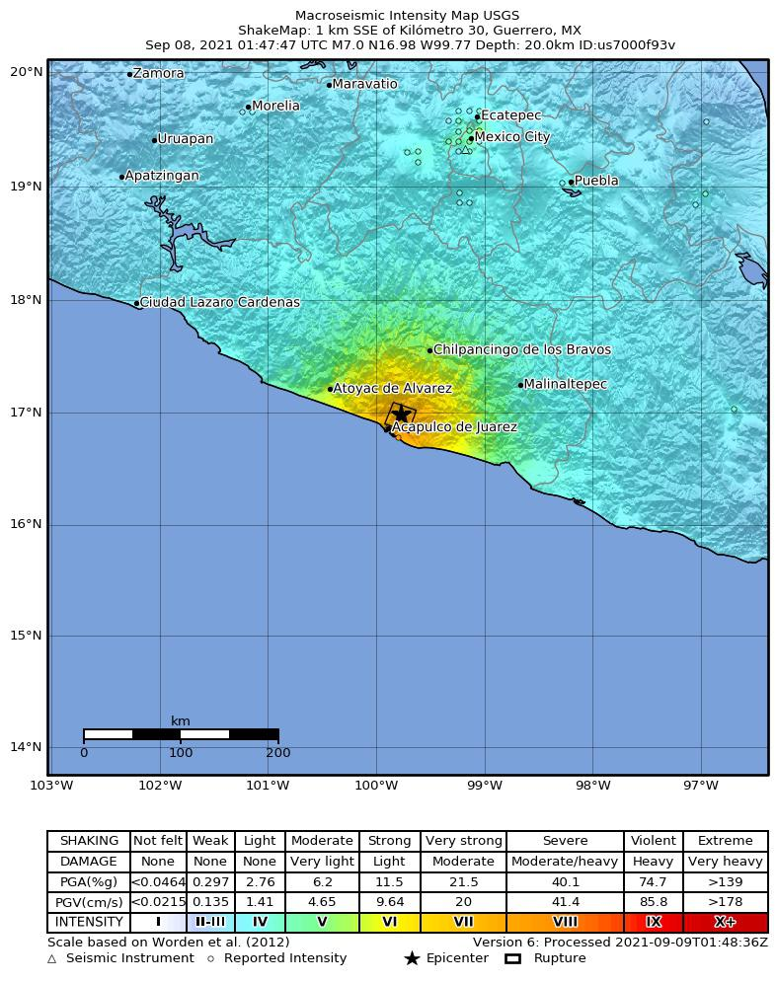

# Buildings

# Infrastructure

# Resilience

There were widespread reports of power outages and major shaking being reported as far away as Mexico City.  
  
Economic losses were expected to be between $1 million and $10 million with a probability of 7%, between $10 million and $100 million with a probability of 26%, between $100 million and $1,000 million with a probability of 38%, between $1,000 million and $10,000 million with a probability of 22%, between $10,000 million and $100,0and 00 million with a probability of 6%.

