Earthquake Report for China on 2021-09-15 13:33:3

# Hazard Description

On September 15, 2021, at approximately 21:33 local time, a magnitude 5.4 earthquake, with a depth of 10 km, struck 52 km West-Southwest of of Yongchuan, China. The coordinate of epicenter of the earthquake was 29.1823°N, 105.3905°E.

Data not available.

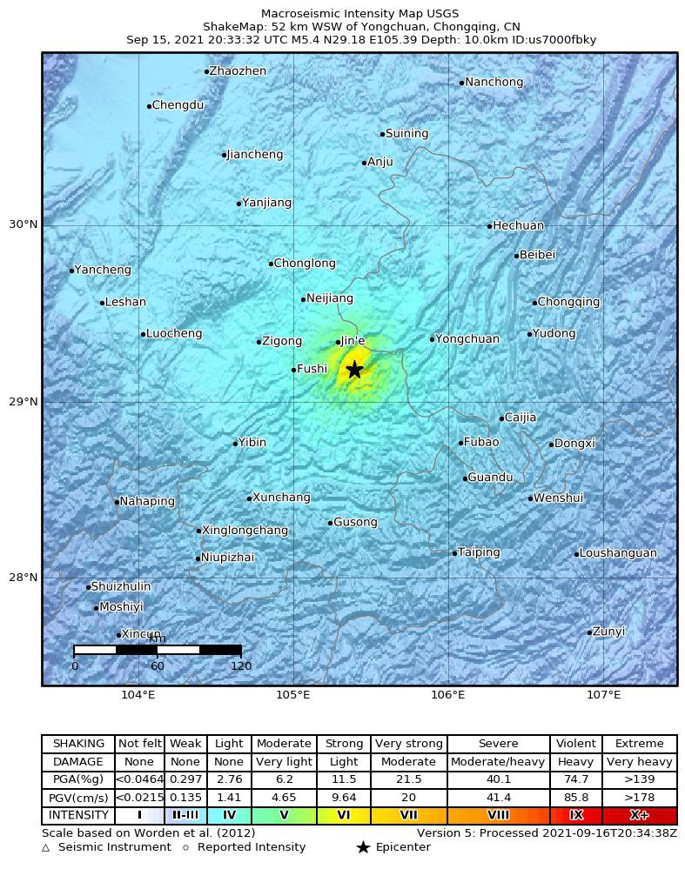

# Buildings

Xinhua reported that collapsed walls and houses could be seen on the way to the epicentre, and that electricity had been suspended in much of Jiaming town. Xinhua reported that collapsed walls and houses could be seen on the way to the epicenter, and that electricity had been cut in much of Jiaming town.

# Infrastructure

# Resilience

An earthquake destroyed houses, killed at least three people and injured dozens Thursday in southwest China's Sichuan province. BEIJING (AP) — An earthquake destroyed houses, killed at least three people and injured dozens Thursday in southwest China’s Sichuan province. A magnitude- .9 quake in May 2008 left nearly 90,000 people dead in Sichuan, many of them in collapsed schools and other poorly constructed buildings. Thursday's quake comes months after a series of strong earthquakes shook sparsely populated areas in north-west and south-west China in May, killing at least two people and injuring dozens. It struck at 4:33 a.m. at a depth of 10 kilometers (6 miles) in Luxian, a county in the city of Luzhou, the official Xinhua News Agency said. BEIJING: Three people were killed and dozens injured when a shallow earthquake struck south-western China on Thursday (Sep 16), triggering the second-highest level of emergency response by rescuers in Sichuan province.  
  
Economic losses were expected to be smaller than $1 million with a probability of 4%, between $1 million and $10 million with a probability of 18%, between $100 million and $1,0and 00 million with a probability of 29%.

