**Entertainer data analysis**

Low Level Design

Author: Vedant Mishra

**Index**

|  |  |  |
| --- | --- | --- |
| **SR.NO** | **Title** | **Page no** |
| 1 | Abstract | 3 |
| 2 | Given Tasks | 3 |
| 3 | Scope | 3 |
| 4 | Architecture | 4 |
| 5 | Data Description | 5 |
| 9 | Connect data with power bi and Deployment | 8 |

**Abstract**

* Normal life can be stressful, and people need to relax. Being entertained by others is a wonderful way to take some time out of life. It can reduce stress and make life's issues easier to face. The media and entertainment industry consist of film, television, radio and print. These segments include movies, TV shows, radio shows, news, music, newspapers, magazines, and books. Entertainment industry is a group of sub-industries devoted to entertainment. Entertainment industry is used to describe the mass media companies that control the distribution and manufacture of mass media entertainment.

**Given Tasks**

* **Task #1** - In a word document write the process and data added to the current dataset. In addition, mention the theme on which you will be creating the dashboard.
* **Task #2** - You can add your data as per your convenience.
* **Task #3** – Do the data preparation part.
* **Task #4** – Build the dashboards.
* **Task #5** – Build a Storyline.

**Scope**

* My main theme is on number of awards won by entertainers throughout their life. I have made two dashboards showing their award-winning performance. Dashboards show highest number of nominees, Oscar awards, Emmy awards, Grammy awards and other awards etc. so that each and every one can analyze which entertainer is the best according to their thought process.
* My main theme is to create dashboards on top entertainers with their highest number of awards and nominees and make visualization on it.

Architecture

* The architecture of the project is given below



**Power BI Desktop, client, visualization**

Power Bi

* Our Entire data source is our excel file and through power bi we can access the data
* Power BI has many architecture component
* The screen of the power BI Desktop ,charts and dashboards are present at client side
* The client can select the graphs according to his/her preference and then add the data to the graph to get the data in a visualized format
* If the client is not satisfied with the result he/she can choose the graph accordingly otherwise make changes to the graph to get the required result

**Data Description**

* Data was given into three parts in excel file which are Entertainer – Basic Info, Entertainer – Breakthrough Info and Entertainer - Last work Info.
* Basic Info includes name, gender and birth year of entertainer.
* Breakthrough Info includes year of breakthrough/#1 hit/award nomination, breakthrough name, year of first Oscar/Grammy/Emmy along with name of entertainers.
* Last work Info includes last major work (arguable), year of death (if they are) along with name of entertainers.
* 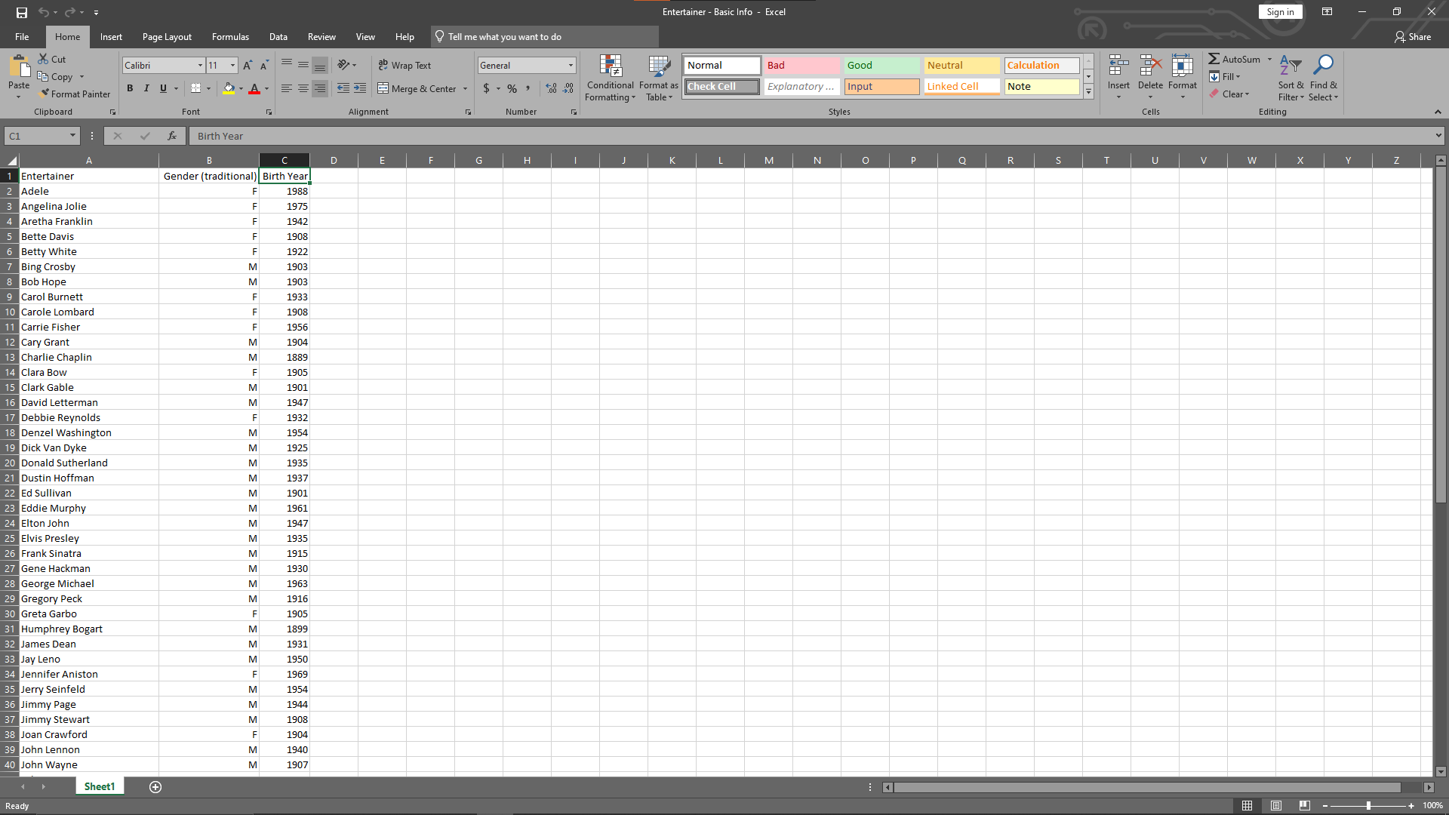Glimpse of Entertainer – Basic Info:
* Glimpse of Entertainer – Breakthrough Info: 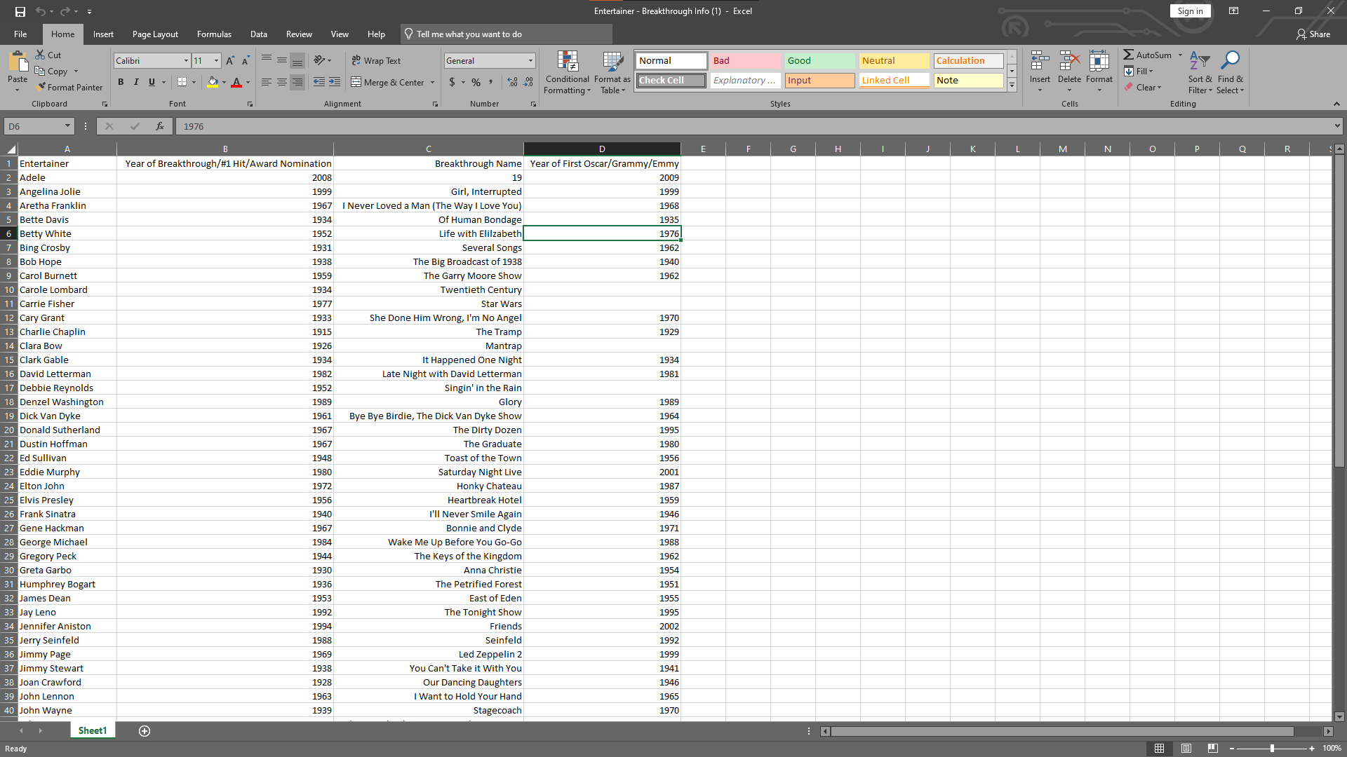
* 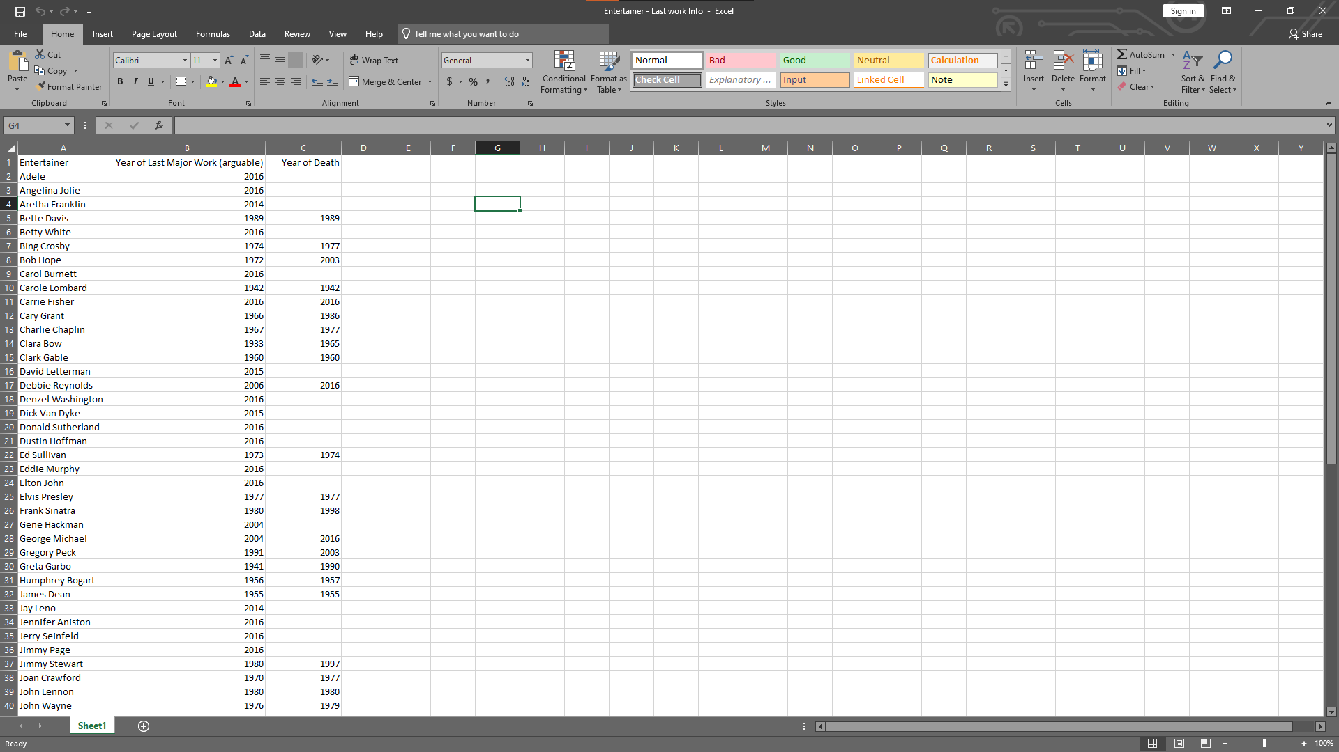Glimpse of Entertainer – Last work Info
* After this, I combined this data into one sheet named Entertainer – Final, but this data isn’t sufficient to do analysis and make dashboard on it. For this, I have added some external information like awards they won, nominees etc. from IMDb’s official website ([IMDB](https://www.imdb.com/)).
* 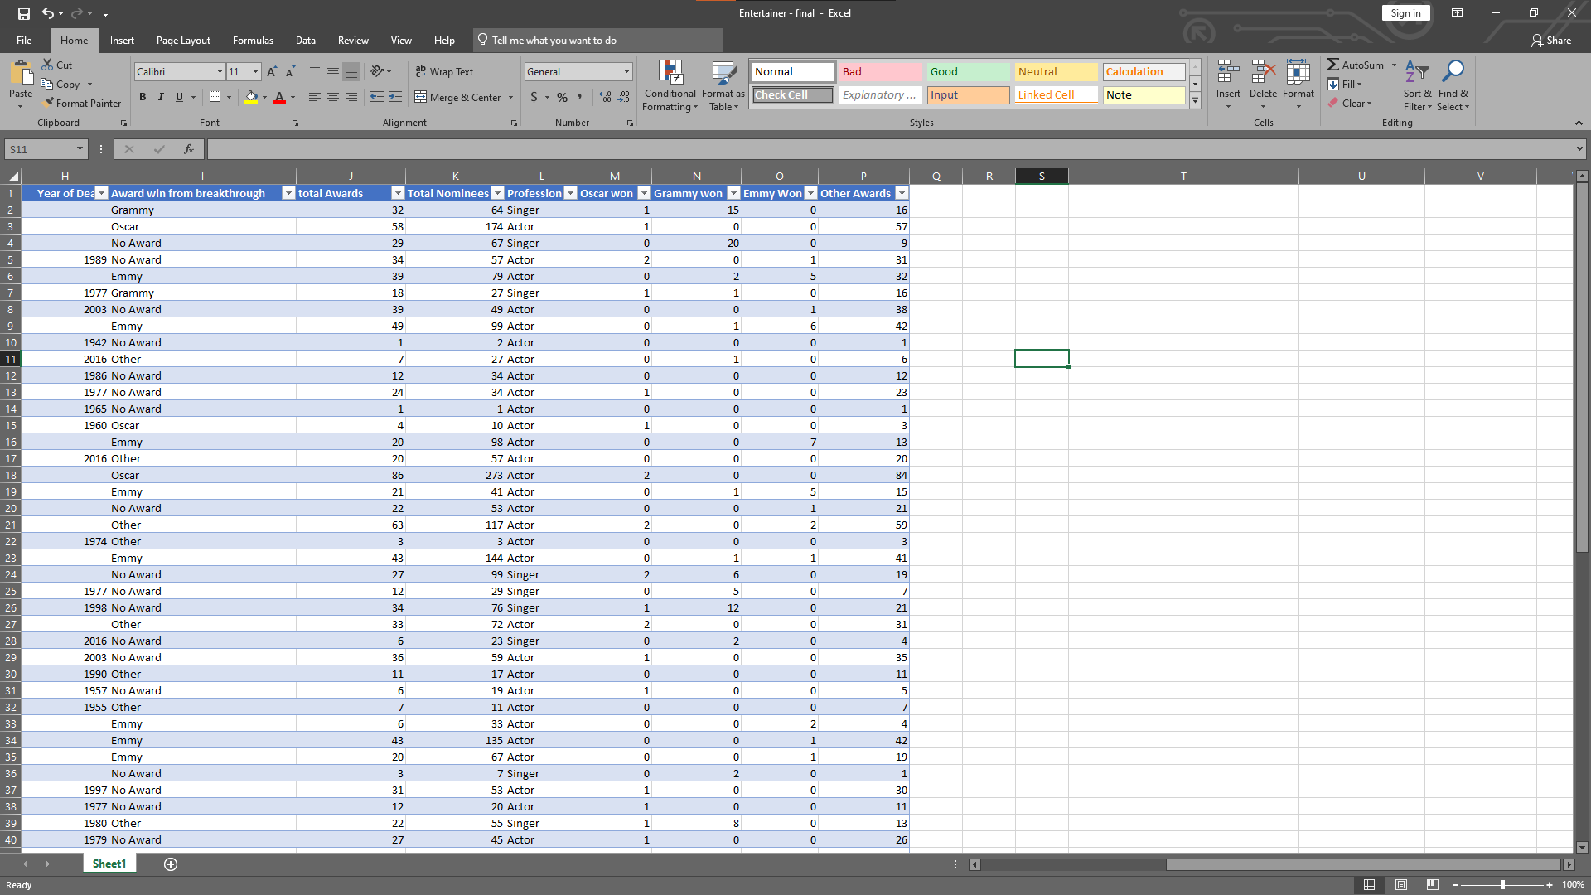After some processing data looks like this:
* **Entertainer:** Name of the entertainer.
* **Gender (traditional):** Gender of that entertainer
* **Birth Year:** Birth year of that entertainer
* **Year of Breakthrough/#1 hit/Award Nomination:** Here, breakthrough means super hit or career changing performance. Column shows year of breakthrough
* **Breakthrough Name:** Name of breakthrough. It can be either musical album or TV show or movie.
* **Year of first Oscar/Grammy/Emmy:** Year if first mega award they won.
* **Year of Last Major Work (arguable):** Last major show or movie or album. You can also say last appearance.
* **Year of Death:** Entertainer’s year of death, if they die.
* **Award won from Breakthrough:** Any award/s from breakthrough. I only wrote mega awards they won in this column. If they had other awards for breakthrough, I wrote “other”, if they haven’t, I wrote “No Award”. If they have mega award, I wrote that award name.
* **Total Awards Won:** Total awards that entertainer won throughout.
* **Total Nominees:** Total nominees for they have chosen for award.
* **Profession:** Category of entertainer either singer or actor. Pop stars and dancers are included in singer and TV hosts and TV actors are included in actors.
* **Oscar won:** Number of total Oscar awards they won.
* **Grammy won:** Number of total Grammy awards they won.
* **Emmy won:** Number of total Emmy awards they won.
* **Other Awards:** Number of other awards they won apart from Oscar, Grammy and Emmy.

**Connect data with power bi and deployment:**

* 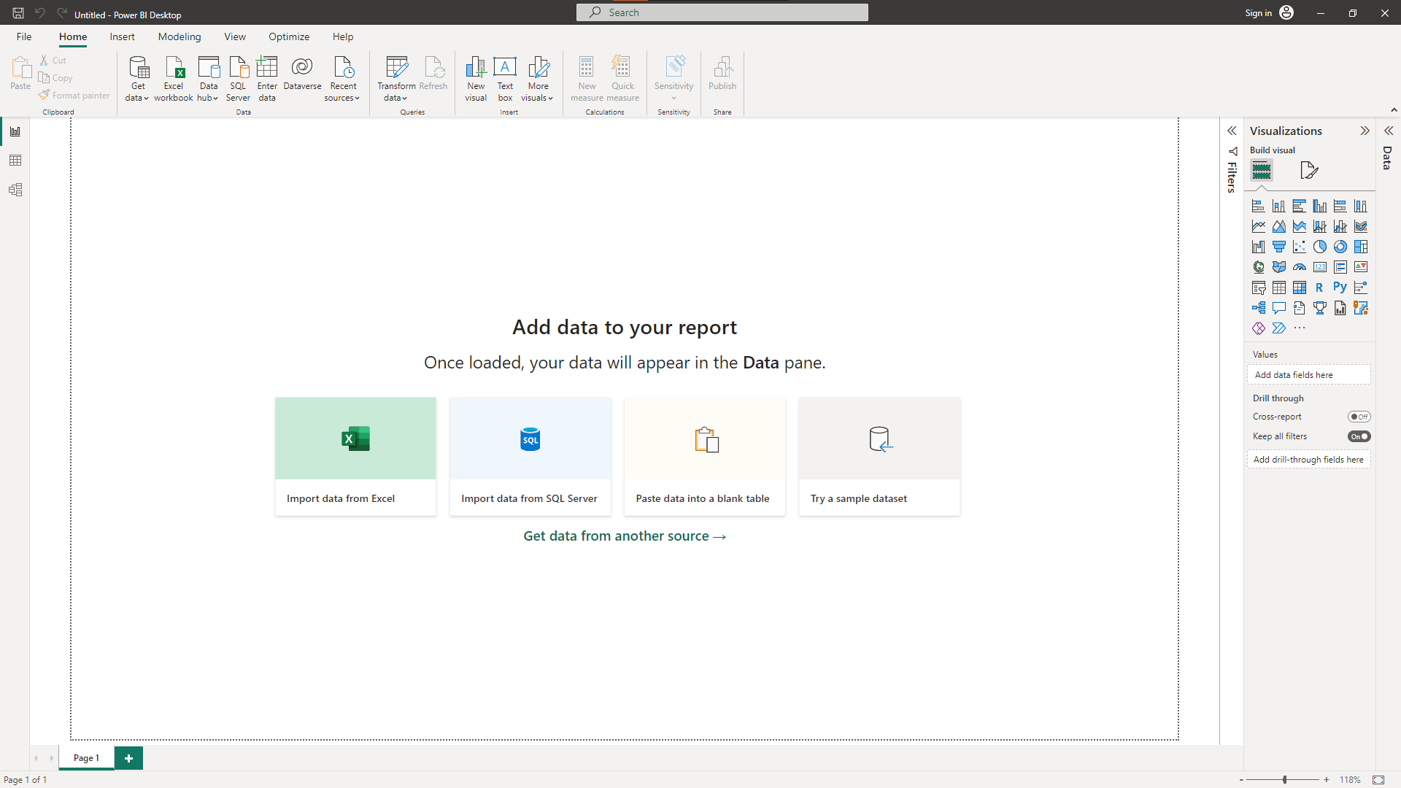First open power bi the power bi interface looks like this the first screen will ask you to add data from the file which you have like MS Excel, SQl Server, csv files etc.
* Make sure internet connection is connected well while working with power bi, otherwise it will show the error.
* After completion of work, you can simply press ctrl + s or save it from file menu. And you can then publish it on power bi server.