**Entertainer data analysis**

wireframe

Theme: Top Entertainer based on Awards

**Dashboard 1 :**

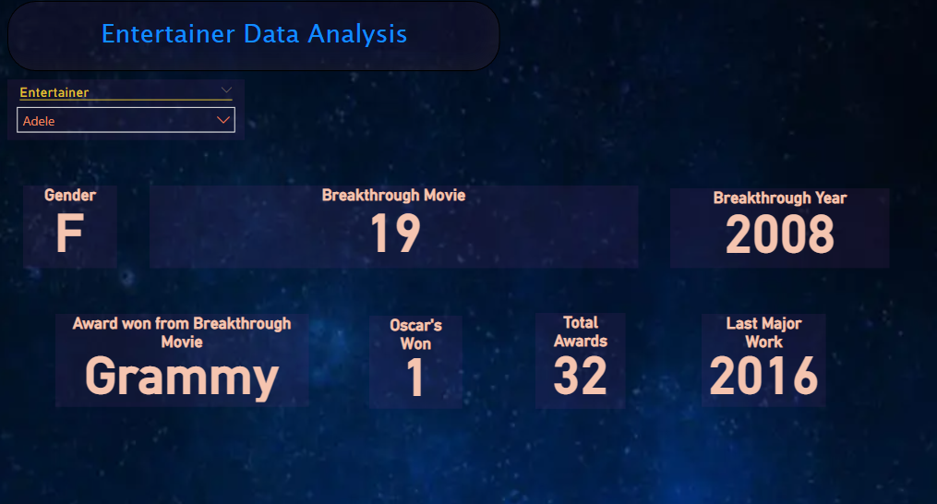

This is the first Dashboard in which there are basic things like **breakthrough movie and year, award won from breakthrough movie, total awards won, total Oscars won, their gender** there is a dropdown menu we can change select which entertainers detail we want to se and it will be displayed

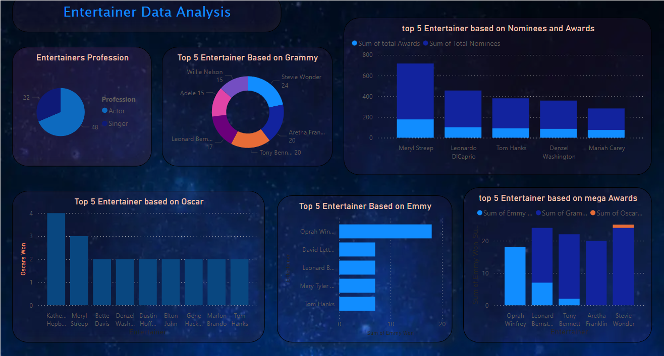**Dashboard 2 :**

This is the main dashboard

* Top Entertainers are shown in this dashboard
* Let’s look at every chart one by one

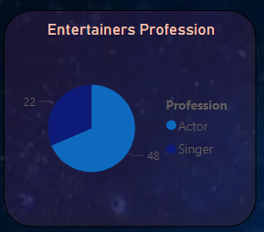

* So, the data contain two major category **actors** and **singers**. pop stars, stage performers etc are included in singers and tv actors, tv host etc are included in actors

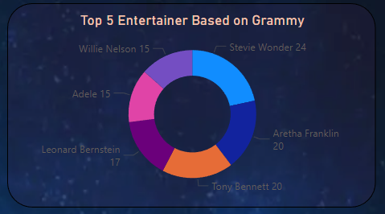

* here is a donut chart showing the top entertainers based on most numbers of Grammy won the data contains many more entertainers but here I have only shown top five and we can see that **Stevie Wonder** has won most number of Grammy that is 20 Grammy are given to singers.

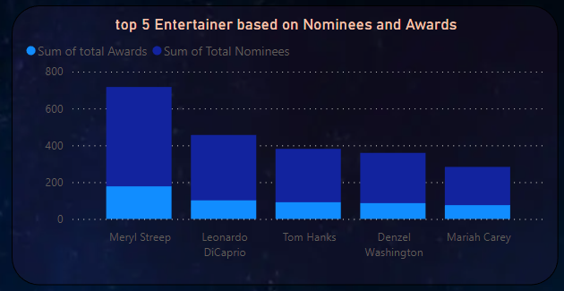

* this stacked bar graph shows the top nominees and Awards won by the entertainer the dark blue color shows the number of nominees and the blue color shows number of awards won by the entertainer and **Meryl Streep** has been nominated most of the time and won most number of awards

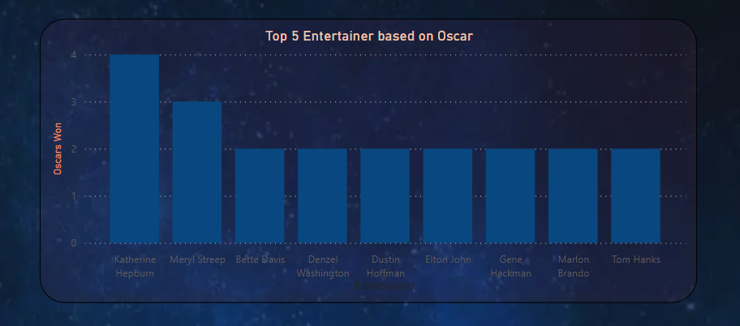

* This chart shows the Oscar winning performers with most number of time winning the Oscars

Oscars are given to actors for their phenomenal performance. Sometime it is given to singers also **Katherine Hepburn** leads the tally

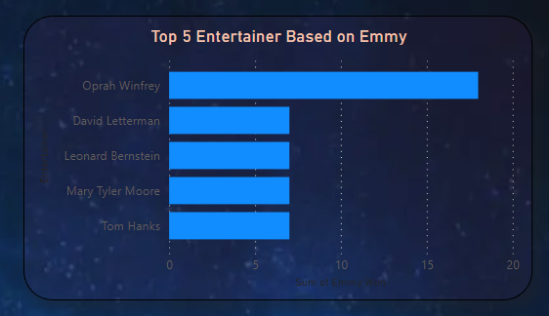

* This chart shows the entertainer who has won most number of Emmy awards and we can see **Oprah Winfrey** leads the tally Emmy awards is given to the TV industry , host etc.

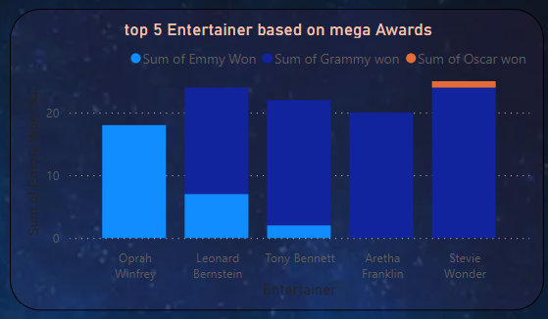

* This chart shows the entertainers who have won most number of mega awards (Oscars, Grammy, Emmy) And **Stevie Wonder** leads the tally