WITHOUT THE ADAPTIVE THRESHOLD (FIXED THRESHOLD VALUE)
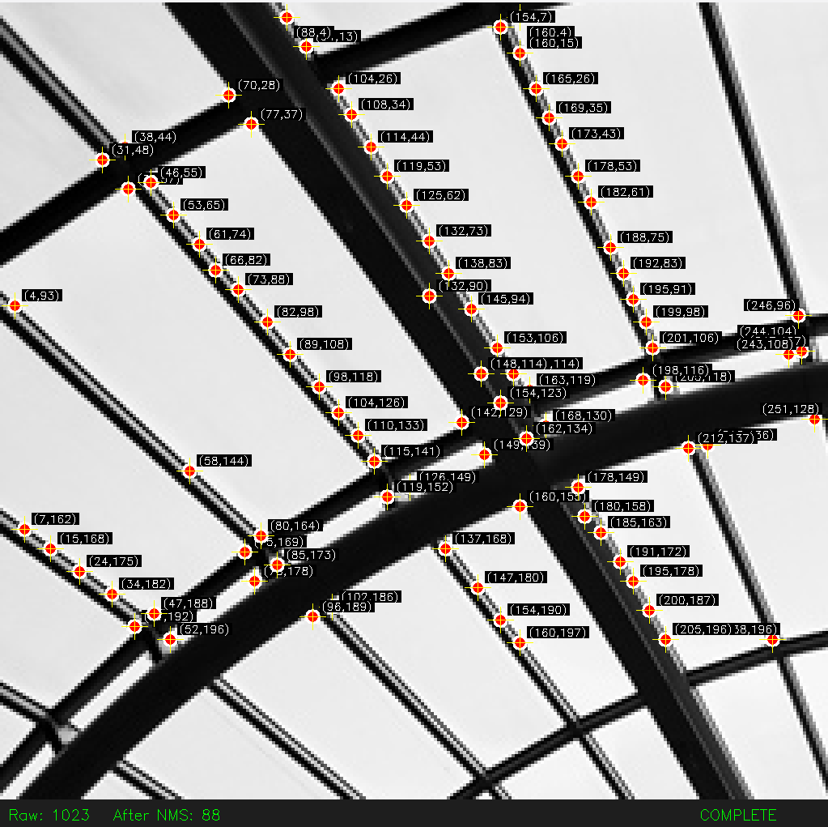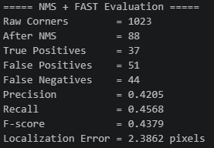 RESISTORS TO HOLD CORNERS SATURATED AT 1023

WITH GLOBAL ADAPTIVE THRESHOLD
