WITH THE LOCAL ADAPTIVE THRESHOLD
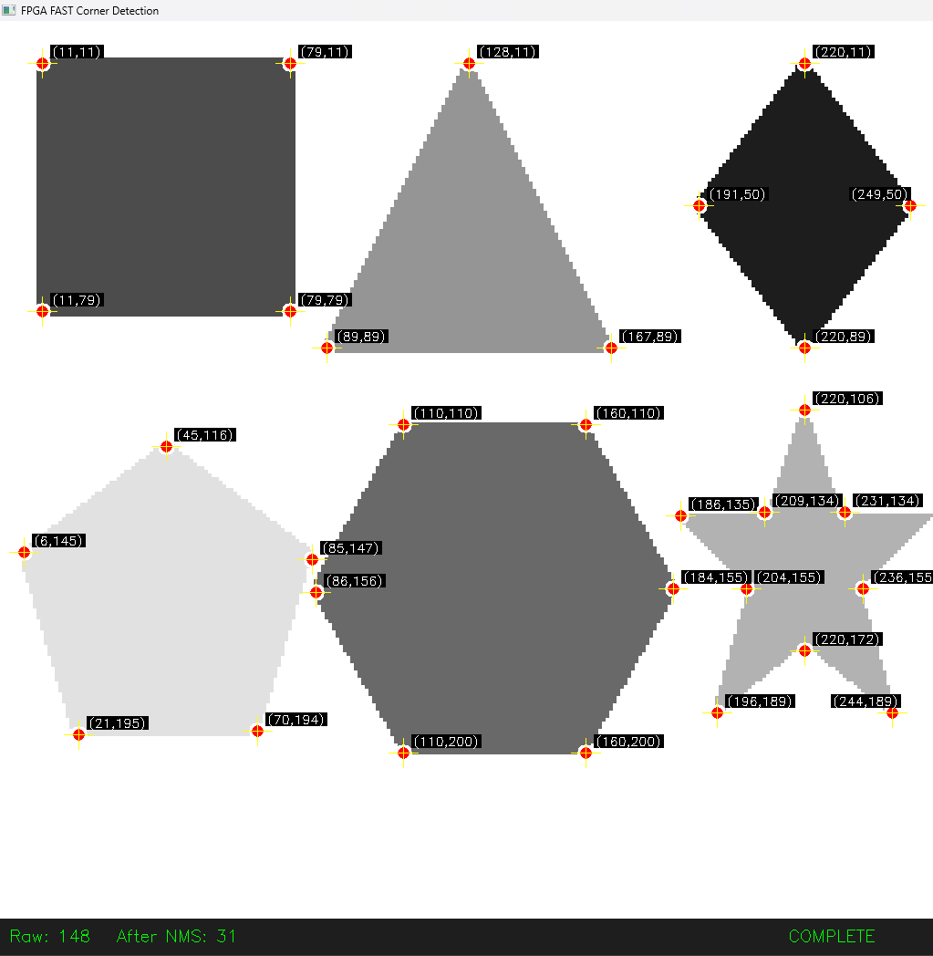

WITH GLOBAL ADAPTIVE THRESHOLD
