WITH THE LOCAL ADAPTIVE THRESHOLD
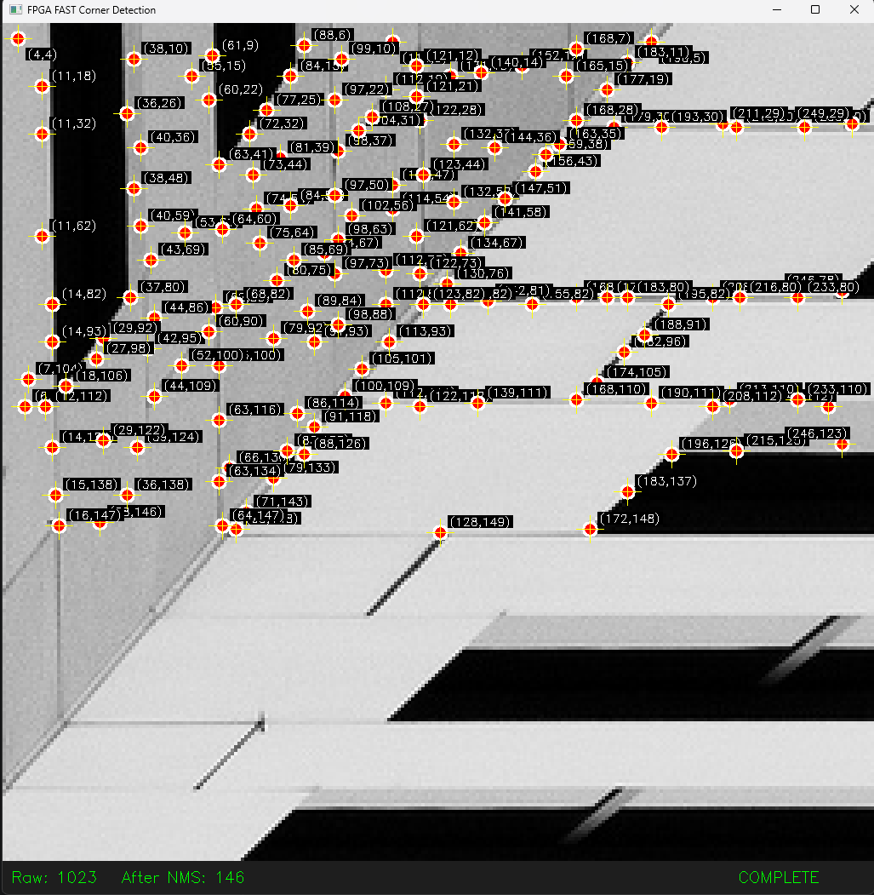

WITHOUT THE ADAPTIVE THRESHOLD (FIXED THRESHOLD VALUE)
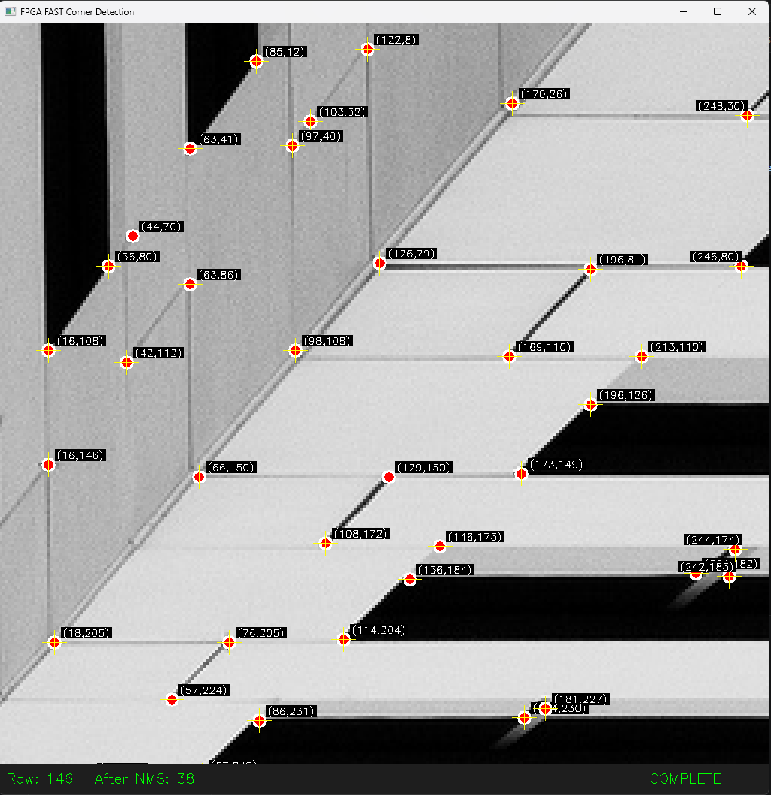

WITH GLOBAL ADAPTIVE THRESHOLD
