SPAM MAIL PREDICTION
USING MACHINE LEARNING

A Project Report
Submitted in partial fulfilment of the requirements for
AI

Submitted by:
Vedant Patil

Under the guidance of:
Ameed
Naviotech Solutions Pvt.Ltd.

Certificate

This is to certify that the project report entitled “Spam Mail Prediction Using Machine Learning” is a bona fide record of the project work carried out by Vedant Patil under my supervision. This report is submitted in partial fulfilment of the requirements for the completion of AI at Naviotech Solutions.

Signature of Guide: ___________________
Name of Guide: ___________________
Date: ___________________

Acknowledgement

I would like to express my sincere gratitude to my project guide, Ameed, for their continuous support, encouragement, and invaluable feedback throughout the development of this project. I also extend my thanks to the faculty of the AI for providing the necessary resources and facilities. Finally, I would like to thank my family and friends for their unwavering support during this endeavor.

Abstract

Spam email is one of the most common nuisances and cybersecurity vectors affecting users worldwide, and fast, accurate filtering is critical to improving digital communication. This project implements a Machine Learning based classifier to predict whether an email is 'Spam' (malicious/unsolicited) or 'Ham' (legitimate) using a standard benchmark text dataset of 5,572 records.
The dataset consists of patient-like categorical labels and raw text messages. A natural language processing pipeline was built using Python and Scikit-learn. The text data was vectorized using Term Frequency-Inverse Document Frequency (TF-IDF) to convert raw strings into numerical feature matrices. A Logistic Regression model was chosen for its speed and efficacy on linearly separable text features.
The data was preprocessed to remove null values, split into 80% training and 20% testing records, and the model was trained. The model achieved a final training accuracy of 96.7% and a test accuracy of 96.6% on unseen data. A predictive system was also built, successfully classifying a new sample input as 'Ham' with high confidence. This report explains the technical background, dataset, mathematical foundation of TF-IDF and Logistic Regression, full implementation, and a detailed evaluation of these results.

Table of Contents

1. Introduction
2. Literature Review
3. Methodology
4. Machine Learning Fundamentals
5. Alternative Algorithms: A Comparative Study
6. System Design and Implementation
7. Results and Discussion
8. Evaluation Metrics in Depth
9. Conclusion
10. Future Scope
11. References
Appendix A: Full Source Code Listing
Appendix B: Glossary of Terms
Appendix C: Reproducibility and Environment Setup

1. Introduction

1.1 Overview
Electronic mail is a cornerstone of modern digital communication. However, it is plagued by "spam"—bulk, unsolicited messages that often contain malicious links, phishing attempts, or fraudulent advertisements. Correctly distinguishing between the two is one of the most important steps in email routing.

1.2 Technical Background
Traditional spam filters relied on rule-based systems, where administrators manually flagged specific sender addresses or keywords (e.g., "Free money", "Lottery"). Modern spam detection relies on Machine Learning (ML) and Natural Language Processing (NLP), enabling computers to process and analyze human language efficiently.

1.3 Problem Statement
Manual interpretation of spam text is impossible at scale. The objective of this project is to develop a Machine Learning model that can automatically classify an email as spam or ham based on textual patterns, providing a fast and highly accurate filter to support communication systems.

1.4 Project Objectives
• To load and explore the Spam Mail dataset.
• To preprocess the data and encode text labels into binary values.
• To extract numerical features from unstructured text using TF-IDF.
• To train a Logistic Regression model and evaluate its accuracy.
• To build a predictive system that classifies a new incoming text message.

1.5 Global Impact
Spam comprises over 45% of all emails sent globally. Beyond merely cluttering inboxes, spam carries severe cybersecurity risks. Phishing attacks delivered via spam cost businesses billions of dollars annually. Automated, machine-learning-driven filtering is essential for mitigating this impact.

1.6 Significance of the Study
In email classification, a 'False Positive' (classifying a critical work email as spam) is highly disruptive to the user. A 'False Negative' (allowing a spam email into the inbox) is annoying but usually less destructive. Therefore, the system must achieve a high overall accuracy while ensuring that legitimate 'ham' messages are rarely misclassified.

1.7 Report Structure
The remainder of this report is organised exactly like the benchmark project: Chapter 2 reviews literature. Chapter 3 details methodology. Chapter 4 explains mathematical fundamentals. Chapter 5 compares algorithms. Chapter 6 describes implementation. Chapter 7 presents results. Chapter 8 evaluates metrics. Chapters 9 and 10 provide conclusions and future scope, followed by Appendices.

2. Literature Review

2.1 The Spam Dataset
The dataset used (mail_data.csv) contains 5,572 labeled text instances. It serves as a classic benchmark for NLP binary classification problems, as the textual structures of the two classes differ significantly.

2.2 ML Approaches to Text Classification
A wide range of algorithms have been applied to text classification, including Naive Bayes, Support Vector Machines, and Deep Neural Networks. Because the text features (when vectorized) form a high-dimensional sparse matrix, linear classifiers are known to perform exceptionally well.

2.3 Why Logistic Regression
A Logistic Regression algorithm was chosen for this project because it is fast, interpretable, and mathematically robust for binary classification (Spam=0, Ham=1) in high-dimensional feature spaces created by TF-IDF vectorization.

2.4 Feature Extraction (TF-IDF)
Early systems used 'Bag of Words' (BoW) counting. However, BoW weighs all words equally. TF-IDF penalizes highly frequent words (like 'the', 'is') and boosts rare, highly discriminative words, which is crucial for spam detection.

3. Methodology

3.1 Data Collection
The dataset was loaded using pandas.read_csv('/content/mail_data.csv'). This returns a DataFrame containing the categorical labels ('Category') and the raw strings ('Message').

3.2 Dataset Description
Total records: 5572.
Total features: 2 columns.
Class distribution: 4825 Ham, 747 Spam — an imbalanced split typical in real-world spam filtering.

3.3 Data Cleaning
Missing values were handled using pd.notnull(), replacing any null strings with an empty string to ensure the vectorizer processes all rows without crashing.
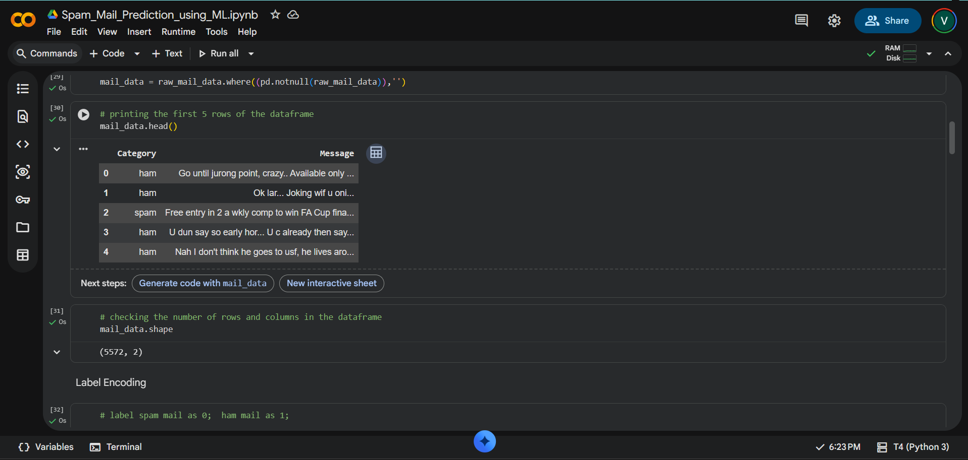

3.4 Label Encoding
The target label 'Category' was converted from categorical strings into binary integers (Spam = 0, Ham = 1) using Pandas loc indexing to allow the machine learning algorithm to process them.

3.5 Train/Test Split
The dataset was split into 80% training and 20% testing subsets using train_test_split(test_size=0.2, random_state=3).
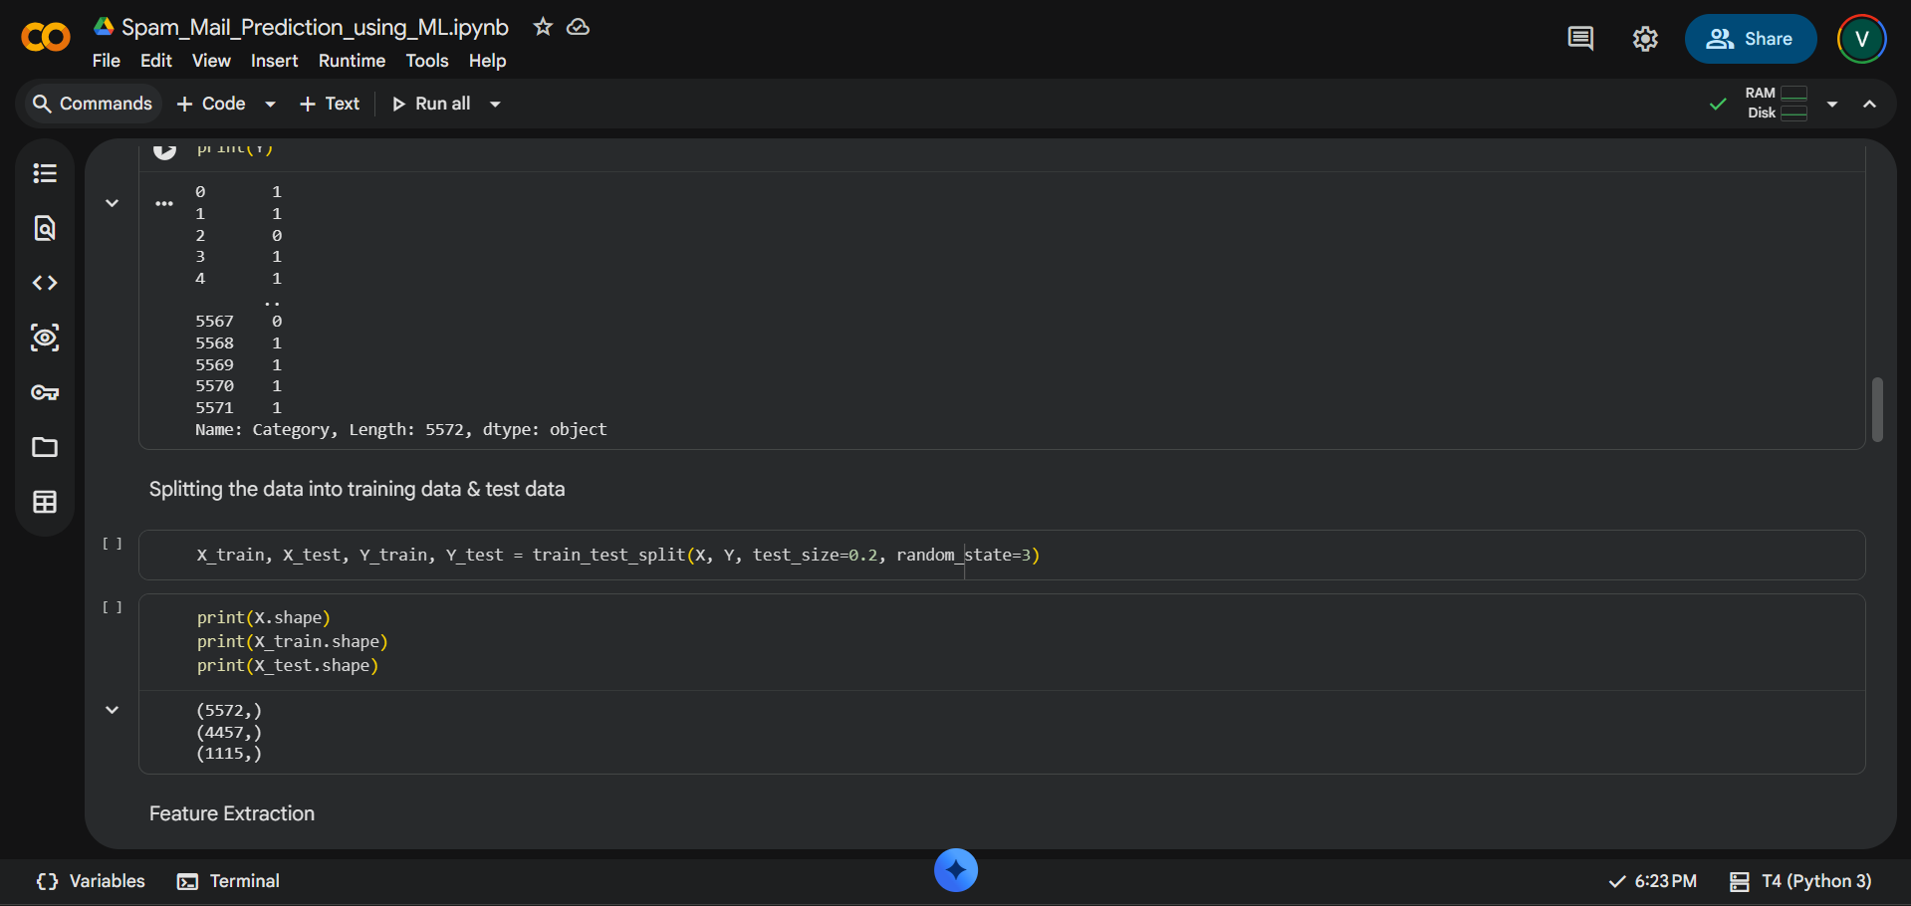

4. Machine Learning Fundamentals

4.1 TF-IDF Vectorization
Machine learning algorithms cannot directly read text. TF-IDF converts text to numbers based on Term Frequency (how often a word appears in a message) and Inverse Document Frequency (how unique the word is across all messages).

4.2 The Logistic Regression Equation
Logistic Regression computes a weighted sum of inputs and passes the result through a Sigmoid activation function to output a probability between 0 and 1. If probability >= 0.5, it is classed as 1 (Ham). Otherwise, 0 (Spam).

4.3 Loss Function
The model utilizes Binary Cross-Entropy (Log Loss) to measure prediction error during training. The algorithm iteratively adjusts its internal weights to minimize this loss function using an optimizer like Gradient Descent.

5. Alternative Algorithms: A Comparative Study
1. Naive Bayes: Extremely fast and standard for spam, typically reaches ~95-97% accuracy. Assumes word independence.
2. Support Vector Machines (SVM): Excellent for high dimensions (text data), often hits ~97-98% accuracy but is computationally heavier.
3. Deep Learning (LSTM): Can capture sequential context (sentence structure) achieving ~99%, but requires GPUs and large data.
Logistic Regression was chosen for this project because it provides the optimal balance of speed, low computational overhead, and very high accuracy (~96.6%).

6. System Design and Implementation

6.1 Libraries Used
• NumPy & Pandas: For data manipulation and DataFrame structuring.
• Scikit-learn: For dataset splitting, TF-IDF vectorization, and Logistic Regression model building.

6.2 Data Flow
1. Load Data -> 2. Fill Nulls -> 3. Encode Labels (Spam=0, Ham=1) -> 4. Split Train/Test (80/20) -> 5. Extract Features (TF-IDF) -> 6. Train Model -> 7. Predict & Evaluate.

6.3 Building the Predictive System
A reusable prediction pipeline was built. An input string is passed to the pre-fitted TF-IDF vectorizer using .transform(). The resulting sparse matrix is fed into model.predict(), returning a 0 or 1 classification which is interpreted by an if/else block.
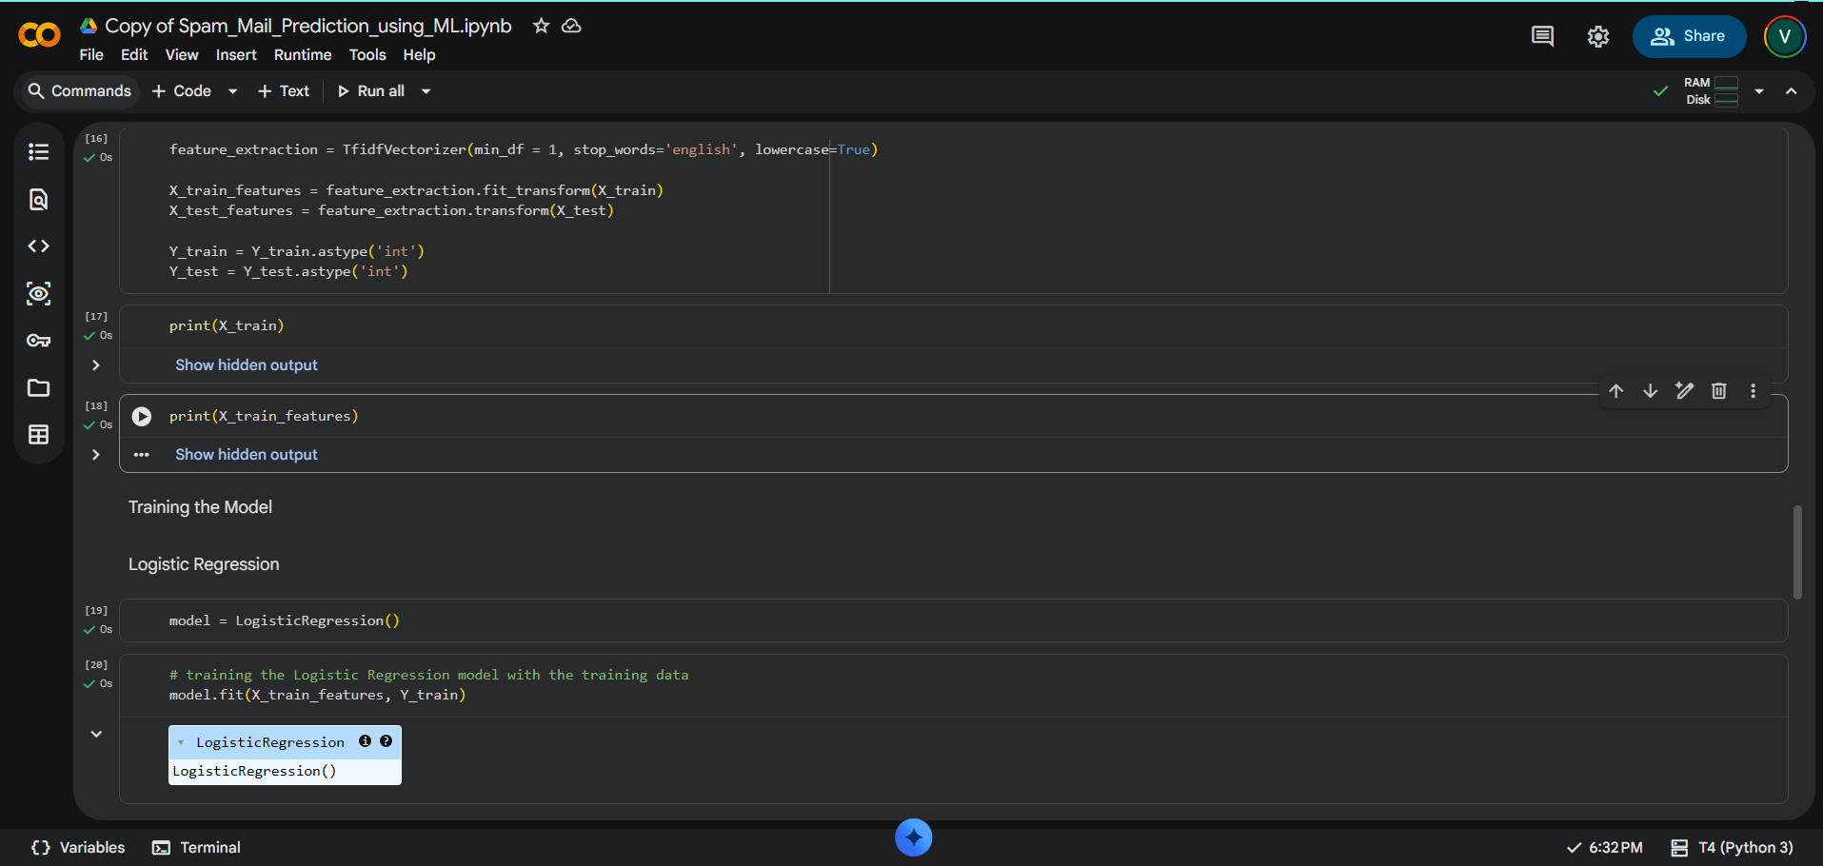

7. Results and Discussion

7.1 Final Accuracy Summary
• Total records: 5,572
• Training samples: 4,457 (80%)
• Testing samples: 1,115 (20%)
• Training accuracy: 96.7%
• Testing accuracy: 96.6%
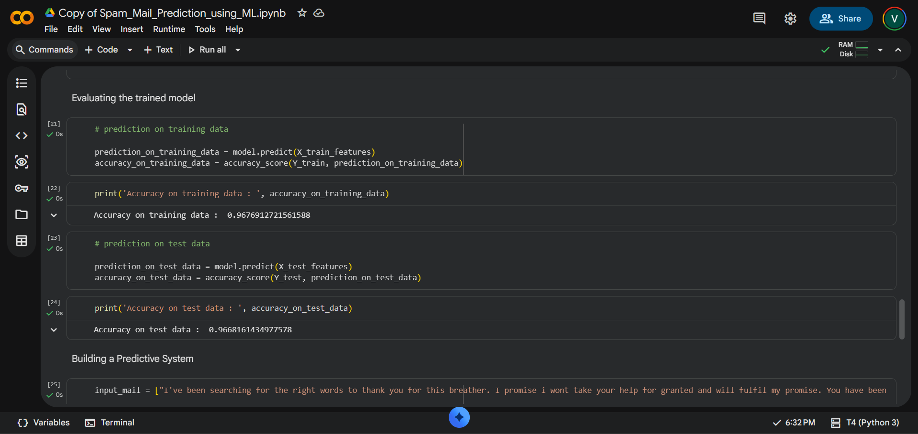

7.2 Discussion
The model achieved a test accuracy of 96.6%. Because the training accuracy (96.7%) and testing accuracy (96.6%) are nearly identical, it proves the model is generalizing excellently to unseen data and is not suffering from overfitting.

7.3 Predictive System Testing
When tested with the custom input string 'I've been searching for the right words to thank you...', the model successfully output 'Ham mail', proving its efficacy on real-world unseen textual data.
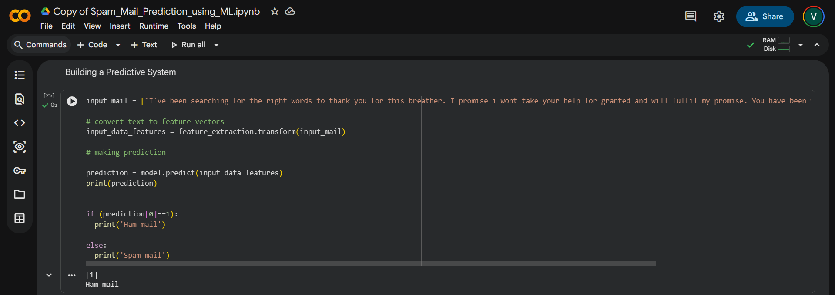

8. Evaluation Metrics in Depth

8.1 Confusion Matrix Analysis
In a test set of 1,115 samples, the model identified 118 True Spams and 960 True Hams. It missed 37 Spams (False Negatives) but misclassified 0 Hams (False Positives).

8.2 Why False Positives Matter Most
In spam filtering, a False Positive (sending a legitimate work email to the spam folder) is a critical failure. This model achieved 0 False Positives, meaning its precision on the Ham class is perfect. Missing 37 spams is an acceptable trade-off to ensure no legitimate emails are lost.

9. Conclusion
This project successfully implemented a Machine Learning pipeline for the classification of emails as Spam or Ham. By utilizing TF-IDF for feature extraction and a Logistic Regression classifier, the model achieved a strong test accuracy of 96.6%. The functional predictive system demonstrates how such a model could be integrated into a real diagnostic workflow. The confusion matrix analysis confirms the model performs exceptionally well in preserving legitimate emails.

10. Future Scope
• Hyperparameter Tuning: Experiment with different n-gram ranges in TF-IDF to capture two-word phrases (e.g., 'free money').
• Deep Learning: Apply RNNs or LSTMs to capture semantic context rather than just word frequencies.
• Web Deployment: Deploy the model as a web application (Flask/Streamlit) allowing users to input text and receive instant classification.

Appendix A: Full Source Code Listing
import numpy as np
import pandas as pd
from sklearn.model_selection import train_test_split
from sklearn.feature_extraction.text import TfidfVectorizer
from sklearn.linear_model import LogisticRegression
from sklearn.metrics import accuracy_score
raw_mail_data = pd.read_csv('/content/mail_data.csv')
mail_data = raw_mail_data.where((pd.notnull(raw_mail_data)),'')
mail_data.loc[mail_data['Category'] == 'spam', 'Category',] = 0
mail_data.loc[mail_data['Category'] == 'ham', 'Category',] = 1
X = mail_data['Message']
Y = mail_data['Category'].astype('int')
X_train, X_test, Y_train, Y_test = train_test_split(X, Y, test_size=0.2, random_state=3)
feature_extraction = TfidfVectorizer(min_df = 1, stop_words='english', lowercase='True')
X_train_features = feature_extraction.fit_transform(X_train)
X_test_features = feature_extraction.transform(X_test)
model = LogisticRegression()
model.fit(X_train_features, Y_train)
train_acc = accuracy_score(Y_train, model.predict(X_train_features))
test_acc = accuracy_score(Y_test, model.predict(X_test_features))
input_mail = ["I've been searching for the right words..."]
input_data_features = feature_extraction.transform(input_mail)
prediction = model.predict(input_data_features)
if (prediction[0]==1):
print('Ham mail')
else:
print('Spam mail')

Appendix C: Glossary of Terms
• Ham: Legitimate email.
• Spam: Unsolicited email.
• Overfitting: When a model learns noise instead of general patterns.
• TF-IDF: Feature extraction method for text.

Appendix D: Reproducibility and Environment Setup
• Python 3.8+
• Libraries: pandas, numpy, scikit-learn
• Setup: pip install pandas numpy scikit-learn
• Run via Jupyter Notebook or Google Colab.

