Mall Management System
Project report: Database Management Systems
React · FastAPI · MySQL 8

Abstract
The Mall Management System is a web application for a shopping-mall management office. It keeps track of the mall's shop units, the tenants that rent them, lease agreements, monthly rent invoices with tax, payments, operating expenses, staff and maintenance work, and turns this data into reports and charts.
The project focuses on the database layer. The data model is normalised to Boyce-Codd normal form, and the important business rules are enforced by the DBMS itself through keys, CHECK constraints, triggers, stored procedures with transactions, views, a scheduled event and least-privilege accounts. Even a client that bypassed the application could not corrupt the data. A FastAPI backend exposes the database through a REST API. A React frontend provides the user interface, including a database explorer that shows the schema, the ER diagram, the source code of every database object, a read-only SQL console and the audit trail.

1. Introduction

1.1 Problem statement
A mall office typically manages its rental business with spreadsheets: a sheet of shops, a sheet of tenants, a rent register and a cash book. This leads to duplicated data (a tenant's phone number in every row of the rent register), inconsistencies (a shop marked vacant although a lease is active), lost history, manual tax calculations, and no reliable way to answer questions such as "which tenants are overdue and by how much?" or "what was our net cash flow each month?".

1.2 Objectives
- Design a relational database that stores mall operations without redundancy or update anomalies (3NF / BCNF).
- Enforce business rules inside the DBMS: domain constraints, referential integrity, derived values and multi-row rules.
- Implement transactional operations (invoice generation, payment recording, lease termination) as stored procedures.
- Provide reports and data analysis through views, CTEs and window functions.
- Secure the database with roles, least-privilege accounts and an audit trail.
- Build a usable full-stack application (REST API + web UI) on top of it.
- Support backup, restore and data export (CSV).

1.3 Scope
In scope: floors and shop categories; shops; tenants; leases; monthly invoices with tax; partial payments; operating expenses with tax; departments and employees; maintenance requests; reports and dashboards; CSV export; user accounts with roles; database administration tools; backup and restore.
Out of scope: online payment gateways, payroll processing, and multi-property support.

2. Requirements

2.1 Functional requirements
ID | Requirement
F1 | Users log in; access depends on role (admin, manager, staff).
F2 | Maintain floors, shop categories, departments and expense categories.
F3 | Maintain shops with floor, category, area, base rent and status.
F4 | Maintain tenants and their contact details.
F5 | Create leases for vacant shops; terminate leases early; expire leases automatically after their end date.
F6 | Generate monthly rent invoices for all active leases, with tax and due date, without creating duplicates.
F7 | Record full or partial payments; invoice status updates automatically; over-payment is rejected.
F8 | Record operating expenses by category, with tax.
F9 | Maintain employees by department; log and track maintenance requests.
F10 | Dashboard with KPIs and charts; 14 reports with charts and CSV export; tenant account statements.
F11 | Explore the database: ER diagram, schema, constraints, views, routines, triggers, events, read-only SQL console, audit log.
F12 | Back up and restore the database.

2.2 Non-functional requirements
Area | Requirement
Integrity | Business rules are enforced in the database, not only in the UI.
Consistency | Multi-step operations are atomic (transactions).
Security | Passwords stored as bcrypt hashes; JWT authentication; DB accounts with minimal privileges; SQL console cannot modify data.
Auditability | Changes to key tables are recorded automatically with old/new values.
Usability | Responsive web UI with search, sort, filters, pagination and readable error messages.
Portability | Runs on Windows, macOS and Linux with only MySQL 8, Python and Node.js installed; one cross-platform helper (manage.py) sets everything up.

3. System design

3.1 Architecture
Browser (React SPA)
│ HTTPS / JSON (JWT bearer token)
▼
FastAPI backend ── routers: auth, resources, billing, reports, admin
│ PyMySQL
├── mall_app (DML on business tables, EXECUTE on procedures)
└── mall_readonly (SELECT only: SQL console, table browser)
▼
MySQL 8 ── mall_db: tables, views, functions, procedures, triggers, event

The backend contains very little business logic: validation of input types (Pydantic), authentication and authorisation, and calls to views and stored procedures. Rules such as "one active lease per shop" or "no over-payment" live in the database, and their error messages are passed through to the user.

3.2 Technology
Layer | Technology
Database | MySQL 8.4 (InnoDB, utf8mb4)
Backend | Python 3, FastAPI, PyMySQL, Pydantic, PyJWT, bcrypt
Frontend | React 19, React Router, Recharts, Vite
Testing | pytest + FastAPI TestClient (integration tests against MySQL)
Tooling | manage.py (Python standard library): database setup, start, backup / restore, tests

3.3 Conceptual design (ER model)
The main entities are Floor, ShopCategory, Shop, Tenant, Lease, Invoice, Payment, Department, Employee, ExpenseCategory, Expense, MaintenanceRequest, AppUser and AuditLog.
The many-to-many relationship between Shop and Tenant is resolved by the Lease entity. A lease has its own attributes (dates, rent, deposit, tax rate, status) and its own history: a shop can be leased to different tenants over time, and a tenant can lease several shops. Each lease produces one invoice per month; each invoice can be settled by several payments.
The full diagram with cardinalities is in ER_DIAGRAM.md. The running application draws it live from the data dictionary (Database → ER diagram).

3.4 Logical design and normalisation
The schema was derived from a flat "rent register" by removing repeating groups (1NF), partial dependencies on the composite key {unit, month} (2NF) and transitive dependencies such as tenant → phone (3NF). Every determinant in the final schema is a candidate key (BCNF). The derivation and the list of deliberate, controlled redundancies (invoice amount snapshot, generated columns, status columns kept by triggers) are in NORMALIZATION.md.

3.5 Physical design
Element | Count | Examples
Tables | 14 | shops, leases, invoices, payments, audit_log
Foreign keys | 12 | RESTRICT for financial data, SET NULL for optional links
CHECK constraints | 22 | area_sqft > 0, end_date > start_date, tax_rate BETWEEN 0 AND 100, e-mail / phone format via REGEXP
Unique keys | 14 | natural keys, UNIQUE(lease_id, billing_month)
Indexes | 49 | FK columns, status / date columns used by reports
Generated columns | 5 | tax_amount, total_amount (STORED), active_shop_key (VIRTUAL)
Views | 13 | v_invoice_summary, v_tenant_balances, v_profit_and_loss
Functions | 3 | fn_invoice_paid, fn_invoice_balance, fn_invoice_status
Procedures | 7 | sp_generate_invoices, sp_record_payment, sp_terminate_lease, sp_monthly_summary
Triggers | 25 | validation, derived status, audit
Events | 1 | ev_daily_expire_leases

Monetary values use DECIMAL(12,2), never floating point. Every table has a surrogate AUTO_INCREMENT key, and the natural key is kept as a UNIQUE constraint. The column-level details are in DATA_DICTIONARY.md.

4. Implementation

4.1 Integrity rules
Level | Mechanism | Example
Domain | data types, ENUM, NOT NULL, CHECK | priority ∈ {low, medium, high, critical}
Entity | PRIMARY KEY, UNIQUE | unit code, invoice number, username
Referential | FOREIGN KEY … ON DELETE RESTRICT / SET NULL ON UPDATE CASCADE | a floor with shops cannot be deleted
Multi-row | BEFORE triggers with SIGNAL | a shop can have only one active lease
Temporal | triggers (CHECK cannot use CURDATE()) | no future payments or expenses
Derived data | generated columns, AFTER triggers | invoice total; shop and invoice status

4.2 Transactions and concurrency
sp_record_payment shows a classic transaction:
- START TRANSACTION
- SELECT … FROM invoices WHERE invoice_id = ? FOR UPDATE locks the invoice row, so two clerks cannot both pay the last balance at the same time.
- Check the status and remaining balance; SIGNAL an error if the payment is not allowed.
- INSERT INTO payments. The AFTER INSERT trigger recalculates the invoice status inside the same transaction.
- COMMIT. On any SQL error an EXIT HANDLER runs ROLLBACK and RESIGNALs the error.
sp_generate_invoices is a set-based, idempotent batch: one INSERT … SELECT for all leases in force during the month. NOT EXISTS and the UNIQUE(lease_id, billing_month) key make it safe to run repeatedly. sp_terminate_lease ends a lease and voids its future unpaid invoices atomically. database/examples/transactions_demo.sql demonstrates COMMIT, ROLLBACK, SAVEPOINT, row locking, and the fact that MySQL has no nested transactions: a procedure's START TRANSACTION commits the caller's open transaction.

4.3 Reporting and analysis
- Views encapsulate joins and aggregations: occupancy per floor, rent per category, tenant balances with overdue amounts, monthly income and expenses, profit and loss, expiring leases, open maintenance, payroll per department.
- sp_monthly_summary(year) uses a recursive CTE to generate all twelve months (including months without data). Correlated subqueries compute the invoiced amount, collections and expenses, and SUM() OVER (ORDER BY …) gives the cumulative net cash flow.
- sp_tenant_statement(tenant) merges invoices and payments with UNION ALL and computes a running balance with a window function.
- The UI shows each report's SQL next to its chart and table, and every report can be exported as CSV.

4.4 Security
- Application level: bcrypt password hashes; JWT tokens; three roles checked by the API on every request and reflected in the UI.
- Database level: two roles, mall_app_role and mall_readonly_role, following the principle of least privilege. The application account cannot UPDATE payments, DELETE invoices, or modify the audit log. The read-only account cannot read password hashes (column-level privilege).
- Controlled elevation: sp_db_objects() is a SQL SECURITY DEFINER procedure. It lets the application list the source code of triggers and routines without receiving broad global privileges.
- SQL console: allows only one SELECT / WITH / SHOW / DESCRIBE / EXPLAIN statement, runs it as mall_readonly in a READ ONLY transaction with MAX_EXECUTION_TIME, and caps the result at 500 rows (defence in depth).
- Audit trail: AFTER triggers write the old and new row images as JSON together with the application user, which the API passes in the session variable @app_user.

4.5 Backend
Module | Responsibility
config.py | settings from environment / .env
database.py | connections (app and read-only), query helpers, procedure calls with OUT parameters
security.py | password hashing, JWT, current user, role checks, SET @app_user
errors.py | maps MySQL error codes to HTTP responses
crud.py | generic list / get / create / update / delete with search, sort, filters, pagination
routers/ | auth, resources, billing, reports, admin

4.6 Frontend
Screen | Purpose
Login | sign in; demo account buttons
Dashboard | KPIs, income vs expenses, invoice status, occupancy per floor, expenses per category, top debtors, expiring leases, recent payments, open tickets
Shops, Tenants, Leases, Invoices, Payments, Expenses, Employees, Maintenance | searchable, sortable, filterable lists with create / edit / delete forms and the domain actions (generate invoices, record payment, terminate lease, tenant statement …)
Reports | report catalogue with SQL, chart, result table and CSV export
Master data | floors, shop categories, departments, expense categories
Database | overview, live ER diagram, schema explorer (structure, data, DDL), views & routines, SQL console, audit log, scripts & backup
Users, My account | user administration; change password

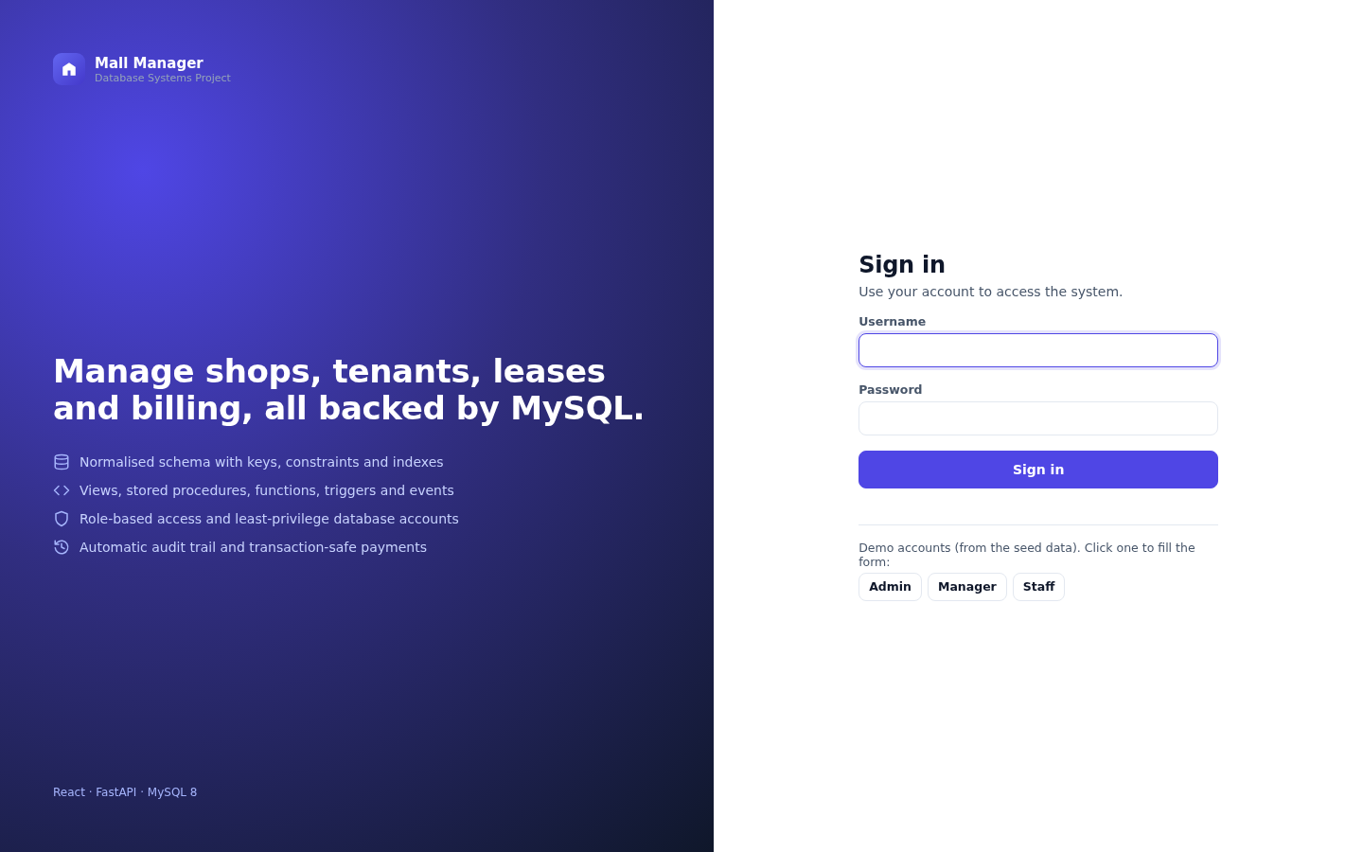  Login | 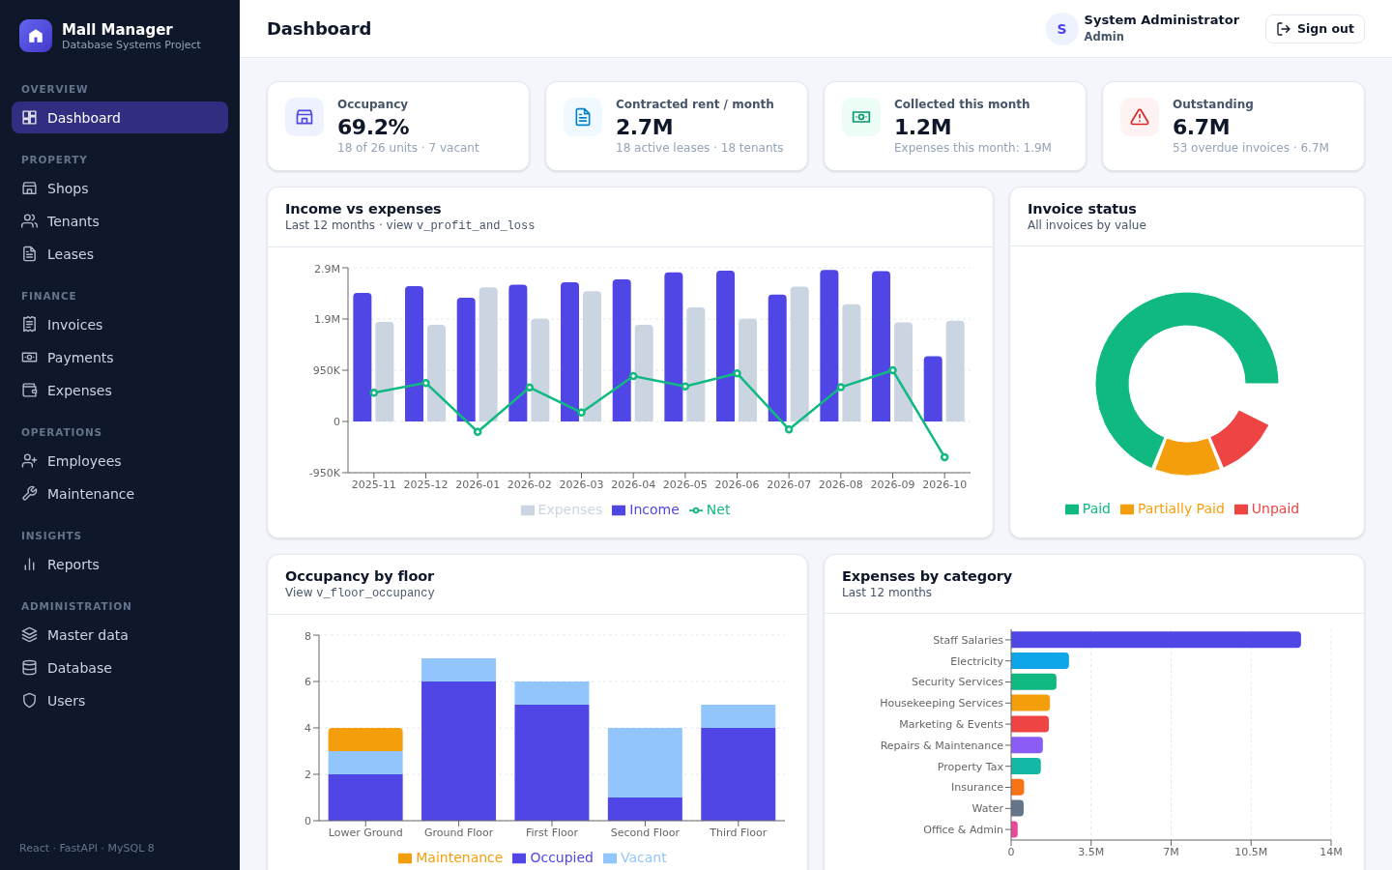  Dashboard
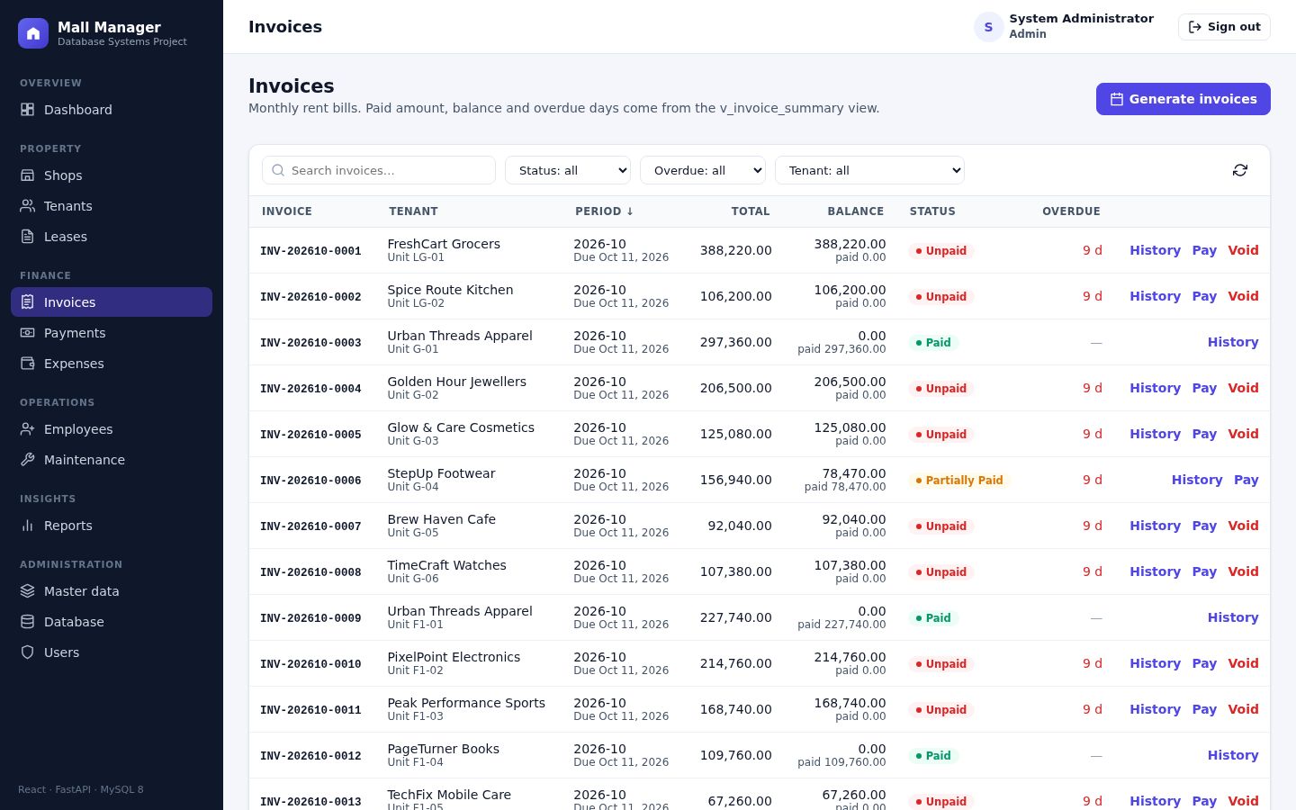  Invoices | 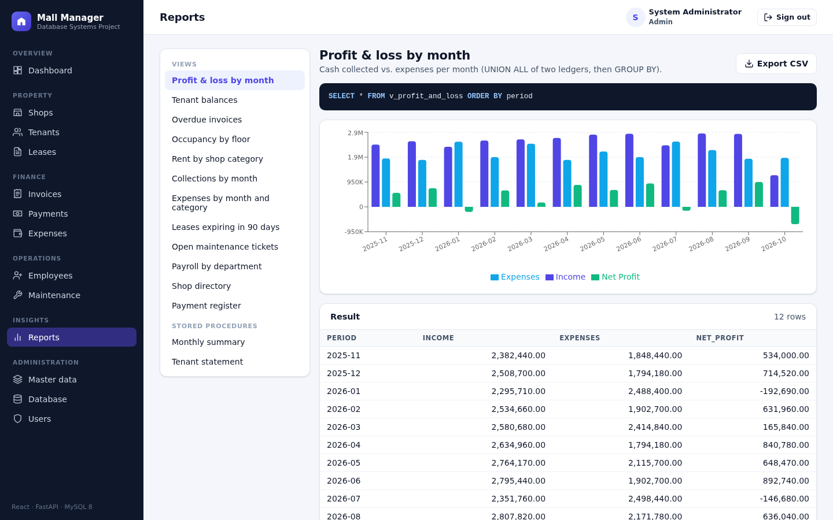  Reports
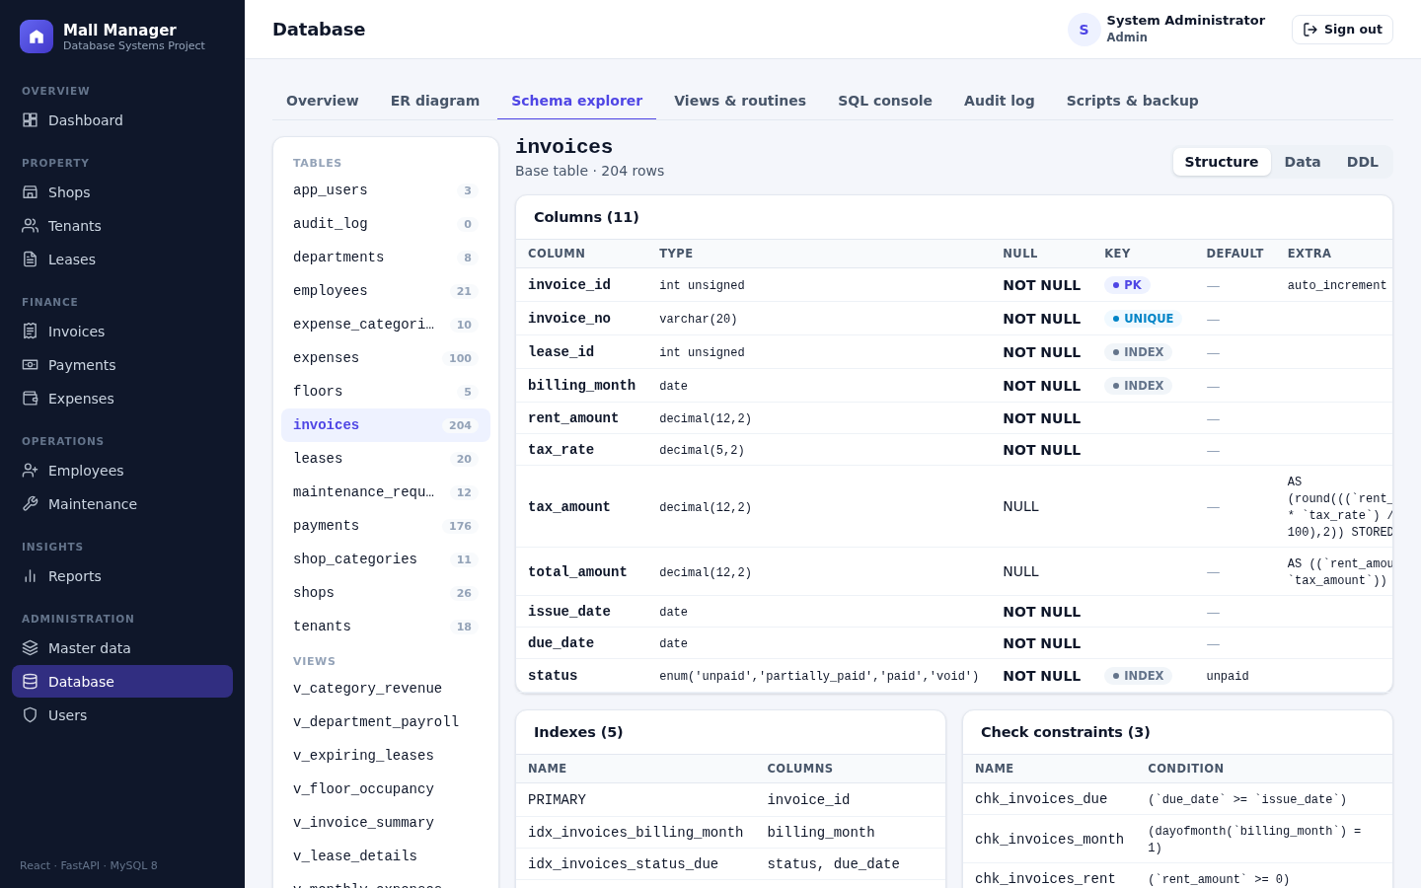  Schema explorer | 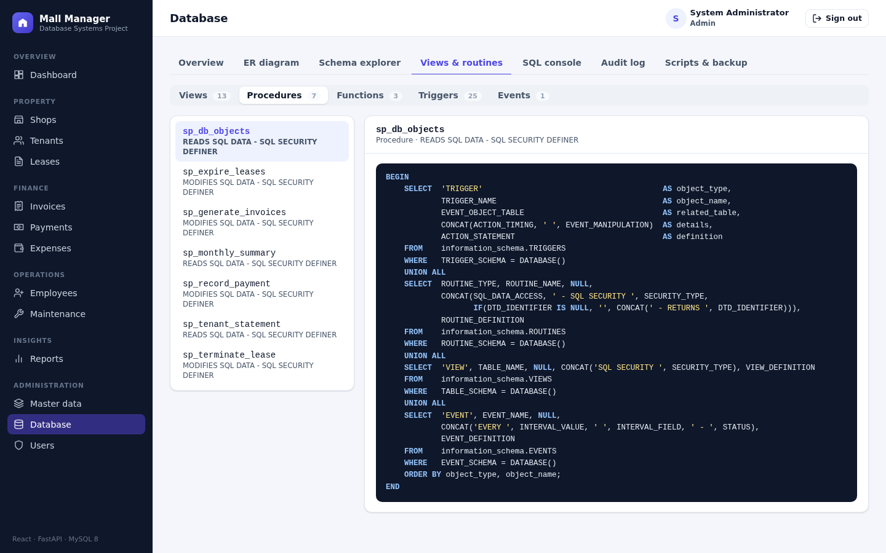  Views and routines

5. Testing
Integration tests (backend/tests/test_api.py) run against a real MySQL database:
# | Test | Expected result
1 | Health check | API and database reachable
2 | Login with a wrong password | 401
3 | Request without a token | 401
4 | Current user | correct role returned
5 | List with search, sort, pagination | correct subset and total
6 | Staff tries to create a shop | 403
7 | Invalid values / CHECK constraint | 422 with a readable message
8 | Delete a floor that still has shops | 409 (FK RESTRICT)
9 | Full cycle: tenant → shop → lease → shop occupied → second lease rejected → invoices generated (idempotent, tax computed) → partial payment → over-payment rejected → full payment → voiding a paid invoice rejected → statement balance 0 → termination → shop vacant → audit trail shows the application user | every step behaves as specified
10 | Reports, CSV export, monthly summary, tenant statement | data returned, CSV header present
11 | SQL console with DELETE, multiple statements | rejected; SELECT works
12 | Admin tools: overview, schema, objects, audit, backup, ER metadata; staff denied | correct data; 403 for staff
13 | User management | create, update, reset password, delete

In addition, database/examples/transactions_demo.sql lists every integrity rule with a statement that violates it and the error MySQL returns (1062, 1451, 1452, 3819, 1644, 1142).

6. Results
The finished system meets all functional requirements F1–F12. The sample data (26 shops on 5 floors, 18 tenants, 20 leases, 204 invoices, 176 payments, 100 expenses, 21 employees, 12 maintenance requests) produces a populated dashboard for the last twelve months. The seed dates are relative to the day the database is created, so the data always looks current.

7. Limitations and future work
- Single property only; a properties table could make the system multi-site.
- Rent escalation clauses and service charges could be modelled as separate lease terms.
- Payments are entered manually; integrating a payment provider would need an idempotency key per transaction.
- Reports could be materialised (summary tables refreshed by events) if the data volume grew large.
- Point-in-time recovery would require binary-log based backups in addition to logical dumps.

8. Conclusion
The project shows how a relational DBMS can be the guardian of data quality and not just storage. Normalisation removes anomalies. Constraints and triggers make invalid states impossible. Stored procedures turn business operations into atomic transactions. Views and analytical SQL answer management questions directly. Roles and an audit trail keep the data secure and accountable. The web application on top stays simple because the database does the heavy lifting.

References
- MySQL 8.4 Reference Manual, Oracle Corporation. https://dev.mysql.com/doc/refman/8.4/en/
- A. Silberschatz, H. F. Korth, S. Sudarshan, Database System Concepts, McGraw-Hill.
- R. Elmasri, S. B. Navathe, Fundamentals of Database Systems, Pearson.
- FastAPI documentation. https://fastapi.tiangolo.com/
- React documentation. https://react.dev/

