TM 25-1:

Use Visuals

In the rough draft to
- See that ideas are presented completely.
- Find relationships.

In the final draft to
- Make points vivid.
- Emphasize material.
- Present material more compactly and with less repetition.
TM 25-2: Good Stories

May
- Support a hunch you have.
- Surprise you or challenge so-called “common knowledge.”
- Show trends or changes.
- Have commercial or social significance.
- Provide information needed for action.
- Be personally relevant to you and the audience.

To find good stories
- Focus on a topic.
- Simplify the data.

- Look for relationships and changes.

TM 25-3: Using Visuals Effectively

Use tables when the reader needs to be able to identify exact values.

Use a chart or graph when you want the reader to focus on relationships.
- Use a pie chart to compare a part to the whole.
- Use a bar chart or line graph to compare one item to another item or items over time.

Every visual should contain the following six components
  - A title that tells the story that the visual shows.
  - A clear indication of what the data are.
  - Clearly labeled units.
  - Labels or legends for axes, colors, symbols, and so forth.
  - The source of the data.
  - The source of the visual, if it’s reproduced.

TM 25-4: To Use Tables Effectively

- Use tables only when you want the audience to focus on specific numbers. Graphs convey less specific information but are always more memorable.

- Use common, understandable units. Round off to simplify the data (e.g., 35% rather than 35.27%; 34,000 rather than 33,942).

- Provide column and row totals or averages when they’re relevant.

- Put the items you want readers to compare in columns rather than in rows to facilitate mental subtraction and division.

- When you have many rows, screen alternate entries or double space after every five entries to help readers line up items accurately.
TM 25-5: To Use Pie Charts Effectively

- Start at 12 o’clock with the largest percentage or the percentage they want to focus on. Go clockwise to each smaller percentage or to each percentage in some other logical order.

- Make the chart a perfect circle. Perspective circles distort the data.

- Limit the number of segments to five or seven. If the data have more divisions, combine the smallest or the least important into a single “miscellaneous” or “other” category.

- Label the segments outside the circle. Internal labels are hard to read.
TM 25-6: To Use Bar Charts Effectively

- Order the bars in a logical or chronological order.

- Put the bars close enough together to make comparison easy.

- Label both horizontal and vertical axes.

- Put all labels inside the bars or outside them. When some labels are inside and some are outside, the labels carry the visual weight of longer bars, distorting the data.

- Make all the bars the same width.

- Use different colors for different bars only when the meanings are different: estimates as opposed to known numbers, negative as opposed to positive numbers.

- Avoid using perspective. Perspective makes the values harder to read and can make comparison difficult.
TM 25-7: To Use Line Graphs Effectively

- Label both horizontal and vertical axes.

- When time is a variable, put it on the horizontal axis.

- Avoid using more than three different lines on one graph. Even three lines may be too many if they cross each other.

- Avoid using perspective. Perspective makes the values harder to read and can make comparison difficult.
TM 25-8: To Use Color and Clip Art Effectively

- Use no more than five colors when colors have meanings.

- Use glossy paper to make colors more vivid.

- Be aware that colors on a computer screen always look brighter than colors on paper.

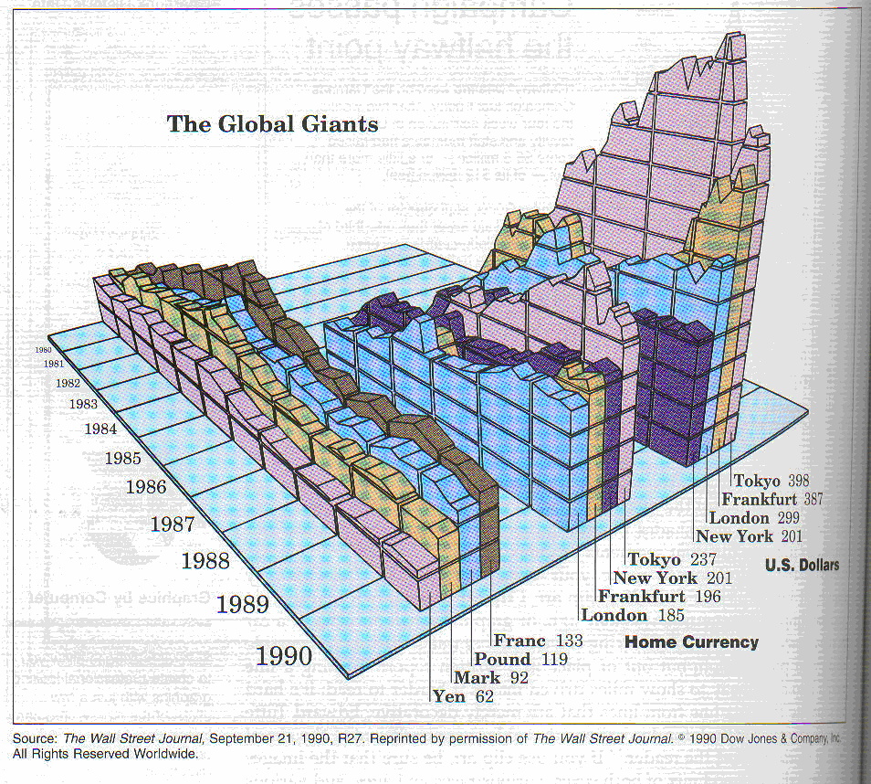
- Be aware of chartjunk—clip art that is only decorative.

0

