**Name: Vedant Shrirao SEM: VII**

**PRN: 21070521091 Section:B**

**Q:2** Generate a model in Python to represent a Housing loan scheme and create a chart to display the Emi based on rate of interest and reducing balance for a given period. If a customer wishes to close the loan earlier, print the interest lost distributed over the remaining no. Of months. Assume suitable data and inputs as necessary.

**Solution:** A housing loan helps individuals purchase property, repaid through Equated Monthly Installments (EMIs) over a set tenure. The EMI includes both principal and interest, where the reducing balance method applies interest on the outstanding loan balance, reducing the interest burden over time. The EMI amount is influenced by the interest rate, with higher rates increasing the EMI. If the borrower chooses early loan closure, they save on the interest that would have been paid on the remaining tenure, reducing the overall cost of the loan.

**Code:**

|  |
| --- |
| import numpy as np  import matplotlib.pyplot as plt  class HousingLoan:  def __init__(self, principal, rate, years):  self.principal = principal  self.annual_rate = rate  self.monthly_rate = rate / (12 * 100)  self.num_years = years  self.num_months = years * 12  def calculate_emi(self):  P = self.principal  r = self.monthly_rate  n = self.num_months  emi = P * r * (1 + r)**n / ((1 + r)**n - 1)  return emi    def calculate_interest_for_period(self, months=None):  if months is None:  months = self.num_months  balance = self.principal  total_interest = 0  emi = self.calculate_emi()    for _ in range(months):  interest = balance * self.monthly_rate  total_interest += interest  principal_paid = emi - interest  balance -= principal_paid  return total_interest    def close_loan_early(self, early_months):  full_interest = self.calculate_interest_for_period()  interest_till_early_close = self.calculate_interest_for_period(early_months)  interest_lost = full_interest - interest_till_early_close  return interest_lost, interest_lost / (self.num_months - early_months)  def plot_emi_vs_interest(principal, years):  rates = np.arange(5, 15, 0.5)  emis = []    for rate in rates:  loan = HousingLoan(principal, rate, years)  emi = loan.calculate_emi()  emis.append(emi)    plt.figure(figsize=(10, 6))  plt.plot(rates, emis, marker='o', color='b')  plt.title(f'EMI vs. Interest Rate for a Loan of {principal} over {years} Years')  plt.xlabel('Interest Rate (%)')  plt.ylabel('EMI (Monthly Payment)')  plt.grid(True)  plt.show()  principal = 5000000  rate = 8  years = 20  loan = HousingLoan(principal, rate, years)  emi = loan.calculate_emi()  print(f"EMI for loan of {principal} at {rate}% for {years} years: {emi:.2f}")  early_months = 120  interest_lost, lost_per_month = loan.close_loan_early(early_months)  print(f"Interest lost if loan is closed after {early_months} months: {interest_lost:.2f}")  print(f"Interest lost per remaining month: {lost_per_month:.2f}")  plot_emi_vs_interest(principal, years) |

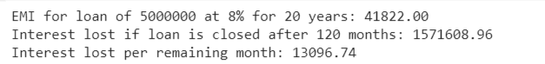**Output:**

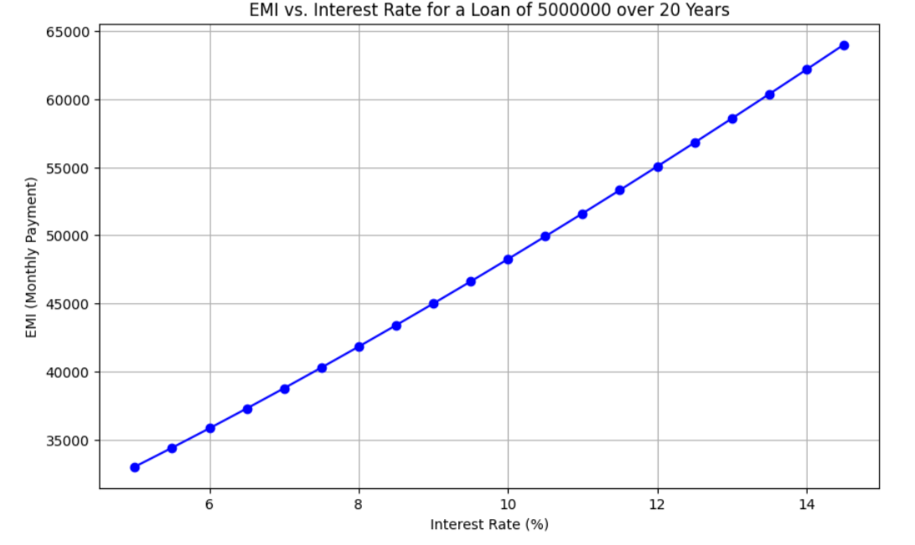

**Q:2** Generate a model for an insurance company to hold information on the insurer's vehicle, and create a chart of monthly, yearly, and quterly premiums based on no. of years of insurance where in each year, the value of the vehicle depreciates by 7%.

**Solution:** The Vehicle Insurance Model calculates the premiums based on the vehicle's depreciating value, which decreases by 7% each year. The insurance premium is determined as a percentage of the vehicle's value and is calculated for monthly, quarterly, and yearly intervals. Over time, as the vehicle's value reduces, the premium amount also decreases. This model helps in understanding how depreciation impacts the cost of insurance and allows visualizing the premiums over multiple years. The premium is lower in later years due to the reduced vehicle value.

**Code:**

|  |
| --- |
| import numpy as np  import matplotlib.pyplot as plt  class VehicleInsurance:  def __init__(self, initial_value, yearly_rate):  self.initial_value = initial_value  self.yearly_rate = yearly_rate  self.depreciation_rate = 0.07    def depreciated_value(self, years):  return self.initial_value * ((1 - self.depreciation_rate) ** years)    def calculate_premium(self, years):  value = self.depreciated_value(years)  yearly_premium = value * self.yearly_rate  quarterly_premium = yearly_premium / 4  monthly_premium = yearly_premium / 12  return monthly_premium, quarterly_premium, yearly_premium  def plot_premiums_over_years(initial_value, yearly_rate, max_years):  years = np.arange(1, max_years + 1)  monthly_premiums = []  quarterly_premiums = []  yearly_premiums = []    insurance = VehicleInsurance(initial_value, yearly_rate)    for year in years:  monthly, quarterly, yearly = insurance.calculate_premium(year)  monthly_premiums.append(monthly)  quarterly_premiums.append(quarterly)  yearly_premiums.append(yearly)    plt.figure(figsize=(10, 6))  plt.plot(years, monthly_premiums, label="Monthly Premium", marker='o')  plt.plot(years, quarterly_premiums, label="Quarterly Premium", marker='s')  plt.plot(years, yearly_premiums, label="Yearly Premium", marker='^')  plt.title(f'Premiums over {max_years} Years (Depreciation: 7%/year)')  plt.xlabel('Years')  plt.ylabel('Premium Amount')  plt.grid(True)  plt.legend()  plt.show()  initial_value = 1000000  yearly_rate = 0.05  max_years = 10  plot_premiums_over_years(initial_value, yearly_rate, max_years) |

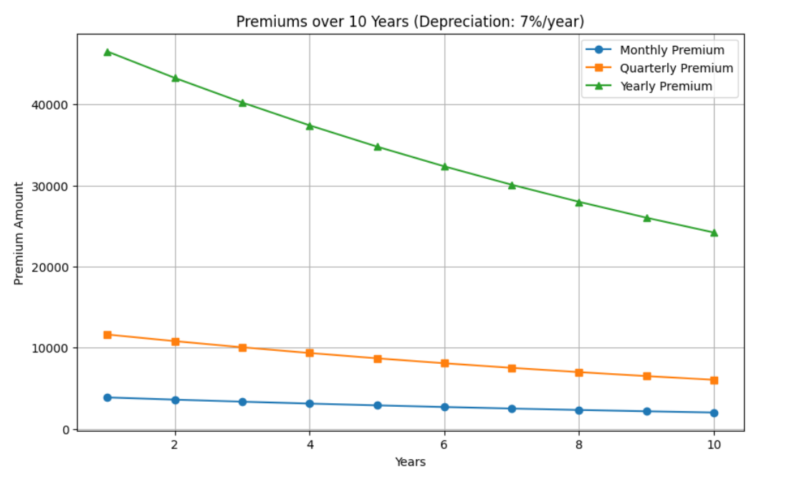**Output:**