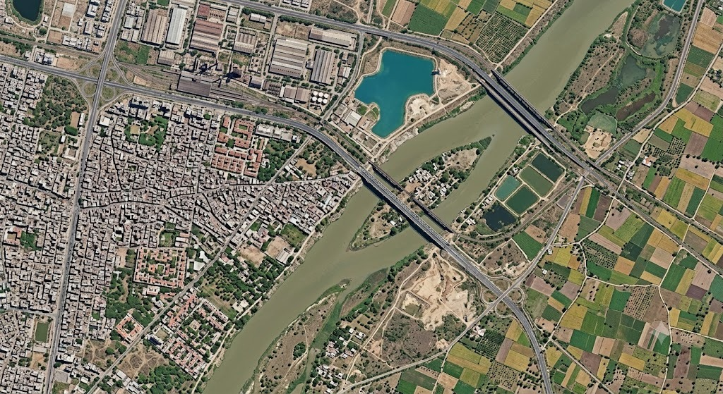
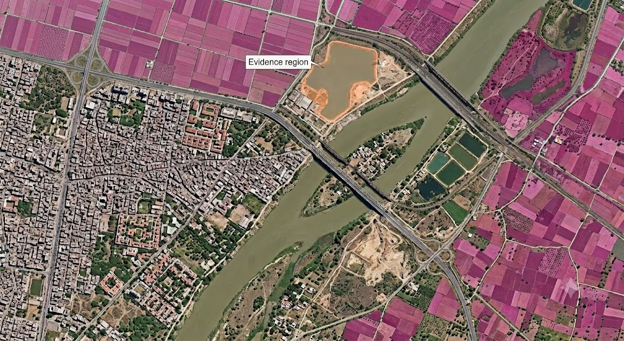
VQA — VISUAL QUESTION ANSWERING
User asks:

“Are there large water bodies near the urban area?”
Backend
Objects:
water_body_1
water_body_2
urban_area

Spatial relationship:
water_body_1 → 0.8 km → urban_area

Confidence: 0.94
Qwen output
YES.

YES — A LARGE WATER BODY IS LOCATED NEAR THE URBAN AREA.

A major water body borders the built-up area directly — the river runs along its eastern edge — and a further lake lies just to the northeast, across the river next to an industrial zone.

The water body is substantially larger than the smaller
ponds visible elsewhere in the scene.

Spatial relationship: NEAR
Relative position: Northeast of the main urban area, opposite bank of the river

Confidence: HIGH

Evidence
✓ Water-body detection
✓ Urban-area detection
✓ Spatial relationship analysis

Confidence: 94%

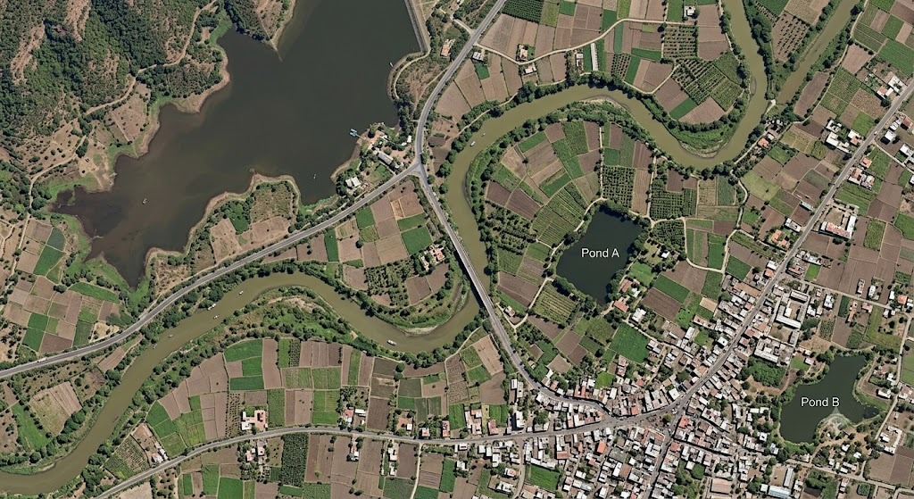
4. GROUNDING
Find and locate all major water bodies in this image
raw o/p:
Water Body #1
Area: 12.8 km²
Confidence: 97%

Water Body #2
Area: 4.2 km²
Confidence: 94%

Water Body #3
Area: 1.8 km²
Confidence: 91%
Backend
Satellite Image
↓
Vision / EO Encoder
↓
Grounding Model
↓
Bounding Boxes / Masks
↓
Spatial Evidence
↓
Qwen
↓
Natural-language answer
User:

“Show me the major water bodies.”

Backend:
Object 1: [x1,y1,x2,y2] confidence 0.97
Object 2: [x1,y1,x2,y2] confidence 0.94
Object 3: [x1,y1,x2,y2] confidence 0.91
Qwen + UI:
3 MAJOR WATER BODIES IDENTIFIED

Largest:
12.8 km² — 97% confidence

Second:
4.2 km² — 94% confidence

Third:
1.8 km² — 91% confidence

[IMAGE WITH BOUNDING BOXES / MASKS]

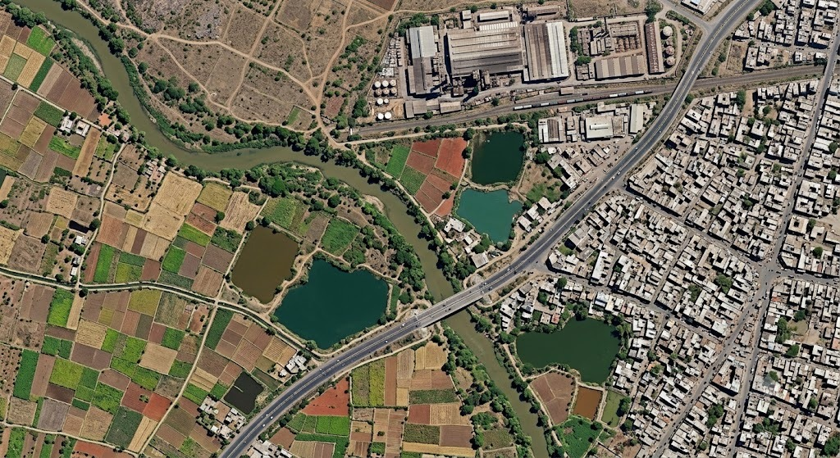

[4:59 pm, 7/9/2026] Shaivi Jaiswal: Captioning
User:

“Describe this satellite image.”
SCENE SUMMARY

The image shows a mixed urban–rural landscape.

* A dense built-up area occupies the eastern portion.
* Agricultural fields surround the settlement.
* A major river crosses the southern region.
* Smaller water bodies are distributed across the
surrounding agricultural land.
* Major roads connect the urban and rural areas.

Overall scene confidence: 92%

If the user then asks:

“Focus only on agriculture.”

Qwen changes the response:

AGRICULTURAL VIEW

Agricultural fields surround the main settlement,
with several contiguous cultivated parcels visible
in the western and northern portions of the image.

No crop-health conclusion is made from this image alone.

prompt:
Describe this satellite image, including the major land-cover types, infrastructure and geographic features.
Caption:
“The scene contains a densely built urban corridor in the eastern sector, surrounded by agricultural parcels and fragmented vegetation. A major river crosses the southern portion of the area, with smaller water bodies distributed across the surrounding agricultural landscape. Multiple road corridors connect the urban and rural zones.”

Backend
Satellite Image
↓
EO / VLM Encoder
↓
Captioning Decoder
↓
EO-aware Description
↓
Qwen
[5:00 pm, 7/9/2026] Shaivi Jaiswal: output:
Urban & Built-Up Areas: The northwestern quadrant displays high spatial frequency built-up surfaces with high spectral variability, representing a medium-to-high density urban center dominated by impervious land cover (asphalt, concrete, roofing materials).

Transportation Infrastructure: Major dual-carriageway transportation corridors (high-albedo linear structures) cross-cut the scene, providing spatial connectivity between the urban core and outer peri-urban zones.

Rural & Agricultural Land: The eastern and southern sectors exhibit a fragmented mosaic of rectangular agricultural parcels. Fields alternate between bare soil (moderate-to-high soil reflectance) and active vegetation canopy (strong green-band reflectance).

Vegetation Cover: Closed-canopy forest patches and narrow riparian vegetation buffers border the hydrological network, exhibiting high spectral contrast against adjacent cultivated fields.

Hydrological Features: A river channel bisects the central terrain from northeast to southwest. Water features display varying degrees of suspended sediment turbidity, transitioning from higher spectral reflectance (sediment-laden) in upper river reaches to lower reflectance (deeper water) toward the coastal discharge outlet.

Spatial Relationships: Distinct urban-rural gradient extending outward from the dense urban core in the northwest to agricultural land in the southeast, anchored by the river channel acting as a natural geographic boundary.

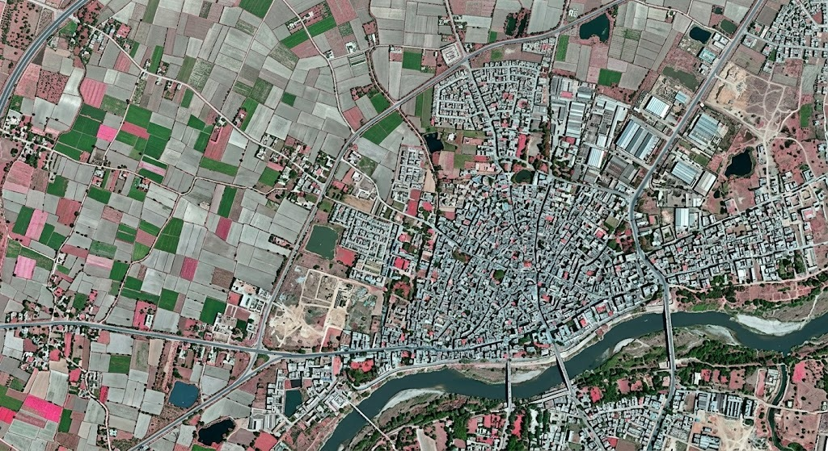

multilingual featre
question:
“उत्तर दिशा में मुख्यतः कौन-सी भूमि उपयोग श्रेणी दिखाई दे रही है, और क्या वहाँ की वनस्पति स्वस्थ प्रतीत होती है?”
🇮🇳 Hindi output

उत्तर क्षेत्र में कृषि भूमि प्रमुख है।

उत्तरी हिस्से में बड़े और अपेक्षाकृत नियमित खेतों का प्रभुत्व दिखाई देता है। वनस्पति वाले खेतों में निकट-अवरक्त और रेड-एज संकेत मजबूत हैं, जो सामान्यतः सक्रिय एवं स्वस्थ वनस्पति के अनुरूप हैं।

निष्कर्ष:
🌾 प्रमुख भूमि उपयोग: कृषि
🌱 वनस्पति स्थिति: अधिकांश दिखाई देने वाले फसल क्षेत्र स्वस्थ/सक्रिय वनस्पति के अनुरूप

विश्वास: उच्च

साक्ष्य
✓ बहु-स्पेक्ट्रल बैंड विश्लेषण
✓ कृषि क्षेत्र पहचान
✓ NIR / Red-edge संकेत
✓ स्थानिक क्षेत्र विश्लेषण

