
Department of CSE

B.Tech. CSE Trimester -5

Roll Number-2520030376
Name-V.VedaPriya

Cloud Infrastructure and Services
25CS2206E

LAB RECORD
2026

Experiment -2

AIM: Creating an IAM User Account in AWS

Description:
Objective
To create a new IAM user in AWS, provide console access, and assign the required permissions to manage AWS services
Steps:
- Login to the AWS Management Console using the root account.
- In the top search bar, type IAM and open Identity and Access Management.
- From the left navigation pane, click Users.
- Click Create user.
User Details:
- Enter the username as VedaPriya Vunnam.
- Enable the option Provide user access to the AWS Management Console.
- Select Autogenerated password to generate a password automatically.
- Enable the password reset option so the user can change the password during the first login.
- Click Next.
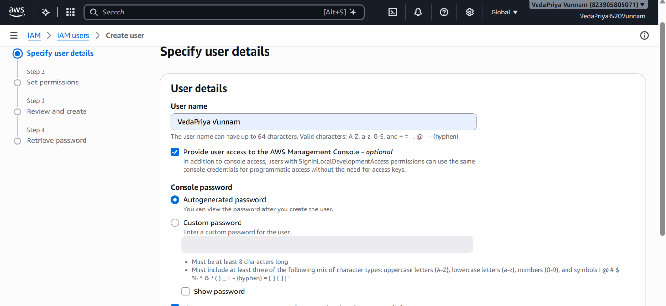

Set Permissions:
- Select Attach policies directly.
- Search for and select the AdministratorAccess policy.
- Also select the IAMUserChangePassword policy.
- Click Next.
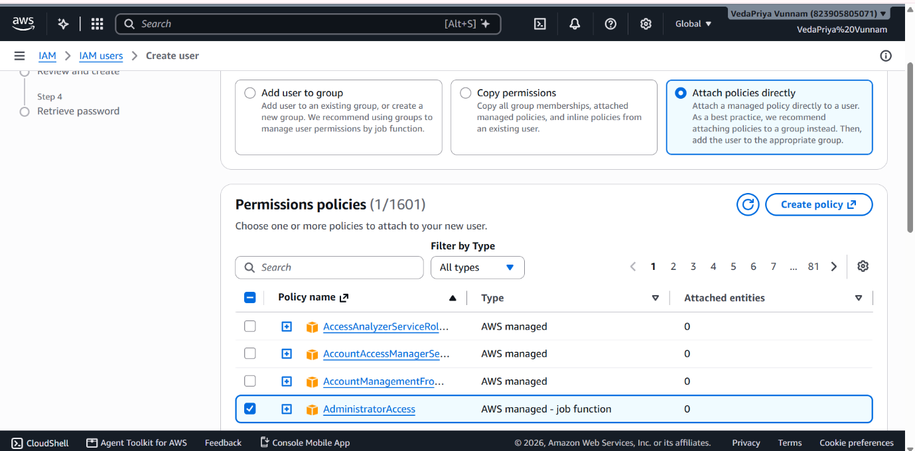

Review and Create:
- Review the username and selected permissions.
- Verify that both policies are attached to the user.
- Click Create user
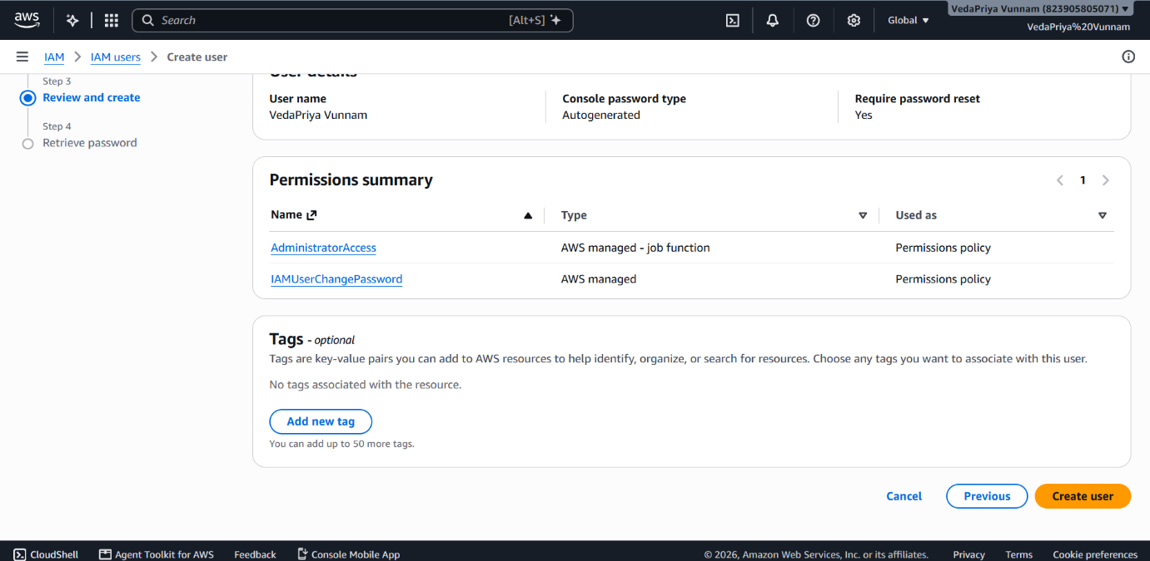

Retrieve Password:
- After successful creation, the AWS console displays a success message.
- View the console sign-in details.
- Note the console sign-in URL and username.
- Retrieve the automatically generated password.
- Download the credentials as a CSV file for future reference
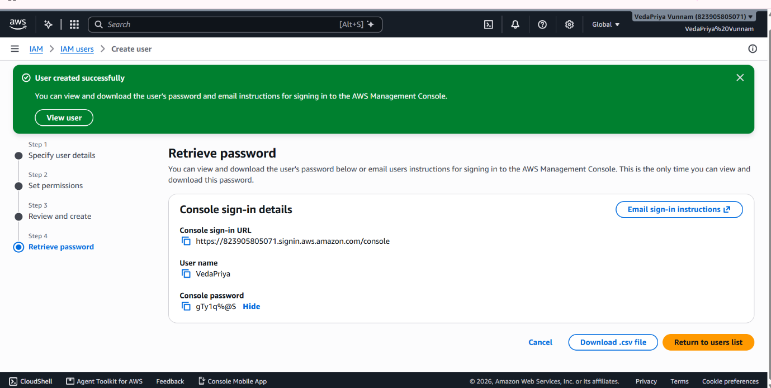

Verification:
- The IAM user is successfully created.
- The username appears in the IAM Users list.
- AdministratorAccess and IAMUserChangePassword policies are attached.
- The user can access the AWS Management Console using the provided sign-in credentials.
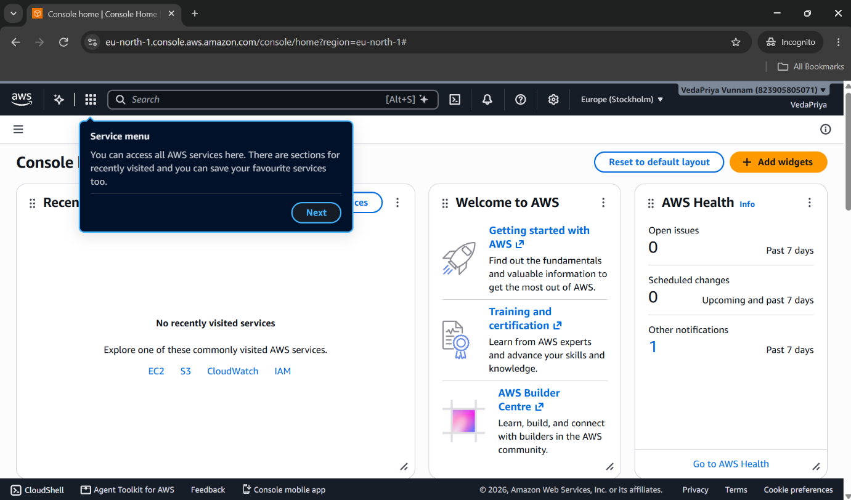

Output:
Successfully created an IAM user account named VedaPriya Vunnam in AWS and assigned the required permissions

