- PROJECT TITLE:

TWSA: Taylor wave search optimization with wideResNet for intrusion detection and mitigation in cloud computing

2. HARDWARE REQUIREMENTS
OS-Windows 11
RAM-8GB
ROM-More than 100 GB
GPU-Yes
CPU-1.7 GHz

3. SOFTWARE REQUIREMENTS
Software name(Python): Version: 3.9.11
(Download link: https://www.python.org/downloads/release/python-396/ )
Click -> Windows x86-64 executable installer.
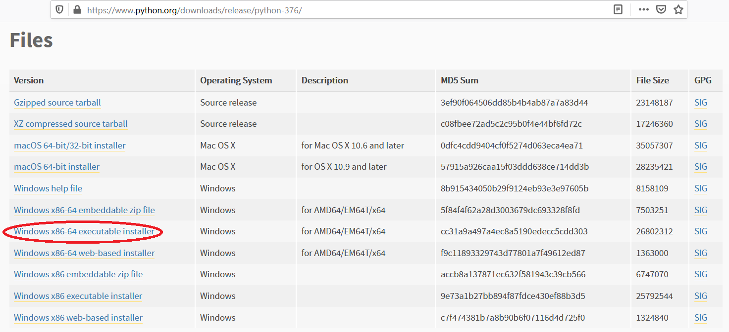

Software name: PyCharm: Version: 2020.3.3
(Download link: https://www.jetbrains.com/pycharm/download/other.html)
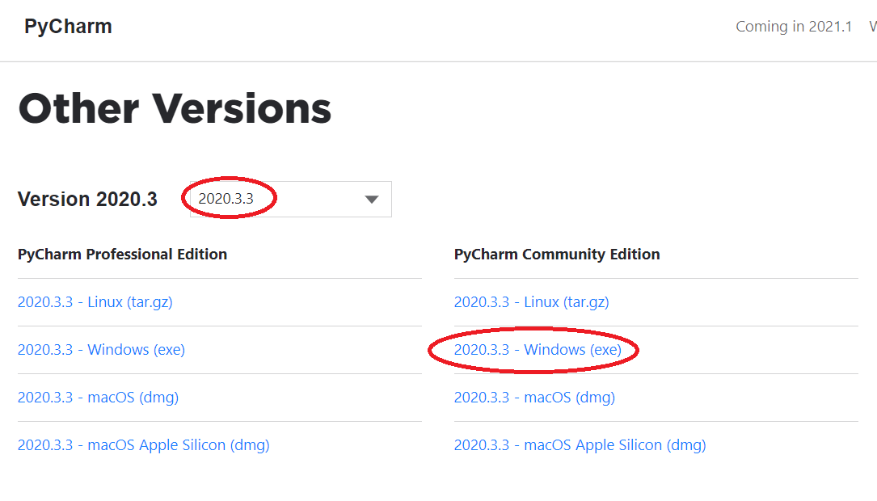
(For installation procedure, please refer the doc “steps to install python.doc”)

4. HOW TO RUN
Step 1: Loading the project in PYCHARM
- Open pycharm
- Go to File, select Open browse the project from your drive and select it. So that the project will get loaded into the Pycharm.
- For the first time, Pycharm will take some time to load the settings.
- Please wait if any process is loading on the bottom of the screen.
- Check the Project Interpreter (File -> Settings -> Project: 294417-> Project Interpreter).
If this location “(C:\Users\---\AppData\Local\Programs\Python\Python39-64\python.exe) is not presented, then add this ‘python.exe’ from the installed location.
- In Pycharm Terminal(bottom left), type the comment “pip install -r requirements.txt”
Step 2: Run the program and getting the results
- From 'current project folder' window in pycharm, Open 294417-> Main->GUI.py’ and click run button
- In GUI window,
- 1) Enter feature dimension (eg: 5,10,15,20)
2) Click START, after some time the result will be displayed
3) Click Run Graph to view the current result graph.
[Expected Execution time expected: 15 – 20 minutes]
- Step 3: Generate the graphs plotted in the paper
- From 'current project folder' window in pycharm, open ‘294417-> Main->Result_graphs.py’, and click run button.

5. IMPORTANT PYTHON FILE AND DESCRIPTION:
Main-> GUI.py: User Interface, code starts here
Main-> Run.py: Main code
Main->Data_Normalization. Py: Data normalization using Min Max normalization method
Main->Feature_selection. Py , HSBOA.py: Feature selection using SVM-RFE with HSBOA

Proposed_TWSA_WRN ->WideResnet.py , TWSA.py : Intrusion detection and attack mitigation using Proposed TWSA-WRNET

