A **Sorting Algorithm** is used to rearrange a given array or list of elements in an order. For example, a given array [10, 20, 5, 2] becomes [2, 5, 10, 20] after sorting in increasing order and becomes [20, 10, 5, 2] after sorting in decreasing order.

* There exist different sorting algorithms for different different types of inputs, for example a binary array, a character array, an array with a large range of values or an array with many duplicates or a small vs large array.
* The algorithms may also differ according to output requirements. For example, stable sorting (or maintains original order of equal elements) or not stable.
* Sorting is provided in library implementation of most of the programming languages. These sorting functions typically are general purpose functions with flexibility of providing the expected sorting order (increasing or decreasing or by a specific key in case of objects).

**Sorting**refers to rearrangement of a given array or list of elements according to a comparison operator on the elements. The comparison operator is used to decide the new order of elements in the respective data structure.

**Sorting Basics**

* [**In-place Sorting**](https://www.geeksforgeeks.org/dsa/in-place-algorithm/)**:**An in-place sorting algorithm uses **constant space**for producing the output (modifies the given array only. Examples: Selection Sort, Bubble Sort, Insertion Sort and Heap Sort.
* **Internal Sorting:**Internal Sorting is when all the data is placed in the **main memory** or **internal memory**. In internal sorting, the problem cannot take input beyond allocated memory size.
* [**External Sorting**](https://www.geeksforgeeks.org/dsa/external-sorting/)**:** External Sorting is when all the data that needs to be sorted need not to be placed in memory at a time, the sorting is called external sorting. External Sorting is used for the massive amount of data. For example Merge sort can be used in external sorting as the whole array does not have to be present all the time in memory,
* [**Stable sorting**](https://www.geeksforgeeks.org/dsa/stable-and-unstable-sorting-algorithms/)**:**When two same items appear in the **same** **order** in sorted data as in the original array called stable sort. Examples: Merge Sort, Insertion Sort, Bubble Sort.
* [**Hybrid Sorting**](https://www.geeksforgeeks.org/dsa/hybrid-sorting-algorithms/)**:**A sorting algorithm is called Hybrid if it uses more than one standard sorting algorithms to sort the array. The idea is to take advantages of multiple sorting algorithms. For Example [Intro Sort](https://www.geeksforgeeks.org/dsa/introsort-cs-sorting-weapon/) uses Insertions sort and Quick Sort.

**Types of Sorting Techniques**

There are various sorting algorithms are used in data structures. The following two types of sorting algorithms can be broadly classified:

1. **Comparison-based:**We compare the elements in a comparison-based sorting algorithm)
2. **Non-comparison-based:**We do not compare the elements in a non-comparison-based sorting algorithm)

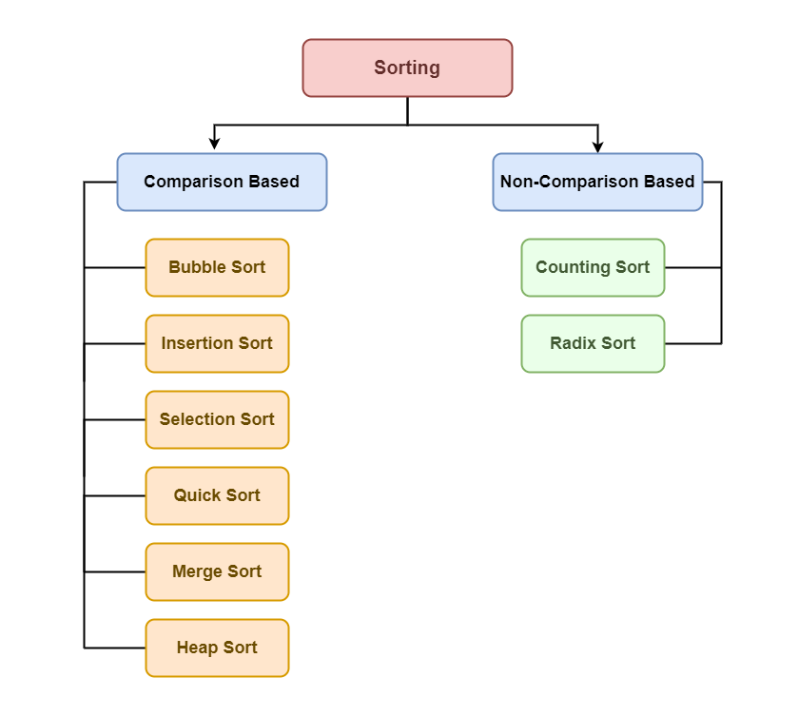

**Bubble Sort - O(n^2) Time and O(1) Space**

It is a simple sorting algorithm that repeatedly swaps adjacent elements if they are in the wrong order. It performs multiple passes through the array, and in each pass, the largest unsorted element moves to its correct position at the end.

After each pass, we ignore the last sorted elements and continue comparing and swapping remaining adjacent pairs. After k passes, the last k elements are sorted.

