JavaScript

"Everything in JavaScript happens inside an Execution Context"
Execution Context is nothing but a container which has two components 1st is Memory comp(where all variables and functions are stored in the form of key value pair) which is also called as variable environment and 2nd is code comp
Where code is executed also called as thread of execution.
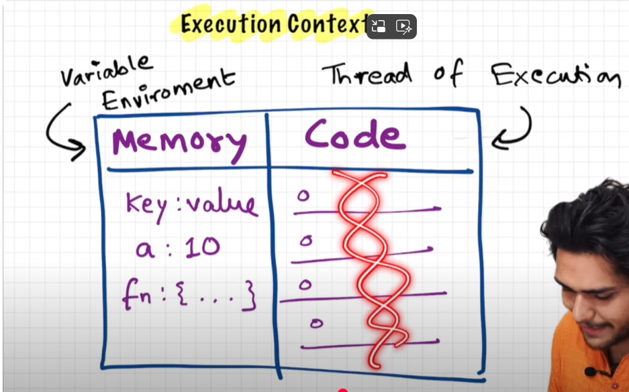

"JavaScript is a synchronous single-threaded language"

Execution context is created in 2 phases

Eg.we have this code 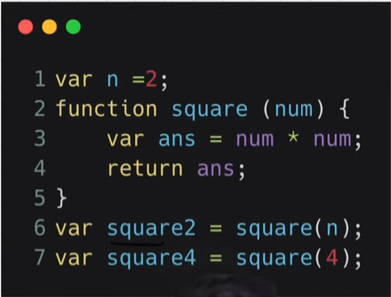
When we run a js program a global execution context is created.
Execution context is created in 2 phases 1st is Memory creation phase, in this phase n is remain undefined
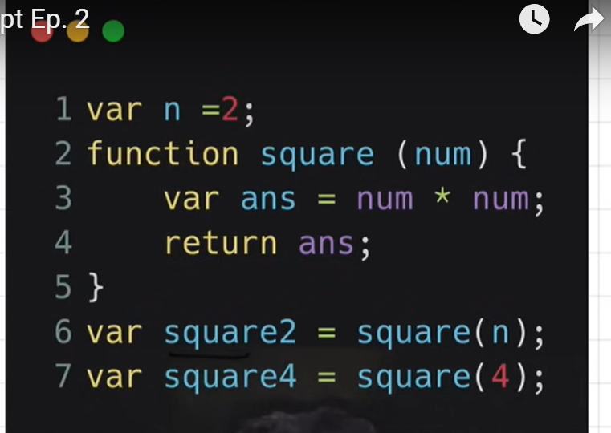
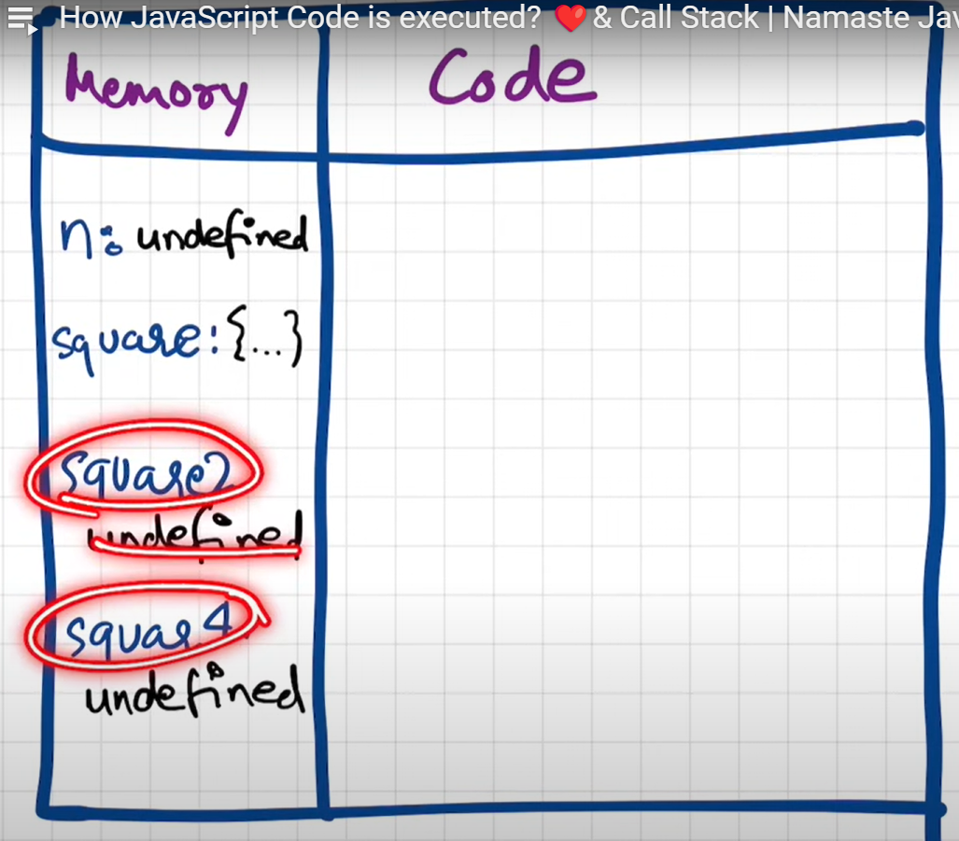

Second Phase is code execution phase, in this phase n = 2
Now we have function to allocate so when it comes to function allocation (when you run a function or envoke it ) a brand new execution context has created which has again 2 phases so in memory allocation will involve its parameters, variables and functions.

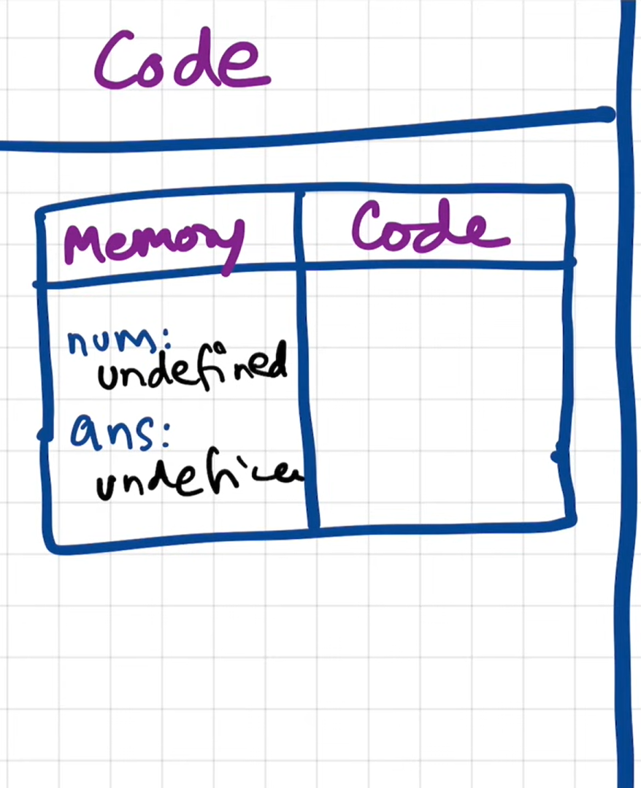

As soon as we return the value the whole execution context gets deleted.
For second envocation function
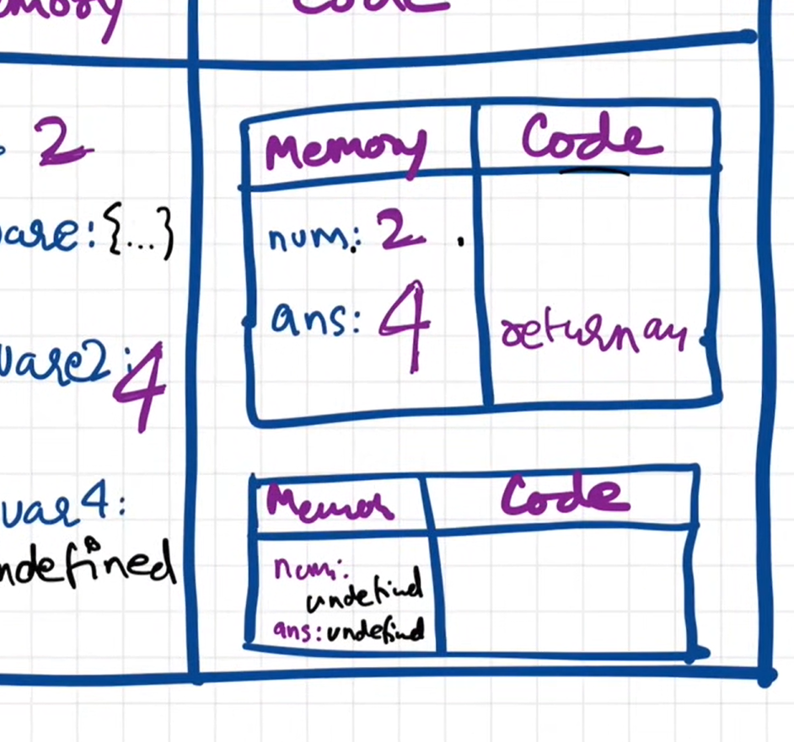

Once the whole program is run the global execution context gets deleted.

Js uses Call stack to manage these execution context

"Call stack maintains the order of execution of execution contexts"

Line by line it runs the code so once a is called it goes to stack after finished it gets popped out and so on

🔄 How Does It Work in the Call Stack?
- JavaScript engine creates the Global Execution Context (GEC).
- It pushes GEC onto the call stack.
- Then it starts running your code line by line from top to bottom.
- When a function is called → a new Execution Context is created and pushed.
- When that function finishes → it’s popped off.
- After everything is done, GEC is popped, and the program ends.

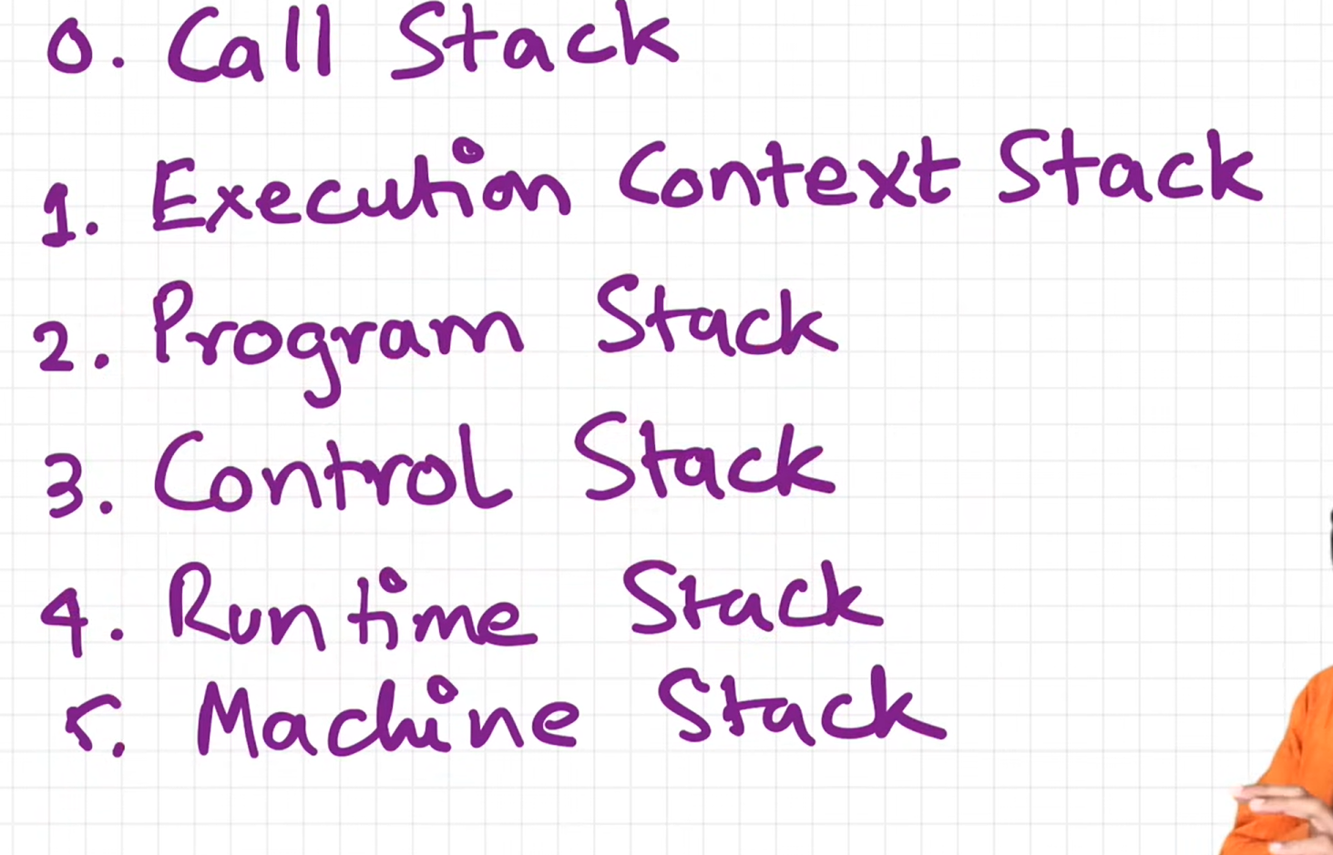
Hoisting
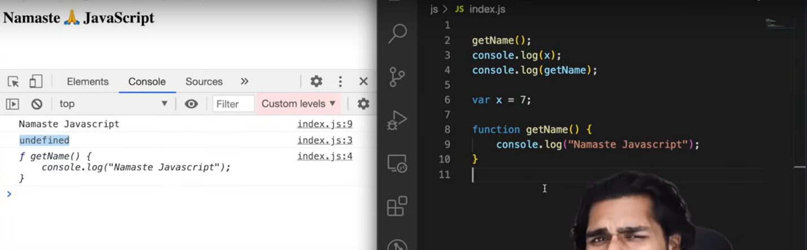

With the help of hoisting you can access these variables or functions even before you have initialize it, can access it without any error.

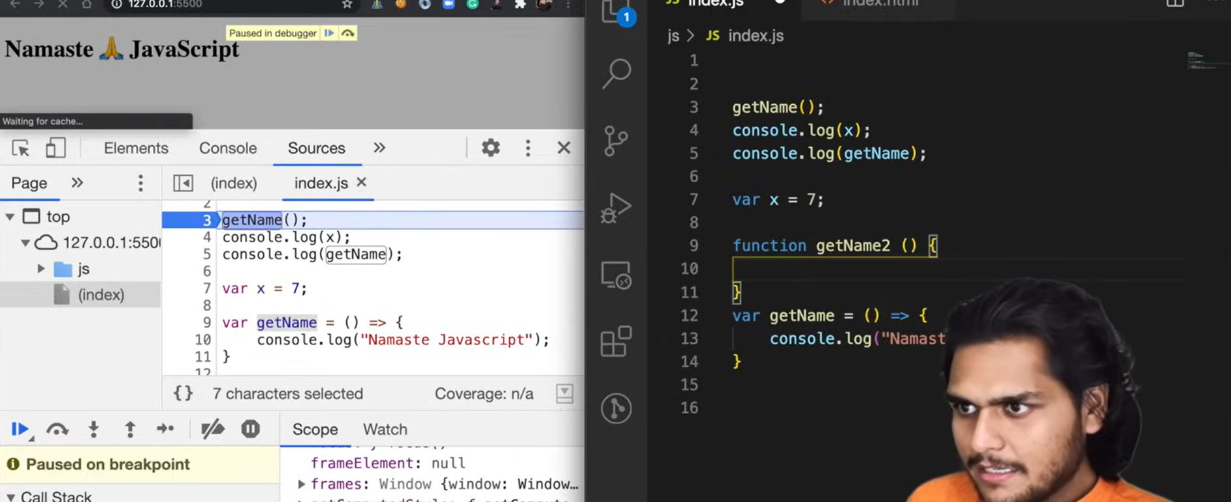
Arrow funt will act as a variable here

Scope and Lexical(hierarchy or sequence) environment
Whenever execution context is created lexical environment is created
The lexical environment is a term used to describe the environment in which a variable or function is declared.
Lexical environment is local memory along with lexical env of its parent

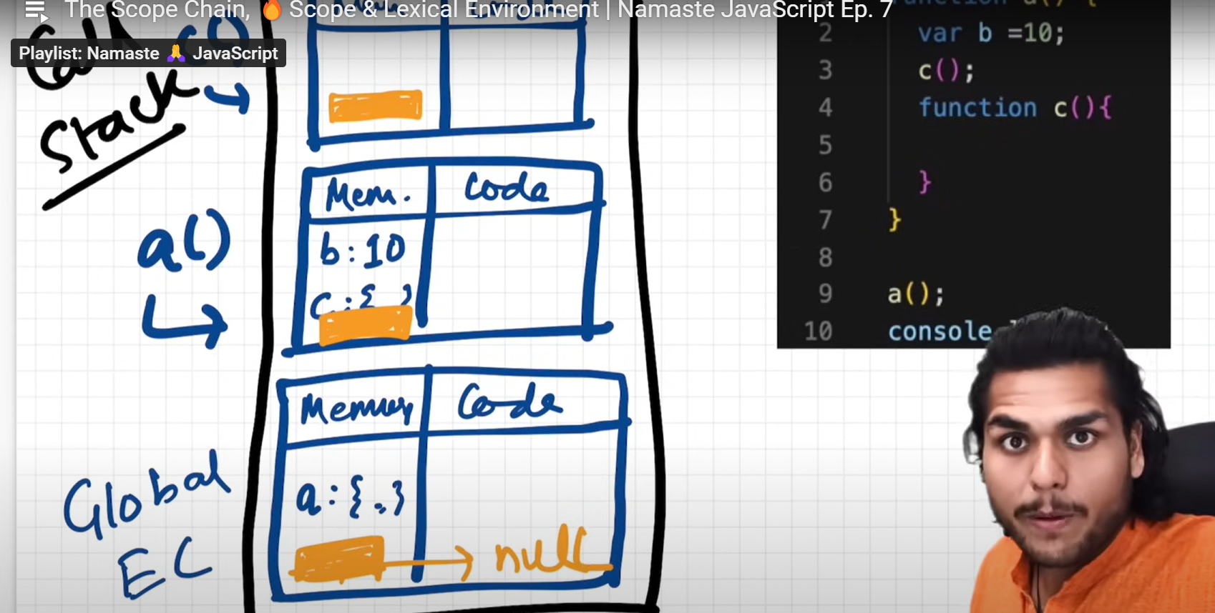

Scope Chain
Scope chain is nothing but chain of all these lexical environment in the parent references

Let, var, const
That phase from hoisting(assigning undefined value) till assigning the actual value that phase is called as temporal dead zone. Var can be hoisted but let and const cant

When we are using let this could happen: cant access before initialization it assigns val as undefined but not accessible so gives reference error.

Also if we try to declare any value using let js rejects it , it doesn’t even allow console log but its possible for var will just overwrite the val.
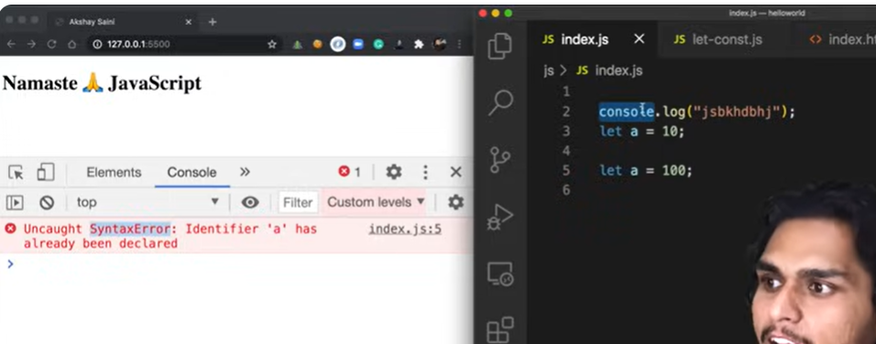
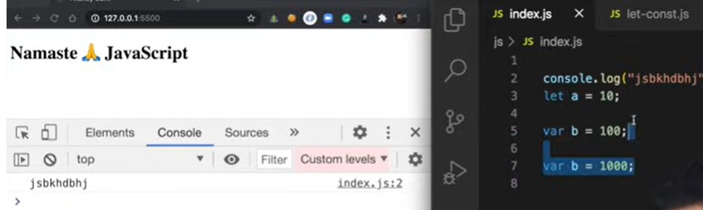
Difference bet reference, syntax and type error check it.
If que is let and const are hoisted or not then explain this term called temporal dead zone.

Block Scope()
In JavaScript, block scope refers to the visibility or lifespan of variables defined within a specific block of code. A block is any section of code enclosed by curly braces { }, such as inside functions, loops, conditionals (like if), and other control structures.
Key Points:
- Variables within a block:
  - Variables declared using let or const are block-scoped, meaning they are only accessible within the block in which they are defined.
  - If a variable is declared inside a block, it cannot be accessed outside that block.
- Example of Block Scope:
if (true) {
let x = 10;
const y = 20;
console.log(x); // 10
console.log(y); // 20
}
// Outside the block
console.log(x); // Error: x is not defined
console.log(y); // Error: y is not defined

Var can be accessible as its in global scope
This is known as shadowing

One b has block scope and other b is in script (not in global )which is outside the block it behaves similar for function scope fun(){}

Closures

Op:7
(A closure is the combination of a function and the lexical environment within which that function was declared.)

Function along with its lexical scope forms closure.
function outer() {
let outerVariable = 'I am from the outer function';

function inner() {
console.log(outerVariable); // Inner function can access outerVariable
}

return inner; // Return the inner function, creating a closure
}

const closureFunction = outer(); // Call outer, which returns the inner function
closureFunction(); // Logs: "I am from the outer function"

🧱 Block Scope vs Function Scope
- Block scope applies to variables declared inside curly braces {} — such as in if statements, loops, and even individual code blocks.
- Function scope applies to variables declared inside a function — variables declared with var are function scoped, meaning they are accessible throughout the entire function, no matter where inside the function they are defined.
🔍 Clarifying with Examples
1. Block Scope (for let and const):
js
CopyEdit
{
let a = 5;
const b = 10;
}
console.log(a); // ❌ ReferenceError: a is not defined
console.log(b); // ❌ ReferenceError: b is not defined
- Here, a and b are only accessible inside the block {} they are defined in.

2. Function Scope (for var):
js
CopyEdit
function example() {
var x = 2;
if (true) {
var y = 3; // var ignores block and is scoped to the function
}
console.log(x); // ✅ 2 (x is accessible in the entire function)
console.log(y); // ✅ 3 (y is also accessible because var is function-scoped)
}
example();
- Even though y is declared inside an if block, var gives it function scope, so it’s accessible anywhere in the function.

🧠 Key Takeaway
- Block scope (let and const) means the variable is only accessible inside the block — i.e., {}. Not inside functions, because functions themselves aren't considered "blocks."
- Function scope (var) means the variable is accessible throughout the entire function, regardless of block boundaries.
So when we say block scope doesn't consider function as a block, it means that let and const behave differently inside functions compared to var. The function isn't treated like a block by let and const.

Difference between return and y()
function x() {
var a = 7;
function y() {
console.log(a);
}
y();
}

x();
What happens here:
- You declare function x.
- Inside x, you declare a variable a = 7.
- Then you define another function y inside x, and y logs a.
- Still inside x, you call y().
- Finally, you call x().
Output:
plaintext
CopyEdit
7
Why?
- JavaScript has lexical scoping, which means that the inner function y can access variables declared in its outer function x.
- So y() has access to a, even though a is not declared inside y.
You said:
what if we dont write this y();
ChatGPT said:
function x() {
var a = 7;
function y() {
console.log(a);
}
}

x();
Then what happens?
- You’re defining the function x, which declares a variable a = 7 and defines a function y.
- But since you never call y, the code inside y (which logs a) is never executed.
So the output will be:
// (nothing)
No errors, no output — just silence 😄
You're basically saying:
"Hey JS, here's a function x, and inside it there's a variable and another function. Cool. Now run x. Inside x, we made some declarations, but didn't actually do anything visible like a console.log."
You said:
instead of y() can we use return key word
ChatGPT said:
Yes! You can totally use the return keyword — and depending on what you return, you can get different behaviors.
Let’s go step by step with your setup, and see what happens if you return y from x.

Example:
javascript
CopyEdit
function x() {
var a = 7;
function y() {
console.log(a);
}
return y;
}

const result = x();
result(); // what happens here?

2nd approach to call main function without storing it is

With one more fun

What’s going on here:
- You define x(), which declares a = 7 and defines an inner function y().
- Instead of calling y() inside x, you return the function itself (return y).
- You assign result = x(); — so now result is a reference to function y.
- Then you call result(); — which is essentially calling y() outside its original scope.

Output:
7
Yep! Even though you're calling y() outside of x(), it still has access to a — because JavaScript remembers the lexical scope where y was defined. That’s a classic closure.

TL;DR:
- ✅ You can return y; instead of calling y().
- ✅ When you call the returned function later, it still remembers the variables from its original environment.
You said:
whats diff between them

🔹 Option 1: y(); — calling the function immediately
function x() {
var a = 7;
function y() {
console.log(a);
}
y(); // this runs y immediately
}

x(); // Output: 7
- You define and call the inner function y right away.
- As soon as you call x(), it runs everything inside — and y() logs 7.
- After x() finishes, everything inside is gone (unless saved somewhere).

🔹 Option 2: return y; — returning the function itself
function x() {
var a = 7;
function y() {
console.log(a);
}
return y; // returning the function, not running it
}

const result = x(); // x() runs, returns function y
result(); // Output: 7
- Here, you're returning the function y, not running it yet.
- You can store it and run it later.
- The returned function still has access to a — thanks to closures.

🎯 The Difference in a Nutshell:
y(); | return y;
Runs y immediately inside x | Returns the y function for later use
You get the output right away | You can choose when to run it later
No closure is created that you can use later | Creates a closure (if you store y)

Real-life use of return y (Closure):
You can use this pattern to preserve private state:
function x() {
var a = 7;
return function() {
console.log(a);
};
}

const fn = x(); // closure created
fn(); // Output: 7
Even though x() is done running, a is still remembered by the returned function.

🧠 Most important/useful way:
Returning the inner function (return y) is more powerful, because it gives you:
✅ Closures
You can return a function that "remembers" its scope and variables. This is super useful for:
- Private variables
- Factory functions
- Custom hooks (in React)
- Currying / partial application
- Debounce/throttle utilities

🔐 Example: Private Counter (using return y)
javascript
function createCounter() {
let count = 0;
return function() {
count++;
console.log(count);
};
}

const counter1 = createCounter();
counter1(); // 1
counter1(); // 2

const counter2 = createCounter();
counter2(); // 1
Each createCounter() call returns a new function that remembers its own count. You can’t directly change count — it's private. This is real closure magic ✨

🔁 When to just use y();
Use y(); when you:
- Just need to organize code inside a function
- Want to immediately execute something (helper function style)
- Don’t need to reuse or save the function later
Example:
javascript
function greet() {
function sayHello() {
console.log("Hello!");
}
sayHello(); // fire it right away
}

greet(); // Output: Hello!
No need for closures here — just clean structure.

🔧 TL;DR:
Situation | Use
Need immediate action | y(); (call right away)
Need reusable / delayed logic | return y; (create closures)
Need private state or encapsulation | return y; (most powerful pattern)

If you’re building more scalable code, returning functions and using closures is where JavaScript really shines.
Want to see how closures are used in async code or React?
You said:
no i meant what shoul we use either return or the other way?
🔹 Use y(); (call the function) when:
- You just want to run some code immediately inside the parent function.
- You don’t need to keep or reuse the inner function later.
✅ Best for:
- Simple helper logic
- Organizing code
- No need for closures
function x() {
function y() {
console.log("Running Y immediately");
}
y(); // just run it
}

x(); // Output: Running Y immediately

🔹 Use return y; when:
- You want to give back the function so it can be used later.
- You want to keep the inner scope (closure).
- You're building modular, reusable, or private logic.
✅ Best for:
- Closures
- Factory functions
- Encapsulation / private state
function x() {
let a = 7;
return function y() {
console.log(a);
};
}

const myFunc = x(); // x() is done, but y() keeps 'a'
myFunc(); // Output: 7

SET TIMEOUT+CLOSURES

for (var i = 0; i < 3; i++) {
setTimeout(() => console.log('var:', i), 1000);
}

for (let j = 0; j < 3; j++) {
setTimeout(() => console.log('let:', j), 1000);
}

Step-by-Step Breakdown
- var i is hoisted outside the loop — it's declared once in the outer function or global scope.
- During each loop iteration, the same variable i is updated.
- Each closure created by setTimeout() captures the same i — which has the value 3 by the time the setTimeout executes.
Memory: {
i: 3,
closures: [ () => console.log(i), () => console.log(i), () => console.log(i) ]
}
Output:
var: 3
var: 3
var: 3

Step-by-Step Breakdown
- let j is block scoped, and inside a for loop, JavaScript creates a new binding for j on each iteration.
- That means for each loop iteration, a new "version" of j is created and captured by that iteration's closure.
{
let j = 0;
setTimeout(() => console.log(j), 1000);
}
{
let j = 1;
setTimeout(() => console.log(j), 1000);
}
{
let j = 2;
setTimeout(() => console.log(j), 1000);
}

[
{ j: 0, closure: () => console.log(j) },
{ j: 1, closure: () => console.log(j) },
{ j: 2, closure: () => console.log(j) },
]

let: 0
let: 1
let: 2

its just because let is block scope creates copy every time on evry iteration and var is a global scope
but if you want it to work with var only then you can do this use closures with help of different function it will happen

🎒 Imagine 3 kids and notebooks
🧠 Case 1: var → ONE shared notebook
for (var i = 0; i < 3; i++) {
setTimeout(() => console.log(i), 1000);
}
👉 Imagine:
- There is ONLY ONE notebook
- All kids write in the SAME notebook

✍️ What happens:
Kid 1 writes → 0
Kid 2 overwrites → 1
Kid 3 overwrites → 2
After loop ends → notebook has 3

⏰ After 1 sec (setTimeout):
All kids check notebook 📖
👉 They all see:
3
3
3

📓 Case 2: let → EACH kid gets OWN notebook
for (let i = 0; i < 3; i++) {
setTimeout(() => console.log(i), 1000);
}

✍️ What happens:
Kid 1 → notebook1 → 0
Kid 2 → notebook2 → 1
Kid 3 → notebook3 → 2

⏰ After 1 sec:
Each kid checks THEIR notebook
👉 Output:
0
1
2

🎯 THAT is the whole difference
Keyword | Memory
var | ONE shared memory 🧾
let | NEW memory each loop 🔁
const | same as let (but value can’t change)

🧠 Now real explanation (simple)
🔴 var
- Function scoped
- Only one variable exists
- Loop does NOT create new copy

🟢 let
- Block scoped
- Loop creates new variable each iteration

🔵 const
- Same as let (block scoped)
- But value cannot change

What Is a Constructor Function?
A regular function, when called with the new keyword, becomes a constructor:
js
CopyEdit
function Person(name, age) {
this.name = name;
this.age = age;
}
When you use it like this:
js
CopyEdit
const p1 = new Person("Alice", 25);
console.log(p1.name); // Alice
console.log(p1.age); // 25
It constructs a new object:
- Creates an empty object: {}
- Sets this to point to that object
- Assigns properties to it
- Returns the object automatically

FUNCTION WITHOUT NAME

Anonymous functions are used when they are used as values just as function expression

BUT IF WE TRY TO RETURN IT INSIDE A FUNCTION THEN IT WORKS

FUNC STATEMENT IS ALSO KNOWN AS FUNCTION DECLARATION
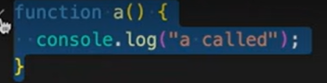

FUNC EXPRESSION

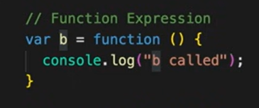

DIFFERENCE BETWEEN TWO OF THEM IS RELATED TO HOISTING LIKE IF WE TRY TO CALL THEM BEFORE INITIALIZATION THEN FUNCTION EXPREESION WILL GIVE AN ERROR BUT FUN STATEMENT WONT

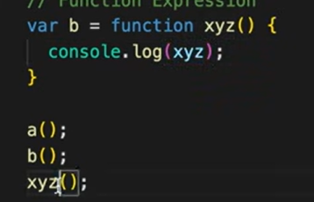
IF WE TRY TO ACCESS XYZ INSIDE THE FUNCTION THEN ITS POSIIBLE BUT IF WE TRY CALLING IT OUT IT WILL GIVE AN ERROR THAT XYZ IS NOT A FUNCT COZ ITS NOT DEFINED IN GLOBAL SCOPE

FIRST CLASS FUNCTION
WHEN THEY ARE TREATED AS VALUE, PASSED INSIDE ANOTHER FUNCTION, OR RETURNED FROM ANOTHER FUNCTIONS
What That Means in Practice:
You can:
- ✅ Store functions in variables
- ✅ Pass functions as arguments to other functions
- ✅ Return functions from other functions
- ✅ Assign functions as object properties (methods)
1. Store in a variable
const greet = function () {
console.log("Hello!");
};
greet(); // Hello!
2. Pass as an argument
function sayHi() {
console.log("Hi!");
}

function execute(fn) {
fn();
}

execute(sayHi); // Hi!
3. Return from another function
function multiplier(factor) {
return function (number) {
return number * factor;
};
}

const double = multiplier(2);
console.log(double(5)); // 10
4. Assign as a property
const person = {
speak: function () {
console.log("I'm speaking");
}
};
person.speak(); // I'm speaking

📦 Why This Matters
First-class functions are what make powerful patterns like:
- Callbacks
- Higher-order functions
- Functional programming
- Closures
- Custom control flow (e.g., debounce, throttle)

✅ What is a Callback Function?
A callback is a function passed as an argument to another function and called later.
It can be:
- Synchronous → runs immediately
- Asynchronous → runs after some time

1. ✅ Synchronous Callback
function greet(name, callback) {
console.log("Hello, " + name);
callback(); // runs immediately
}

greet("Alice", function () {
console.log("Nice to meet you!");
});
This is a synchronous callback. Everything runs immediately, one after the other.

2. ⏳ Asynchronous Callback
setTimeout(function () {
console.log("This runs after 2 seconds");
}, 2000);

🧠 Why Are Callback Functions Used?
1. ✅ To handle asynchronous operations
setTimeout(function () {
console.log("This runs after 2 seconds");
}, 2000);
- You pass a function to setTimeout, and JS calls it later.
- This is crucial for non-blocking behavior (e.g., API calls, timers, animations).

2. ✅ To customize behavior
function calculate(a, b, operation) {
return operation(a, b);
}

function add(x, y) {
return x + y;
}

console.log(calculate(3, 4, add)); // 7
- add is a callback, allowing calculate to work with any logic you pass.

3. ✅ Used in built-in methods
const numbers = [1, 2, 3];

numbers.forEach(function (num) {
console.log(num);
});
- The anonymous function is a callback passed to forEach().

🔁 Sync vs Async Callbacks
Type | Example | Called
Synchronous | arr.map(callback) | Immediately
Asynchronous | setTimeout(callback) | Later (non-blocking)

ITS LIKE JS HAS ONE CALL STACK WHICH IS ALSO CALLED AS MAIN THREAD
So when ever we use apis it take lot of time to load right until then we don’t want to keep our ui freeze or block for that we use these async calls settimeout is one of the eg of it

ASYNCRONOUSE JS AND EVENT LOOPS

We get to use all this options using the keyword window inside the call stack(global env of js) , window is a global object

WHEN CALL BACK FUNCTION IS CREATED USING SETTIME OUT AS SOON AS THIS TIME IS OVER CB FUNCTION GOES TO CB QUEUE THEN WITH THE HELP OF EVENT LOOP IT GETS PUSHES INSIDE CALL STACK AND IT RUNS THE FUNCTION THEN AFTER ITS RUN IT GETS POPED OUT

2nd example with api(
Concurrency Model
Is nothing but below whole structure which
Handles multiple tasks non-blockingly
)
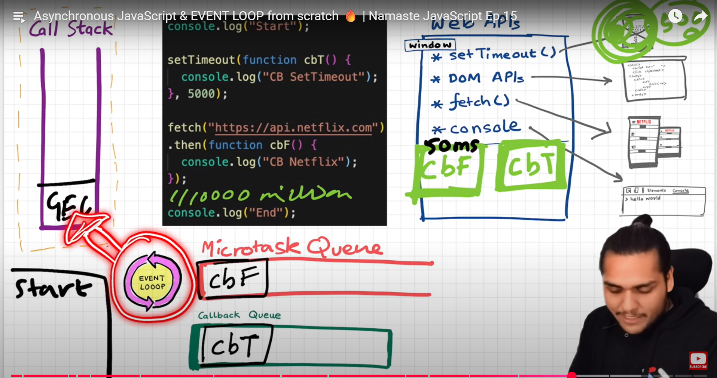

SO HERE IN THIS EXAMPLE WE ARE USING API SO FOR API CALL BACKS WE HAVE OTHER MICROTASK QUEUE (SO ALL CALLBACKS WHICH WILL COME THROUGH PROMISES WILL GO INSIDE OF MT Q) HOW DOES IT WORK SO WHEN WE RUN CODE FIRST IT WILL PRINT START IN CONSOLE THAT MEANS IN OUR CALL STACK FIRST THERE IS GLOBAL EXECUTION CONTEXT THEN IT WILL TRY TO RUN SETTIMEOUT CB IT WILL GET INTO WEB API ENV WHICH IS NOTHING BUT BROWSER COMP AND AFETR 5 SEC THEN GOES TO CB QUEUE THEN IT WILL TRY TO RUN API THROUGH FETCH ONCE THE DATA IS LOADED IT WILL GO INSIDE MICROTASK Q (IT HAS MORE IMP THAN CB Q) NOW HERE OUR EVENT LOOP IS CONTINUOSLY CHECKING CALL STACK IS EMPTY OR NOT COZ THERE ARE MANY THINGS GOING ON IN OUR BROWSER BUT ITS OUR CALL STACK WHO IS NOT ABLE T RUN MULTIPLE THINGS AT A TIME SO IT WAITS TO POP OUT GEC ONCE WE PRINT END IN CONSOLE OUT GEC GETS OUT THEN EVENT LOOP SEES CALL STACK IS EMPTY AND BOTH THE Q’S HAS FUNCTIONS BUT FIRST IT GAVES PRIORITY TO MT Q AND THEN TO CB Q

MutationObserver
🧬 What is it?
A MutationObserver watches for DOM changes — like when:
- Elements are added/removed
- Attributes change
- Text content changes
Why use it?
- When you want to react to DOM updates
- Useful for:
  - Custom components
  - Tracking content changes
  - Working with dynamic UIs

✅ When you use normal functions (no async or callbacks):
- JavaScript starts with the Global Execution Context (GEC).
- Functions are executed immediately, one by one → on the Call Stack.
- Once everything is done, the GEC is popped off and the program ends.

✅ When you use asynchronous callbacks (like setTimeout, fetch, or event listeners):
- The GEC is created and pushed.
- Async functions like setTimeout, fetch, or addEventListener are offloaded to the Web APIs.
- Once the GEC code finishes, and the Call Stack is empty, the Event Loop:
  - Takes any ready callback from the Callback Queue
  - Pushes it into the Call Stack for execution.

🔁 Two Main Queues in JavaScript Runtime:
1. 🧵 Callback Queue (Task Queue)
- Used by:
  - setTimeout
  - setInterval
  - DOM events (addEventListener)
  - Other regular async tasks

2. ⚡ Microtask Queue
- Used by:
  - Promises (.then, .catch, .finally)
  - async/await
  - queueMicrotask()
  - MutationObserver

💡 Execution Order Rule (VERY Important):
✅ Microtask Queue has higher priority than the Callback Queue!
So after each task from the call stack completes, JS:
- First clears all microtasks
- Then takes the next task from the Callback Queue

Browser Components:
- JavaScript Engine (like V8) – runs your code (Call Stack, Execution Context, etc.)
- Web APIs – browser-provided features that run async tasks
- Callback Queue + Event Loop – control the order of execution

Arch of JAVASCRIPT
HIGHER ORDER FUNCTIONS

Callback Functions
- A callback is a function passed as an argument to another function.
- It is usually invoked inside the other function to complete some kind of action.
function greet(name, callback) {
console.log("Hello, " + name);
callback();
}

function sayGoodbye() {
console.log("Goodbye!");
}

greet("Alice", sayGoodbye);

Higher-Order Functions (HOFs)
- A higher-order function is any function that takes another function as an argument or returns a function (or both).
- So callback functions are one use case of higher-order functions, but HOFs have a broader definition.
function multiplier(factor) {
return function(x) {
return x * factor;
};
}

const double = multiplier(2);
console.log(double(5)); // 10

Summary
Concept | Takes Function as Argument | Returns Function | Example Use
Callback Function | ✅ | ❌ | setTimeout, forEach
Higher-Order Function | ✅ or ✅ | ✅ or ✅ | map, filter, reduce, custom

✅ All functions using callbacks are higher-order functions, but
❌ Not all higher-order functions are just about callbacks.

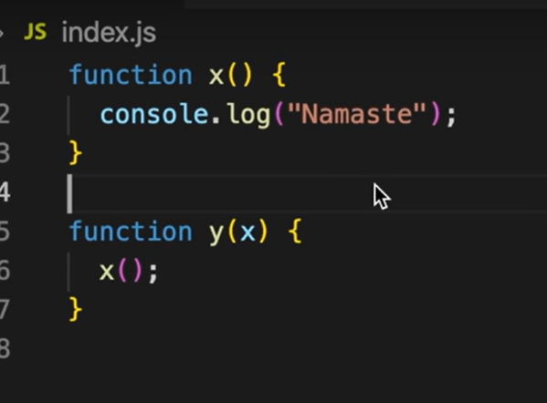

HERE X IS THE CALLBACK FUN AND Y IS HIGHER ORDER FUNCTION

so its like first whenever script is loaded global execution context is created(there are two types global exe context which is created once when script is loaded and functional exe context which is created when function is called), now global exe context has two parts memory and code so what memory does reads the whole code variables are set to be hoisted means initialized to undefined if its let and const they are still hoisted but not initialized and until they are initialized they are in tdz, A closure is when a function remembers variables from its outer scope even after the outer function has finished execution this terms can also be called as lexical env means it knows local memory + reference to outer lexical environment, The process of searching variables through lexical environments is scope chain

Function declarations are fully hoisted with their definitions, while function expressions and arrow functions follow variable hoisting rules—meaning they are not callable before initialization.

var a; // declaration
a = 10; // initialization

var b = 20; // declaration + initialization (same line)

why closures

🎯 Final clarity
👉 Normal function:
- Data is exposed
👉 Closure:
- Data is hidden
- Access only through controlled functions

⚡ One-line answer
Closures provide data privacy by keeping variables inside a function scope and allowing access only through specific returned functions.

First, big idea
useState is basically a closure that stores private state and gives you controlled access to it.

🎒 Step 1: Build useState yourself (simple version)
Let’s mimic React:
function useState(initialValue) {
let state = initialValue; // 🔐 private variable
function setState(newValue) {
state = newValue;
}
function getState() {
return state;
}
return [getState, setState];
}

Is js Concurrent and parallel
Graceful degradation
Dependency injection
currying
memorization

