1.Unzip the folder named Decison Tree

2.In the Package Explorer of your workspace import the folder Decison Tree

a.File->Import->Existing Projects into your workspace

b.Make sure the path is for example of the type E:\DecisonTrees and the box is checked

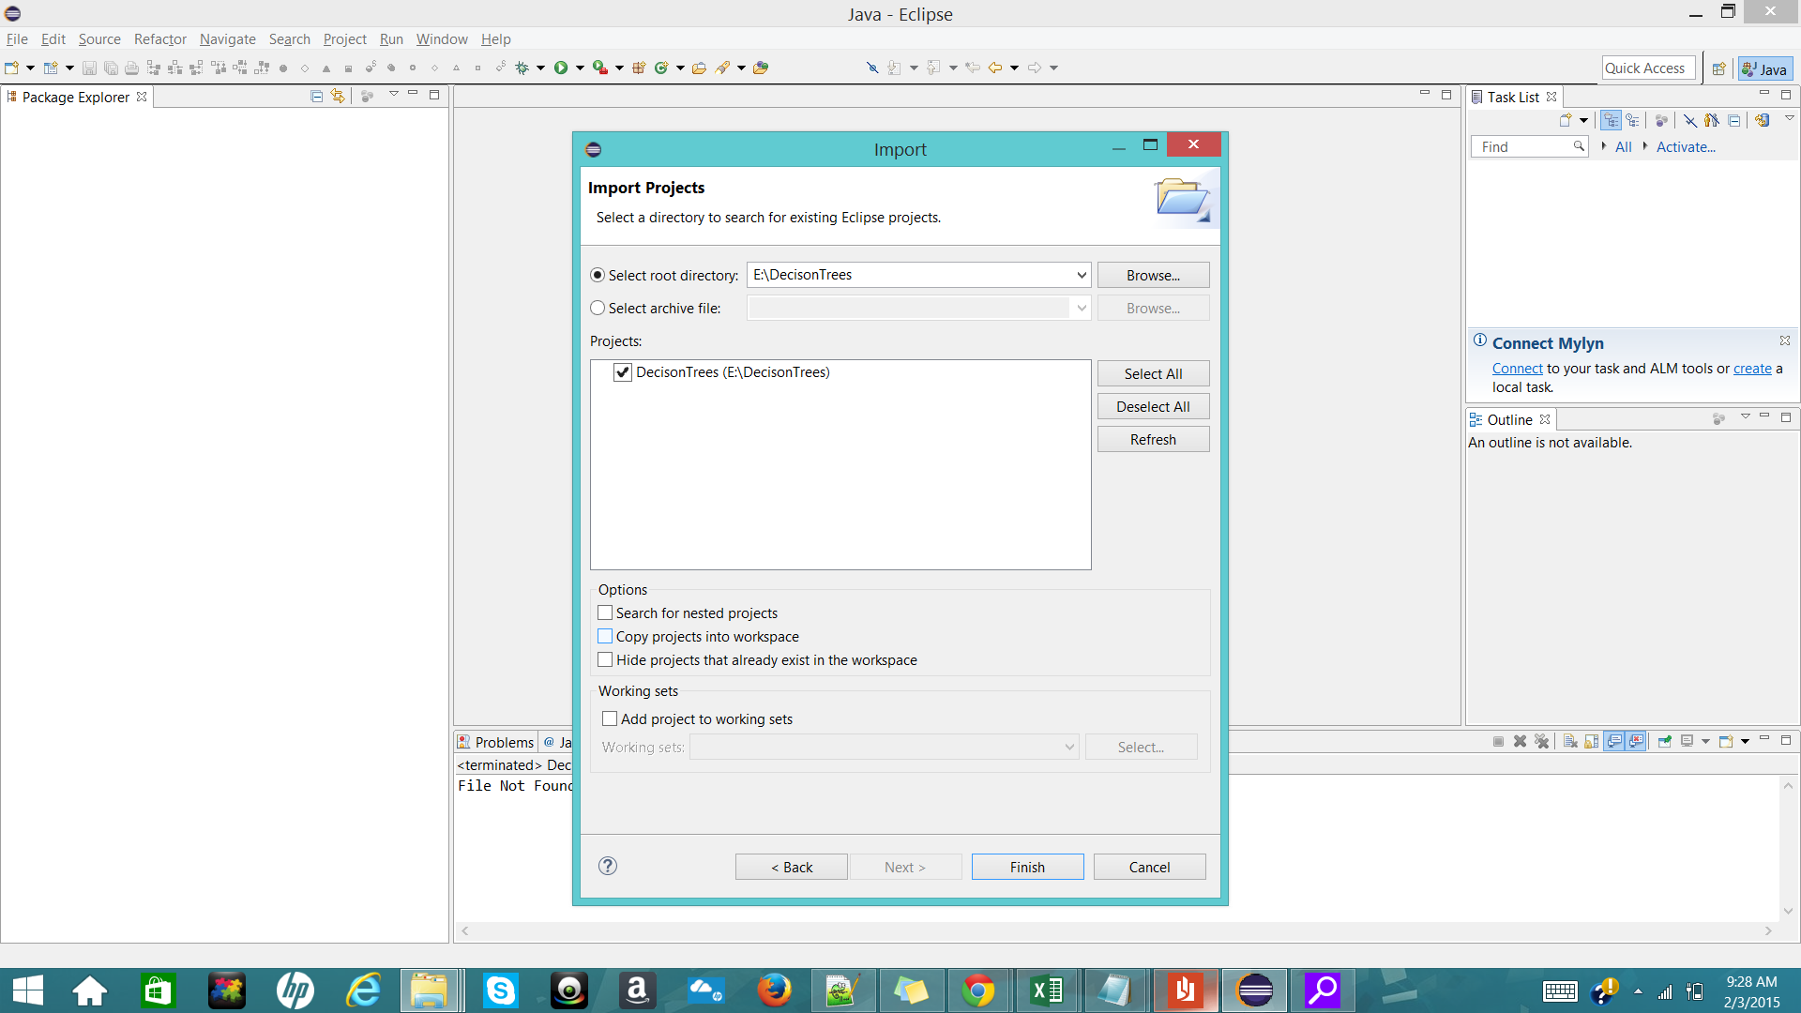

3.After importing the file,place any new training or testing files to be used in the path .

E:\DecisonTrees\

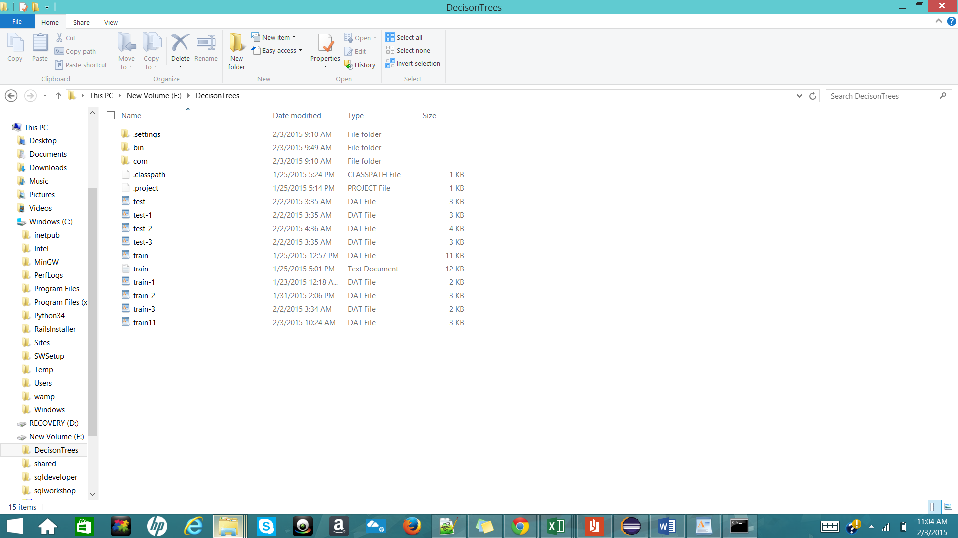

4**. If the new files are to be placed**

**To use a new training file search for comment “training file” in the file DecisionTree.java** and replace in the obtained line the name of file with double quotes

BufferedReader reader = new BufferedReader(new FileReader("Name.dat"));//training file

If the file name for training file is train-11 then:

BufferedReader reader = new BufferedReader(new FileReader("train-11.dat"));//training file

Make sure the file is there in the path E:/DecisonTree/

As shown below

5. **To replace the testing file search for comment “testing file” in DecisonTree.java**

**Replace the file name in the following line:**

BufferedReader reader = new BufferedReader(new FileReader("Name.dat"));//training file

Example:

BufferedReader reader = new BufferedReader(new FileReader("test-11.dat"));//training file