Quality Control and Assurance [week-13 theory]

Concept of software quality

Software quality is defined as a field of study and practice that describes the desirable attributes of software products.

Compliance

- Software compliance refers to how well an application obeys the rules in a standard.
- Here's where you can find the relationship between software quality and software compliance.
- If your application complies with software standards, it's less likely to contain bugs, security weaknesses, and design flaws.

Quality Standards

- Quality standards are defined as documents that provide requirements, specifications, guidelines, or characteristics that can be used consistently to ensure that materials, products, processes, and services are fit for their purpose.
- Standards provide organizations with the shared vision, understanding, procedures, and vocabulary needed to meet the expectations of their stakeholders.

Quality control

- Quality Control also known as QC is a sequence of tasks to ensure the quality of software by identifying defects and correction of defects in the developed software.
- It is a reactive process, and the main purpose of this process is to correct all types of defects before releasing the software.
- The process is done by eliminating sources of problems (which cause to low the quality) through the corrective tools so that software can meet customer's requirements and high quality.
- The responsibility of quality control is of a specific team which is known as a testing team that tests the defects of software by validation and corrective tools.

  - Quality Control provides identification of defects.
  - Quality Control is product oriented.
  - Quality Control is a corrective tool.
  - Testing team is responsible for Quality control.
  - Quality Control is a reactive process.

Quality assurance

- Quality assurance also known as QA is a sequence of tasks to prevent defects and ensure that the techniques, methods, approaches, and processes are designed for a specific application must be implemented correctly.
- This is an ongoing process within the development of a software system.

- The development of units of an application is checked under the quality assurance specifications in the sequence of their development.
- Quality assurance test ensures the development of high-quality software because of its main focus on the high-quality processes, good quality management system and periodic conformance audit during the development of software.
- The responsibility of quality assurance is not of any specific team, but it is a responsibility of each member of the development team.

  - Quality assurance prevents defects.
  - Quality assurance is process oriented.
  - Quality assurance is proactive in a process and preventive in nature.
  - Quality assurance is a managerial tool.
  - Each developer is responsible for quality assurance.

Difference between QC & QA

Quality Control | Quality Assurance
The quality of request required In QA is  achieved in QC | Quality assurance provides assurance that  the quality request has been met.
The goal of quality control is to recognize and  fix defects. | The goal of quality assurance is to prevent  the defects.
Quality control checks the quality-Validation. | Quality assurance manages the quality  Verification.
It requires execution of program. | It does not include the execution of program.
Quality control is a reactive technique. | Quality assurance is a proactive technique.
It is a reactive measure. | It is a proactive measure.
It is a procedure to check those deliverables. | It is a procedure to produce the deliverables  i.e., a product of development process.
Quality testing is included in complete  software testing life cycle. | Quality assurance is included in complete  software development life cycle.
It ensures that the standards are followed  while working on the product. | It defines the standards and methodologies  to meet customer requirements.
It is executed only after quality assurance  activity is completed. | It is executed before quality control.
Quality control is a more time-consuming  activity. | Quality assurance is a less time-consuming  activity.
Statistical technique applied on QC is known  as Statistical Quality Control (SQC). | Statistical technique applied on QA is  known as Statistical Process Control (SPC).

Need for auditing

Software audits may be conducted for many reasons, including the following,
- To track and report software use, including frequency and who is using the software;
- To verify licensing compliance;
- To monitor for quality assurance (QA);
- To comply with industry standards; and

- To meet legal requirements.

Auditing fundamentals: Auditing

- A software audit is an internal or external review of a software program to check its quality, progress or adherence to plans, standards and regulations.
- The process is conducted by either internal teams or by one or more independent auditors.

The two audit options,
- Internal audit - The business assesses its systems and data to determine if its complying with its own standards and policies.
- External audit - An outside group conducts the audit often to see if the organization complying with the industry standards or government regulations.

Elements of auditing

Research the Audit Area
  - It is essential to understand the business process or function to be audited. If not familiar with it, thoroughly research the process or function to fully understand the subject matter.
  - Review internal procedures, search the internet for resources, and seek help from subject matter experts.

Maintain Open Communications Throughout the Planning Process
  - The sooner the audit team reaches out to the auditee, the better. Communicating in person is always preferable.
  - If this is not possible, telephone calls are the next best thing. Avoid communicating by email if possible.

Conduct Process Walk-Throughs
  - With a working understanding of the process or function, conduct a face-to-face walk through with the auditee. Identify key business objectives, methods employed to meet objectives, and applicable rules or regulations.
  - A walkthrough may include a tour of facilities. You may gather background information relative to the nature, purpose, volume, size, or complexity of automated systems, processes, or organizational structure. You might scan documents or records for general condition.

Map Risks to the Organization, Process, or Function
  - Ask the auditee what his concerns are, what "keeps him up at night."
  - Through research and interviews, identify risks to meeting business objectives and controls employed to mitigate those risks.

Audit types

Financial statement audits
Financial statement audits involve independent auditors who will report on whether a company’s financial statements align with the applicable financial reporting standards.

Performance audits
Performance audits cover a wide variety of assessments. An entity may request or require a performance audit to evaluate any of the following objectives,
  - Program effectiveness and results
  - Internal controls
  - Compliance with certain requirements
  - Prospective analysis

Operational audits
Operational audits review an organization’s activities in relation to specific objectives. An auditor will analyse processes, procedures, and systems; and evaluate operational effectiveness, efficiency, and productivity.

Employee benefit plan audits
An employee benefit plan (EBP) audit analyses and evaluates your benefit plan’s financial statements. This type of audit can highlight opportunities for improvement within plan operations, efficiencies, controls, and how well the plan complies with select regulations.

Single audits
Single audits are report cards. They inform federal agencies if there are problems with how grantees use federal funds.

Compliance audits
A compliance audit is when an entity is audited to determine if it complies with a government’s rules, standards, and requirements. A government sets the requirements and hires an auditor to evaluate the entity’s compliance with them.

Information system audits
Information system audits evaluate the management controls within a company’s information technology (IT) infrastructure. An audit will determine if the systems are safeguarding assets, maintaining data integrity, and operating effectively.

Payroll audits
Payroll audits review payroll processes and reports. An audit can help identify errors, improve compliance, and protect the business from fraud.

Forensic audits
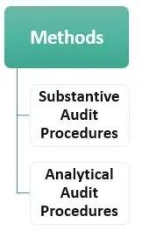
A forensic audit examines a company’s financial records to identify illegal finance activity.

Auditing methods

They can be divided into two types,

Substantive Audit Procedures
  - Substantive procedures are processes, steps, and tests performed by auditors, which create conclusive evidence regarding accuracy, completeness, existence, disclosure, rights, or valuation of assets/ liability, books of accounts, or financial statements

  - For any procedure to be concluded, the auditor should collect enough audit evidence so that another competent auditor makes the same conclusion when applying the same procedure to the same documents. It can be regarded as complete checking. Auditor usually uses this procedure when he believes the audit area includes a high frequency of risk.

Analytical Audit Procedures
  - Analytical procedures can be defined as tests/studies/ evaluations of financial information through analysis of plausible relationships among both financial and non-financial data.
  - In simple language, certain checks/tests are conducted by auditors based on study/ knowledge/ previous year figures to check and form an opinion on financial statements. Depending on the audit area, the analytical audit procedure may differ. For example, the auditor may compare two sets of financial statements of the same entity about two different financial years or sometimes may compare two separate entities’ financial data for obtaining audit evidence.

Benefits of auditing

- Promote best practices for controls.
- Ensure compliance with policies and regulations.
- Identify operational inefficiencies and waste.
- Review IT projects, systems, and technology.
- Assess efficient and responsible use of resources.
- Identify potential cost savings.
- Assist management in addressing complex, cross-functional issues.

Quality and Process improvement tools and techniques
- Pareto chart

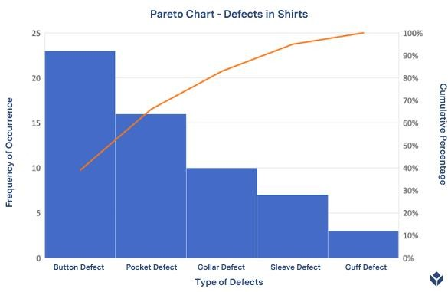
- A Pareto Chart is a combination of a bar graph and a line graph. Notice the presence of both bars and a line on the Pareto Chart below.
- Each bar usually represents a type of defect or problem. The height of the bar represents any important unit of measure - often the frequency of occurrence or cost.
- The bars are presented in descending order (from tallest to shortest). Therefore, you can see which defects are more frequent at a glance.
- The line represents the cumulative percentage of defects.

PDCA cycle

- The PDCA/PDSA (Plan-Do-Check-Act/Plan-Do-Study-Act) cycle is a continuous loop of planning, doing, checking (or studying), and acting. It provides a simple and effective approach for solving problems and managing change.
- The model is useful for testing improvement measures on a small scale before updating procedures and working practices.

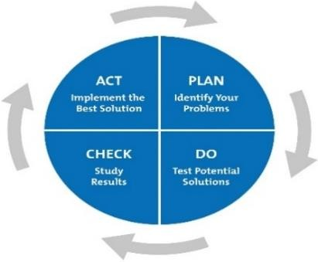
The Four Phases of the PDCA Cycle

- Plan - First, identify and understand your problem or opportunity. Perhaps the standard of a finished product isn't high enough, or an aspect of your marketing process should be getting better results.

- Do - Once you've identified a potential solution, test it safely with a small-scale pilot project. This will show whether your proposed changes achieve the desired outcome - with minimal disruption to the rest of your operation if they don't. As you run the pilot project, gather data to show whether the change has worked or not. You'll use this in the next stage.

- Check - Next, analyse your pilot project's results against the criteria that you defined in Step 1, to assess whether your idea was a success. If it wasn't, return to Step 1. If it was, advance to Step 4. You may decide to try out more changes, and repeat the Do and Check phases. But if your original plan definitely isn't working, you'll need to return to Step 1.

- Act - This is where you implement your solution. But remember that PDCA/PDSA is a loop, not a process with a beginning and end. Your improved process or product becomes the new baseline, but you continue to look for ways to make it even better.

Six sigma and Lean process

Lean and Six Sigma has common motive - Both wants to eliminate waste and increase productivity & efficiency of organizational operations but methodology to beat goal of both model is distinct (means they identify root cause of problem in different manner).

Six Sigma
  - It is the process of producing high and improved quality output. This can be done in two phases - identification and elimination. The cause of defects is identified and appropriate elimination is done which reduces variation in whole processes. A six sigma method is one in which 99.99966% of all the products to be produced have the same features and are of free from defects.
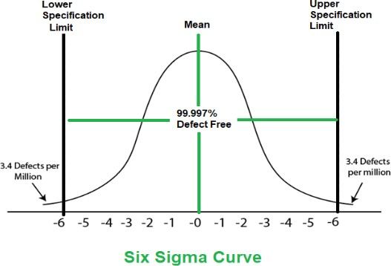

Lean Process
  - It is completely focused on eliminating waste by eliminating bottlenecks and improving quality of your products providing maximum profit value to customers with lowest possible amount of investment and risks. Prime motive of Lean model is Customer satisfaction.

