Breadth First Search in Python (with Code) | BFS Algorithm
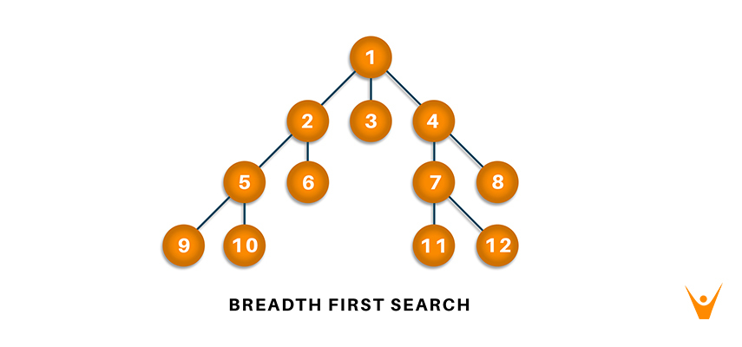
Breadth-first search and Depth-first search in python are algorithms used to traverse a graph or a tree.

What is Breadth-First Search?
Breadth-First Search (BFS) is an algorithm used for traversing graphs or trees. Traversing means visiting each node of the graph. Breadth-First Search is a recursive algorithm to search all the vertices of a graph or a tree. BFS in python can be implemented by using data structures like a dictionary and lists. Breadth-First Search in tree and graph is almost the same. The only difference is that the graph may contain cycles, so we may traverse to the same node again.
BFS Algorithm :As breadth-first search is the process of traversing each node of the graph, a standard BFS algorithm traverses each vertex of the graph into two parts: 1) Visited 2) Not Visited. So, the purpose of the algorithm is to visit all the vertex while avoiding cycles.
BFS starts from a node, then it checks all the nodes at distance one from the beginning node, then it checks all the nodes at distance two, and so on. So as to recollect the nodes to be visited, BFS uses a queue.
The steps of the algorithm work as follow:
- Start by putting any one of the graph’s vertices at the back of the queue.
- Now take the front item of the queue and add it to the visited list.
- Create a list of that vertex's adjacent nodes. Add those which are not within the visited list to the rear of the queue.
- Keep continuing steps two and three till the queue is empty.
Many times, a graph may contain two different disconnected parts and therefore to make sure that we have visited every vertex, we can also run the BFS algorithm at every node.

BFS pseudocode
The pseudocode for BFS in python goes as below:
create a queue Q
mark v as visited and put v into Q
while Q is non-empty
remove the head u of Q
mark and enqueue all (unvisited) neighbors of u
BFS implementation in Python (Source Code)
Now, we will see how the source code of the program for implementing breadth first search in python.
Consider the following graph which is implemented in the code below:
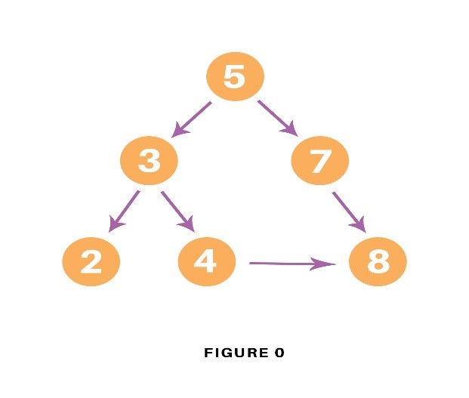
graph = {
'5' : ['3','7'],
'3' : ['2', '4'],
'7' : ['8'],
'2' : [],
'4' : ['8'],
'8' : []
}

visited = [] # List for visited nodes.
queue = [] #Initialize a queue

def bfs(visited, graph, node): #function for BFS
visited.append(node)
queue.append(node)

while queue: # Creating loop to visit each node
m = queue.pop(0)
print (m, end = " ")

for neighbour in graph[m]:
if neighbour not in visited:
visited.append(neighbour)
queue.append(neighbour)

# Driver Code
print("Following is the Breadth-First Search")
bfs(visited, graph, '5') # function calling
In the above code, first, we will create the graph for which we will use the breadth-first search. After creation, we will create two lists, one to store the visited node of the graph and another one for storing the nodes in the queue.
After the above process, we will declare a function with the parameters as visited nodes, the graph itself and the node respectively. And inside a function, we will keep appending the visited and queue lists.
Then we will run the while loop for the queue for visiting the nodes and then will remove the same node and print it as it is visited.
At last, we will run the for loop to check the not visited nodes and then append the same from the visited and queue list.
As the driver code, we will call the user to define the bfs function with the first node we wish to visit.

Output :The output of the above code will be as follow:
Following is the Breadth-First Search
5 3 7 2 4 8

Example:Let us see how this algorithm works with an example. Here, we will use an undirected graph with 5 vertices.
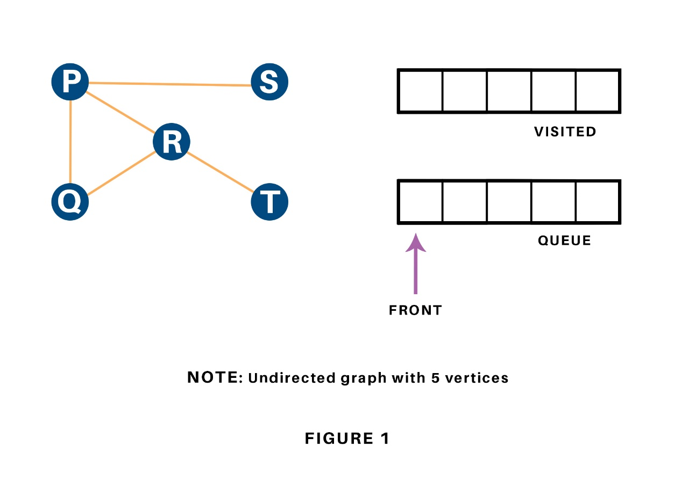
We begin from the vertex P, the BFS algorithmic program starts by putting it within the Visited list and puts all its adjacent vertices within the stack.
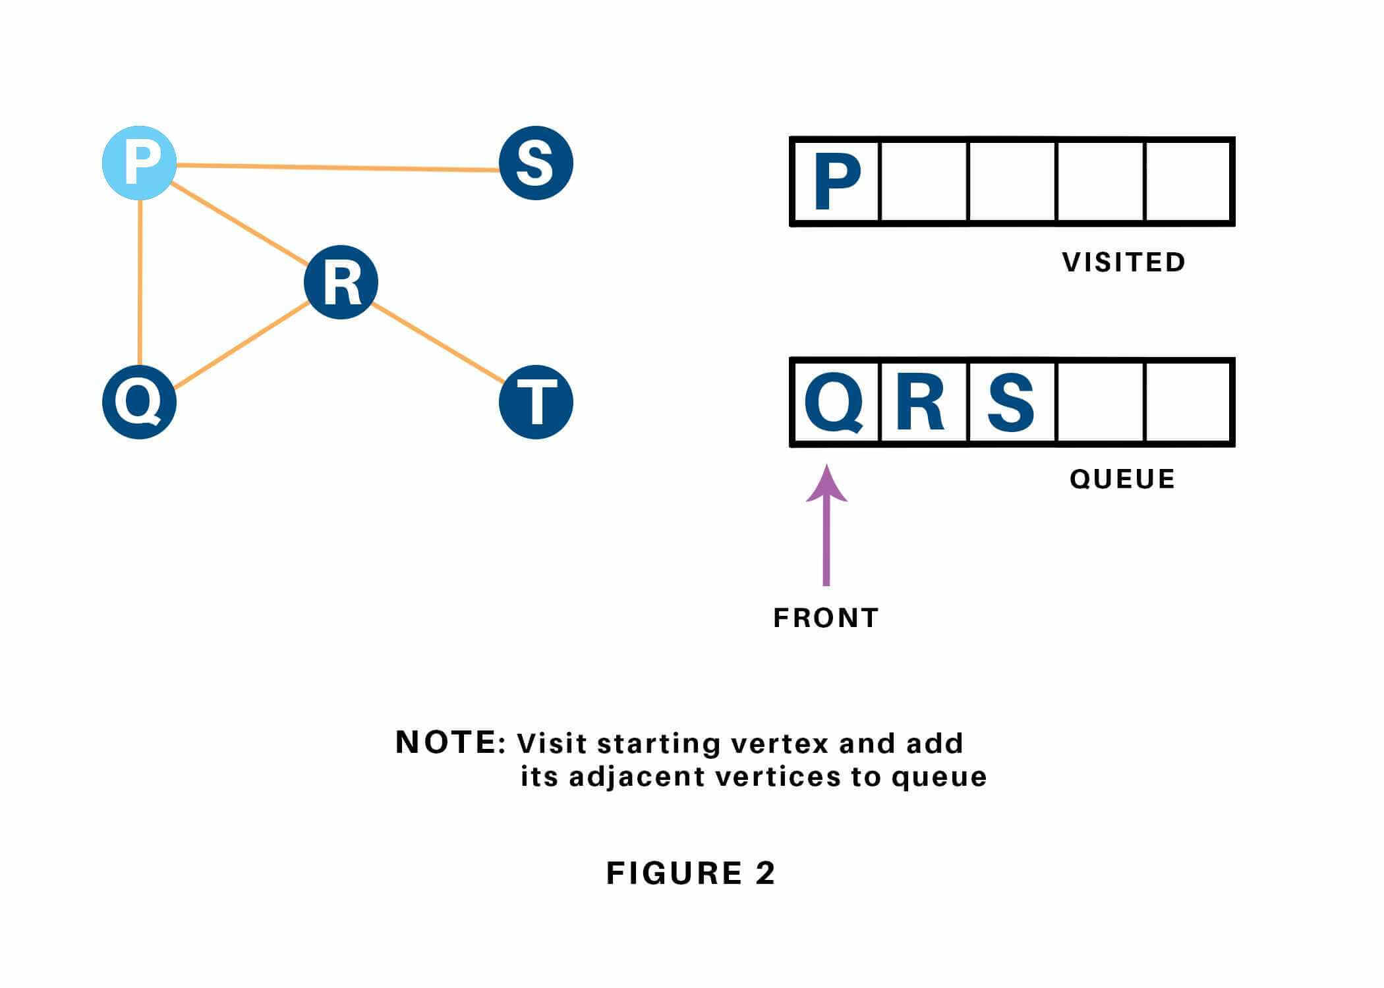
Next, we have a tendency to visit the part at the front of the queue i.e. Q and visit its adjacent nodes. Since P has already been visited, we have a tendency to visit R instead.
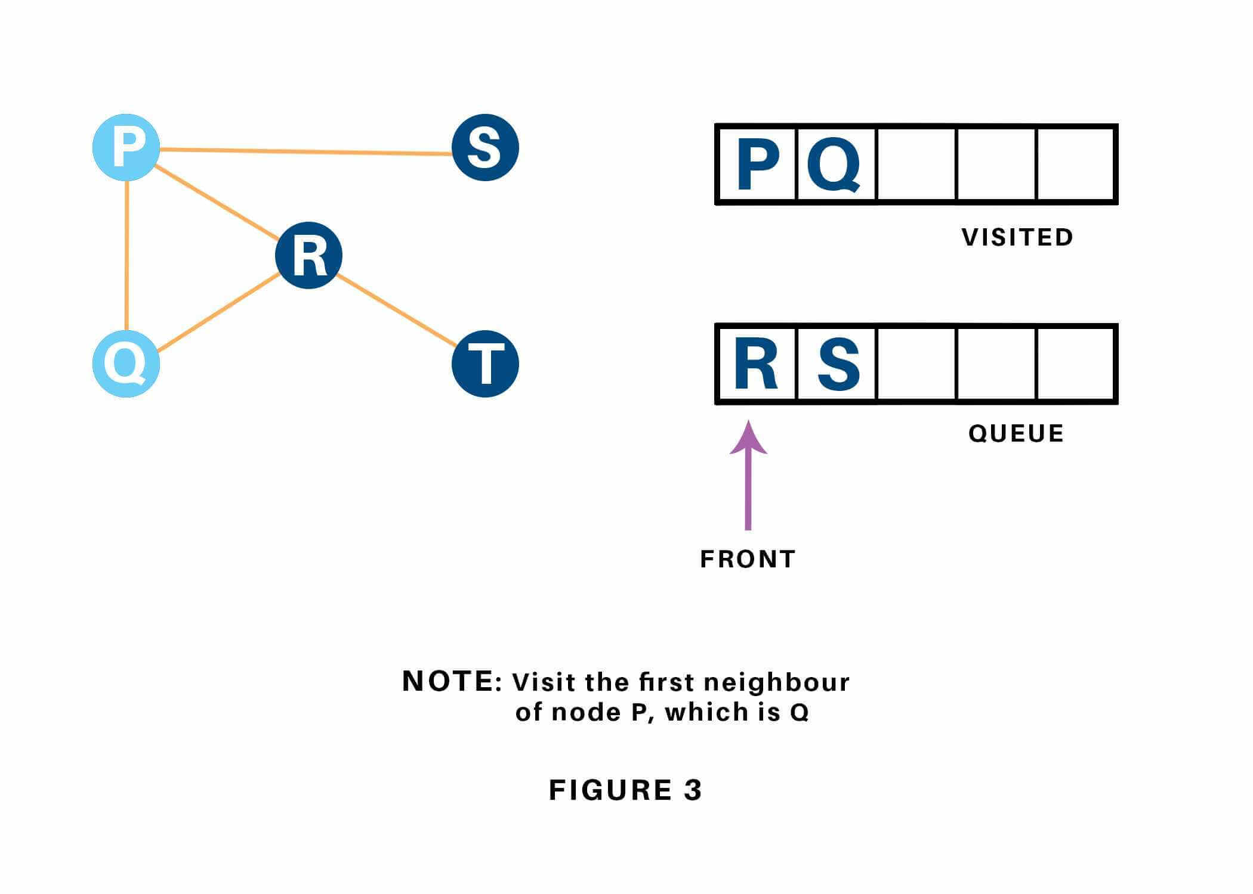
Vertex R has an unvisited adjacent vertex in T, thus we have a tendency to add that to the rear of the queue and visit S, which is at the front of the queue.
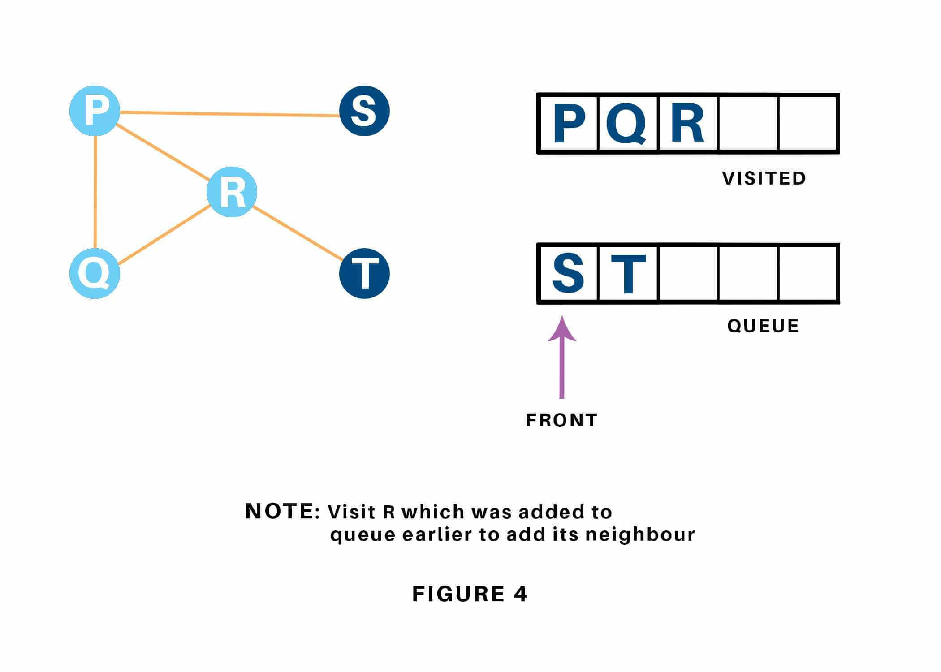
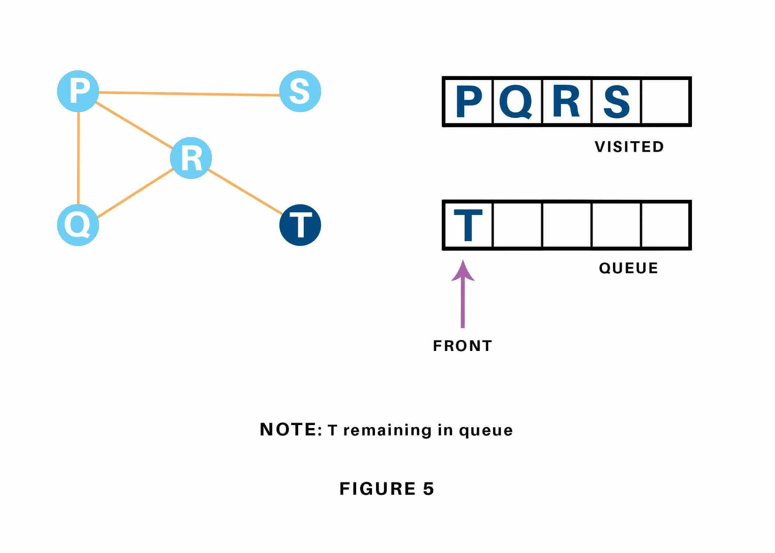

Now, only T remains within the queue since the only adjacent node of S i.e. P is already visited. We have a tendency to visit it.
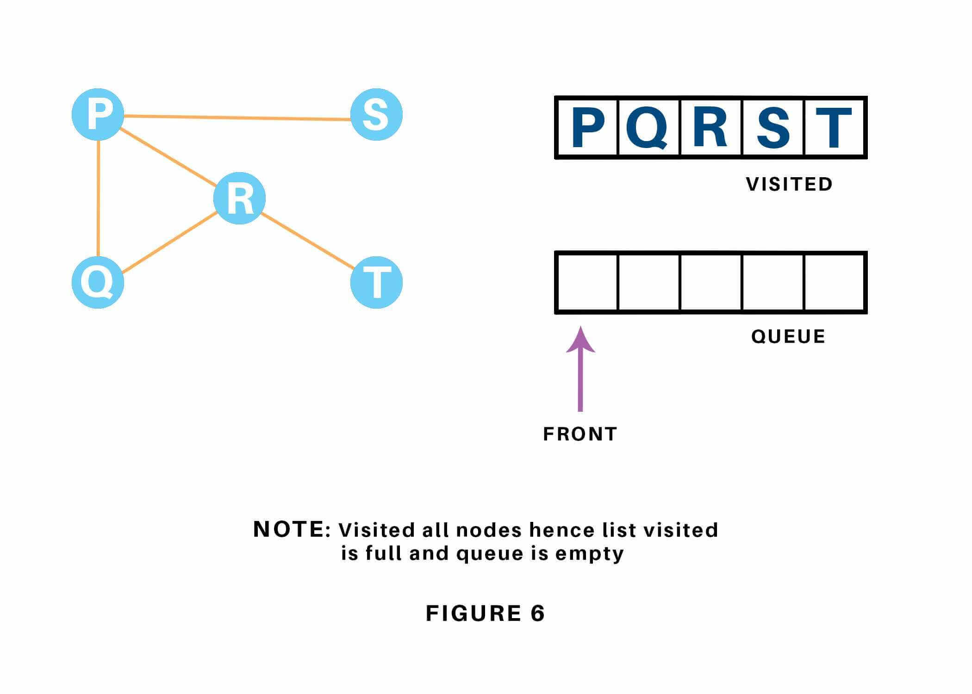
Since the queue is empty, we've completed the Traversal of the graph.

Applications
Breadth-first Search Algorithm has a wide range of applications in the real-world. Some of them are as discussed below:
- In GPS navigation, it helps in finding the shortest path available from one point to another.
- In pathfinding algorithms
- Cycle detection in an undirected graph
- In minimum spanning tree
- To build index by search index
- In Ford-Fulkerson algorithm to find maximum flow in a network.

How to implement a ​breadth-first search in Python
Breadth-first search (BFS) is an algorithm used for tree traversal on graphs or tree data structures. BFS can be easily implemented using recursion and data structures like dictionaries and lists.

The Algorithm
- Pick any node, visit the adjacent unvisited vertex, mark it as visited, display it, and insert it in a queue.
- If there are no remaining adjacent vertices left, remove the first vertex from the queue.
- Repeat step 1 and step 2 until the queue is empty or the desired node is found.

Implementation
Consider the​ graph, which ​is implemented in the code below:
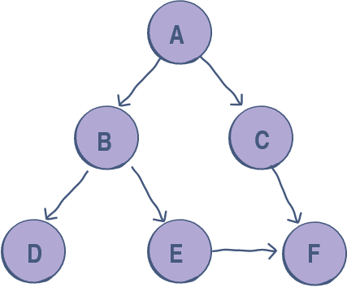

graph = {
'A' : ['B','C'],
'B' : ['D', 'E'],
'C' : ['F'],
'D' : [],
'E' : ['F'],
'F' : []
}

visited = [] # List to keep track of visited nodes.
queue = [] #Initialize a queue

def bfs(visited, graph, node):
visited.append(node)
queue.append(node)

while queue:
s = queue.pop(0)
print (s, end = " ")

for neighbour in graph[s]:
if neighbour not in visited:
visited.append(neighbour)
queue.append(neighbour)

# Driver Code
bfs(visited, graph, 'A')

Explanation
- Lines 3-10: The illustrated graph is represented using an adjacency list. An easy way to do this in Python is to use a dictionary data structure, where each vertex has a stored list of its adjacent nodes.
- Line 12: visited is a list that is used to keep track of visited nodes.
- Line 13: queue is a list that is used to keep track of nodes currently in the queue.
- Line 29: The arguments of the bfs function are the visited list, the graph in the form of a dictionary, and the starting node A.
- Lines 15-26: bfs follows the algorithm described above:
  - It checks and appends the starting node to the visited list and the queue.
  - Then, while the queue contains elements, it keeps taking out nodes from the queue, appends the neighbors of that node to the queue if they are unvisited, and marks them as visited.
  - This continues until the queue is empty.

How to implement depth-first search in Python

Depth First Search in Python (with Code) | DFS Algorithm
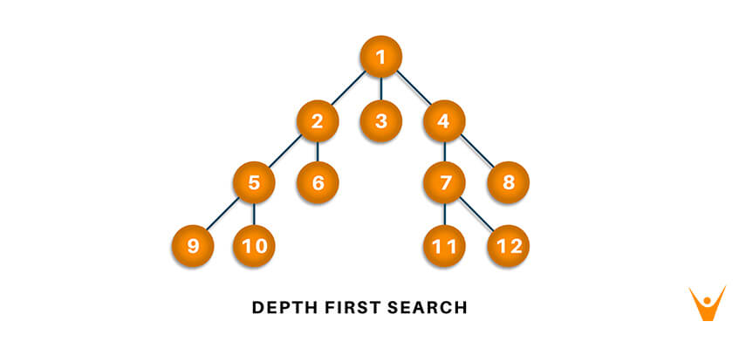
Traversal means that visiting all the nodes of a graph which can be done through Depth-first search or Breadth-first search in python. Depth-first traversal or Depth-first Search is an algorithm to look at all the vertices of a graph or tree data structure.

What is Depth First Search?
The Depth-First Search is a recursive algorithm that uses the concept of backtracking. It involves thorough searches of all the nodes by going ahead if potential, else by backtracking. Here, the word backtrack means once you are moving forward and there are not any more nodes along the present path, you progress backward on an equivalent path to seek out nodes to traverse. All the nodes are progressing to be visited on the current path until all the unvisited nodes are traversed after which subsequent paths are going to be selected.

DFS Algorithm: Before learning the python code for Depth-First and its output, let us go through the algorithm it follows for the same. The recursive method of the Depth-First Search algorithm is implemented using stack. A standard Depth-First Search implementation puts every vertex of the graph into one in all 2 categories: 1) Visited 2) Not Visited. The only purpose of this algorithm is to visit all the vertex of the graph avoiding cycles.
The DSF algorithm follows as:
- We will start by putting any one of the graph's vertex on top of the stack.
- After that take the top item of the stack and add it to the visited list of the vertex.
- Next, create a list of that adjacent node of the vertex. Add the ones which aren't in the visited list of vertexes to the top of the stack.
- Lastly, keep repeating steps 2 and 3 until the stack is empty.

DFS pseudocode : The pseudocode for Depth-First Search in python goes as below: In the init() function, notice that we run the DFS function on every node because many times, a graph may contain two different disconnected part and therefore to make sure that we have visited every vertex, we can also run the DFS algorithm at every node.
DFS(G, u)
u.visited = true
for each v ∈ G.Adj[u]
if v.visited == false
DFS(G,v)
init() {
For each u ∈ G
u.visited = false
For each u ∈ G
DFS(G, u)
}

DFS Implementation in Python (Source Code) : Now, knowing the algorithm to apply the Depth-First Search implementation in python, we will see how the source code of the program works.
Consider the following graph which is implemented in the code below:
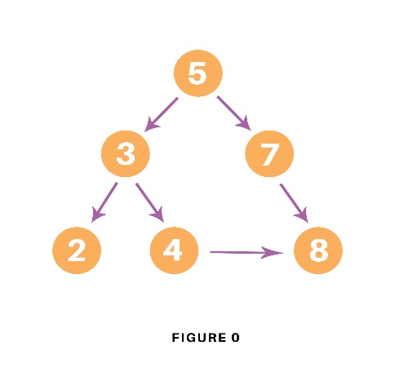

# Using a Python dictionary to act as an adjacency list
graph = {
'5' : ['3','7'],
'3' : ['2', '4'],
'7' : ['8'],
'2' : [],
'4' : ['8'],
'8' : []
}

visited = set() # Set to keep track of visited nodes of graph.

def dfs(visited, graph, node): #function for dfs
if node not in visited:
print (node)
visited.add(node)
for neighbour in graph[node]:
dfs(visited, graph, neighbour)

# Driver Code
print("Following is the Depth-First Search")
dfs(visited, graph, '5')
In the above code, first, we will create the graph for which we will use the depth-first search. After creation, we will create a set for storing the value of the visited nodes to keep track of the visited nodes of the graph.
After the above process, we will declare a function with the parameters as visited nodes, the graph itself and the node respectively. And inside the function, we will check whether any node of the graph is visited or not using the “if” condition. If not, then we will print the node and add it to the visited set of nodes.
Then we will go to the neighboring node of the graph and again call the DFS function to use the neighbor parameter.
At last, we will run the driver code which prints the final result of DFS by calling the DFS the first time with the starting vertex of the graph.

Output : The output of the above code is as follow:
Following is the Depth-First Search
5 3 2 4 8 7

Applications
Depth-First Search Algorithm has a wide range of applications for practical purposes. Some of them are as discussed below:
- For finding the strongly connected components of the graph
- For finding the path
- To test if the graph is bipartite
- For detecting cycles in a graph
- Topological Sorting
- Solving the puzzle with only one solution.
- Network Analysis
- Mapping Routes
- Scheduling a problem
Depth-first search (DFS), is an algorithm for tree traversal on graph or tree data structures. It can be implemented easily using recursion and data structures like dictionaries and sets.

The Algorithm
- Pick any node. If it is unvisited, mark it as visited and recur on all its adjacent nodes.
- Repeat until all the nodes are visited, or the node to be searched is found.

Implementation : Consider this graph, implemented in the code below:

# Using a Python dictionary to act as an adjacency list
graph = {
'A' : ['B','C'],
'B' : ['D', 'E'],
'C' : ['F'],
'D' : [],
'E' : ['F'],
'F' : []
}

visited = set() # Set to keep track of visited nodes.

def dfs(visited, graph, node):
if node not in visited:
print (node)
visited.add(node)
for neighbour in graph[node]:
dfs(visited, graph, neighbour)

# Driver Code
dfs(visited, graph, 'A')

Explanation
- Lines 2-9: The illustrated graph is represented using an adjacency list - an easy way to do it in Python is to use a dictionary data structure. Each vertex has a list of its adjacent nodes stored.
- Line 11: visited is a set that is used to keep track of visited nodes.
- Line 21: The dfs function is called and is passed the visited set, the graph in the form of a dictionary, and A, which is the starting node.
- Lines 13-18: dfs follows the algorithm described above:
  - It first checks if the current node is unvisited - if yes, it is appended in the visited set.
  - Then for each neighbor of the current node, the dfs function is invoked again.
  - The base case is invoked when all the nodes are visited. The function then returns.

Difference between BFS and DFS

BFS :Breadth First Search (BFS) algorithm traverses a graph in a breadthward motion and uses a queue to remember to get the next vertex to start a search when a dead end occurs in any iteration.
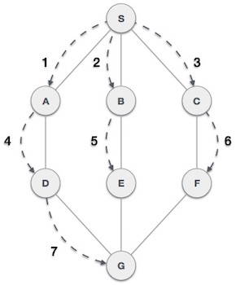

DFS : Depth First Search (DFS) algorithm traverses a graph in a depthward motion and uses a stack to remember to get the next vertex to start a search when a dead end occurs in any iteration.
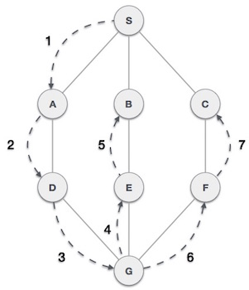
Following are the important differences between BFS and DFS.
Sr. No. | Key | BFS | DFS
1 | Definition | BFS, stands for Breadth First Search. | DFS, stands for Depth First Search.
2 | Data structure | BFS uses Queue to find the shortest path. | DFS uses Stack to find the shortest path.
3 | Source | BFS is better when target is closer to Source. | DFS is better when target is far from source.
4 | Suitablity for decision tree | As BFS considers all neighbour so it is not suitable for decision tree used in puzzle games. | DFS is more suitable for decision tree. As with one decision, we need to traverse further to augment the decision. If we reach the conclusion, we won.
5 | Speed | BFS is slower than DFS. | DFS is faster than BFS.
6 | Time Complexity | Time Complexity of BFS = O(V+E) where V is vertices and E is edges. | Time Complexity of DFS is also O(V+E) where V is vertices and E is edges.

