import pandas as pd

# Load the traffic data
df = pd.read_csv('/content/traffic.csv')

# Display the first 5 rows of the DataFrame
display(df.head())
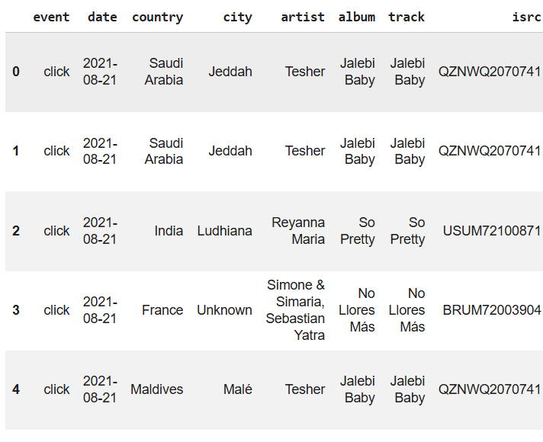
# Display information about the DataFrame to check data types and missing values
df.info()
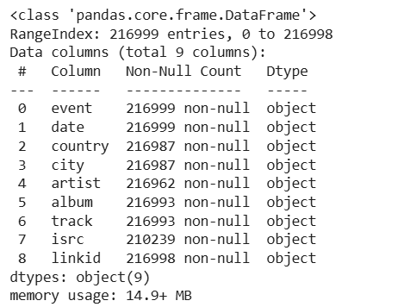
# Convert 'date' column to datetime objects, coercing errors to NaT
df['date'] = pd.to_datetime(df['date'], errors='coerce')

# Drop rows where 'date' is NaT
df.dropna(subset=['date'], inplace=True)

# Display the DataFrame info again to confirm the data type change and row count
df.info()
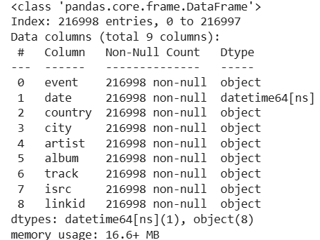
# Check for missing values
missing_values = df.isnull().sum()
print("Missing values before handling:\n", missing_values)

# Fill missing categorical values with 'Unknown'
for col in ['country', 'city', 'artist', 'album', 'track', 'isrc', 'linkid']:
if col in df.columns:
df[col] = df[col].fillna('Unknown')

# Verify that missing values have been handled
print("\nMissing values after handling:\n", df.isnull().sum())
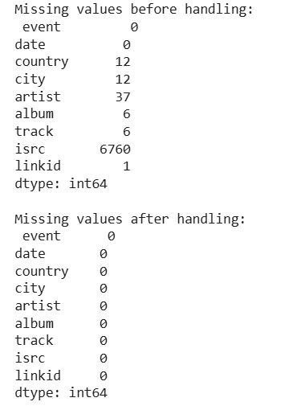
# Calculate total sessions and unique users
total_sessions = df['linkid'].nunique()
total_users = df['linkid'].nunique() # Assuming each linkid represents a unique user session

print(f"Total Sessions: {total_sessions}")
print(f"Total Users (based on unique linkid): {total_users}")

# Calculate bounce rate
# Group by linkid and count events per session
session_event_counts = df.groupby('linkid').size()

# Identify bounced sessions (sessions with only one event)
bounced_sessions_count = (session_event_counts == 1).sum()

# Calculate bounce rate
bounce_rate = (bounced_sessions_count / total_sessions) * 100

print(f"Bounced Sessions: {bounced_sessions_count}")
print(f"Bounce Rate: {bounce_rate:.2f}%")

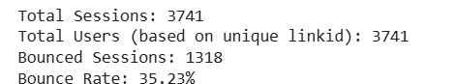
# Identify entry pages (first event in each session)
entry_pages = df.groupby('linkid').first()['track'].value_counts().head(10)

print("Top 10 Entry Pages:")
print(entry_pages)

# Identify exit pages (last event in each session)
exit_pages = df.groupby('linkid').last()['track'].value_counts().head(10)

print("\nTop 10 Exit Pages:")
print(exit_pages)

# Visualize top entry pages
import matplotlib.pyplot as plt
import seaborn as sns

plt.figure(figsize=(12, 6))
sns.barplot(x=entry_pages.index, y=entry_pages.values, palette='viridis')
plt.title('Top 10 Entry Pages')
plt.xlabel('Track (Entry Page)')
plt.ylabel('Number of Sessions')
plt.xticks(rotation=45, ha='right')
plt.tight_layout()
plt.show()

# Visualize top exit pages
plt.figure(figsize=(12, 6))
sns.barplot(x=exit_pages.index, y=exit_pages.values, palette='magma')
plt.title('Top 10 Exit Pages')
plt.xlabel('Track (Exit Page)')
plt.ylabel('Number of Sessions')
plt.xticks(rotation=45, ha='right')
plt.tight_layout()
plt.show()

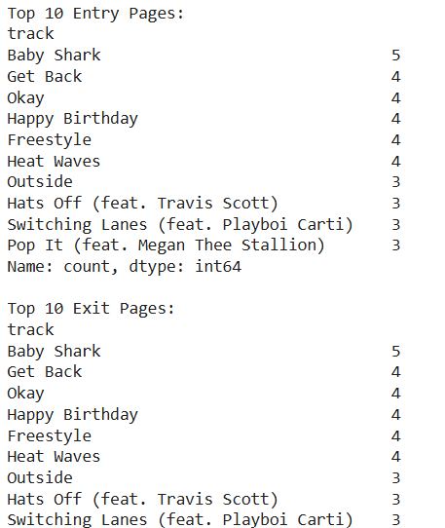
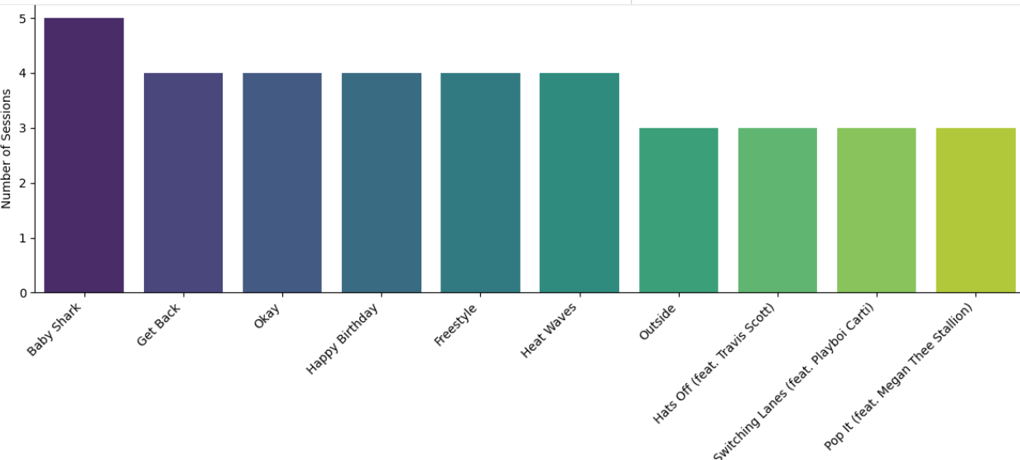
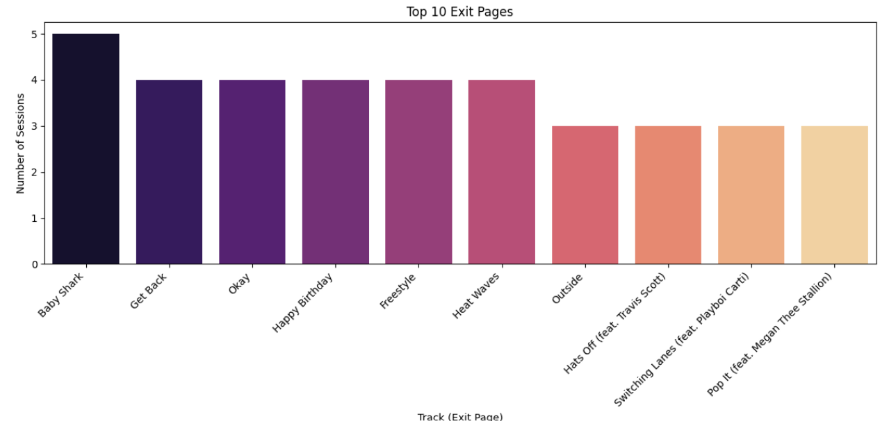
import matplotlib.pyplot as plt
import seaborn as sns

# Group by date and count events
daily_events = df.groupby('date')['event'].count().reset_index()
daily_events.columns = ['date', 'event_count']

# Plot the distribution of events over time
plt.figure(figsize=(14, 7))
sns.lineplot(x='date', y='event_count', data=daily_events)
plt.title('Daily Traffic Events Over Time')
plt.xlabel('Date')
plt.ylabel('Number of Events')
plt.grid(True, linestyle='--', alpha=0.7)
plt.xticks(rotation=45)
plt.tight_layout()
plt.show()
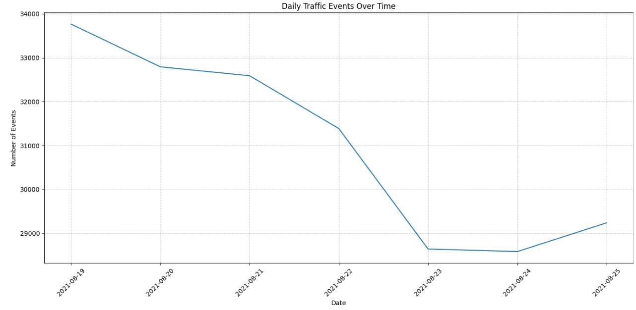
# Calculate the number of events per user (linkid)
events_per_user = df.groupby('linkid')['event'].count()

# Calculate the average number of events per user
average_events_per_user = events_per_user.mean()

print(f"Average number of events per user: {average_events_per_user:.2f}")
# Calculate the number of events per user (linkid) for each country
events_per_user_per_country = df.groupby(['country', 'linkid'])['event'].count()

# Calculate the average number of events per user for each country
average_events_by_country = events_per_user_per_country.groupby('country').mean().sort_values(ascending=False)

print("Average number of events per user by country:")
print(average_events_by_country)
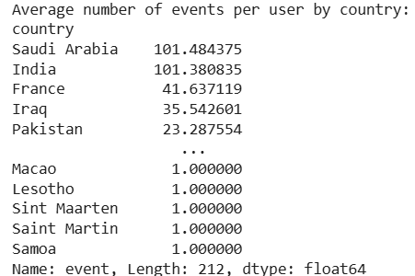
import matplotlib.pyplot as plt
import seaborn as sns

# Get the top 10 countries by average events per user
top_10_countries = average_events_by_country.head(10)

# Create the bar chart
plt.figure(figsize=(12, 7))
sns.barplot(x=top_10_countries.index, y=top_10_countries.values, palette='viridis')
plt.title('Top 10 Countries by Average Events per User')
plt.xlabel('Country')
plt.ylabel('Average Number of Events per User')
plt.xticks(rotation=45, ha='right')
plt.grid(axis='y', linestyle='--', alpha=0.7)
plt.tight_layout()
plt.show()
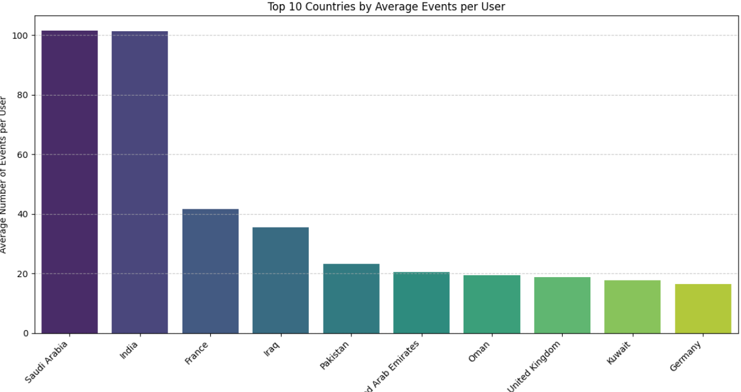
import matplotlib.pyplot as plt
import seaborn as sns

# Get the top 5 countries based on average events per user
top_5_countries = average_events_by_country.head(5).index.tolist()

# Filter the DataFrame for these top 5 countries
df_top5_countries = df[df['country'].isin(top_5_countries)]

# Group by country and event type, then count occurrences
event_type_distribution = df_top5_countries.groupby(['country', 'event']).size().unstack(fill_value=0)

# Plotting the grouped bar chart
ax = event_type_distribution.plot(kind='bar', figsize=(14, 7), width=0.8)
plt.title('Event Type Distribution Across Top 5 Countries')
plt.xlabel('Country')
plt.ylabel('Number of Events')
plt.xticks(rotation=45, ha='right')
plt.legend(title='Event Type')
plt.grid(axis='y', linestyle='--', alpha=0.7)
plt.tight_layout()
plt.show()

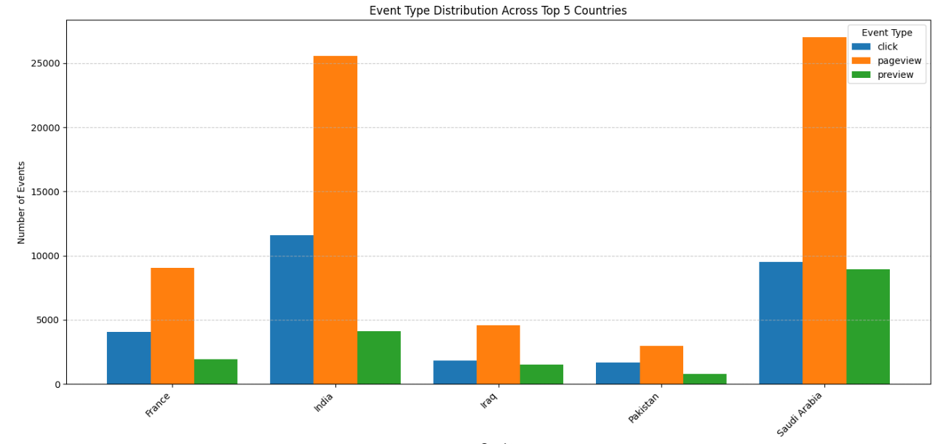
# Group by country and artist, then count events for each artist
artist_counts_per_country = df_top5_countries.groupby(['country', 'artist']).size().reset_index(name='event_count')

# Find the most frequent artist for each country
most_frequent_artist = artist_counts_per_country.loc[artist_counts_per_country.groupby('country')['event_count'].idxmax()]

print("Most Frequent Artist in Top 5 Countries:")
print(most_frequent_artist)
