

Data Structures and Algorithms (23CSE203)
LAB MANUAL
Submitted By:
Name | Rachury Krishna Vedatman
Roll No | AV.SC.U4CSE25145
Year/Sem/Section | 2nd YEAR/SEM-3/CSE-B
Date of Submission
Submitted To:
Name | Dr. Raj Kumar Batchu
Department | CSE
Designation | Assistant Professor(Sl. Gr) , School of Computing

MARKS

Week | TITLE | PAGE NO | REMARKS
Week_1 | 1(A) Aim:  A rocket launch system displays countdown before launch . Using recursion write python program to display countdown to 1 followed by launch.  1(B) Aim:  Write a python program to calculate compound interest by taking user input.  1(C) Aim:  HR Department stores Employee Id’s in a list develop a recursive program in python to search for a given employee Id in the list.  1(D) Aim:  Develop a python program to print 1st n terms of Fibonacci series.  1(E) Aim:  Develop a python program to calculate factorial of a given number. | 6 - 13
Week_2 | 2(A) Aim:  Write a python program to implement linear search.  2(B)(i) Aim: Write a python program to implement binary search with sorted array as input.  (ii) Aim: Write a python program to implement binary search with unsorted array as input. | 14 - 30
Week_3 | 3(A) Aim:  Write a python program to apply insertion sort where input elements are taken from the user .  3(B) Aim:  Write a python program to apply bubble sort where input elements are taken from the user .  3(C) Aim:  Write a python program to apply selection sort where input elements are taken from the user . | 31 - 44
4. | 4(A) Aim:  To understand the concept of forms and design a structured student registration form using HTML tables, including various input types such as text fields, radio buttons, checkboxes, file upload, and dropdown lists.  4(B) Aim:  To understand the concept of forms and design user login and registration webpages using HTML, and to display them within a single interface using iframe for better layout and user interaction. | 45 - 52
5. | 5(A) Aim:  To create a responsive card layout using HTML and CSS with three cards, each containing an image, title, and button.  5(B) Aim:  To design a mini website using iframe with navigation links (Home, About, Contact), where clicking on each link displays the respective content within the same page using internal or external CSS.  5(C) Aim:  To design an Amrita login page using HTML and CSS that displays different campuses, where clicking on each campus shows its details on the same page. | 53 – 68
6. | 6(A) Aim: Design a responsive e-commerce application using the grid layout. This application should contain different categories of products such as electronics, clothing, home-appliances, books. Based on the category we select corresponding products should be displayed on the sidebar. | 69 - 77
7. | 7(A) Aim: To Upload files to the GITHUB Platform. | 78
8. | 8(A) Aim: Create a webpage that displays a square that continuously rotates 360⁰ using CSS animations.  8(B) Aim: Create a webpage that displays a ball moving up and down continuously using CSS Animations.  8(C) Aim: Create a webpage that displays a circle moving horizontally and rotating at the same time. | 79 - 90
9. | 9(A)Aim: Create a button for each program, based on the button clicked the corresponding program has to be executed and should display the output. The logics for each button includes finding an even numbers, odd number, prime or not, factorial of a number, amstrong or not. Use appropriate designs to display the output. | 91 - 101
10. | 10(A)Aim: Use JavaScript to find sign of product of 3 numbers (Using functions and conditional statements).Display an alert with specified sign(+,-).  10(B)Aim: Sort 3 numbers using functions and display an alert box to show the result.  10(C)Aim: Find the largest of 5 numbers using functions and onclick and display the result using an alert box.  10(D)Aim: Use for loop in JavaScript to iterate from 0-15 to check and print if the given number is even/odd.  10(E)Aim: Write a JavaScript program to read marks of 6 subjects from students then compute average marks of the student and then finally determine their corresponding grade. | 102 - 121
11. | 11(A)Aim: A website requires users to enter a username. The system should display a message while typing if the username is less than 5 characters.  11(B)Aim: A registration form should validate email format before submission. If invalid, the form should not be submitted.  11(C)Aim: A system should check password strength while typing and display whether it is weak or strong.  11(D)Aim : A form should validate a mobile number when the user leaves the input field. The number must be exactly 10 digits.  11(E)Aim : Design an HTML page, such that the registration form must validate:  Name (not empty)  Email (valid format)  Password (minimum 6 characters) | 122 - 159
12. | 12(A)Aim : Set up electron in VS Code | 160 - 164

LAB-1:
1.)Basic Programs Using Recursions :
A.) Aim: A rocket launch system displays countdown before launch . Using recursion write python program to display countdown to 1 followed by launch.
Program:
def rocket_countdown(n):
if n == 0:
print("LAUNCHED! 🚀")
return

print(n)

rocket_countdown(n - 1)

start_num = int(input("Enter starting countdown number: "))

print("\n--- Starting Countdown ---")
rocket_countdown(start_num)

Output(+Ve Case):
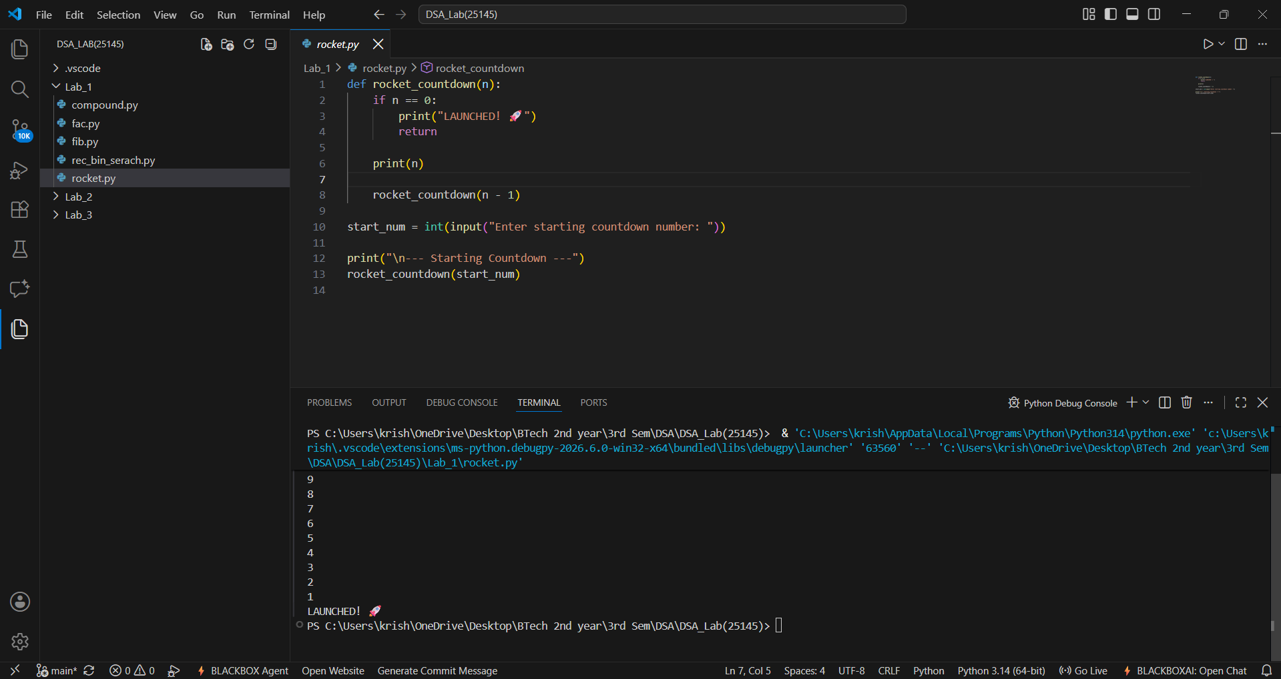
Output(-Ve Case):
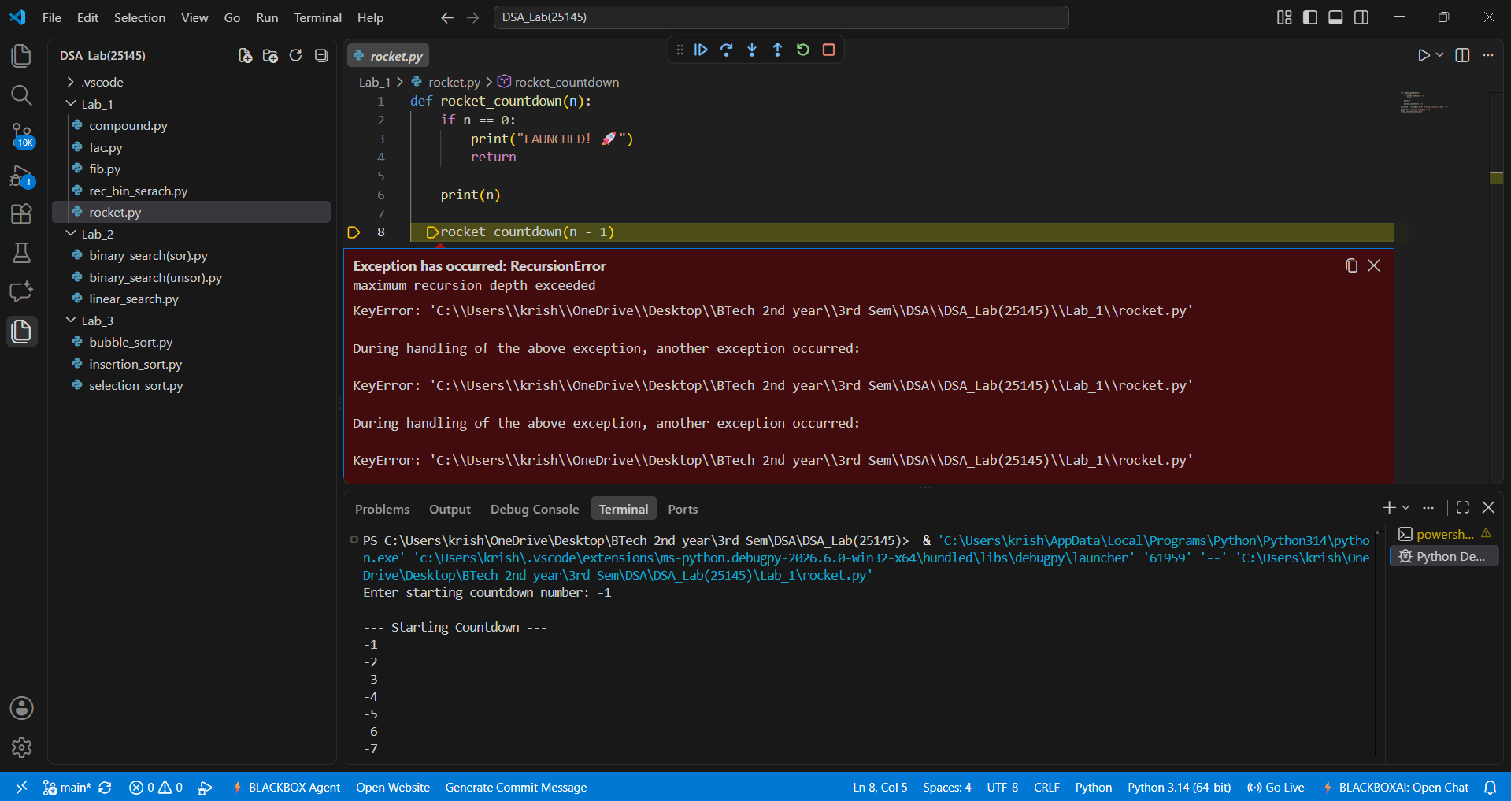
Explanation : This negative scenario has occurred due to infinite recursion . Countdown should never start from -ve integers as decrement will lead to negative infinity and the program crashes.

Error Table:
Line No. | Code with Error | Correct Code
1 | def C_Int(p,n,r,t) | def C_Int(p,n,r,t):
5 | total_amount = p*(1+decimal_rate/n)**(n*t | total_amount = p*(1+decimal_rate/n)**(n*t)
9 | return total_amount interest_earned | return total_amount, interest_earned

B.) Aim: Write a python program to calculate compound interest by taking user input.
Program:
def C_Int(p,n,r,t):
decimal_rate = r/100
total_amount = p*(1+decimal_rate/n)**(n*t)
interest_earned = total_amount - p
return total_amount, interest_earned

p = int(input("Enter the principal amount (₹) : "))
n = int(input("Times compounded per year : "))
r = float(input("Enter the annual interest rate (%) : "))
t = float(input("Enter the number of years : "))

final_balance, pure_interest = C_Int(p, n, r, t)

print("\n--- Financial Breakdown ---")
print(f"Interest Earned: ₹{pure_interest:.2f}")
print(f"Total Balance: ₹{final_balance:.2f}")
Output(+Ve Case):
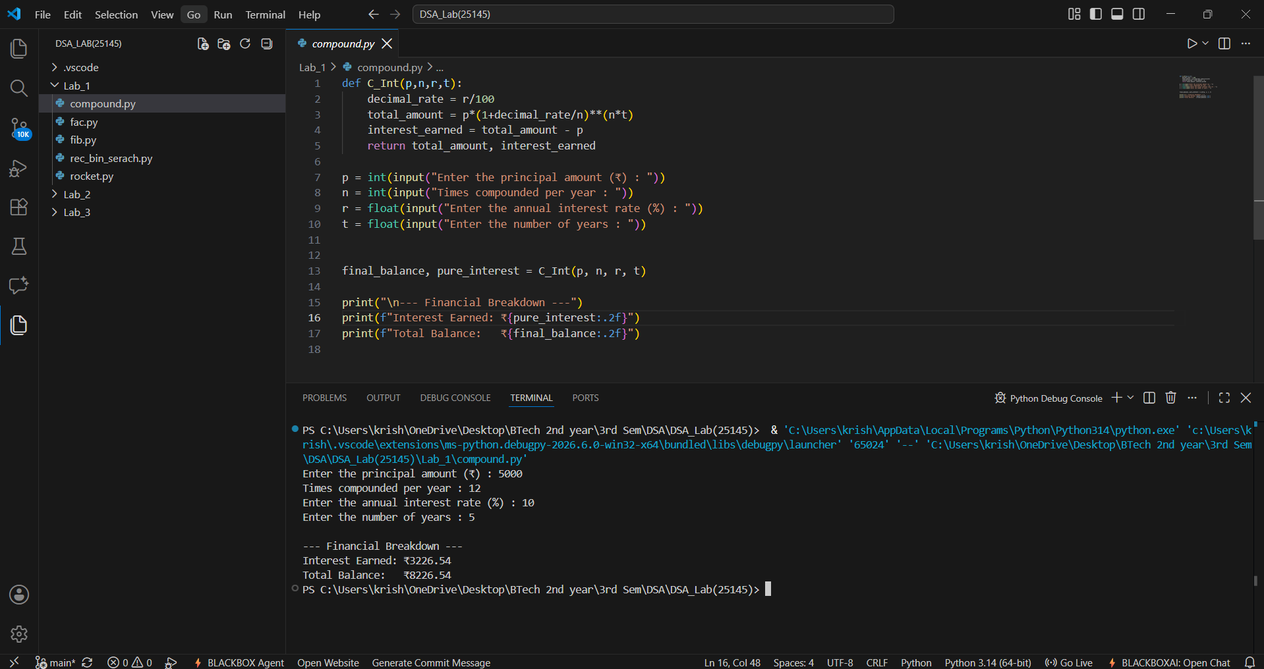
Output(-Ve Case):
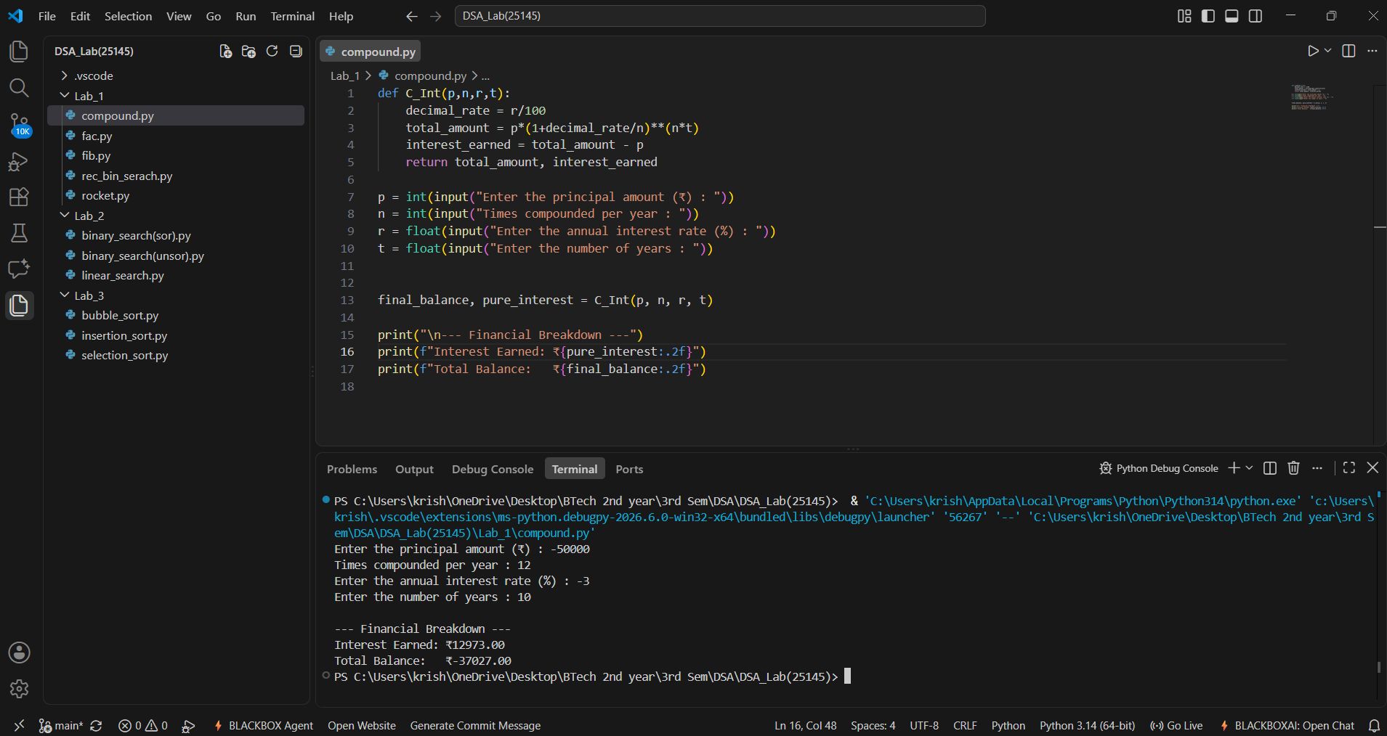
Explanation : Financial values such as Principal Amount, Rate of interest , Number of years should never be allowed to be negative this program projects a just output if and only if all of the input values are +ve.

Error Table:
Line No. | Code with Error | Correct Code
1 | def fac (n) | def fac (n):
5 | return None | return None
9 | return n*fac(n-1) | return n * fac(n-1)

C.) Aim: HR Department stores Employee Id’s in a list develop a recursive program in python to search for a given employee Id in the list.
Program:
def rec_bin_search(arr,key,low,high):
if low > high :
return -1
mid = (low+high)//2

if arr[mid] == key:
return mid
elif key < arr[mid]:
return rec_bin_search(arr,key,low,mid-1)
else:
return rec_bin_search(arr,key,mid+1,high)

Emp_Ids = [1002, 1005, 1012, 1025, 1040, 1077, 1100]
search_id = int(input("Enter Employee ID to search: "))

result_index = rec_bin_search(Emp_Ids,search_id,0,(len(Emp_Ids)-1))
if result_index != -1:
print(f"Employee ID {search_id} found at index {result_index}.")
else:
print(f"Employee ID {search_id} not found in the HR system.")
Output(+Ve Case):
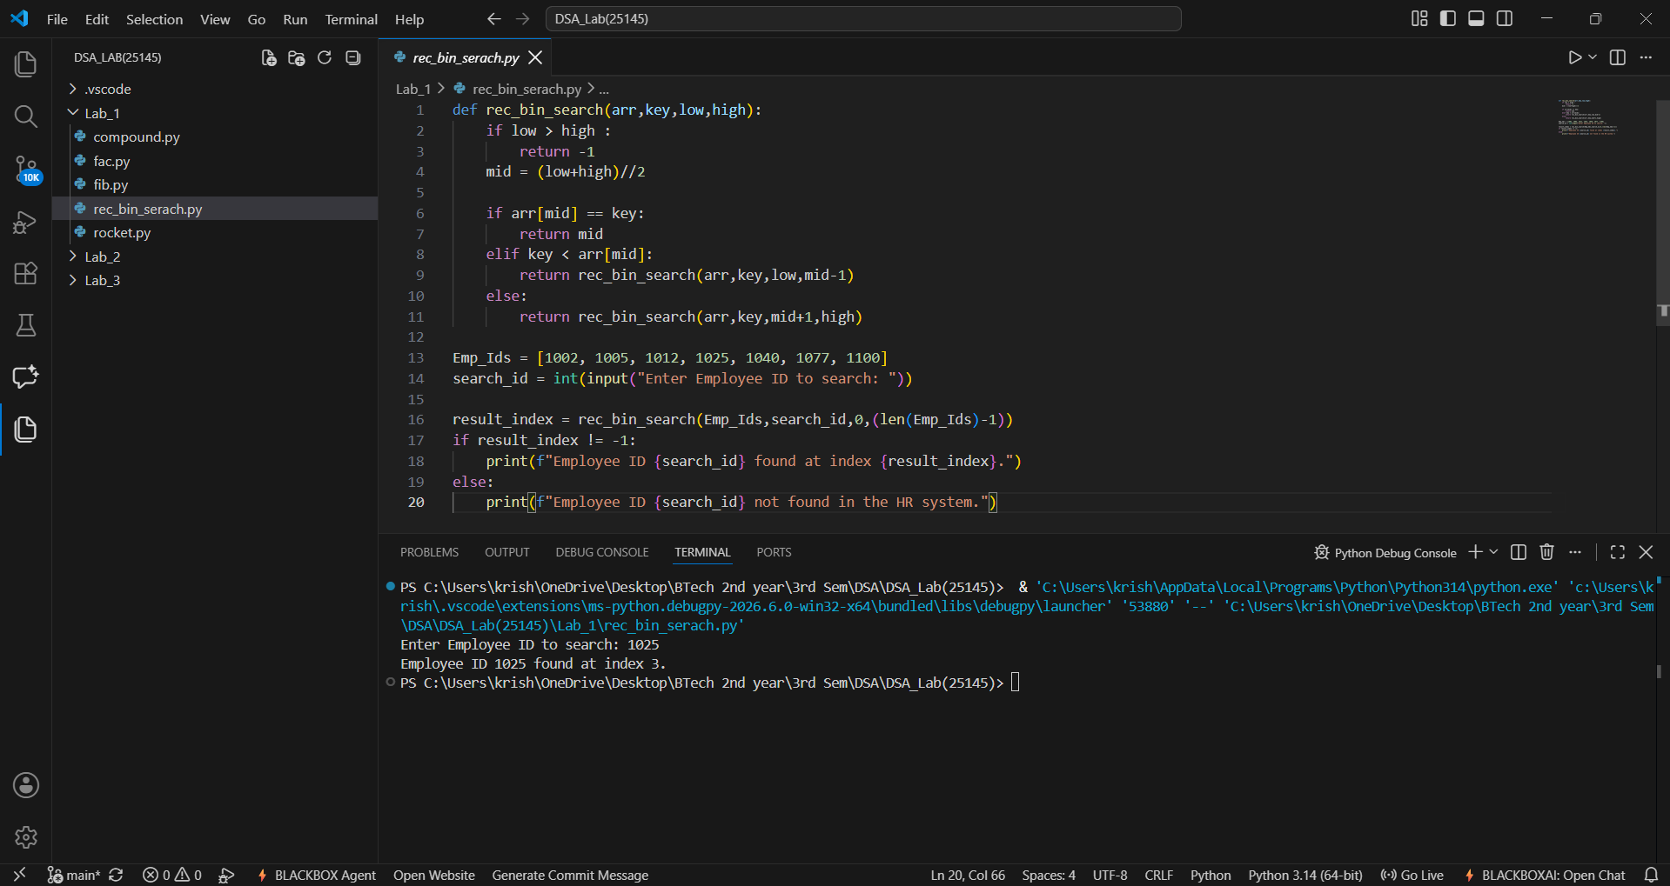
Output(-Ve Case):
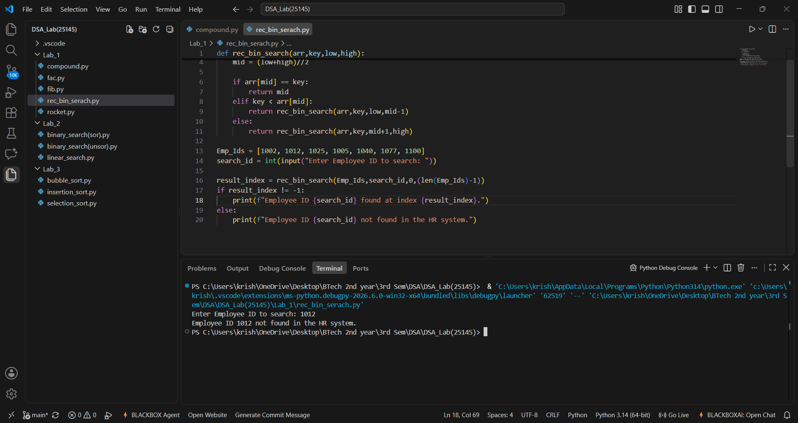
Explanation : Binary Search only works when the given array is in sorted order. Although the element 1012 Exists in the lists the program has returned that it doesn’t which is an error.
Error Table:
Line No. | Code with Error | Correct Code
7 | return fib(n-1)-fib(n-2) | return fib(n-1)+fib(n-2)
10 | n = float(input("Enter the number : ")) | n = int(input("Enter the number : "))
12 | for i in range (n): | for i in range (n+1):

D.) Aim: Develop a python program to print 1st n terms of Fibonacci series.
Program:
def fib(n):
if(n < 0):
print("Please enter a +ve number")
return None
if (n == 0 or n == 1):
return n
else:
return fib(n-1)+fib(n-2)

n = int(input("Enter the number : "))
for i in range (n+1):
print(f"{fib(i)}",end = " ")

Output(+Ve Case):
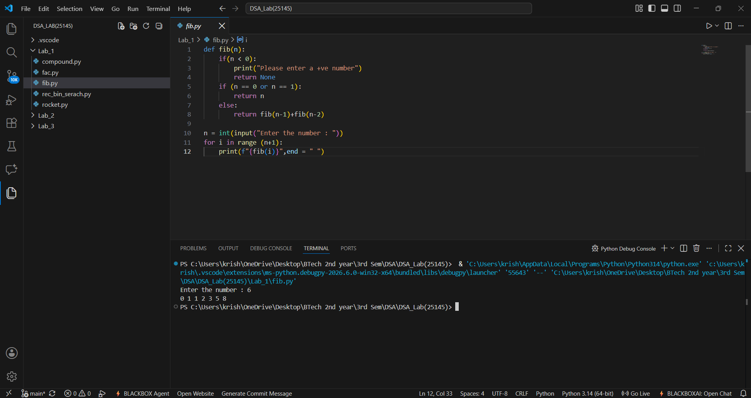
Output(-Ve Case):
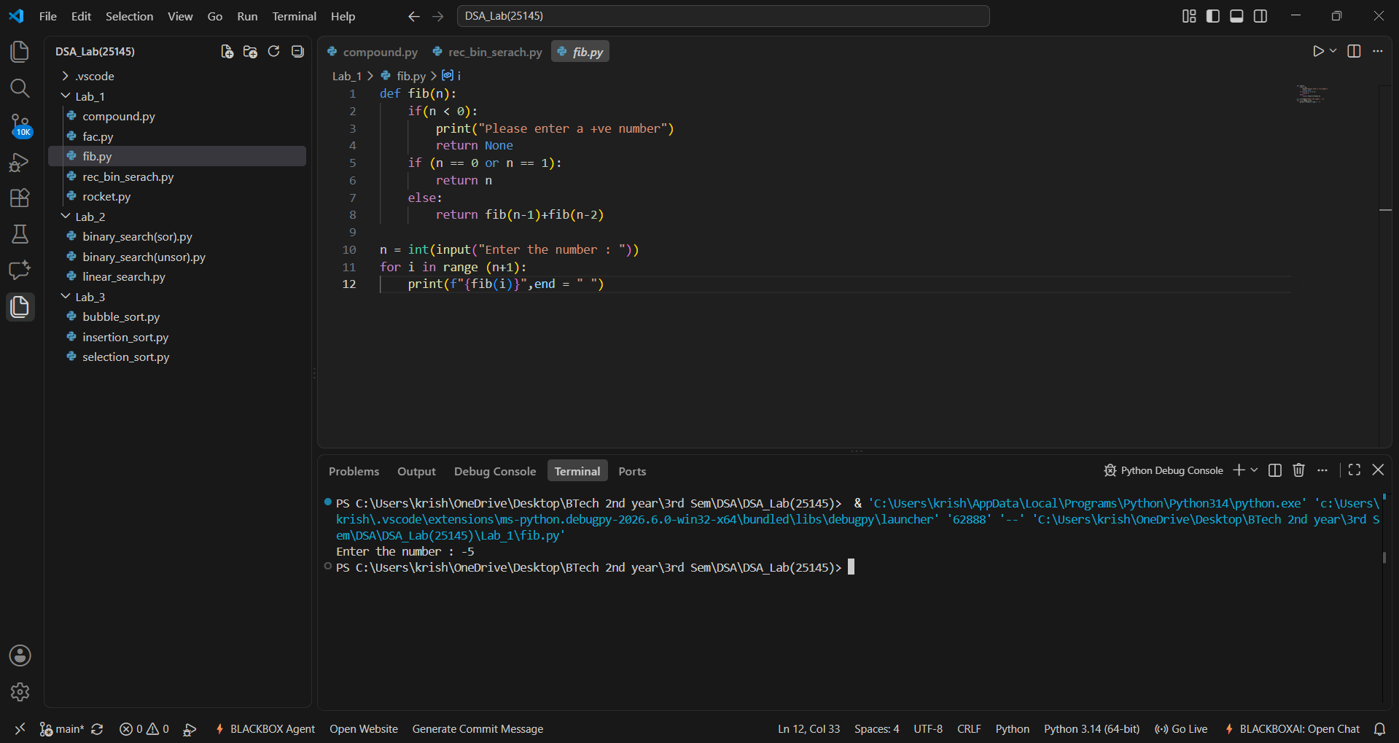
Explanation : a standard Fibonacci function should not accept negative numbers because negative inputs break the standard forward-sum logic and cause infinite loops.

Error Table:
Line No. | Code with Error | Correct Code
1 | def rec_bin_search(arr,key,low,high) | def rec_bin_search(arr,key,low,high):
7 | elif key > arr[mid]: | elif key < arr[mid]:
17 | if result_index = -1: | if result_index != -1:

E.) Aim: Develop a python program to calculate factorial of a given number.
Program:
def fac (n):
if n < 0 :
print("Please aenter a +ve number")
return None
if n == 0 or n == 1:
return 1
else:
return n*fac(n-1)

n = int(input("Enter a number : "))
print(f"The Factorial of {n} is {fac(n)}")

Output(+Ve Case):
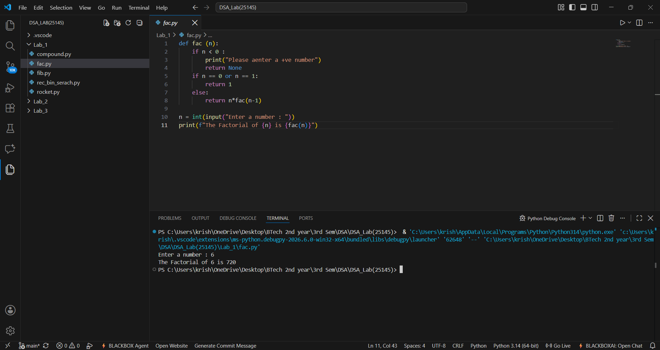
Output(-Ve Case):
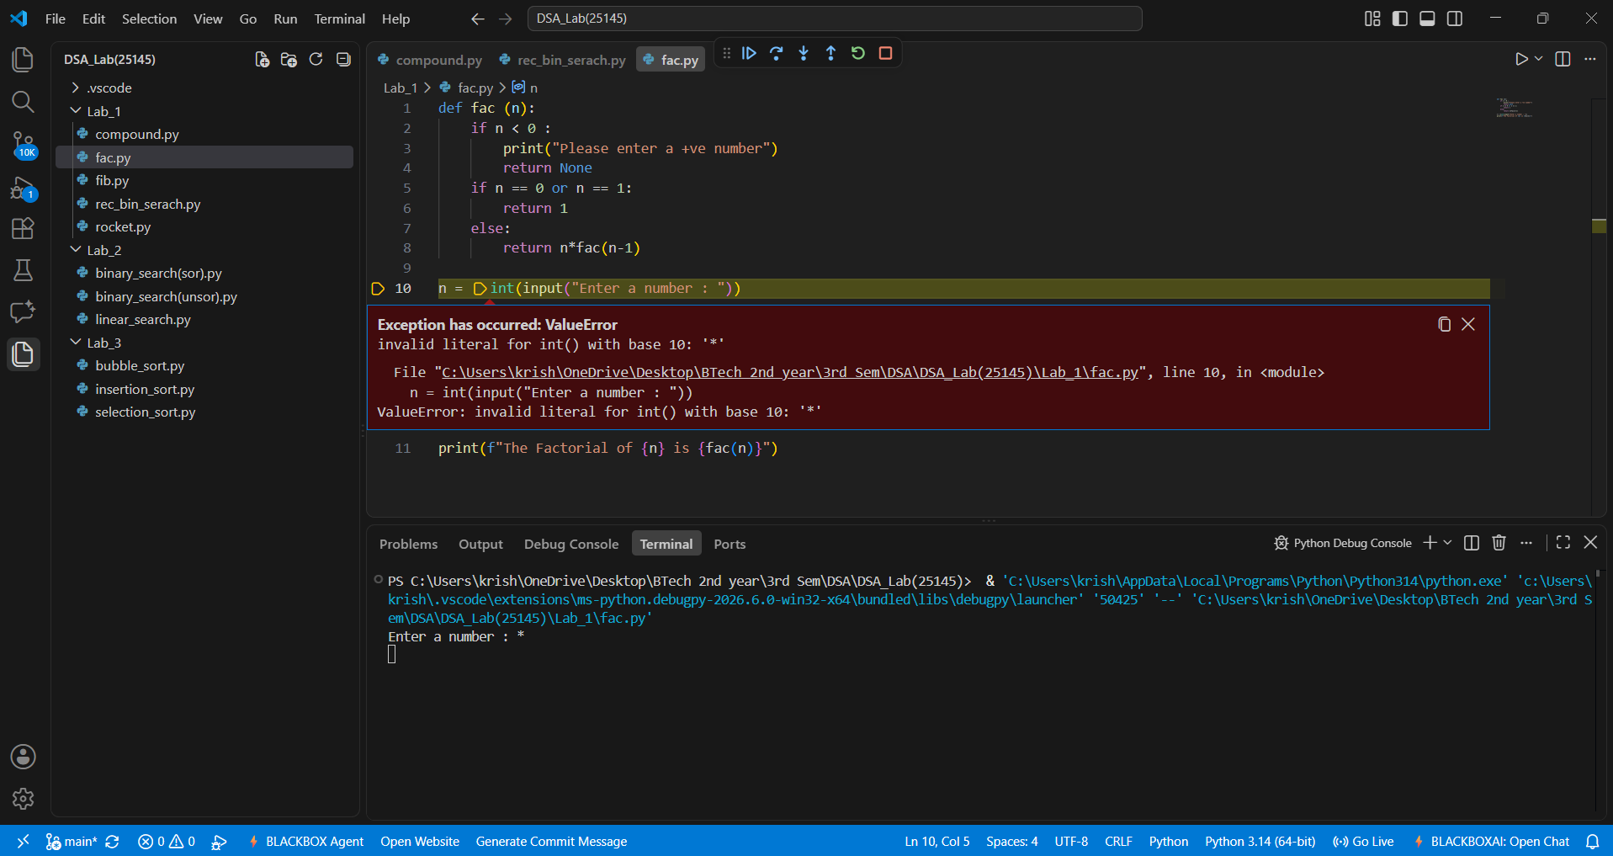
Explanation : The given Fibonacci sequence generator accepts only integer values giving values other than the integer data type such as float or special characters results in this type of Value Error.
Error Table:
Line No. | Code with Error | Correct Code
2 | if n != 0: | if n == 0:
7 | rocket_countdown(n + 1) | rocket_countdown(n - 1)
14 | rocket_countdown(start_num - 1) | rocket_countdown(start_num)

LAB-2:
1.)Applying Searching Algorithms :
A.) Aim: Write a python program to implement linear search.
Program:
def lin_search(arr, key):
for i in range(len(arr)):
if arr[i] == key:
print(f"{key} at index {i}")
return
print(f"{key} not found")

n = int(input("Enter the number of elements: "))

arr = []

print("Enter elements:")
for i in range(n):
arr.append(int(input()))

key = int(input("Enter the key: "))

result = lin_search(arr, key)

Output(+Ve Case):
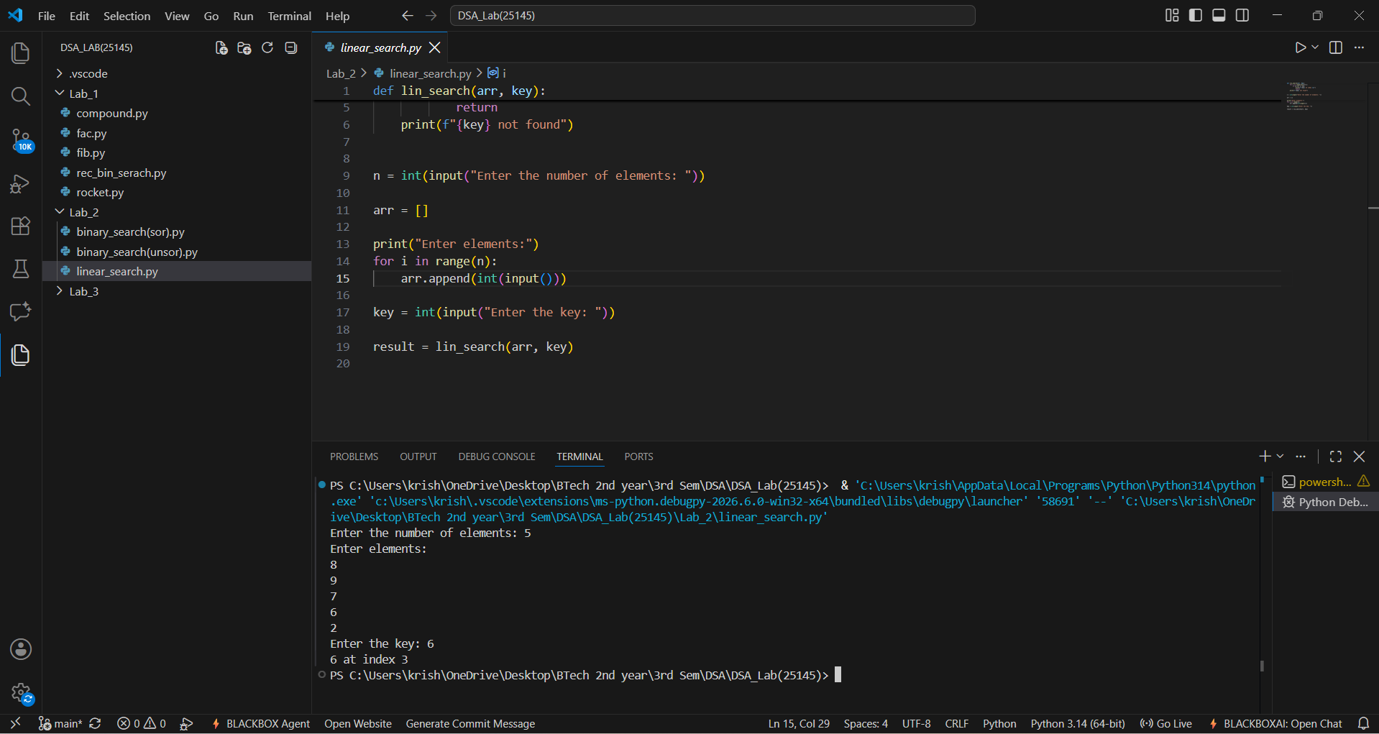
Output(-Ve Case):
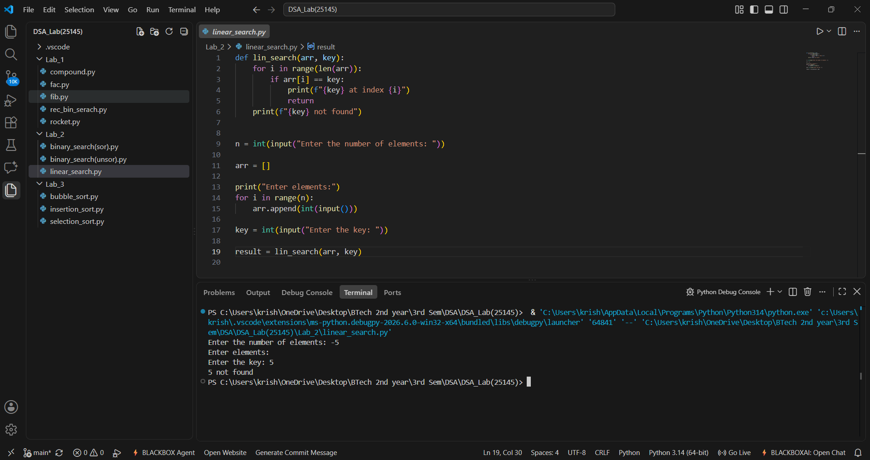
Explanation : The number of input elements should never be negative . In this case since input elements are -5 the program doesn’t allow me to enter any input elements nor is able to check the key given by the user.

Error Table:
Line No. | Code with Error | Correct Code
5 | if arr[i] != key: | if arr[i] == key:
8 | print(f"{key} found") | print(f"{key} not found")
21 | result = lin_search(arr) | result = lin_search(arr, key)

B.)(i) Aim: Write a python program to implement binary search with sorted array as input.
Program:
def bin_search(arr,key):
low = 0
high = len(arr) - 1
while low <= high:
mid = (high+low)//2
if arr[mid] == key:
return mid
elif arr[mid] < key:
low = mid+1
else:
high = mid-1
return -1

n = int(input("Enter the number of elements: "))

arr = []

print("Enter elements:")
for i in range(n):
arr.append(int(input()))

key = int(input("Enter the key: "))

result = bin_search(arr, key)
if result!=-1:
print(f"Element found at index {result}")
else:
print("Element not found")
Output(+Ve Case):
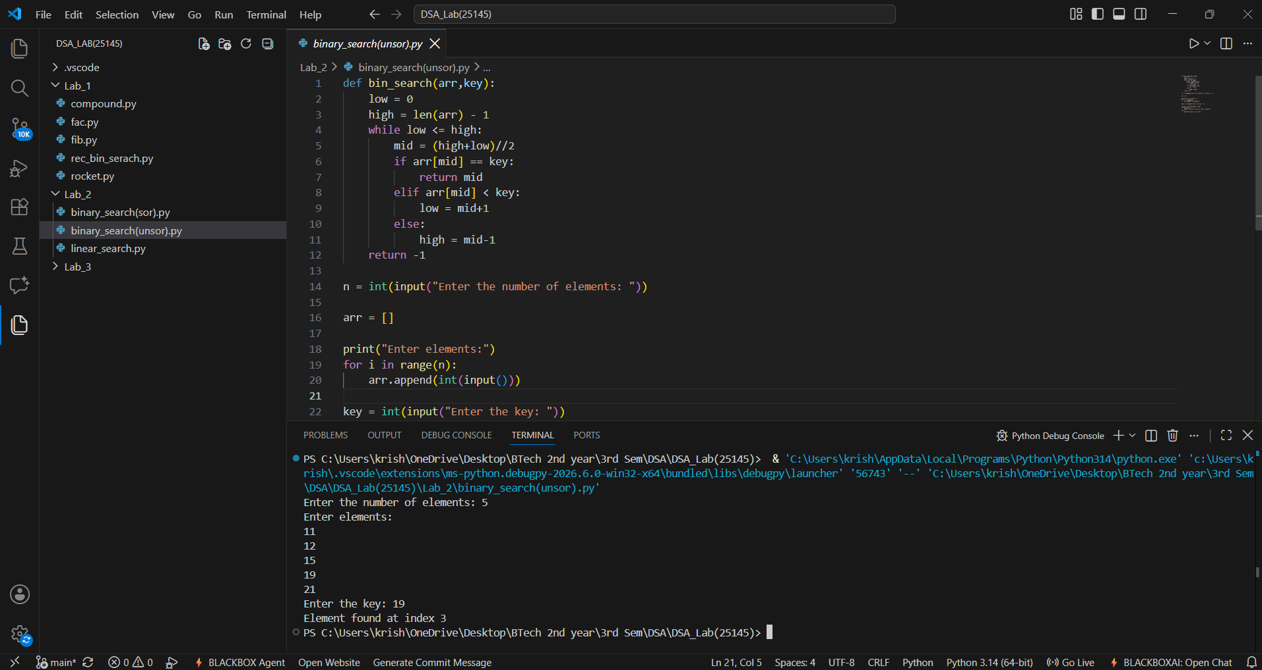

Output(-Ve Case):
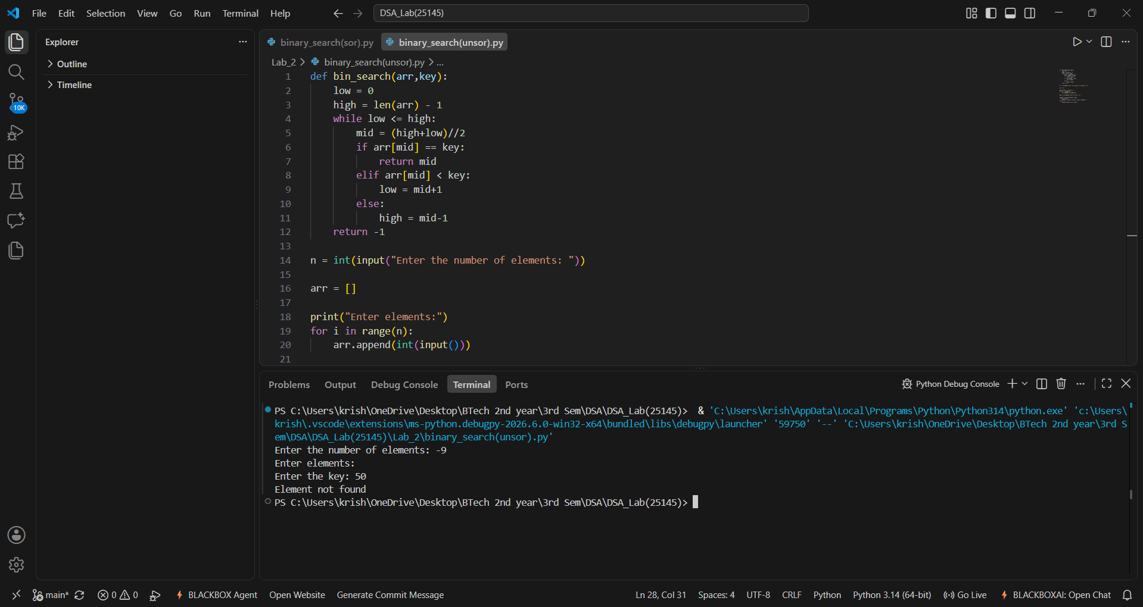
Explanation : The number of input elements should never be negative . In this case since input elements are -5 the program doesn’t allow me to enter any input elements nor is able to check the key given by the user.
(ii) Aim: Write a python program to implement binary search with unsorted array as input.
Program:
def bin_search(arr,key):
low = 0
high = len(arr) - 1
while low <= high:
mid = (high+low)//2
if arr[mid] == key:
return mid
elif arr[mid] < key:
low = mid+1
else:
high = mid-1
return -1

n = int(input("Enter the number of elements: "))

arr = []

print("Enter elements:")
for i in range(n):
arr.append(int(input()))
if arr == sorted(arr):
print("\n input list is already sorted")
else:
print("input list is not sorted")
print("sorting list....")
arr.sort()
print(f"Sorted List : {arr}")

key = int(input("Enter the key: "))

result = bin_search(arr, key)
if result!=-1:
print(f"Element found at index {result}")
else:
print("Element not found")

Output(+Ve Case):
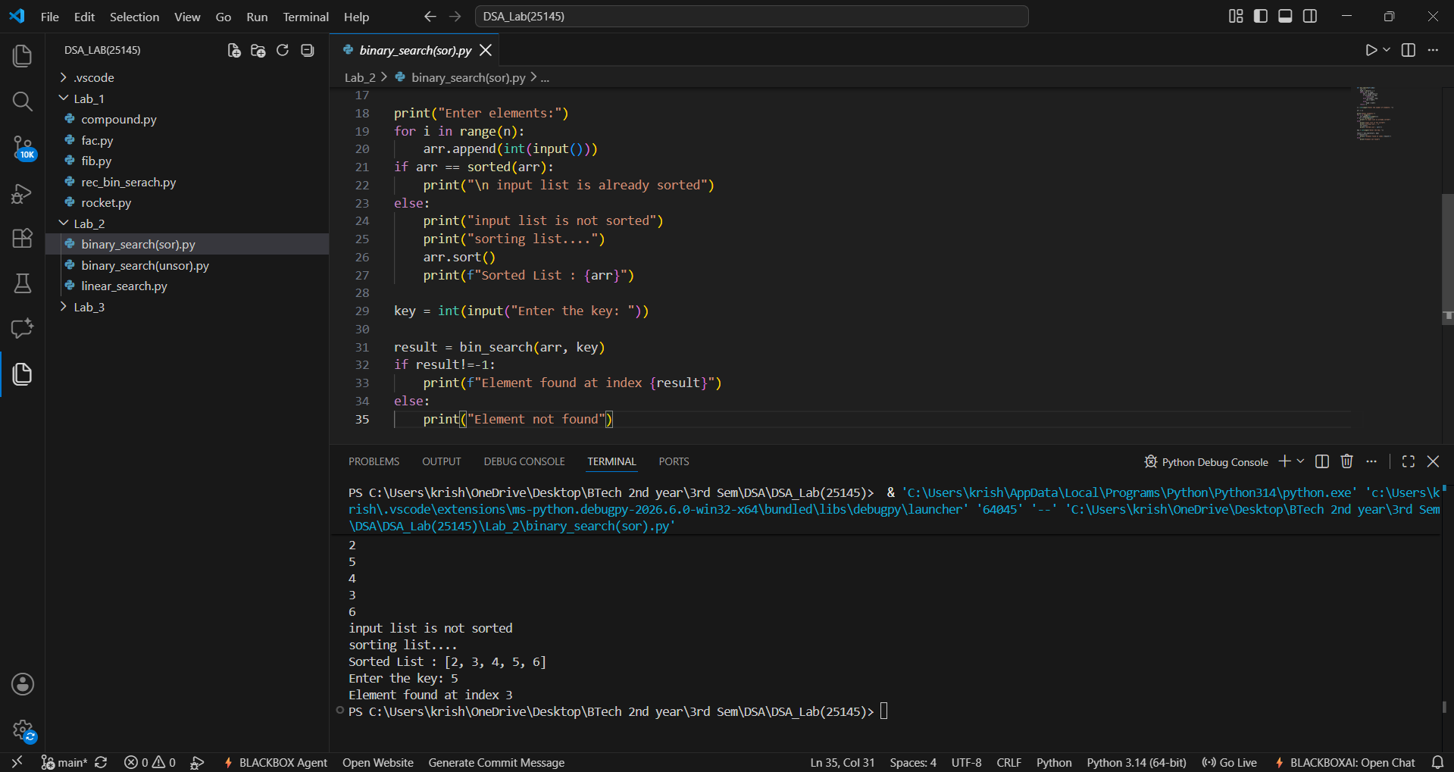
Output(-Ve Case):
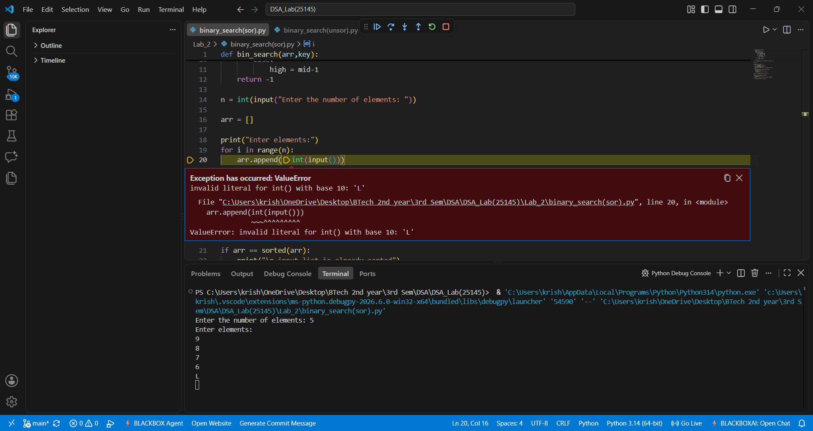

Explanation : The given Binary Search accepts only integer values giving values other than the integer data type such as float or special characters results in this type of Value Error.
Error Table(i+ii):
(ii)
Line No. | Code with Error | Correct Code
5 | while low >= high: | while low <= high:
8 | elif arr[mid] > key: | elif arr[mid] < key:
11 | high = mid + 1 | high = mid – 1
20 | if arr != sorted(arr): | if arr == sorted(arr):
25 | arr.sort(reverse=True) | arr.sort()

(i)
Line No. | Code with Error | Correct Code
5 | while low >= high: | while low <= high:
8 | elif arr[mid] > key: | elif arr[mid] < key:
11 | high = mid + 1 | high = mid - 1
31 | result = bin_search(arr) | result = bin_search(arr, key)
33 | if result == -1: | if result != -1:

LAB-3:
1.)Applying Sorting Algorithms :
A.) Aim: Write a python program to apply bubble sort where input elements are taken from the user .
Program:
def bubble_sort(arr):
n = len(arr)
for i in range(n-1):
for j in range(n-i-1):
if arr[j] > arr[j+1]:
arr[j],arr[j+1] = arr[j+1],arr[j]
return arr

n = int(input("Enter the number of elements: "))

arr = []

print("Enter elements:")
for i in range(n):
arr.append(int(input()))

result = bubble_sort(arr)
print(f"Sorted array : {result}")

Output(+Ve Case):
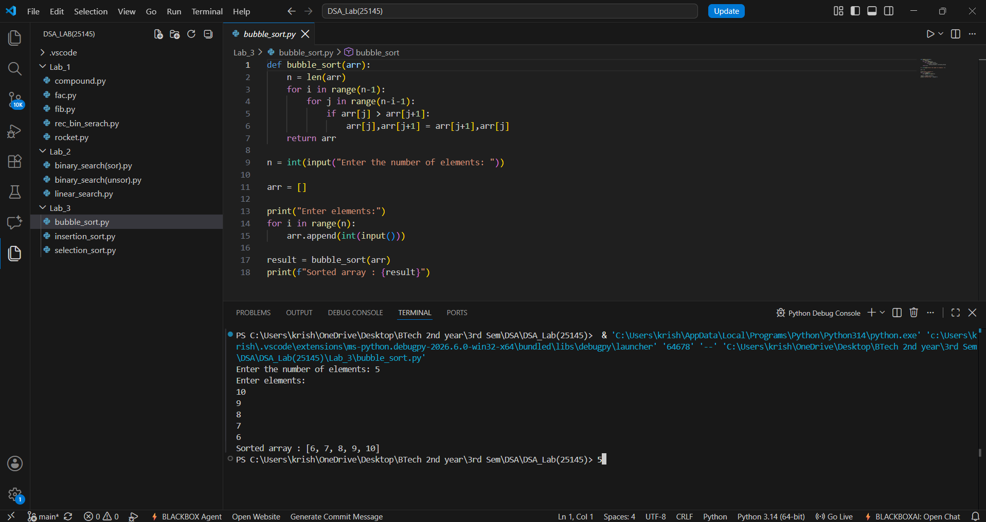
Output(-Ve Case):
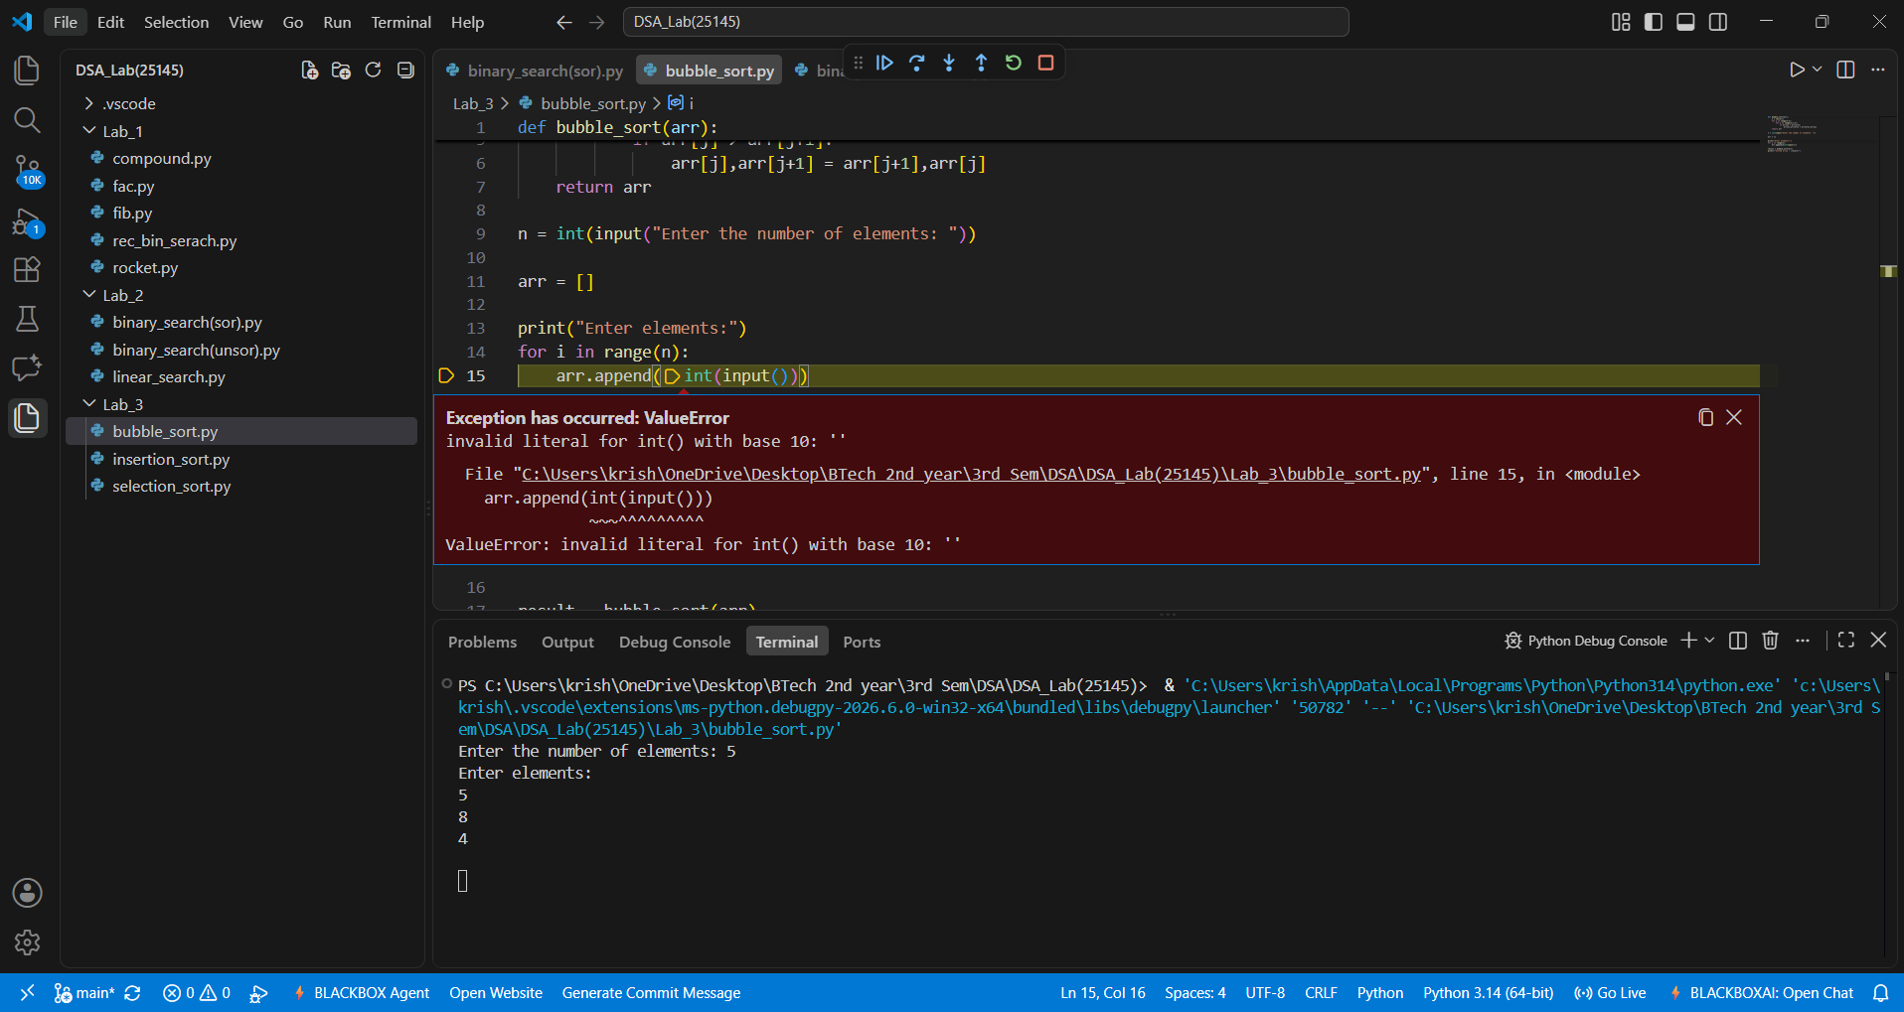
Explanation:
The input values for a given sorting algorithm for an array must never be null hence it throws the error invalid for int() input.
Error Table:
Line No. | Code with Error | Correct Code
4 | for i in range(n): | for i in range(n-1):
5 | for j in range(n-i): | for j in range(n-i-1):
6 | if arr[j] < arr[j+1]: | if arr[j] > arr[j+1]:

B.) Aim: Write a python program to apply insertion sort where input elements are taken from the user .
Program:
def insertion_sort(arr):
n = len(arr)
for i in range(1,n):
key = arr[i]
j = i-1
while j >= 0 and arr[j] > key:
arr[j+1] = arr[j]
j = j-1
arr[j+1] = key
return arr

n = int(input("Enter the number of elements: "))

arr = []

print("Enter elements:")
for i in range(n):
arr.append(int(input()))
result = insertion_sort(arr)
print(f"Sorted array : {result}")
Output(+Ve Case):
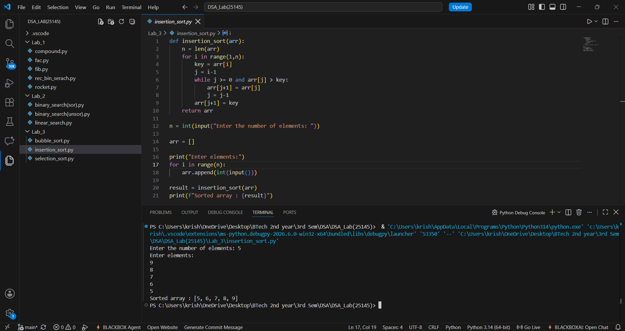
Output(-Ve Case):
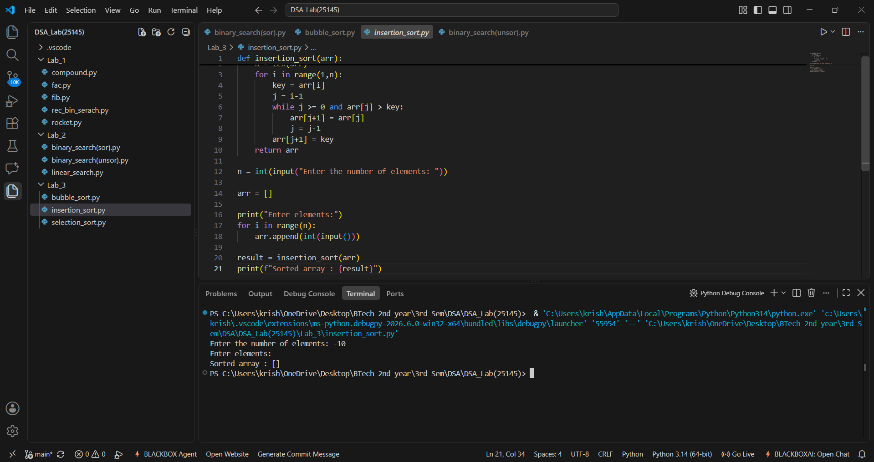
Explanation : The number of input elements should never be negative . In this case since input elements are -10 the program doesn’t allow me to enter any input elements nor is able to sort effeciently.
Error Table:
Line No. | Code with Error | Correct Code
4 | for i in range(0,n): | for i in range(1,n):
8 | while j >= 0 and arr[j] < key: | while j >= 0 and arr[j] > key:
10 | j = j+1 | j = j-1

C.) Aim: Write a python program to apply selection sort where input elements are taken from the user .
Program:
def selection_sort(arr):
n = len(arr)
for i in range(n-1):
min_index = i
for j in range (i+1,n):
if arr[j] < arr[min_index]:
min_index = j
arr[i],arr[min_index] = arr[min_index],arr[i]
return arr

n = int(input("Enter the number of elements: "))

arr = []

print("Enter elements:")
for i in range(n):
arr.append(int(input()))

result = selection_sort(arr)
print(f"Sorted array : {result}")

Output(+Ve Case):
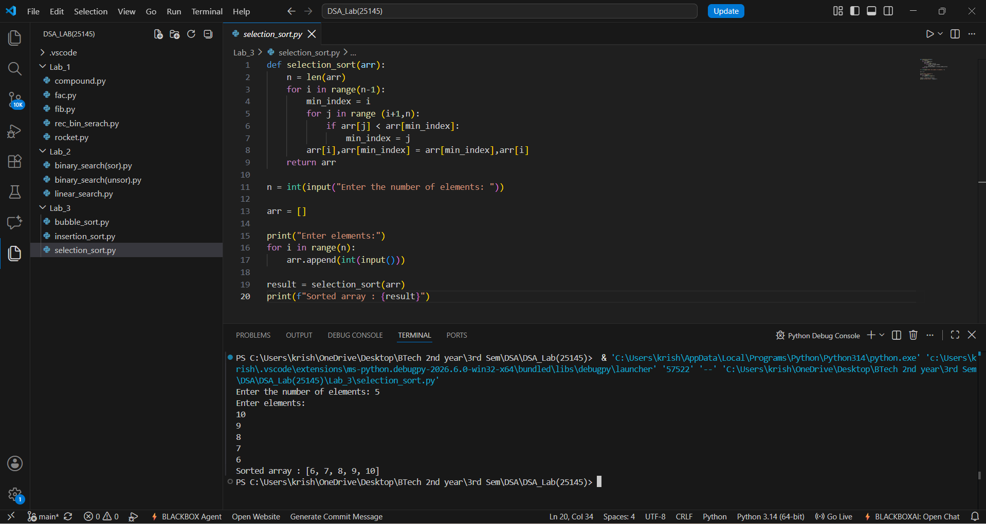

Output(-Ve Case):
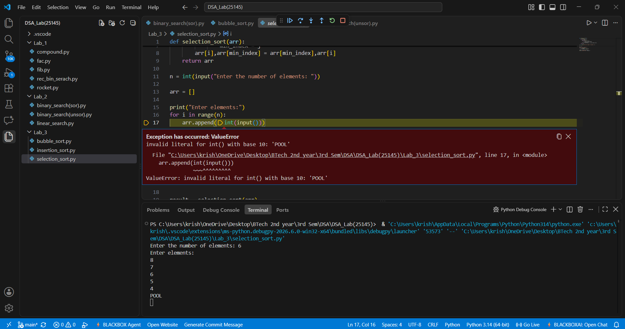
Explanation:
The given Selection Sort accepts only integer values giving values other than the integer data type such as float or special characters or strings results in this type of Value Error.
Error Table:
Line No. | Code with Error | Correct Code
4 | for i in range(n): | for i in range(n-1):
7 | for j in range(i,n): | for j in range(i+1,n):
8 | if arr[j] > arr[min_index]: | if arr[j] < arr[min_index]:

LAB-4:
1.)Applying Advanced Sorting Algorithms :
A.) Aim: Write a python program to apply merge sort where input elements are taken from the user .
Program:
def merge_sort(arr):
# Base Condition
if len(arr) <= 1:
return arr

# Divide Array
mid = len(arr) // 2
left = arr[:mid]
right = arr[mid:]

# Recursive calls
merge_sort(left)
merge_sort(right)

# Merge sorted halves
i = j = k = 0

while i < len(left) and j < len(right):
if left[i] <= right[j]:
arr[k] = left[i]
i += 1
else:
arr[k] = right[j]
j += 1
k += 1

# Copy remaining elements from Left Array
while i < len(left):
arr[k] = left[i]
i += 1
k += 1

# Copy remaining elements from Right Array
while j < len(right):
arr[k] = right[j]
j += 1
k += 1

return arr

n = int(input("Enter the number of elements: "))

arr = []

print("Enter elements:")
for i in range(n):
arr.append(int(input()))

print("Sorted Array :.......")
print(merge_sort(arr))
Output(+Ve Case):
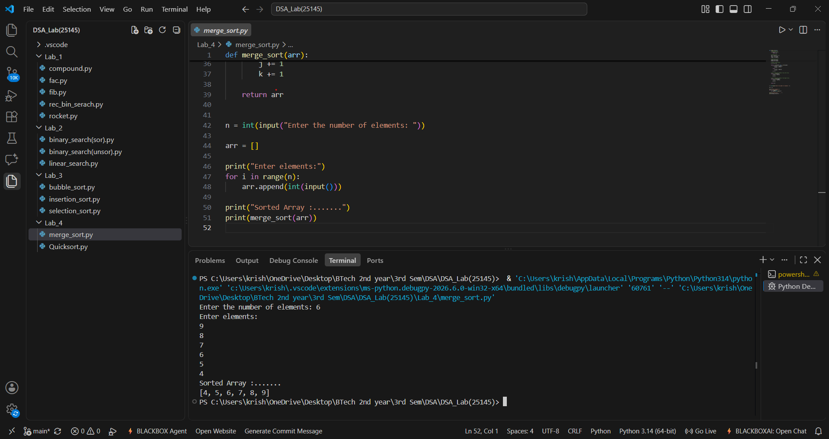
Output(-Ve Case):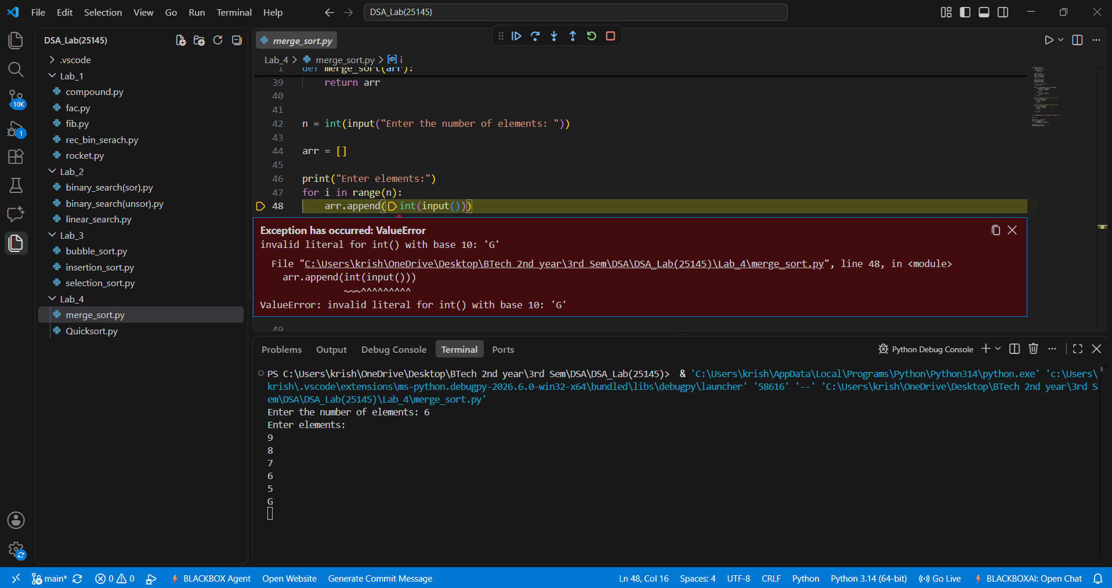
Explanation:
The given Merge Sort accepts only integer values giving values other than the integer data type such as float or special characters or strings results in this type of Value Error.
Error Table:
Line No. | Code with Error | Correct Code
4 | if len(arr) < 1: | if len(arr) <= 1:
9 | right = arr[:mid] | right = arr[mid:]
13 | merge_sort(right) | merge_sort(left)
19 | if left[i] >= right[j]: | if left[i] <= right[j]:
28 | while i > len(left): | while i < len(left):
34 | while j > len(right): | while j < len(right):

B.) Aim: Write a python program to apply Quick sort where input elements are taken from the user .
Program:
def quicksort(a,low,high):
if low < high:
i = low
j = high
pivot = low
while i < j:
while i < len(a) and a[i] <= a[pivot]:
i+=1
while a[j] > a[pivot]:
j-=1
if i < j:
a[i],a[j] = a[j],a[i]
a[j],a[pivot] = a[pivot],a[j]
quicksort(a,low,j-1)#Left Part
quicksort(a,j+1,high)#Right Part

#Entering the Elements
n = int(input("Enter the number of elements: "))
a = []

print("Enter elements:")
for i in range(n):
a.append(int(input()))

quicksort(a, 0, n - 1)

print("Sorted Array :.......")
print(a)

Output(+Ve Case):
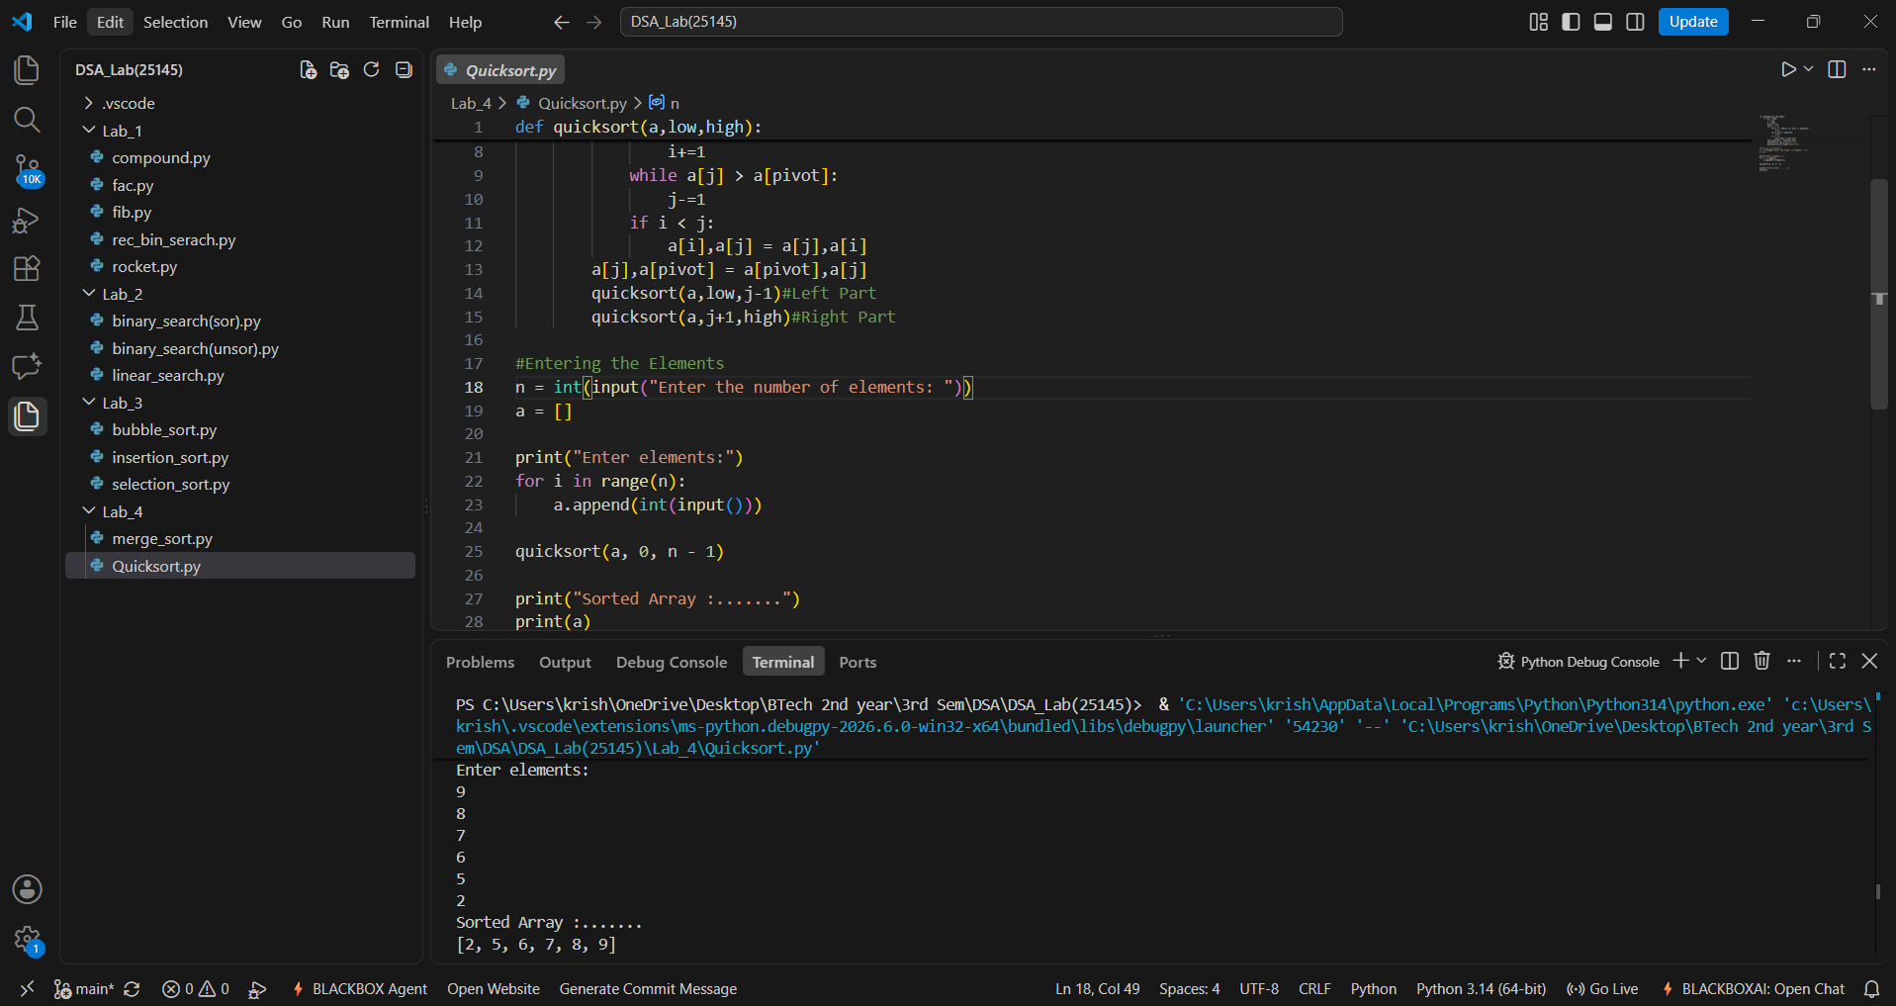
Output(-Ve Case):
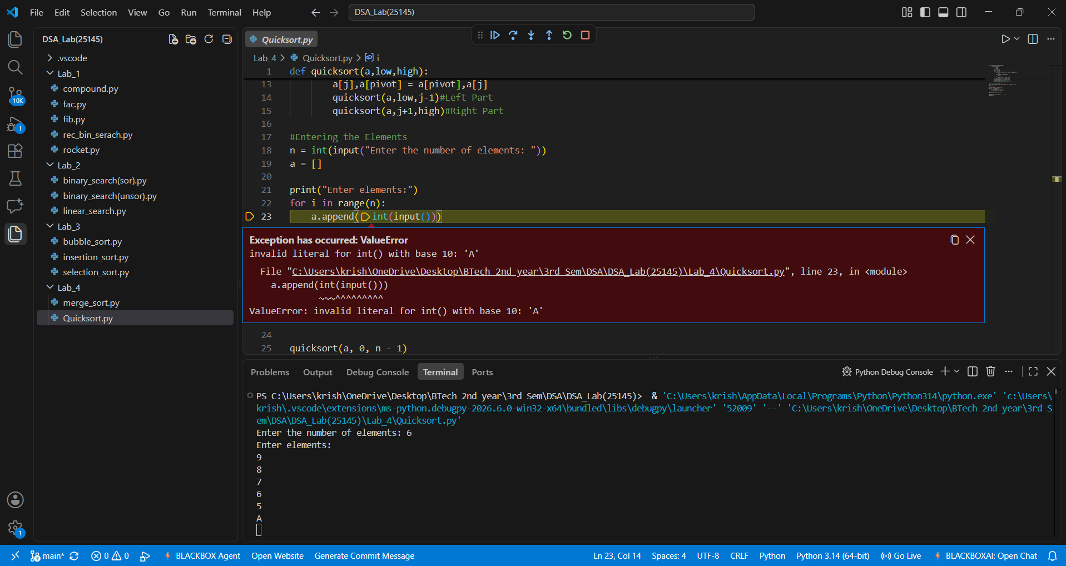

Explanation:
The given Quick Sort accepts only integer values giving values other than the integer data type such as float or special characters or strings results in this type of Value Error.

Error Table:
Line No. | Code with Error | Correct Code
7 | pivot = high | pivot = low
10 | while i < len(a) and a[i] >= a[pivot]: | while i < len(a) and a[i] <= a[pivot]:
13 | while a[j] < a[pivot]: | while a[j] > a[pivot]:
15 | if i > j: | if i < j:
22 | quicksort(a,low,j+1) | quicksort(a,low,j-1)

LAB-5:
1.)Single Linked List:
A.) Aim: Write a python program to add an element at beginning , end , delete an element at beginning , end and add and delete an element at a given position , traverse the list and count number of nodes for a Single Linked List. In the standard menu format.
Program:
class Node:
# Initialize Node
def __init__(self, data):
self.data = data
self.next = None

class SinglyLinkedList:
# Initialize Singly Linked List
def __init__(self):
self.head = None

# Create operation
def create(self):
n = int(input(("Enter number of elements:")))
for i in range(n):
x = int(input(("Enter value:")))
new = Node(x)
if self.head is None:
self.head = new
else:
temp = self.head
while temp.next:
temp = temp.next
temp.next = new

# Insert at Beginning operation
def insert_begin(self, data):
new = Node(data)
new.next = self.head
self.head = new

# Insert at End operation
def insert_end(self, data):
new = Node(data)
if self.head is None:
self.head = new
else:
temp = self.head
while temp.next:
temp = temp.next
temp.next = new

# Insert at Index operation
def insert_index(self, index, data):
if index == 0:
self.insert_begin(data)
return
elif index > self.count() or index < 0:
print("Invalid Index")
return
new = Node(data)
temp = self.head
for i in range(index - 1):
temp = temp.next
new.next = temp.next
temp.next = new

# Delete at Beginning operation
def deleteAtBeg(self):
if self.head is None:
print("No Data to delete")
else:
temp = self.head
self.head = temp.next
print("Deleted Value = ",temp.data)

# Delete at End operation
def deleteAtEnd(self):
if self.head is None:
print("No Data to delete")
elif self.head.next is None:
self.head = None
else:
temp = self.head
temp1 = temp
while temp.next:
temp1 = temp
temp = temp.next
temp1.next = None

# Delete Value operation
def delete(self, value):
if self.head is None:
print("No Data to delete")
else:
temp = self.head
if temp and temp.data == value:
self.head = temp.next
print("Value deleted")
return
while temp.next and temp.next.data != value:
temp = temp.next

if temp.next is None:
print("Value not present")
else:
temp.next = temp.next.next
print("Value deleted")

# Display operation
def display(self):
if self.head is None:
print("No Data")
else:
temp = self.head
while temp:
print(temp.data, end=" -> ")
temp = temp.next
print("None")

# Count operation
def count(self):
if self.head is None:
print("No Linked List")
return 0
else:
c = 0
temp = self.head
while temp:
c += 1
temp = temp.next
print(f"Number of nodes = {c}")
return c

sll = SinglyLinkedList()

while True:
print("\n1. Create\n2. Insert at Beginning\n3. Insert at End\n4. Insert at Index\n5. Delete Value\n6. Delete at Beginning\n7. Delete at End\n8. Count\n9. Display\n10. Exit")
ch = int(input("Enter choice: "))

if ch == 1:
sll.create()
elif ch == 2:
x = int(input("Value: "))
sll.insert_begin(x)
elif ch == 3:
x = int(input("Value: "))
sll.insert_end(x)
elif ch == 4:
idx = int(input("Index: "))
x = int(input("Value: "))
sll.insert_index(idx, x)
elif ch == 5:
x = int(input("Delete value: "))
sll.delete(x)
elif ch == 6:
sll.deleteAtBeg()
elif ch == 7:
sll.deleteAtEnd()
elif ch == 8:
sll.count()
elif ch == 9:
sll.display()
elif ch == 10:
break

Output(+Ve Case):
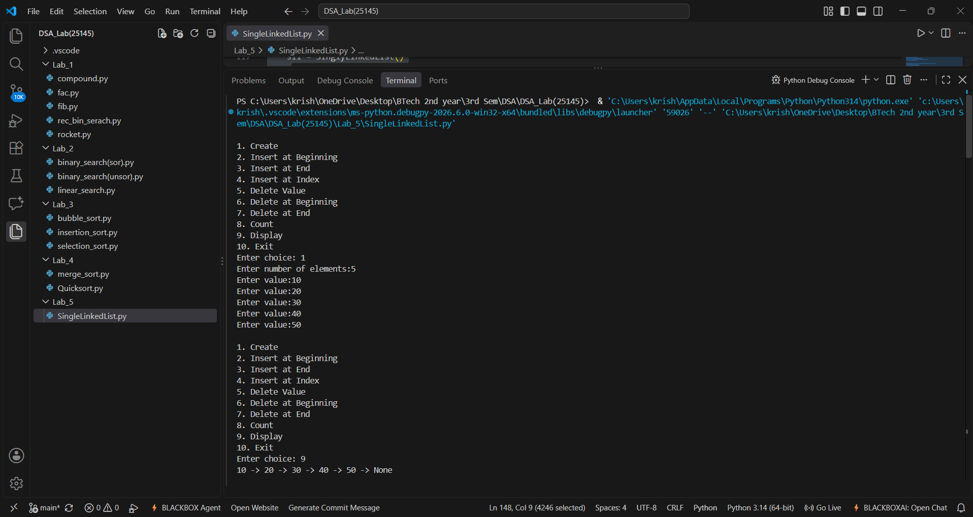
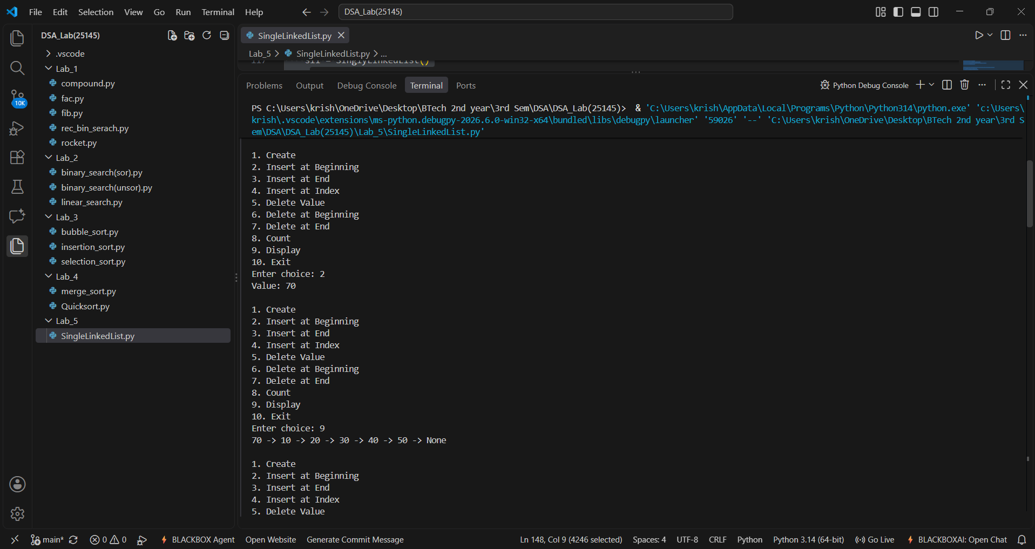

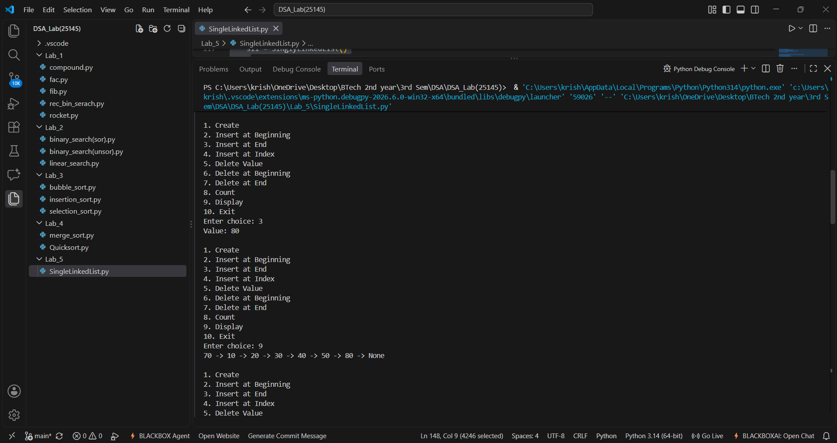
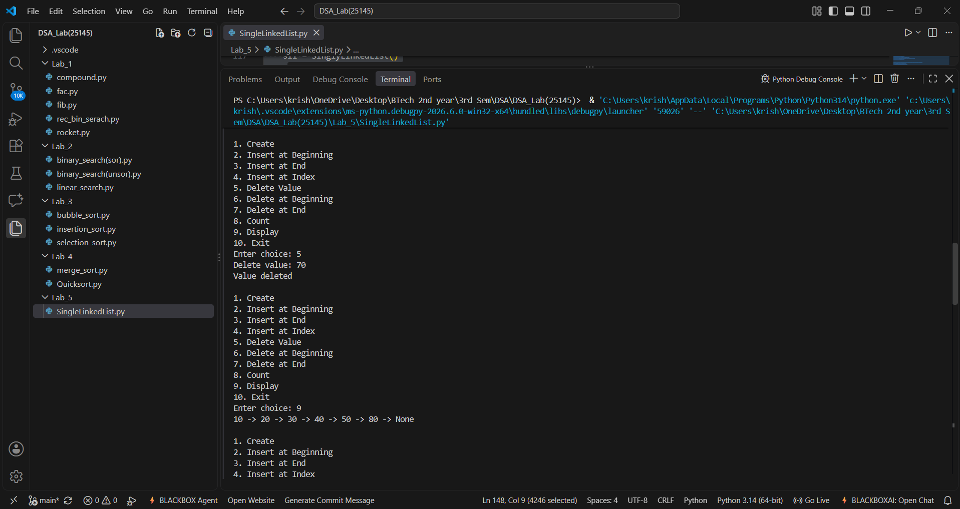

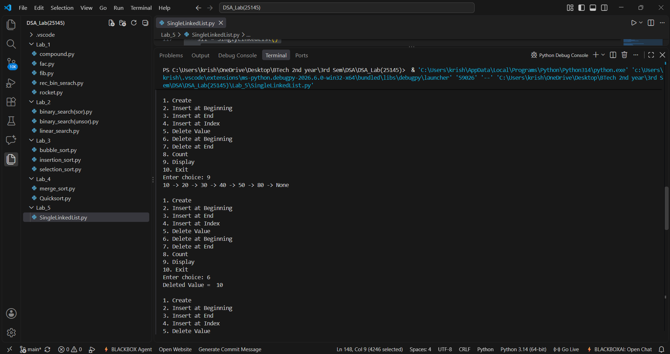
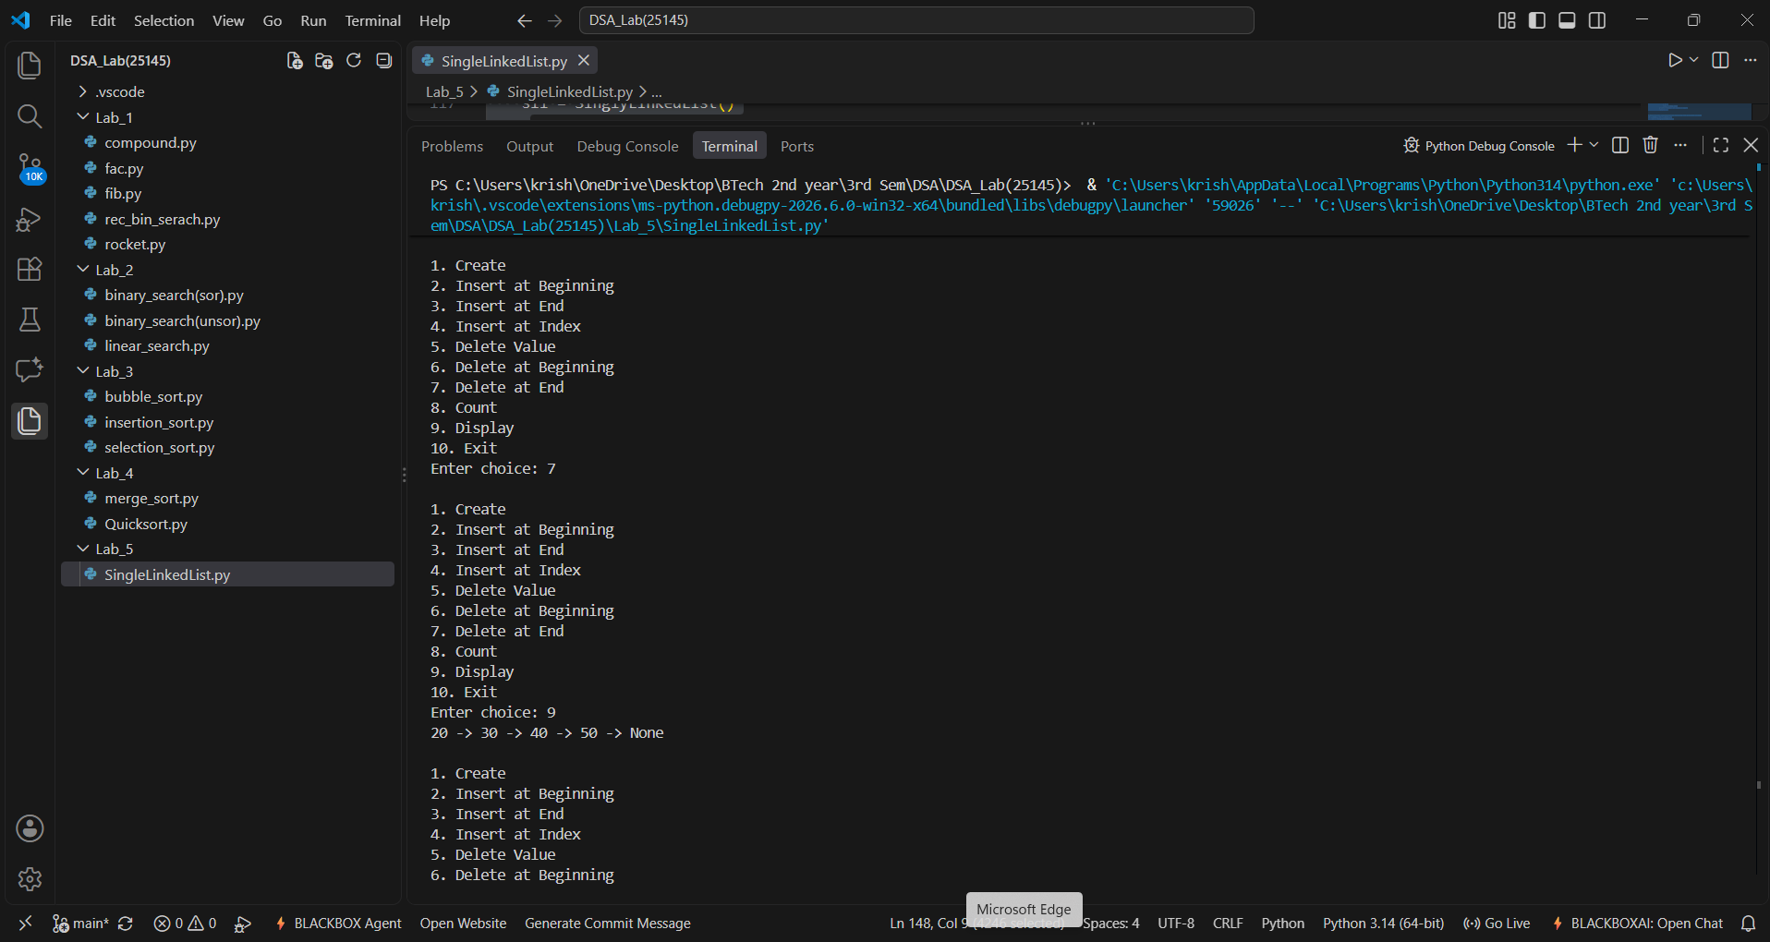

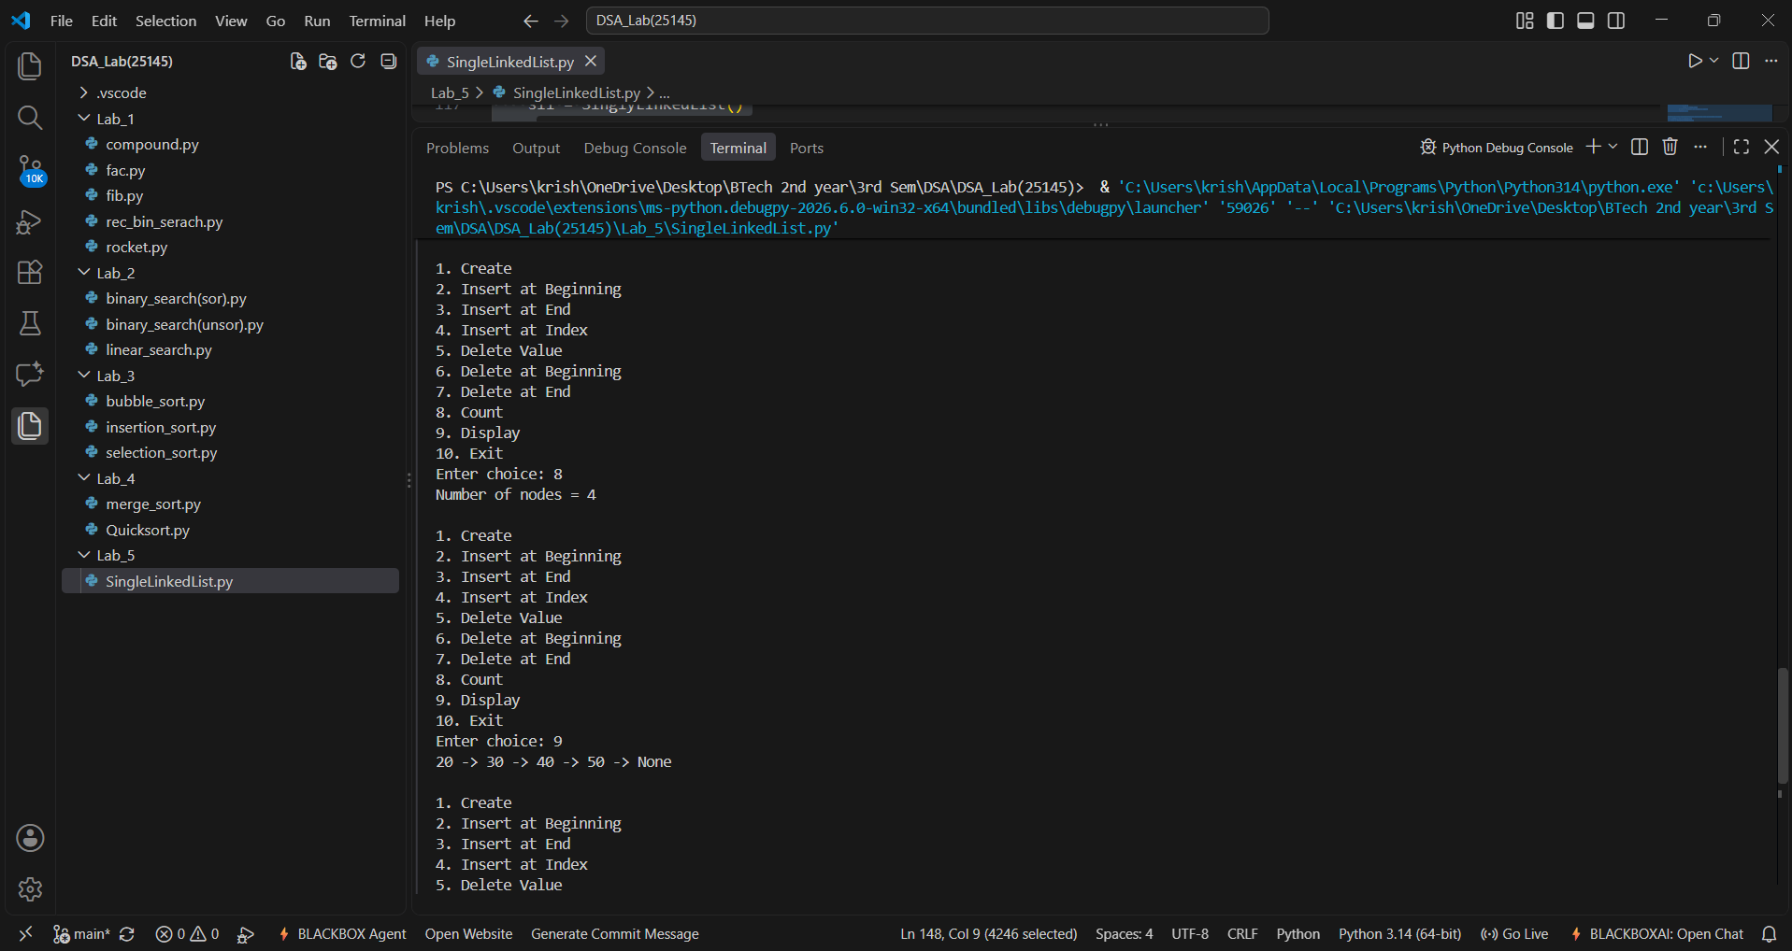
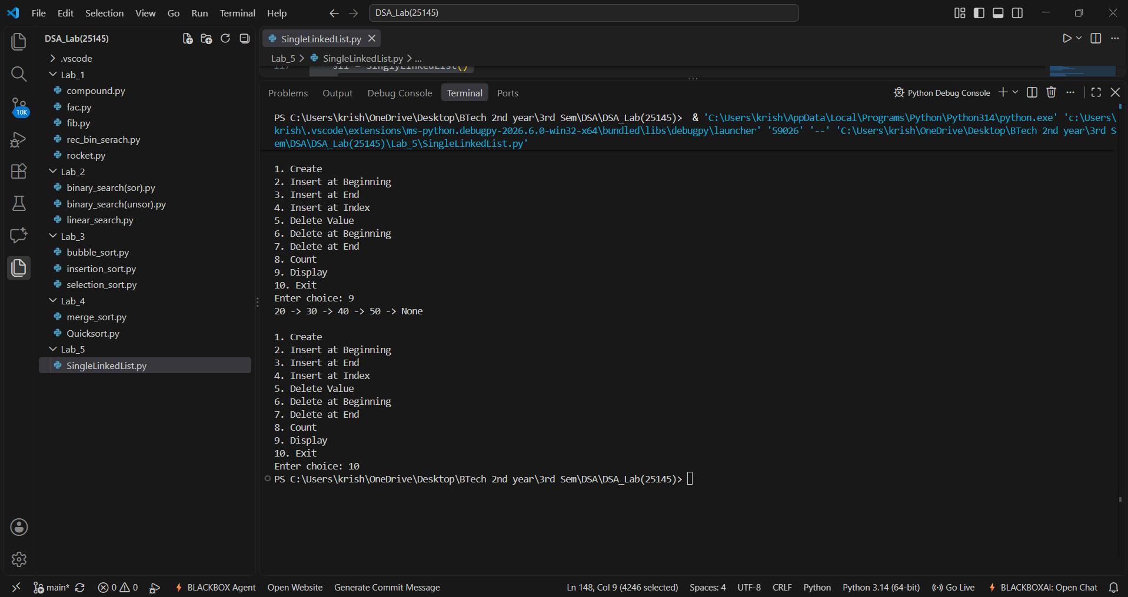

Output (-Ve Case):
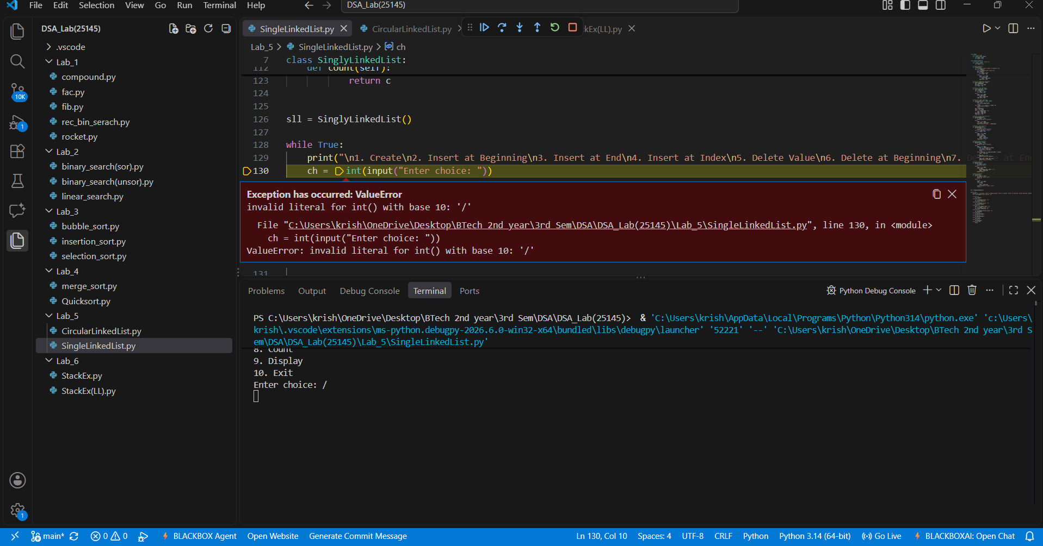
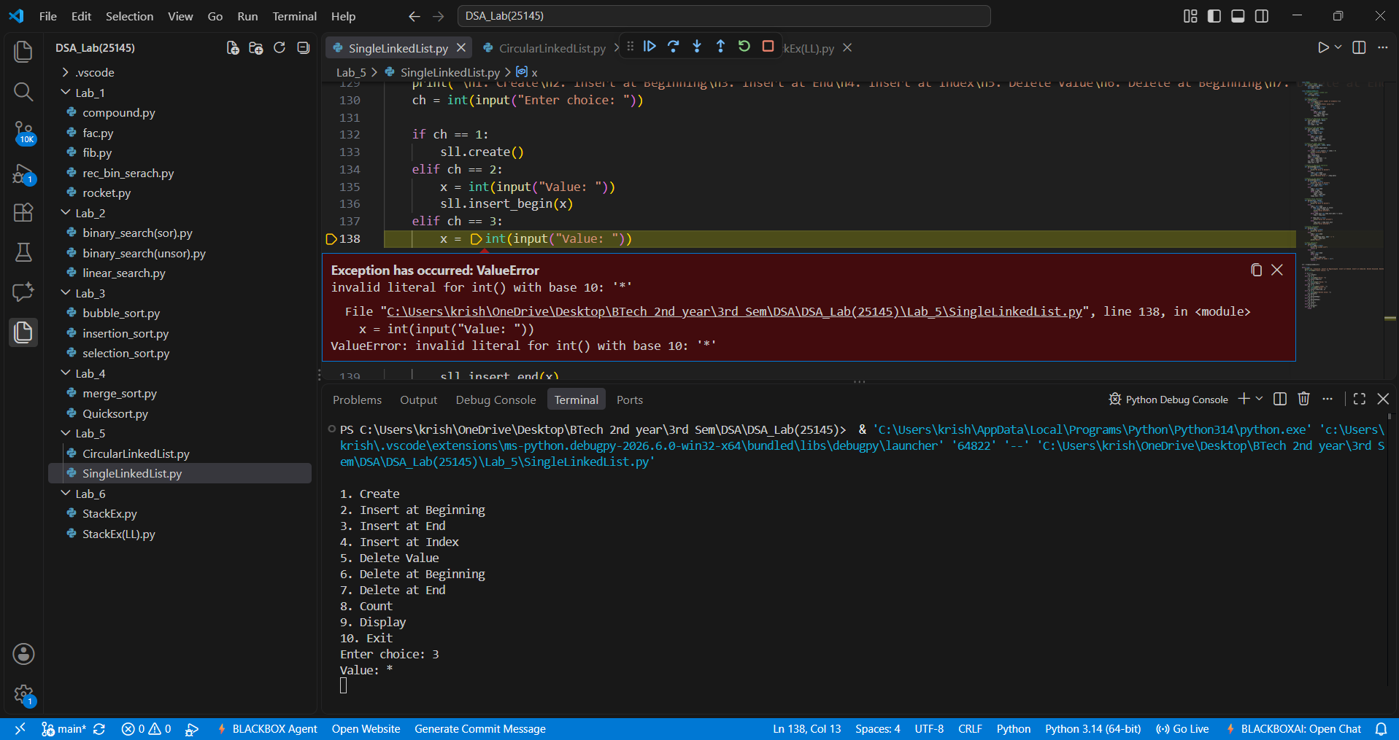
Explanation:
The given Linked List accepts only integer values giving values other than the integer data type such as float or special characters or strings results in this type of Value Error.

Error Table:
Line No. | Code with Error | Correct Code
22 | while temp: | while temp.next:
29 | new.next = head | new.next = self.head
48 | elif index < self.count() or index > 0: | elif index > self.count() or index < 0:
64 | self.head = temp | self.head = temp.next
83 | while temp.next and temp.next.data == value: | while temp.next and temp.next.data != value:

B.) Aim: Write a python program to add an element at beginning , end , delete an element at beginning , end and add and delete an element at a given position , traverse the list and count number of nodes for a Circular Linked List. In the standard menu format.
Program:
class Node:
# Initialize Node
def __init__(self, data):
self.data = data
self.next = None

class CircularLinkedList:
# Initialize Circular Linked List
def __init__(self):
self.head = None
self.tail = None

# Insert at Beginning
def insert_begin(self, data):
new = Node(data)
# Case 1: Empty list
if self.head is None:
self.head = new
self.tail = new
new.next = self.head
# Case 2: Non-empty list
else:
new.next = self.head
self.head = new
self.tail.next = self.head

# Insert at End
def insert_end(self, data):
new = Node(data)
# Case 1: Empty list
if self.head is None:
self.head = new
self.tail = new
new.next = self.head
# Case 2: Non-empty list
else:
new.next = self.head
self.tail.next = new
self.tail = new

# Insert at Particular Position
# Position starts from 0
def insert_position(self, position, data):
# Insert at beginning
if position == 0:
self.insert_begin(data)
return

if self.head is None or position < 0:
print("Invalid position")
return

new = Node(data)
temp = self.head

# Move to the node before the required position
for i in range(position - 1):
temp = temp.next
# We have completed one circle
if temp == self.head:
print("Invalid position")
return

# Insert new node
new.next = temp.next
temp.next = new

# If inserted after tail, update tail
if temp == self.tail:
self.tail = new

# Delete at Beginning
def delete_begin(self):
if self.head is None:
print("List is empty")
return

# Only one node
if self.head == self.tail:
self.head = None
self.tail = None
# More than one node
else:
self.head = self.head.next
self.tail.next = self.head

# Delete at End
def delete_end(self):
if self.head is None:
print("List is empty")
return

# Only one node
if self.head == self.tail:
self.head = None
self.tail = None
return

# Find node before tail
temp = self.head
while temp.next != self.tail:
temp = temp.next
temp.next = self.head
self.tail = temp

# Traverse the Circular Linked List
def traverse(self):
if self.head is None:
print("List is empty")
return

temp = self.head
while True:
print(temp.data, end=" -> ")
temp = temp.next
if temp == self.head:
break
print("(back to head)")

# Display Head and Tail
def display_head_tail(self):
if self.head is None:
print("List is empty")
else:
print("Head =", self.head.data)
print("Tail =", self.tail.data)
print("Tail.next =", self.tail.next.data)

cll = CircularLinkedList()

while True:
print("\n--- Circular Linked List Menu ---")
print("1. Insert at Beginning")
print("2. Insert at End")
print("3. Insert at Position")
print("4. Delete at Beginning")
print("5. Delete at End")
print("6. Traverse List")
print("7. Display Head and Tail")
print("8. Exit")

ch = int(input("Enter your choice: "))

if ch == 1:
x = int(input("Value: "))
cll.insert_begin(x)
elif ch == 2:
x = int(input("Value: "))
cll.insert_end(x)
elif ch == 3:
pos = int(input("Position (starts from 0): "))
x = int(input("Value: "))
cll.insert_position(pos, x)
elif ch == 4:
cll.delete_begin()
elif ch == 5:
cll.delete_end()
elif ch == 6:
cll.traverse()
elif ch == 7:
cll.display_head_tail()
elif ch == 8:
print("Exiting...")
break
else:
print("Invalid choice, please try again.")

Output(+Ve Case):
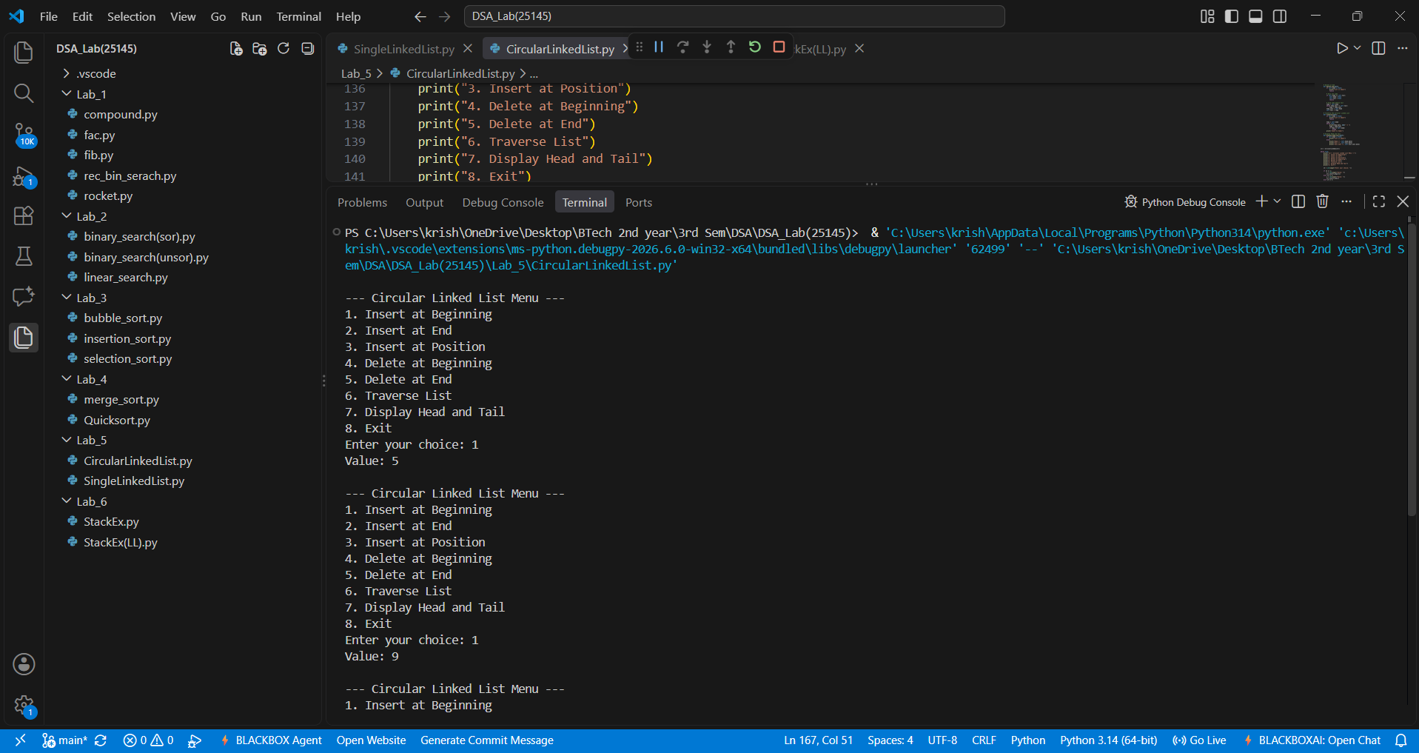
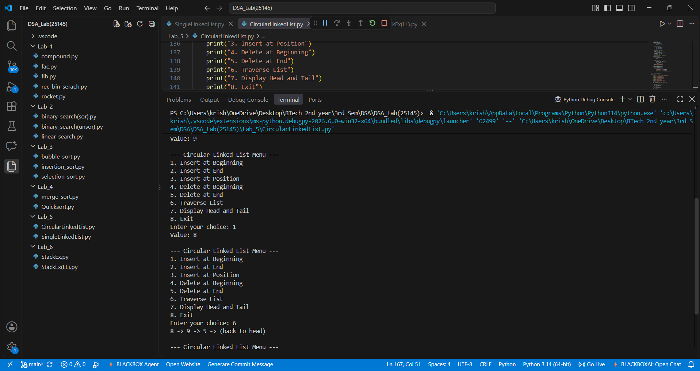

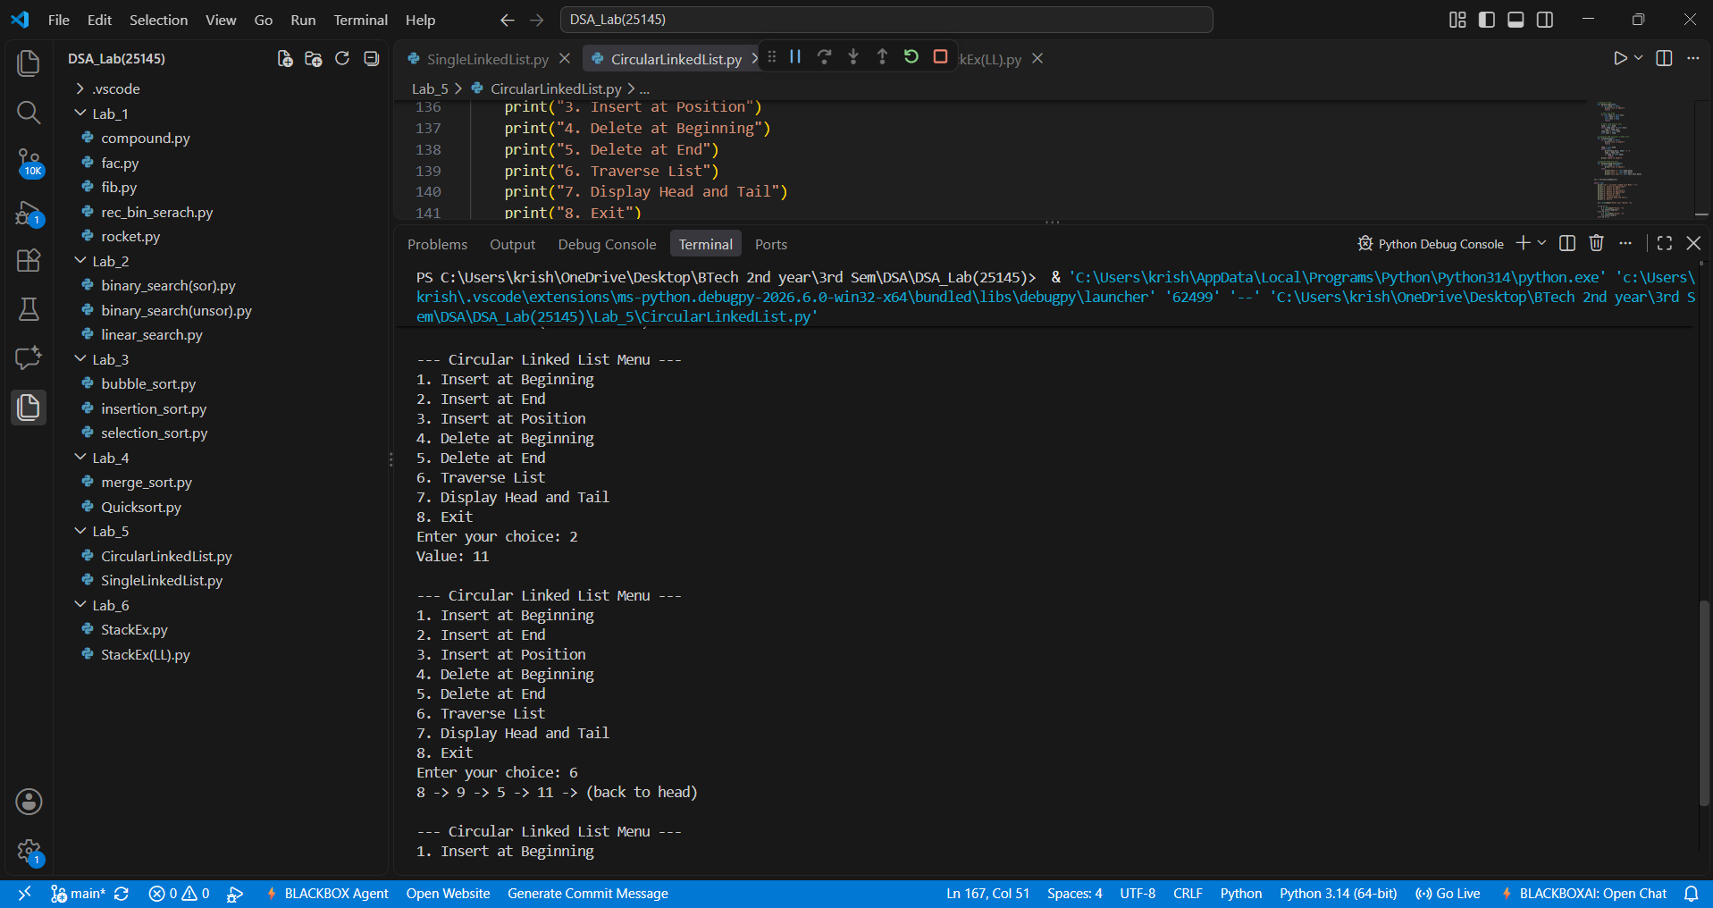
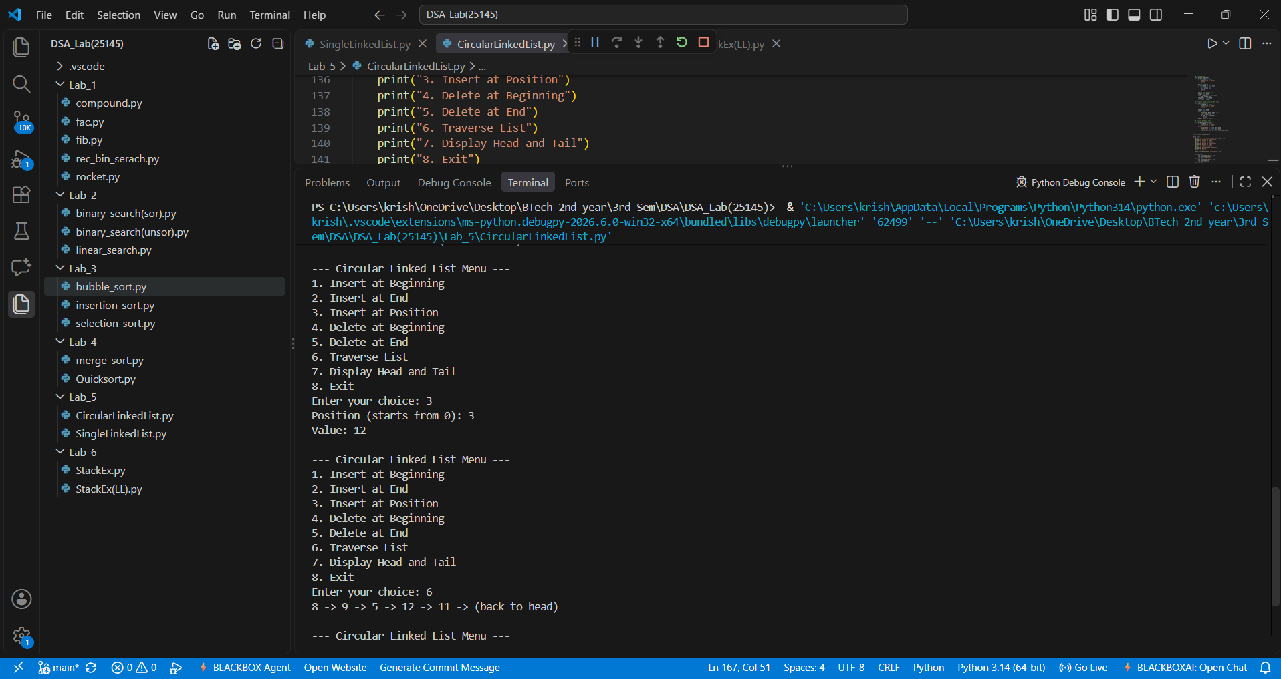

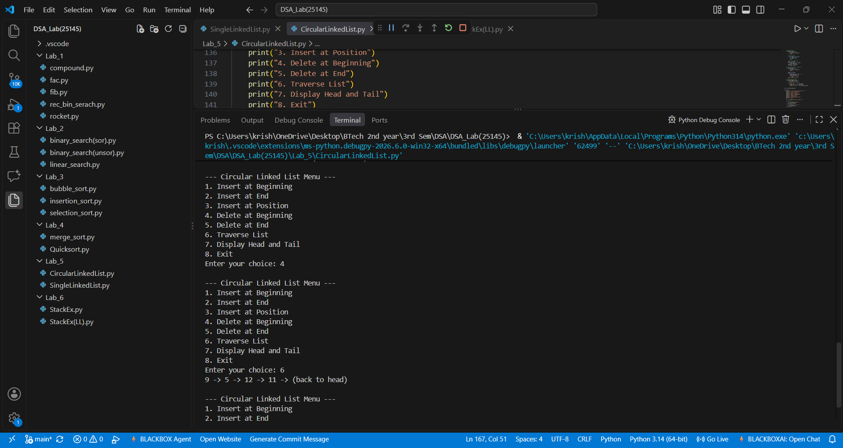
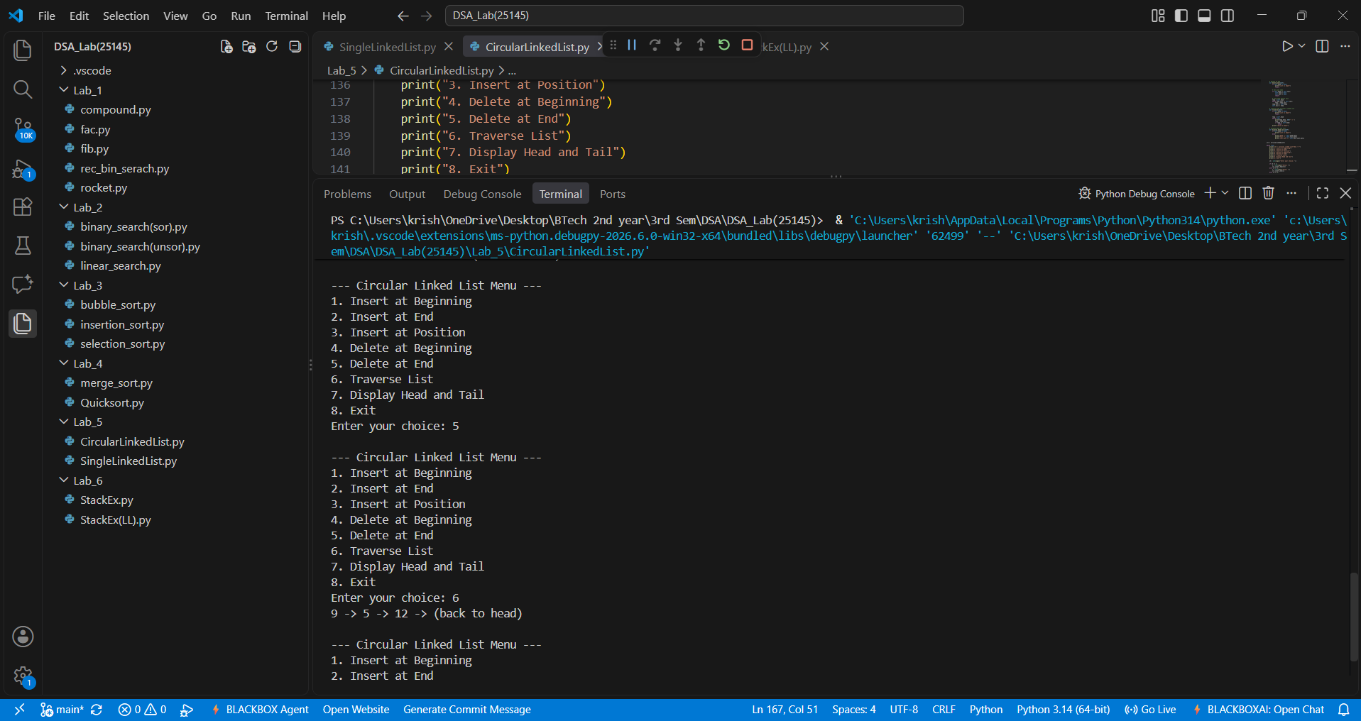

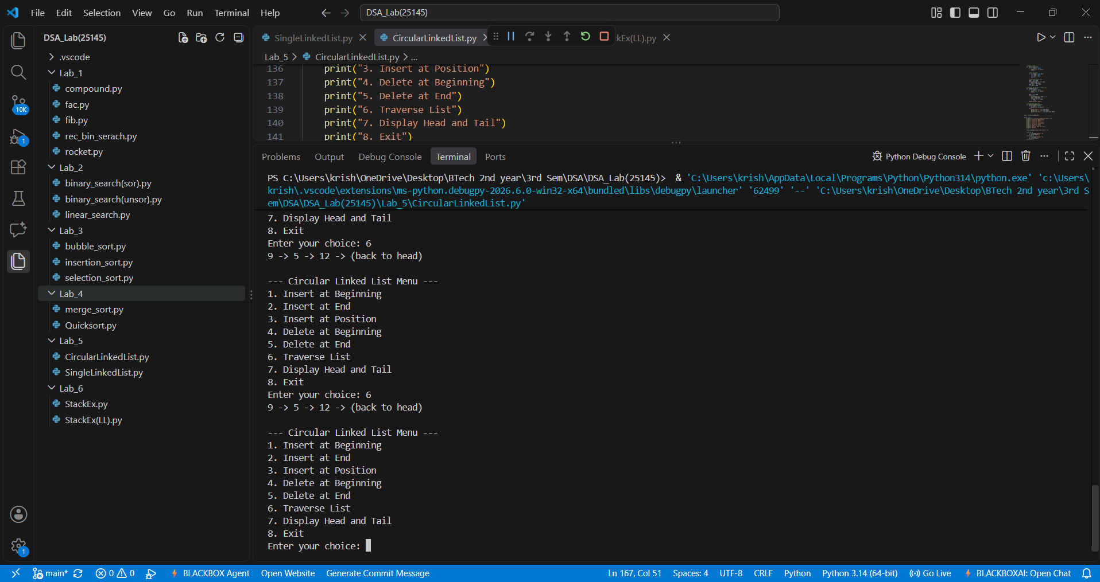
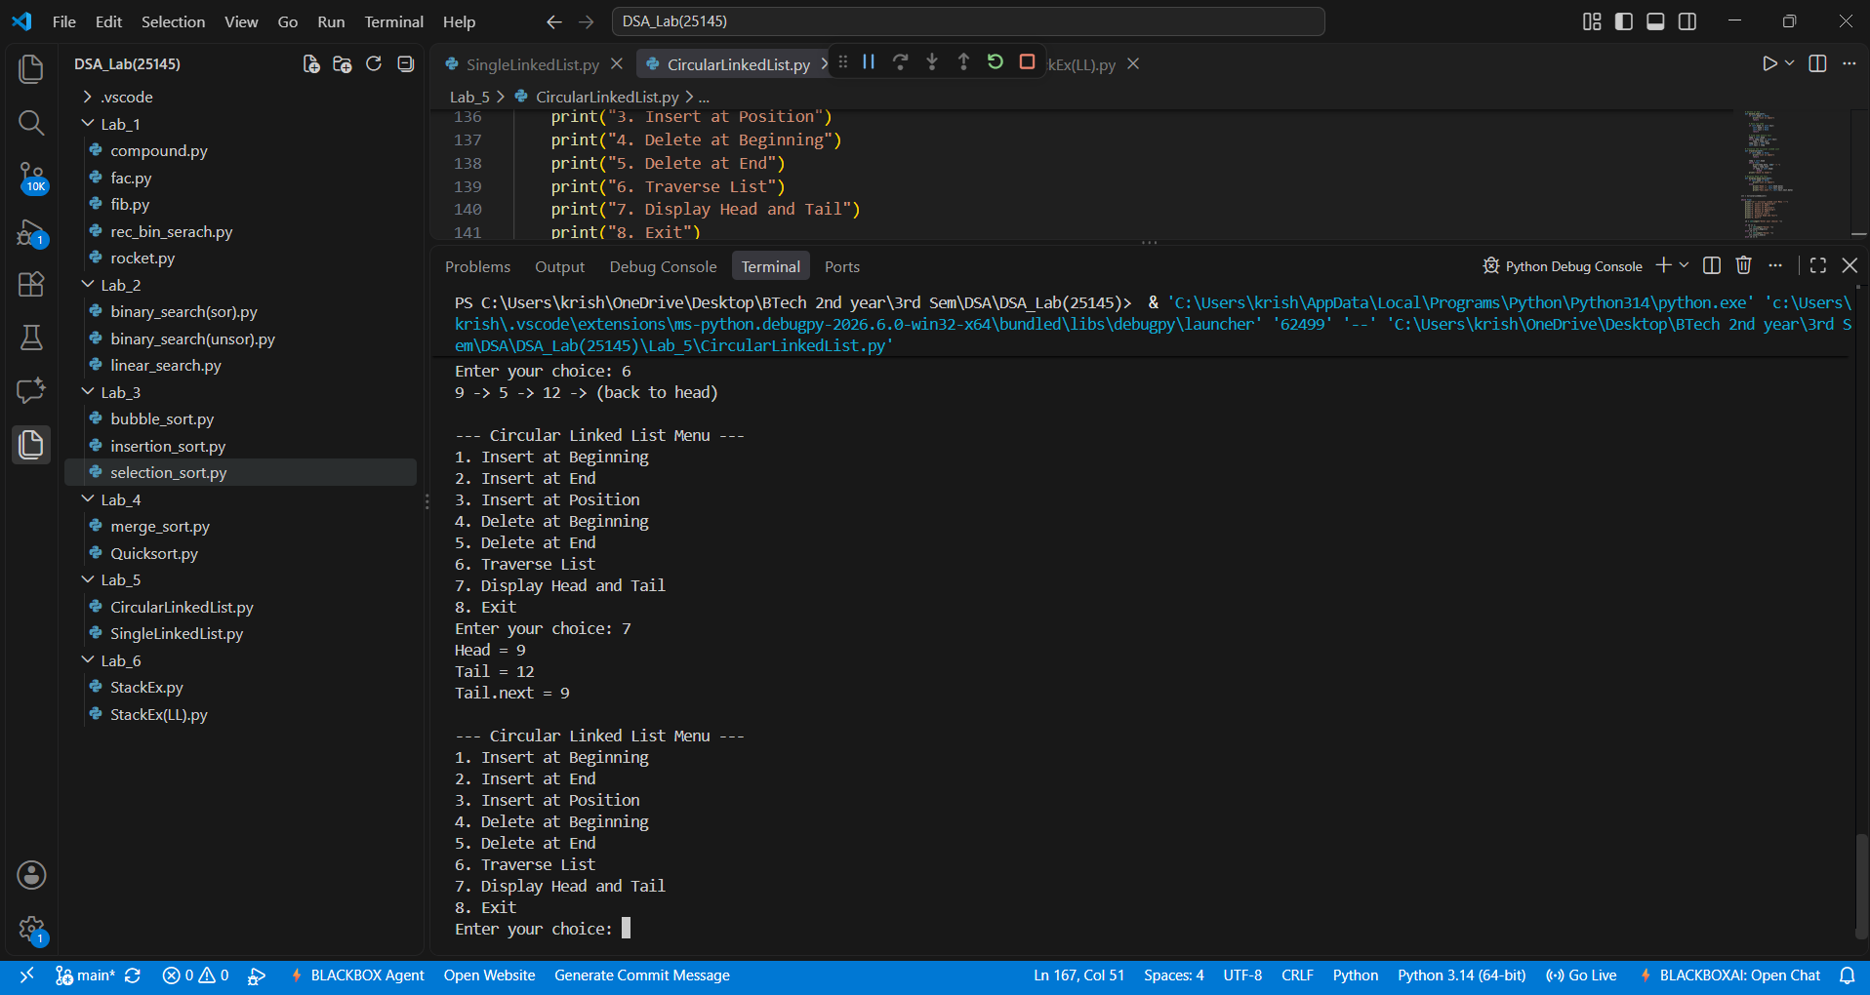

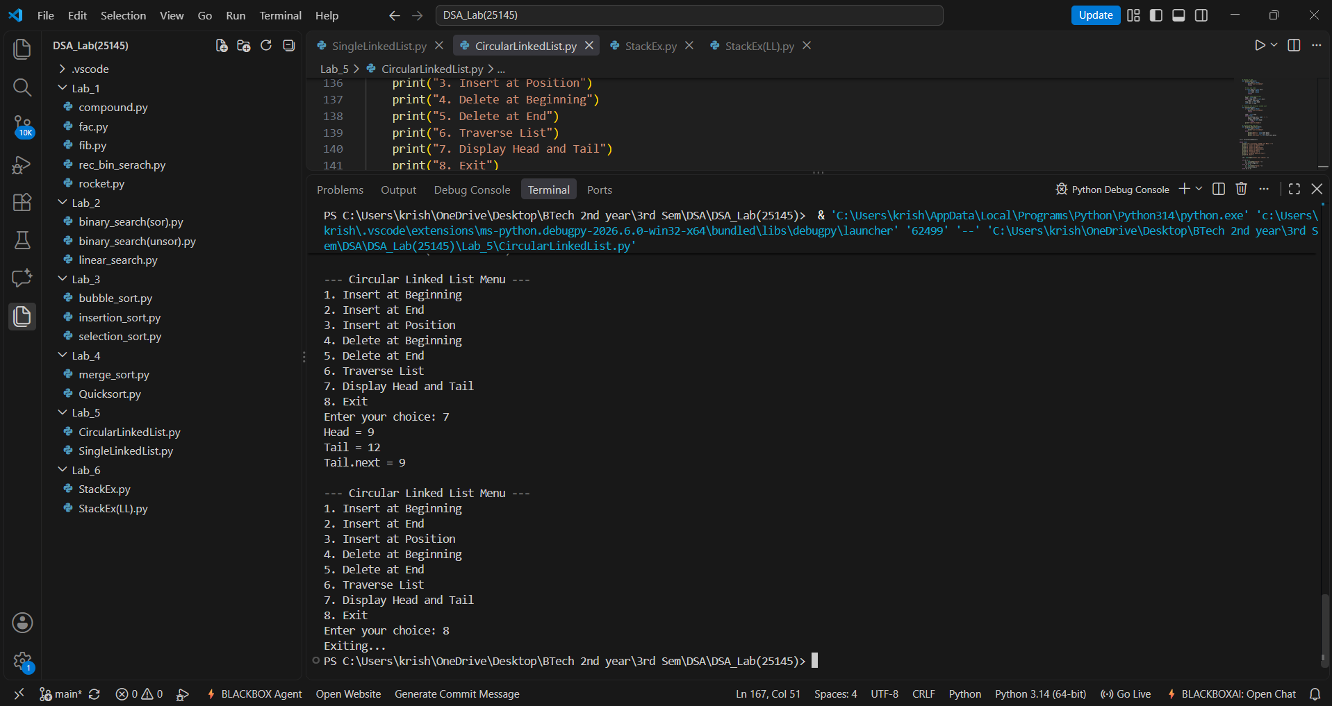

Output(-Ve Case):
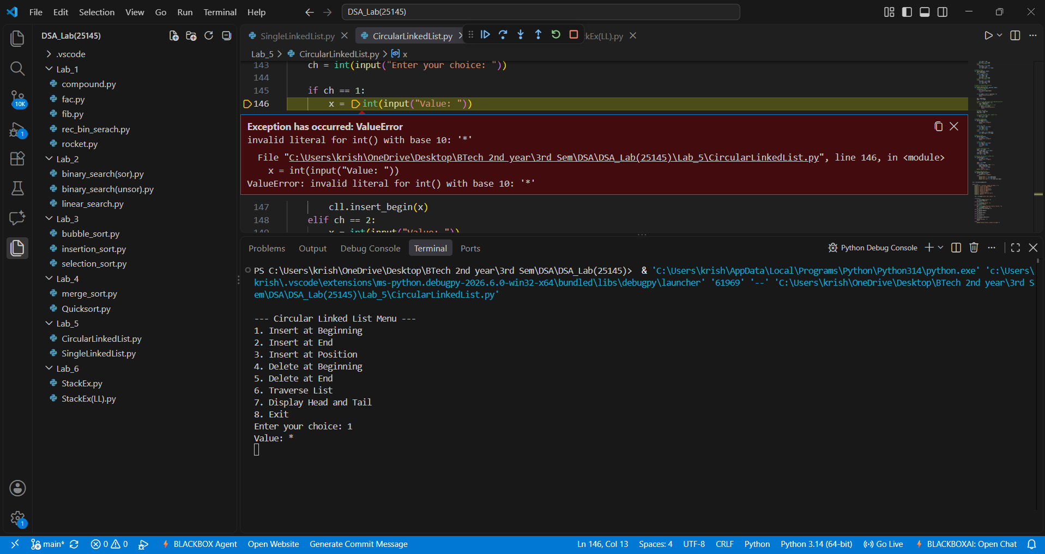

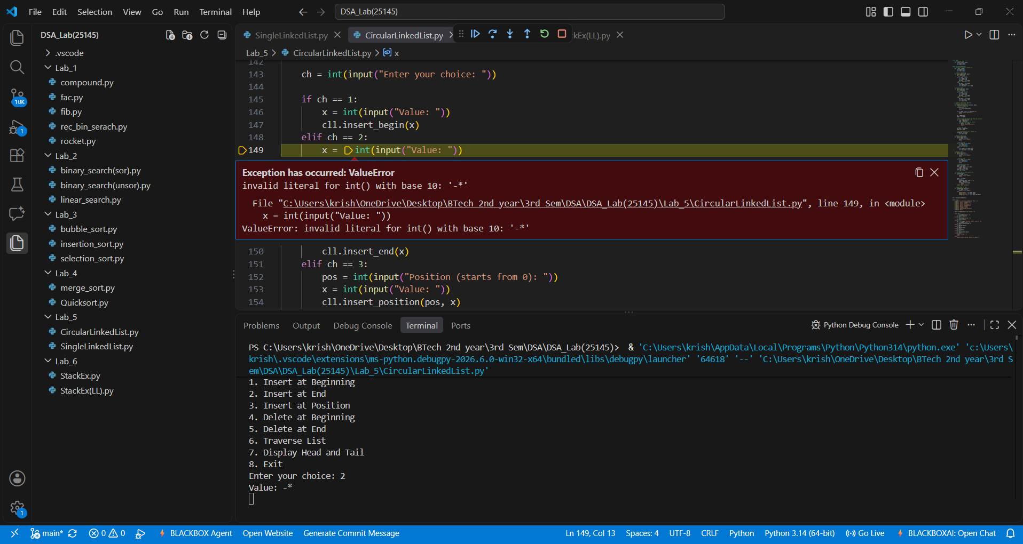
Explanation:
The given Circular Linked List accepts only integer values giving values other than the integer data type such as float or special characters or strings results in this type of Value Error.

Error Table:
Line No. | Code with Error | Correct Code
17 | if self.head == None: | if self.head is None:
38 | self.tail.next = Node(new) | self.tail.next = new
49 | if self.head is None and position < 0: | if self.head is None or position < 0:
84 | self.head = head.next | self.head = self.head.next
114 | print(temp.data, end=" ") | print(temp.data, end=" -> ")

LAB-6:
1.)Stack Implementation:
A.) Aim: Write a python program to implement various stack operations such as push , pop , peak , display using an array.
Program:
class StackEx:
# Initialize Stack
def __init__(self, size):
self.size = size
self.stack = [None] * size
self.top = -1

# Push operation
def push(self, item):
if self.top == self.size - 1:
print("Stack Overflow")
else:
self.top += 1
self.stack[self.top] = item
print(item, "pushed into the stack")

# Pop operation
def pop(self):
if self.top == -1:
print("Stack Underflow")
else:
item = self.stack[self.top]
self.stack[self.top] = None
self.top -= 1
print(item, "popped from the stack")

# Peek operation
def peek(self):
if self.top == -1:
print("Stack is empty")
else:
print("Top element:", self.stack[self.top])

# Display operation
def display(self):
if self.top == -1:
print("Stack is empty")
else:
print("The elements of the stack are:")
for i in range(self.top, -1, -1):
print(self.stack[i])

# Create stack
size = int(input("Enter the size of the stack: "))
s = StackEx(size)
while True:
print("\n----- STACK MENU -----")
print("1. Push")
print("2. Pop")
print("3. Peek")
print("4. Display")
print("5. Exit")
choice = int(input("Enter your choice: "))
if choice == 1:
item = int(input("Enter the element to push: "))
s.push(item)
elif choice == 2:
s.pop()
elif choice == 3:
s.peek()
elif choice == 4:
s.display()
elif choice == 5:
print("Program terminated.")
break
else:
print("Invalid choice")

Output(+Ve Case):
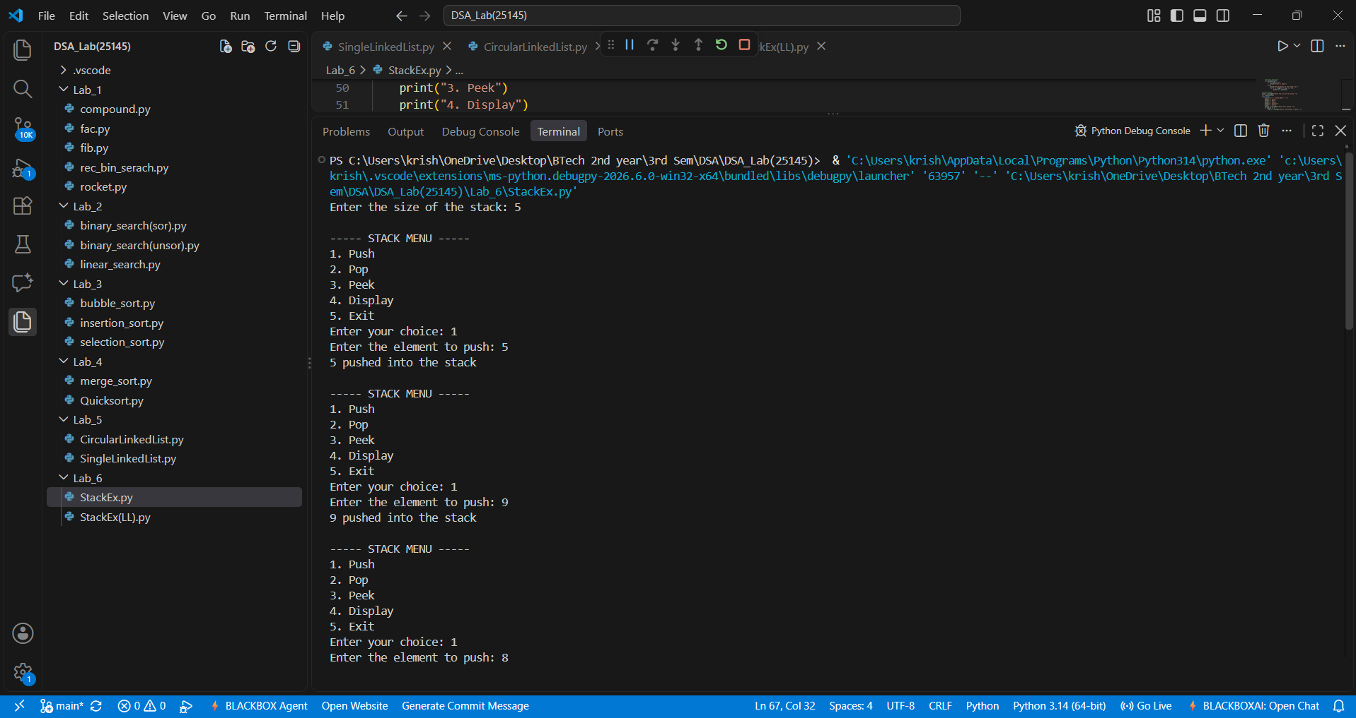
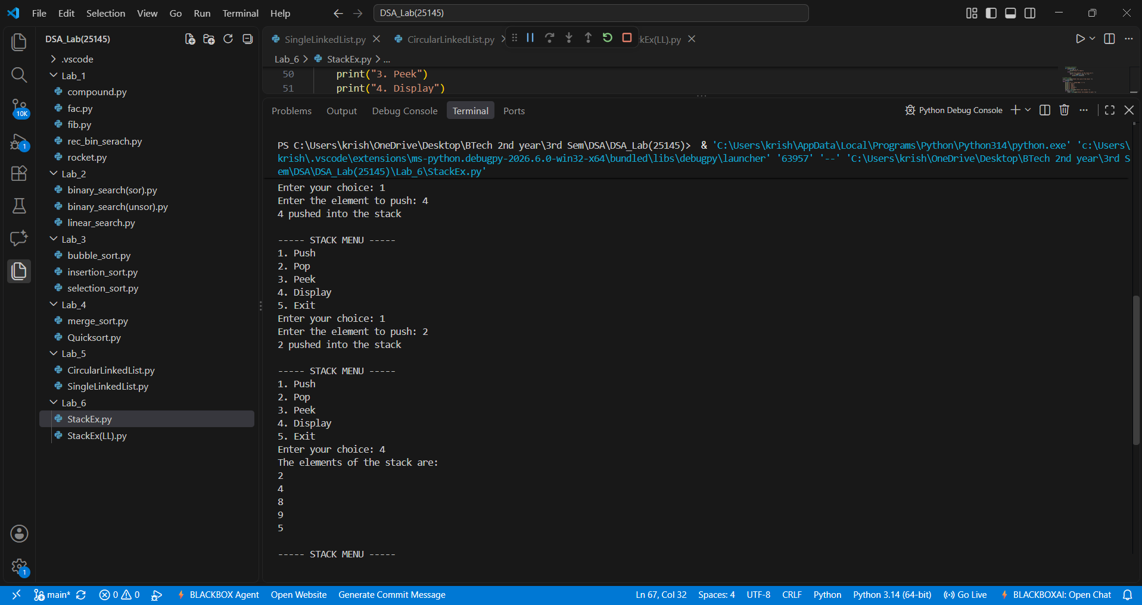

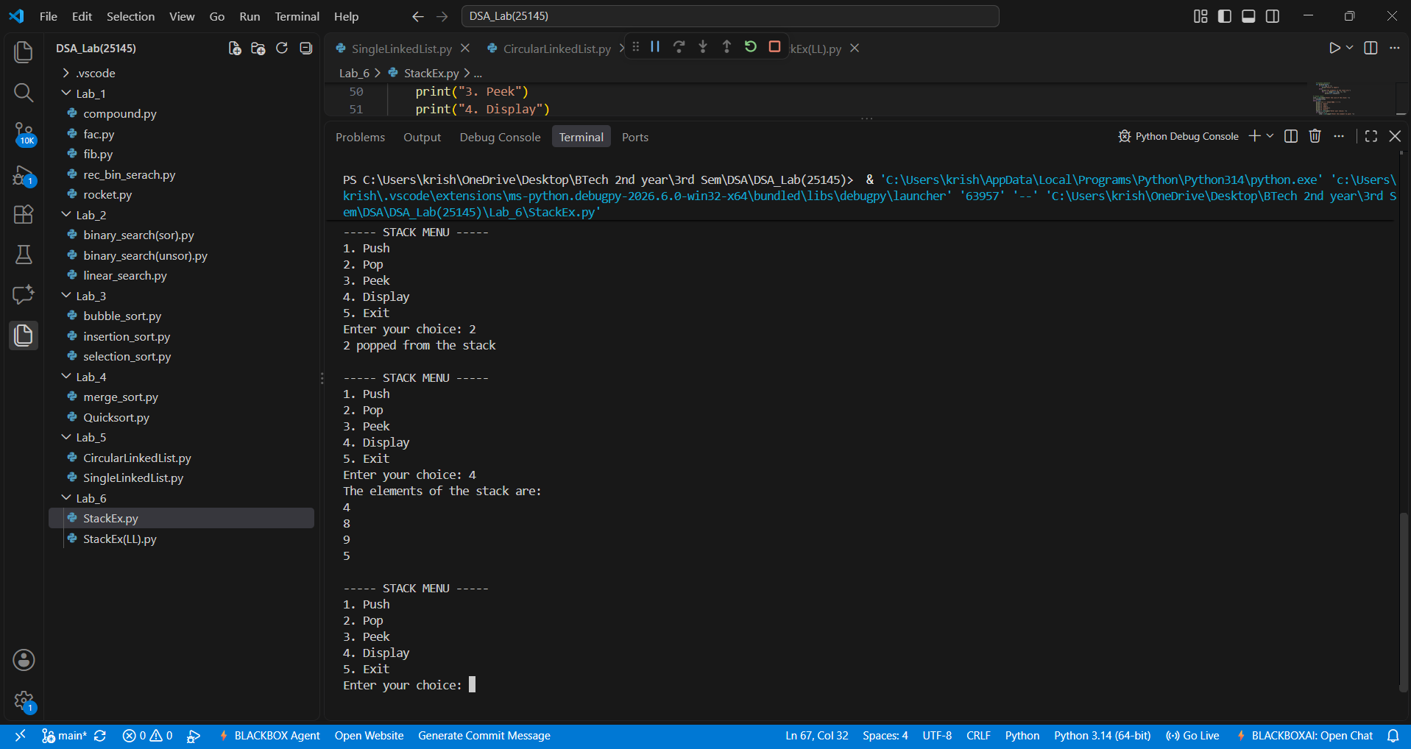
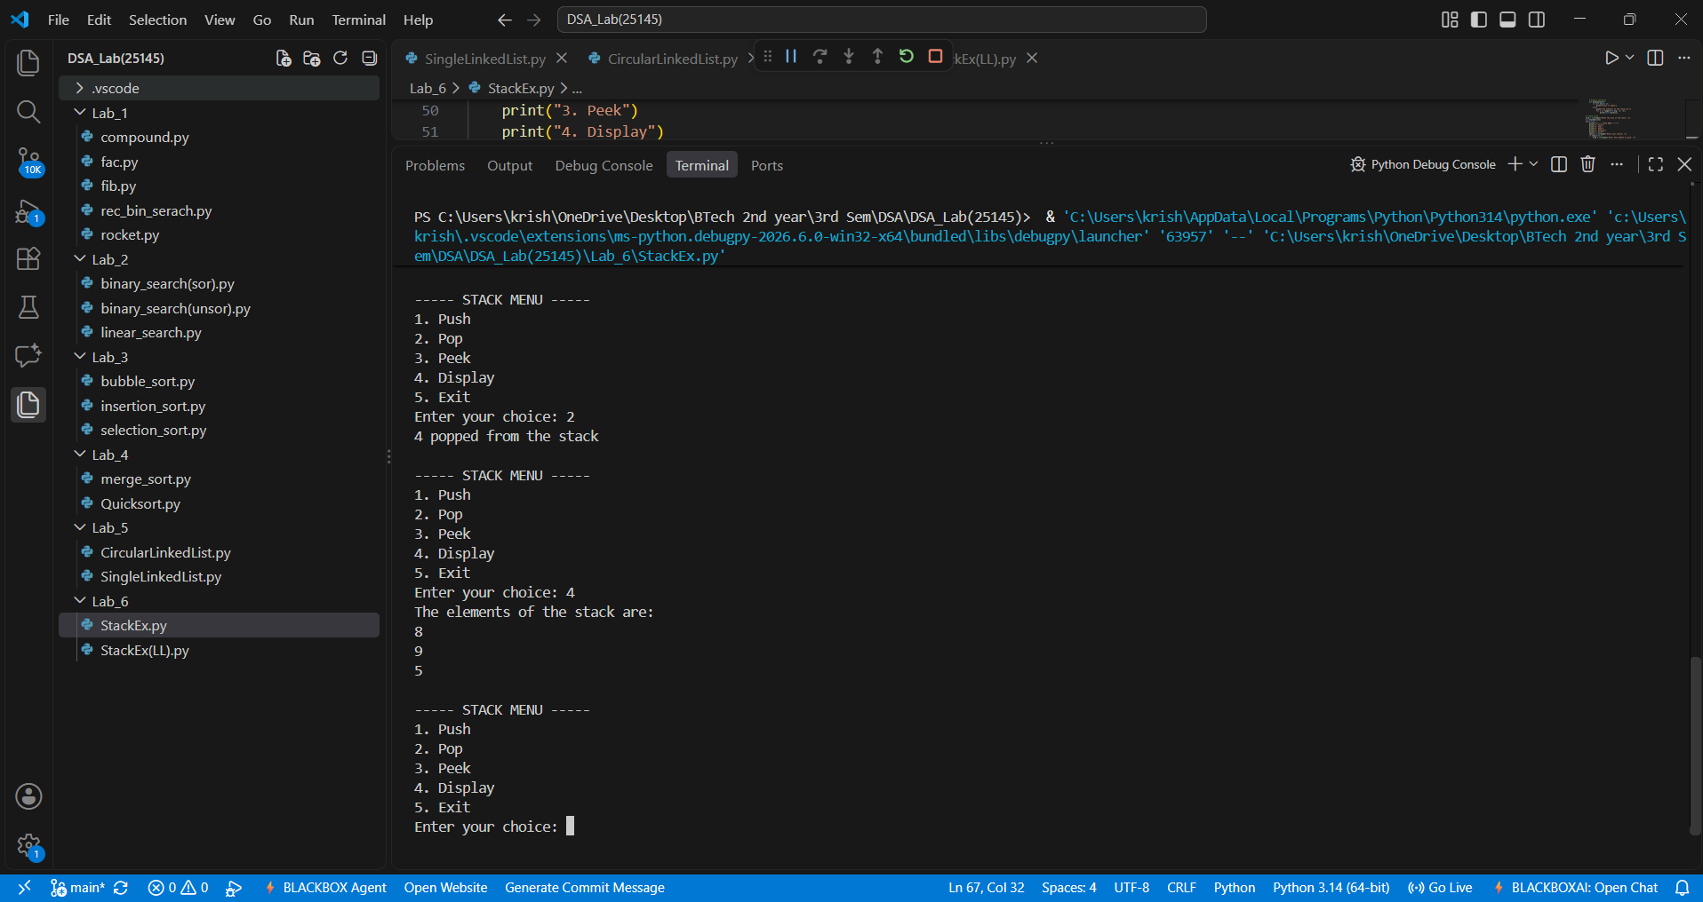

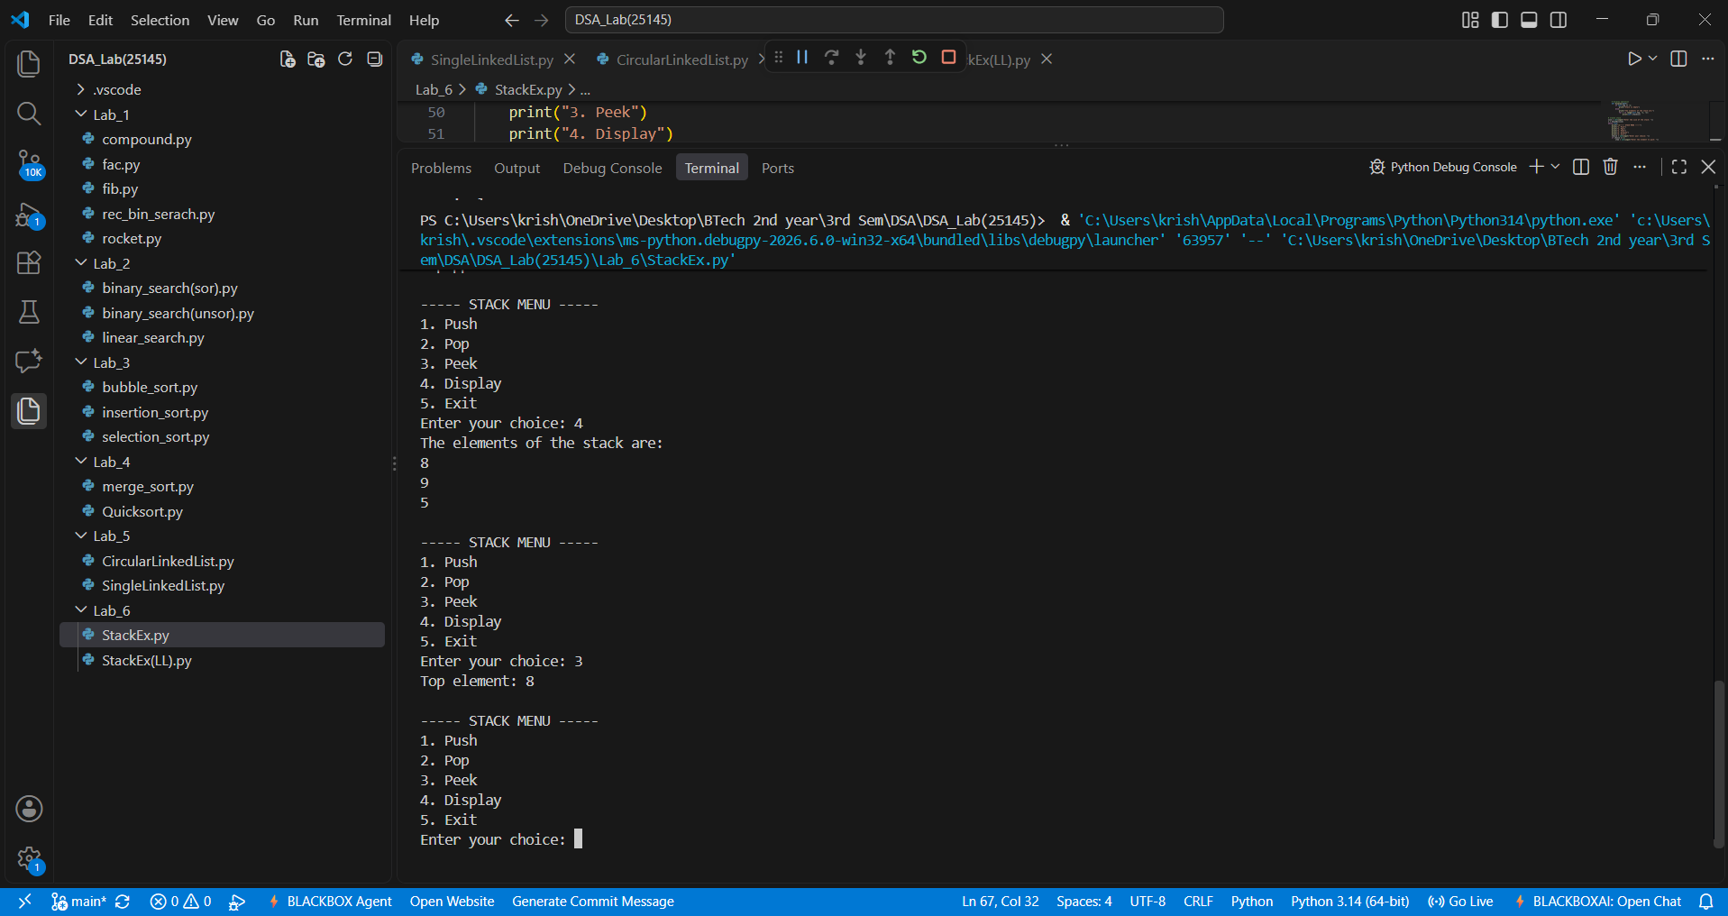
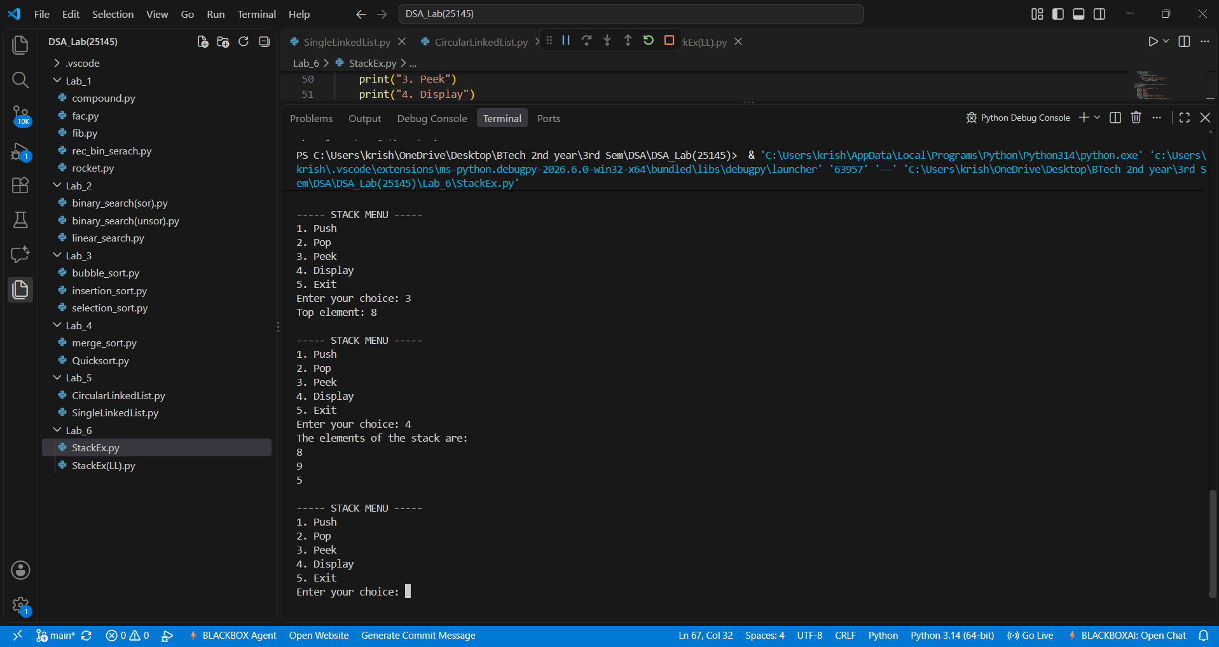

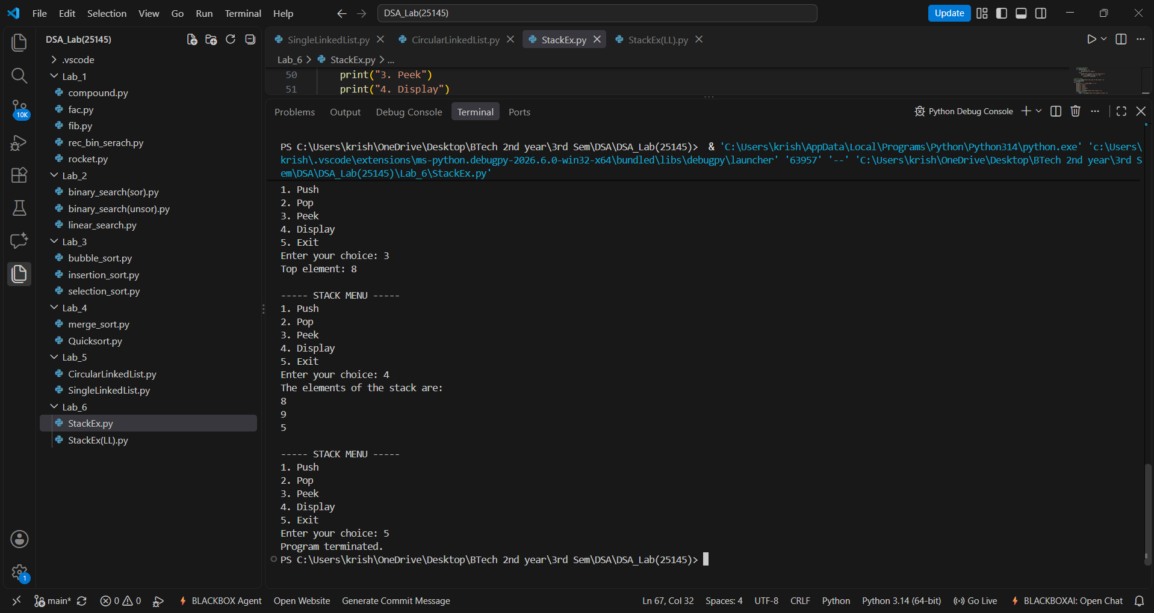

Output(-Ve Case):
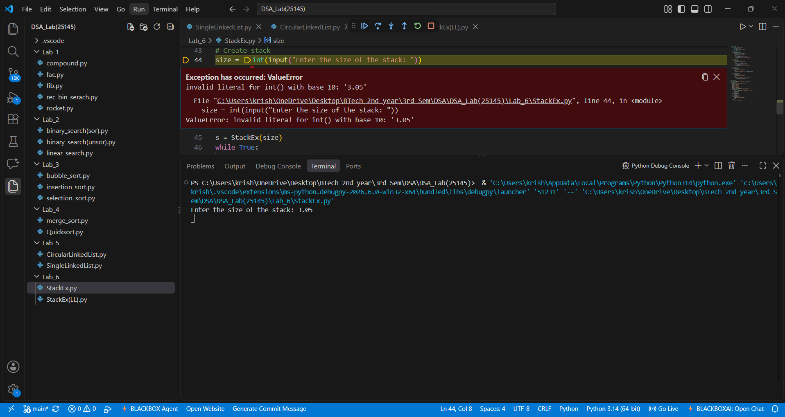
Explanation:
The given Stack accepts only integer values giving values other than the integer data type such as float or special characters or strings results in this type of Value Error.
Error Table:
Line No. | Code with Error | Correct Code
5 | self.stack = [None] + size | self.stack = [None] * size
10 | if self.top == self.size: | if self.top == self.size - 1:
24 | self.top += 1 | self.top -= 1
40 | for i in range(self.top, 0, -1): | for i in range(self.top, -1, -1):
53 | choice = input("Enter your choice: ") | choice = int(input("Enter your choice: "))

B.) Aim: Write a python program to implement various stack operations such as push , pop , peak , display using a Linked List based implementation.
Program:
class Node:
# Initialize Node
def __init__(self, data):
self.data = data
self.next = None

class Stack:
# Initialize Stack
def __init__(self):
self.top = None

# Push operation
def push(self, data):
new = Node(data)
new.next = self.top
self.top = new
print(data, "pushed into stack")

# Pop operation
def pop(self):
if self.top is None:
print("Stack Underflow")
else:
temp = self.top
print(temp.data, "popped from stack")
self.top = self.top.next

# Peek operation
def peek(self):
if self.top is None:
print("Stack is empty")
else:
print("Top element:", self.top.data)

# Display operation
def display(self):
if self.top is None:
print("Stack is empty")
else:
temp = self.top
print("Stack elements:")
while temp is not None:
print(temp.data)
temp = temp.next

s = Stack()
while True:
print("\n--- STACK USING LINKED LIST ---")
print("1. Push")
print("2. Pop")
print("3. Peek")
print("4. Display")
print("5. Exit")
choice = int(input("Enter your choice: "))
if choice == 1:
data = int(input("Enter the element: "))
s.push(data)
elif choice == 2:
s.pop()
elif choice == 3:
s.peek()
elif choice == 4:
s.display()
elif choice == 5:
print("Program terminated")
break
else:
print("Invalid choice")

Output(+Ve Case):
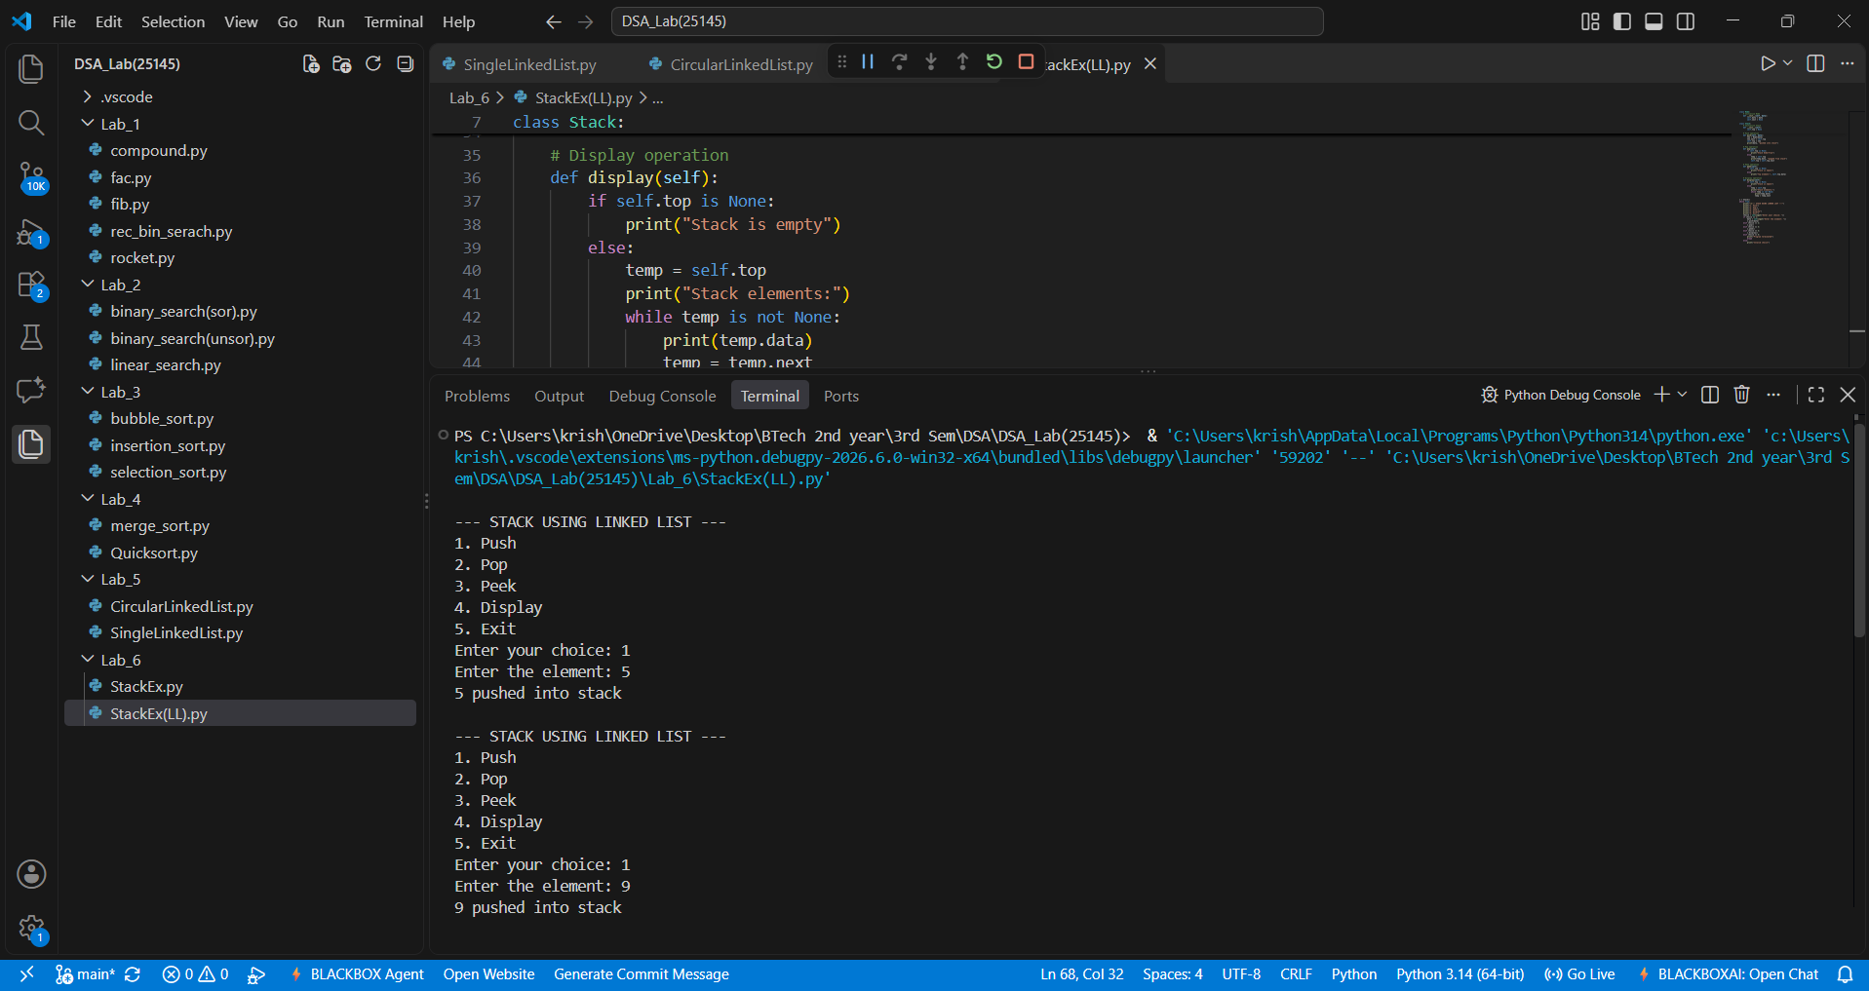
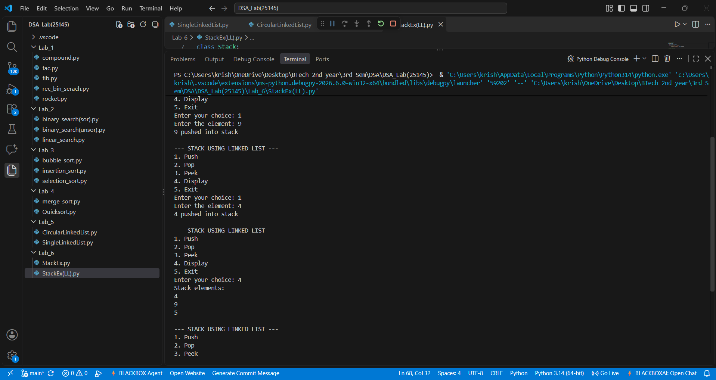

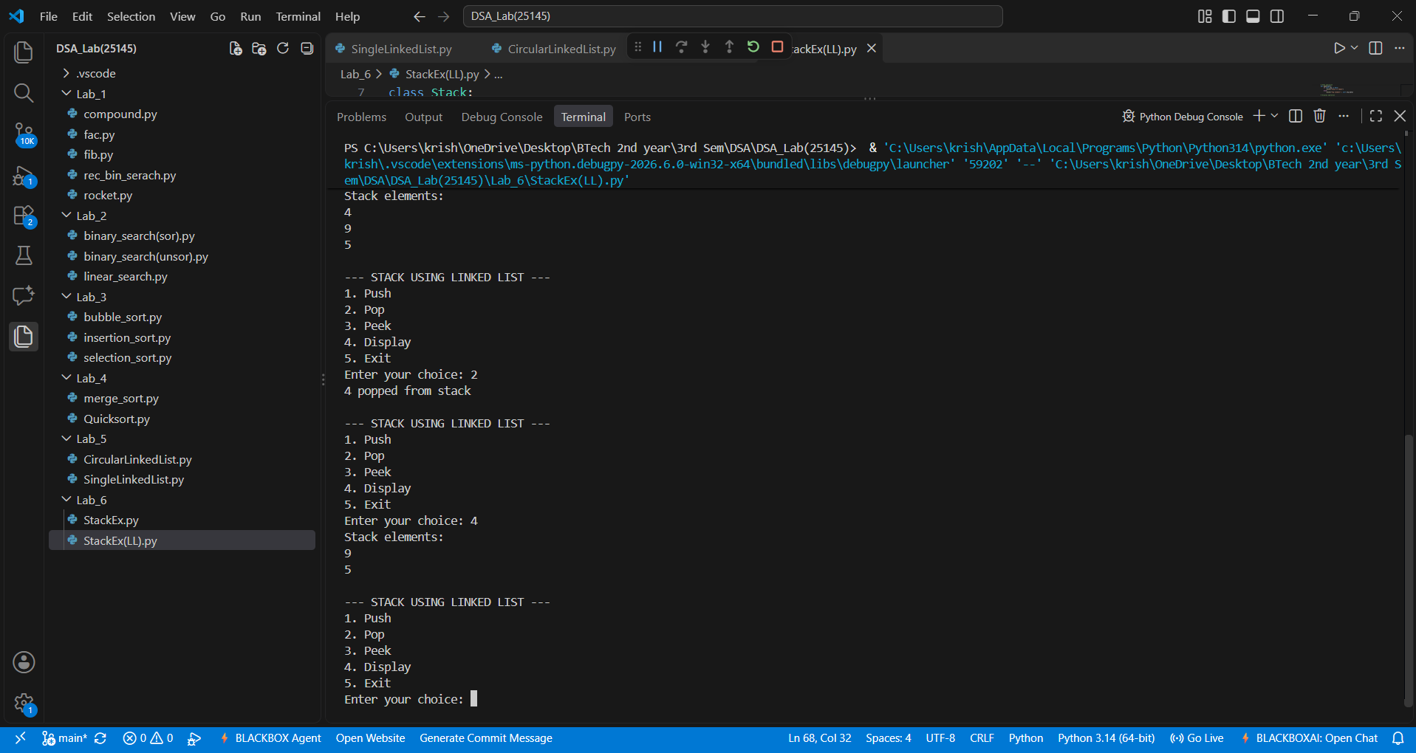
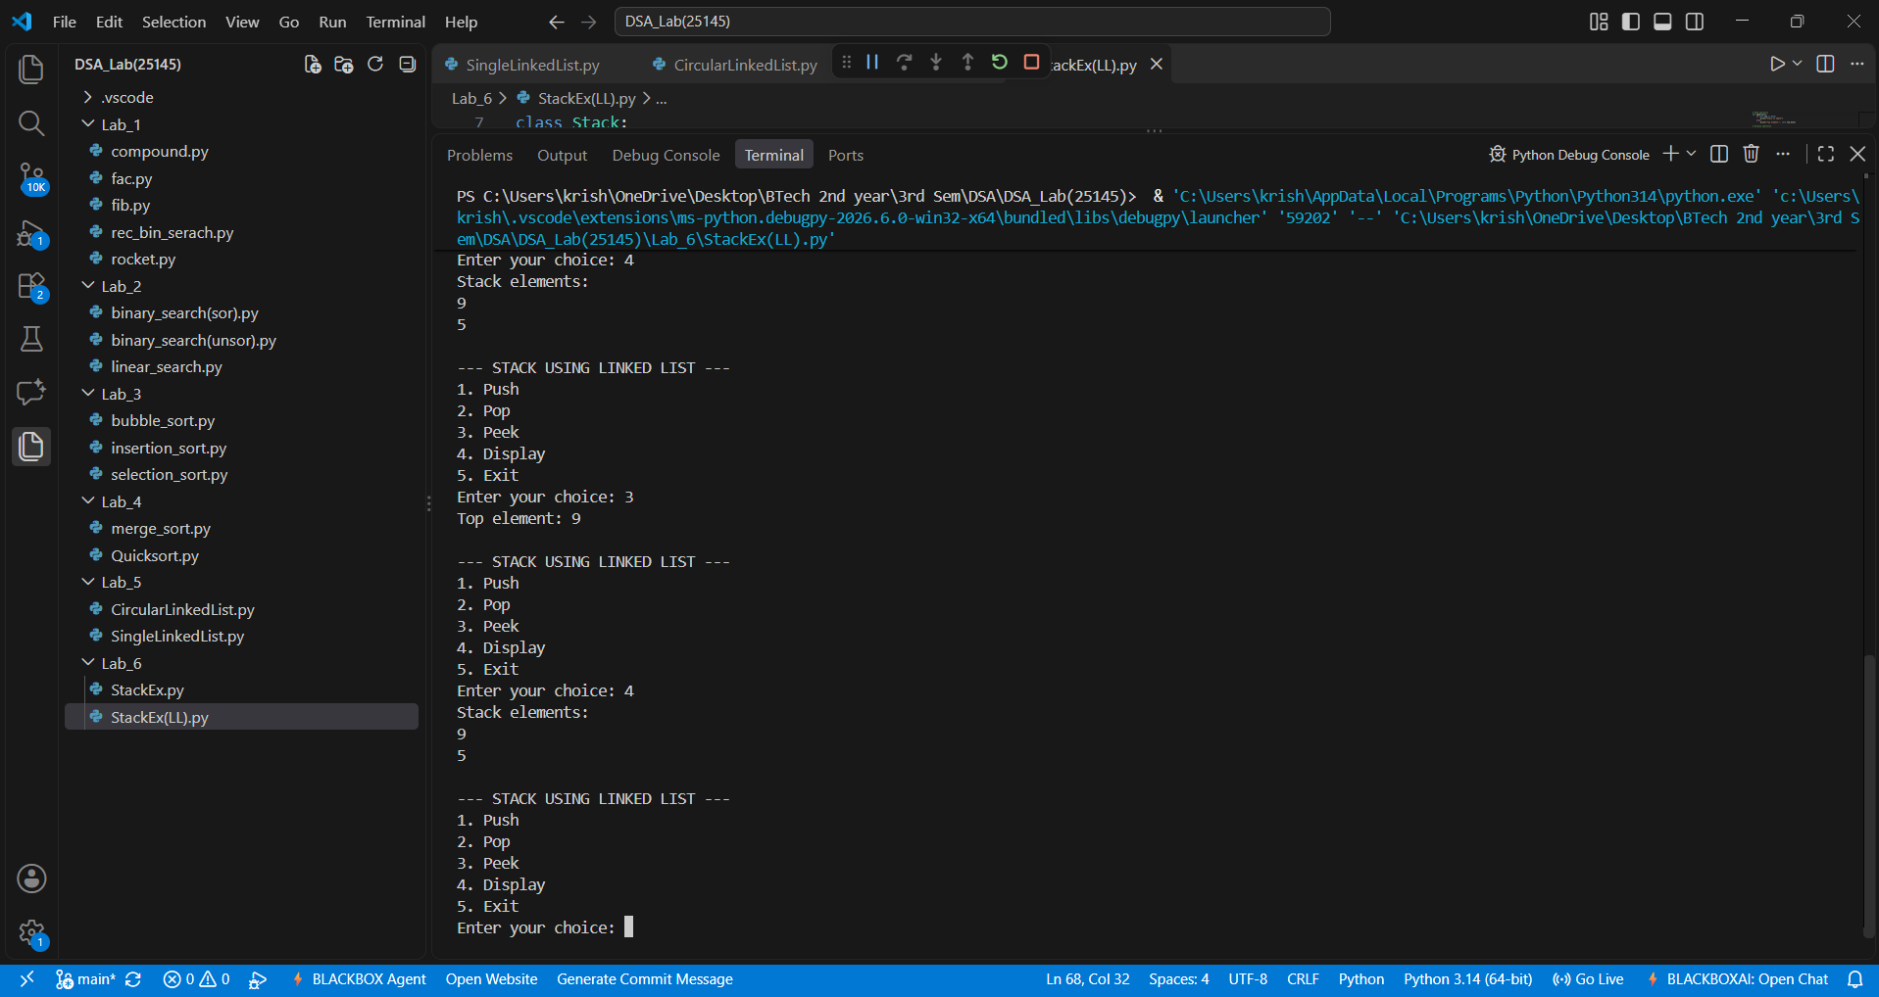

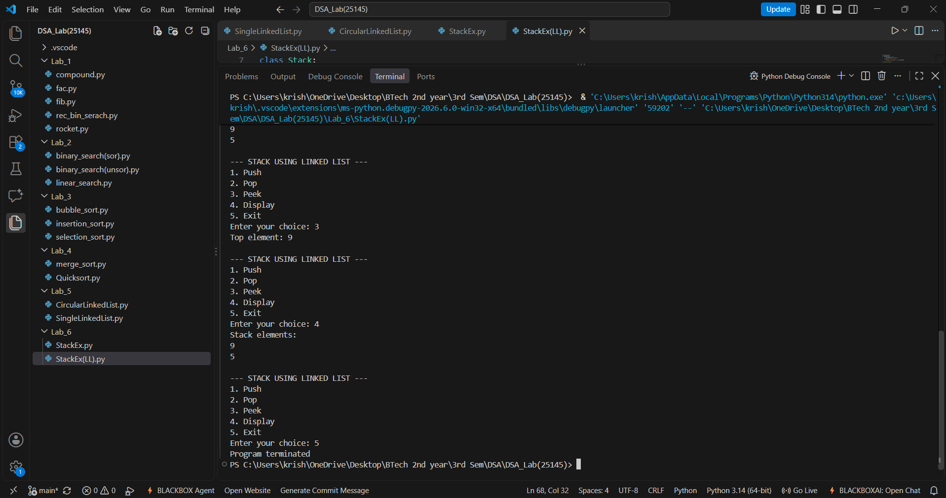

Output(-Ve Case):
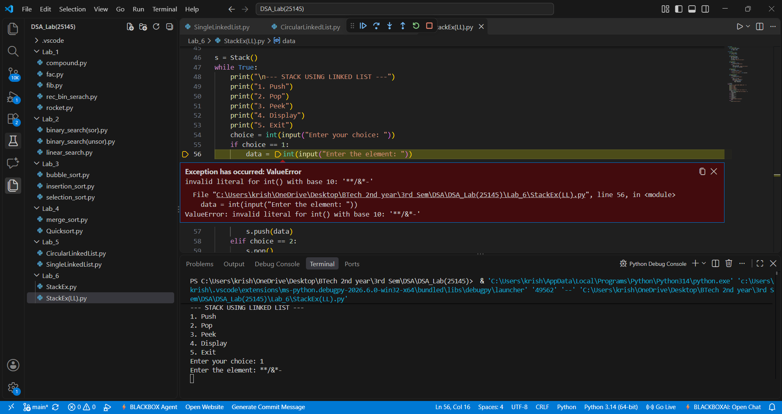
Explanation:
The given Stack accepts only integer values giving values other than the integer data type such as float or special characters or strings results in this type of Value Error.
Error Table:
Line No. | Code with Error | Correct Code
15 | new.next = self.head | new.next = self.top
21 | if self.top == 0: | if self.top is None:
26 | self.top = temp | self.top = self.top.next
44 | temp = self.top.next | temp = temp.next
56 | data = input("Enter the element: ") | data = int(input("Enter the element: "))

LAB-7:
1.) Queue Implementation:
A.) Aim: Write a program to implement queue and its operations such as enqueue, dequeue, peek, display with a menu driven approach using arrays
Program:

