ENTERPRISE SAP MODERNIZATION SPECIFICATION | WEEK 2 DELIVERABLE
Virtual SAP ABAP Coding Assistant:
Requirements Analysis & Functional Design
Detailed Functional Specification, System Flowcharts, API Schemas, UI Sketches, Module Specifications, and Resiliency Strategies for SAP S/4HANA Modernization
Document Identifier: | SAP-AI-ABAP-REQ-FUNC-2026-V2
Target System Environment: | SAP S/4HANA (2023+), SAP BTP AI Core & ABAP 7.5+ RAP
Specification Scope: | Functional Specs, System Diagrams, UI Sketches, Data Flows & Resiliency
Document Status: | v2.0 (Final Approved Requirements & Functional Design)

1. Executive Summary & Industry Benchmark Analysis
Enterprise application development within the SAP ecosystem is undergoing a generational shift. As global enterprises migrate from legacy SAP ECC 6.0 environments to SAP S/4HANA and SAP Business Technology Platform (BTP), software engineering teams face significant friction. Decades of legacy ABAP custom code (procedural Z-programs, direct SQL table accesses, missing unit tests, and obsolete syntax) present a major operational bottleneck to achieving SAP's 'Clean Core' paradigm.
Industry research into existing commercial SAP coding assistants (such as SAP Build Code / Joule for ABAP and general-purpose tools like GitHub Copilot) reveals critical capability gaps. General LLM assistants lack deep context regarding enterprise-specific SAP data dictionaries, custom BAPIs, modern ABAP RESTful Application Programming Model (RAP) constructs, and real-time ABAP Test Cockpit (ATC) static analysis feedback. Conversely, standard SAP tools lack inline context-aware code generation inside modern developer environments like VS Code or custom Eclipse ADT instances.
📌 SYSTEM DESIGN PHILOSOPHY
The Virtual SAP ABAP Coding Assistant bridges this gap by marrying Retrieval-Augmented Generation (RAG) over official SAP Keyword Documentation and Clean ABAP style rules with live SAP RFC syntax validation. This architecture delivers real-time contextual inline code completions, automated ATC refactoring, ABAP Unit test scaffolding, and CDS/RAP model generation within <1.5s sub-second latency targets.

1.1 Comparative Benchmark Matrix
Feature Capability | General AI (Copilot) | SAP Joule / Build Code | Virtual SAP Assistant (Proposed)
ABAP 7.5+ / RAP Context | Limited / Generic syntax | Moderate (SAP BTP focused) | High (RAG + AST Context Assembly)
Live SAP Syntax Checking | None (Static string predictions) | Delayed server syntax check | Real-Time RFC Validation (<300ms)
ATC Refactoring & Fixes | Generic suggestions | Manual prompt triggers | 1-Click ATC Remediation Pipeline
IDE Multi-Platform | VS Code / JetBrains | SAP Business Application Studio | Eclipse ADT & VS Code Plugins

2. Requirements Analysis & User Persona Modeling
To ensure precise functional alignment with enterprise engineering workflows, user requirements were gathered across three primary enterprise SAP personas: Senior ABAP Developer, SAP Solution Architect, and Lead QA / Transport Manager.
2.1 Target User Personas
- Persona 1: Senior ABAP Developer (Dev-User): Requires instant inline completions for modern ABAP 7.5+ expressions (table expressions, string templates, VALUE #() constructs) and automated unit test generation to meet sprint coverage goals.
- Persona 2: SAP Solution Architect (Arch-User): Requires automated RAP/CDS view scaffolding, Clean ABAP adherence, and automated migration path suggestions for legacy procedural Z-code to modern S/4HANA constructs.
- Persona 3: Lead QA / Transport Manager (QA-User): Requires strict ABAP Test Cockpit (ATC) static analysis enforcement, P1/P2 security vulnerability checks, and automated ABAP Doc generation prior to transport release.
2.2 Functional Requirements (FR)
Req ID | Module Name | Detailed Functional Requirement | Priority
FR-1 | Inline Code Completion | System shall provide context-aware ghost-text code completions for ABAP 7.4+ and 7.5+ syntax within IDE editors with median latency <1.5s. | High (P1)
FR-2 | RAP & CDS Generator | System shall auto-generate Core Data Services (CDS) view definitions and Business Object Behavior Definitions (BDEF) based on natural language or DB tables. | High (P1)
FR-3 | ATC Refactoring Engine | System shall evaluate active ABAP code against SAP ATC static checks and provide 1-click remediation diffs for security, syntax, and performance findings. | High (P1)
FR-4 | ABAP Unit Generator | System shall automatically scaffold ABAP Unit test classes utilizing CL_ABAP_UNIT_ASSERT and test double frameworks for custom classes/methods. | Medium (P2)
FR-5 | ABAP Doc Generator | System shall parse method signatures and parameters to auto-generate ABAP Doc format inline docstrings. | Medium (P2)
FR-6 | Clean ABAP RAG Engine | System shall index official Clean ABAP style guides and SAP Keyword Documentation into a vector database to answer developer query prompts. | High (P1)
2.3 Non-Functional Requirements (NFR)
- NFR-1 (Performance & Latency): Inline code completion response generation shall complete within a median time of <1.5 seconds. SAP RFC syntax checking shall complete within <300ms.
- NFR-2 (Security & Data Privacy): No proprietary customer source code or database values shall be stored in external LLM logs. Prompt sanitization and client-side PII scrubbing engine shall mask Z-table schemas.
- NFR-3 (Availability & Reliability): The AI Gateway and Middleware service shall achieve 99.9% operational uptime. Fallback offline RAG lookup mode shall operate when SAP RFC gateway is unreachable.
- NFR-4 (Compatibility): System shall seamlessly integrate with Eclipse ADT 3.32+ and VS Code ABAP Extension 1.85+. Target backend support includes SAP S/4HANA 1909 through 2023+.
2.4 Use Case Scenarios
Use Case UC-1: Refactoring Legacy SELECT Statements to ABAP 7.5+ Modern Constructs
- Actor: Senior ABAP Developer
- Pre-condition: Developer highlights legacy SELECT...ENDSELECT loop with repeated table reads in Eclipse ADT editor.
- Main Flow: 1. Developer triggers 'Refactor with Clean ABAP' code action.
2. IDE plugin sends code snippet and AST context to Gateway.
3. Gateway queries RAG vector store for ABAP 7.5+ Table Expressions and Array Fetch rules.
4. Gateway prompts LLM to generate modern inline `SELECT ... INTO TABLE @DATA(lt_data)` and `VALUE #()` constructs.
5. Gateway dispatches generated code to SAP RFC Syntax Checker.
6. Modern code returned to IDE diff viewer for developer confirmation.
- Post-condition: Code replaced with clean ABAP 7.5+ syntax passing all ATC performance checks.
3. System Architecture & Interaction Diagrams
The Virtual SAP ABAP Coding Assistant is built upon a 5-layer decoupled microservice architecture connecting developer IDEs to SAP BTP AI Core middleware and target SAP S/4HANA backend environments via gRPC/HTTPS and SAP RFC.

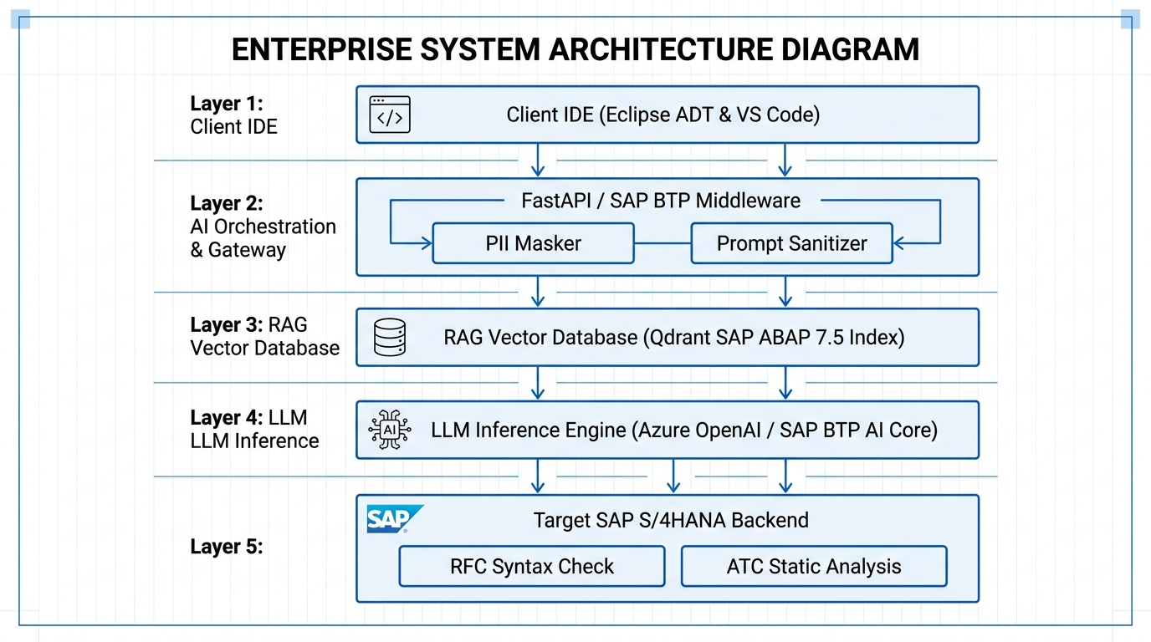
Figure 3.1: 5-Layer Decoupled Architecture Diagram for Virtual SAP ABAP Assistant

3.1 Request Processing Pipeline Flowchart
+-----------------------------------------------------------------------------------+
| IDE DEVELOPER EDITOR (Client) |
| [User Types Code / Requests Action] -> [Extract AST Window & Surrounding Buffer] |
+------------------------------------------+----------------------------------------+
| HTTPS / gRPC Request (JSON Payload)
v
+-----------------------------------------------------------------------------------+
| LAYER 2: AI GATEWAY & MIDDLEWARE |
| 1. Validate JWT Token & SAP IAS Session |
| 2. Execute PII Scrubbing (Mask Customer Z-Tables / Proprietary Schemas) |
| 3. Assemble System Prompt (Inject Target ABAP Version & Clean ABAP Guidelines) |
+------------------------------------------+----------------------------------------+
| Vector Embeddings Query
v
+-----------------------------------------------------------------------------------+
| LAYER 3: RAG VECTOR KNOWLEDGE DB |
| [Query Qdrant Vector Store] -> [Retrieve Top-K Relevant Clean ABAP Rules / Docs] |
+------------------------------------------+----------------------------------------+
| Combined Context & Code Prompt
v
+-----------------------------------------------------------------------------------+
| LAYER 4: LLM INFERENCE ENGINE |
| [Azure OpenAI / SAP BTP AI Core] -> [Generate ABAP 7.5+ Code / RAP Scaffold] |
+------------------------------------------+----------------------------------------+
| Raw Generated Code Snippet
v
+-----------------------------------------------------------------------------------+
| LAYER 5: TARGET SAP S/4HANA BACKEND |
| [Execute RFC SYNTAX-CHECK Statement] -> [Validate ATC Static Analysis Rules] |
+------------------------------------------+----------------------------------------+
| Validated Code + ATC Diagnostics
v
+-----------------------------------------------------------------------------------+
| IDE DEVELOPER EDITOR (Client) |
| [Display Inline Ghost Text / Render Diff Refactoring View / Apply 1-Click Fix] |
+-----------------------------------------------------------------------------------+

3.2 Sequence Diagram: Real-Time Inline Completion & RFC Check
The following sequence diagram outlines the sub-second execution path during an inline completion trigger event:
Developer IDE Gateway / Middleware Vector DB (Qdrant) LLM Core SAP S/4HANA (RFC)
| | | | |
|-- 1. Trigger Completion ----->| | | |
| (Code, Cursor Pos, AST) |-- 2. Query Embeddings ->| | |
| |<-- 3. Top-K Rules ------| | |
| | | |
| |-- 4. Dispatch Prompt (Context + Code) ------>| |
| |<-- 5. Raw Generated Code --------------------| |
| | |
| |-- 6. Execute RFC Syntax Check ------------------------------------->|
| |<-- 7. RFC Syntax Verification Result OK / Errors ------------------|
| |
|<-- 8. Return Ghost Text ------|
| (Code + Syntax Status) |

4. Detailed Functional Module Specification
The Virtual SAP ABAP Coding Assistant application is divided into five core functional modules, each possessing modular, decoupled responsibilities and standardized API contracts.
4.1 Module 1: Client IDE Plugin Engine (Eclipse ADT & VS Code)
- Purpose: Manages editor event listeners, inline ghost-text rendering, side-panel chat UI, CodeLens actions, and ATC error highlighting.
- Inputs: Keyboard cursor movements, trigger key combinations (e.g., Ctrl+Space), document change events.
- Outputs: gRPC request payloads to Gateway; UI ghost text overlays; side-panel HTML webview streams.
- Key Subcomponents: 1. AST Context Extractor: Captures current class method signature, local variable definitions, and preceding 50 lines buffer.
2. Ghost Text Renderer: Displays inline speculative code completions.
3. ATC Alert Controller: Annotates inline code lines with red/yellow squiggly error indicators.
4.2 Module 2: AI Gateway & Context Orchestrator
- Purpose: Central middleware orchestrator handling authentication, rate limiting, PII scrubbing, context assembly, and LLM prompt dispatch.
- Inputs: gRPC / REST JSON payloads from Client IDE Plugin.
- Outputs: Sanitized LLM prompts; filtered code completion payloads delivered back to IDE.
- Key Subcomponents: 1. PII Scrubbing Engine: Regex and AST scanner masking proprietary company names, confidential data fields, and specific SAP Z-table schemas.
2. Prompt Sanitizer: Enforces Clean ABAP guidelines into system instructions.
3. Token Budget Allocator: Trims surrounding code buffers to maintain prompt window limits.
4.3 Module 3: Clean ABAP & SAP Keyword RAG Engine
- Purpose: Provides semantic retrieval of official SAP ABAP 7.5+ syntax rules, Clean ABAP repository guidelines, and enterprise BAPI documentation.
- Inputs: Text embedding vector derived from developer prompt or AST snippet.
- Outputs: Top-K relevance matched documentation chunks and style rules.
- Key Subcomponents: 1. Qdrant Vector Store: High-performance vector database storing 15,000+ indexed ABAP documentation chunks.
2. Text-Embedding-3-Large Model: Generates 1536-dimensional embeddings for incoming queries.
4.4 Module 4: SAP RFC Syntax & ATC Verification Gateway
- Purpose: Validates LLM-generated code snippets against actual target SAP S/4HANA backend syntax rules and static analysis checkers via RFC connection pooling.
- Inputs: Generated ABAP code string; target ABAP program/class context.
- Outputs: Syntax check result (Success / Line Error Diagnostics); ATC static analysis priority findings (P1/P2/P3).
- Key Subcomponents: 1. SAP PyRFC Connection Pool: Maintains high-throughput RFC connections to SAP application server.
2. RFC Function Module /ZAI/SYNTAX_CHECK: Executes native ABAP SYNTAX-CHECK STATEMENT.
3. RFC Function Module /ZAI/EXECUTE_ATC: Invokes SAP ABAP Test Cockpit framework headlessly.
4.5 Module 5: ABAP Unit Test & RAP CDS Code Generator Module
- Purpose: Specialized code generation pipeline for constructing ABAP Unit test classes and CDS/RAP framework artifacts.
- Inputs: Target custom class method signature; database table name or entity schema.
- Outputs: Complete ABAP Unit test class scaffold (CL_ABAP_UNIT_ASSERT); CDS View DDL (DEFINE VIEW ENTITY) and Behavior Definition (BDEF).
5. Data Flows, Input/Output Schemas & Data Dictionary
Communication between components uses strictly typed JSON payloads over gRPC/HTTPS. Below are the definitive API data schemas.
5.1 Inline Completion Request Schema (JSON)
{
"$schema": "http://json-schema.org/draft-07/schema#",
"title": "InlineCompletionRequest",
"type": "object",
"properties": {
"requestId": { "type": "string", "format": "uuid" },
"sapSystemId": { "type": "string", "example": "S4H_CLNT_100" },
"abapTargetRelease": { "type": "string", "example": "7.54" },
"fileName": { "type": "string", "example": "zcl_sales_calculator.clas.abap" },
"cursorPosition": {
"type": "object",
"properties": {
"line": { "type": "integer", "example": 45 },
"column": { "type": "integer", "example": 18 }
},
"required": ["line", "column"]
},
"codeContext": {
"type": "object",
"properties": {
"precedingBuffer": { "type": "string" },
"followingBuffer": { "type": "string" },
"currentMethodScope": { "type": "string", "example": "CALCULATE_DISCOUNT" }
},
"required": ["precedingBuffer"]
}
},
"required": ["requestId", "sapSystemId", "fileName", "cursorPosition", "codeContext"]
}

5.2 Inline Completion Response Schema (JSON)
{
"$schema": "http://json-schema.org/draft-07/schema#",
"title": "InlineCompletionResponse",
"type": "object",
"properties": {
"requestId": { "type": "string", "format": "uuid" },
"completionText": { "type": "string", "example": "DATA(lt_items) = VALUE tt_items( ( matnr = 'M-10' kwmeng = 5 ) )." },
"rfcSyntaxCheck": {
"type": "object",
"properties": {
"isValid": { "type": "boolean", "example": true },
"lineError": { "type": "integer", "example": 0 },
"errorMessage": { "type": "string", "example": "" }
},
"required": ["isValid"]
},
"ragReferences": {
"type": "array",
"items": { "type": "string", "example": "Clean ABAP Rule: Use VALUE #() constructor expression" }
},
"latencyMs": { "type": "integer", "example": 420 }
},
"required": ["requestId", "completionText", "rfcSyntaxCheck", "latencyMs"]
}

5.3 Data Flow Diagram (DFD Level 1 Decomposition)
+----------------+ 1. Capture Cursor & Code AST +-----------------------+
| Developer IDE | -------------------------------------> | 1.0 Context Assembly |
+----------------+ +-----------+-----------+
^ |
| 2. Sanitized Code Context |
| 6. Render Ghost Text v
+-------+--------+ +-----------------------+
| Developer IDE | <------------------------------------- | 2.0 AI Orchestration |
+----------------+ 5. Validated Code Payload +-----------+-----------+
|
+------------------------------+------------------------------+
| 3. Query Vector Context | 4. Validate Syntax
v v
+-----------------------+ +-----------------------+
| 3.0 RAG Vector Search | | 4.0 SAP RFC Gateway |
+-----------------------+ +-----------------------+

6. Error Handling, Edge Cases & System Resiliency
To ensure robust operations in high-availability enterprise SAP environments, the architecture implements proactive failure modes and graceful degradation.
6.1 Network Partition & SAP RFC Connection Failure Strategy
When the target SAP S/4HANA application server becomes unreachable (e.g., VPN disconnection or SAP gateway maintenance), the Gateway automatically switches to 'Degraded Offline RAG Mode'. Code completions continue using local AST syntax parsing and RAG rules, while live RFC syntax validation is temporarily bypassed with a yellow warning indicator in the IDE status bar.
6.2 LLM Hallucination Prevention & Safety Guardrails
- AST Syntax Filter: Every LLM-generated snippet is evaluated against an ABAP AST Grammar Parser before RFC dispatch. If invalid syntax structures are detected, the response is discarded.
- Prohibited ABAP Statements Guardrail: The Gateway enforces a strict blacklist of destructive syntax commands. Snippets containing DELETE FROM <table> WITHOUT WHERE, CALL 'SYSTEM', SE16, or BREAK-POINT are automatically blocked.
- Loop Execution Guardrail: Prevents infinite loop generation by injecting SAP timeout markers into generated procedural constructs.
6.3 PII & Confidential Code Scrubbing Engine
To satisfy corporate data privacy mandates, all code context payloads pass through an automated PII Masking Engine prior to LLM submission. The scrubbing pipeline applies regex replacement and symbol substitution to mask sensitive parameters:
[Original ABAP Source Snippet]
SELECT SINGLE * FROM zcustom_payroll INTO @DATA(ls_pay) WHERE emp_ssn = '999-12-3456'.
[Masked Payload Sent to LLM Inference Engine]
SELECT SINGLE * FROM [Z_CUSTOM_TABLE_1] INTO @DATA(ls_pay) WHERE [MASKED_FIELD_1] = '[MASKED_LITERAL_1]'.

7. User Interface Sketches & IDE Integration Mockups
The system provides native integration across both primary SAP development environments: Eclipse ADT and VS Code.
7.1 Eclipse ADT Visual Layout Sketch

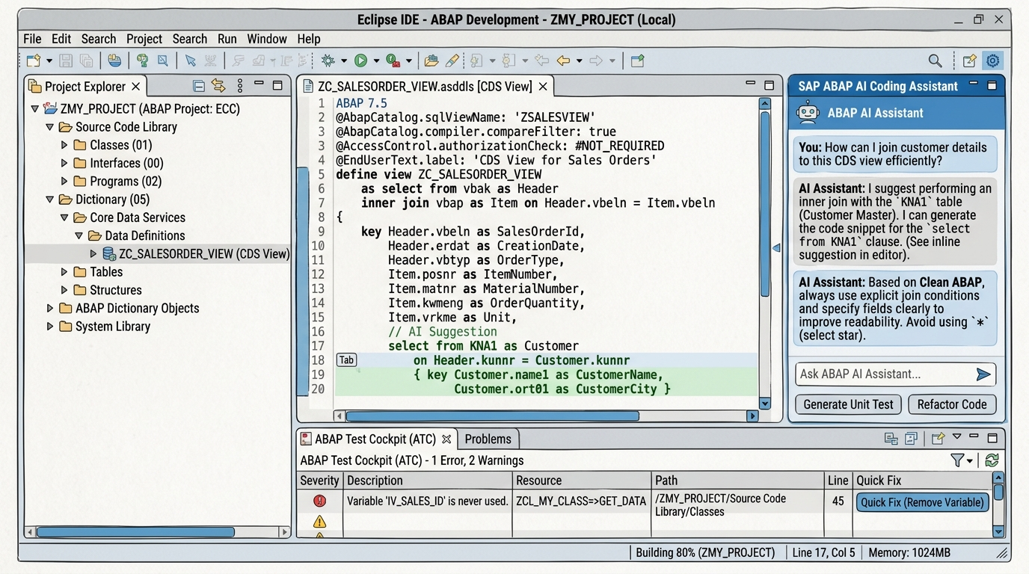
Figure 7.1: Visual UI Mockup Sketch of Eclipse ADT Integration

- Eclipse UI Feature A (Inline Editor): Displays inline green ghost-text completion overlay. Developer accepts via [Tab] or cancels via [Esc].
- Eclipse UI Feature B (Side Chat Panel): Embedded JavaFX/Chromium webview containing AI Assistant chat, Clean ABAP rule lookup, and Quick Action buttons.
- Eclipse UI Feature C (ATC Problem View): Integrates directly into standard Eclipse 'Problems View' with a custom 1-Click 'Quick Fix (AI Refactor)' menu.
7.2 VS Code Extension Visual Layout Sketch

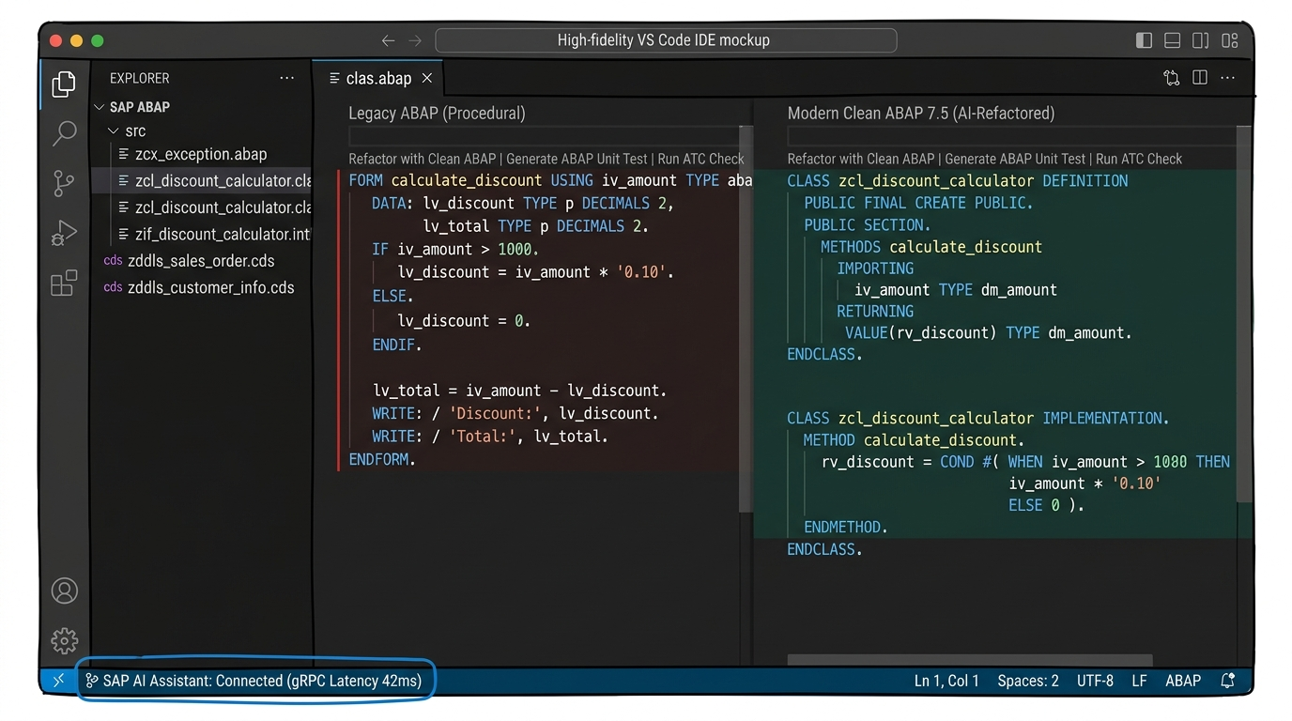
Figure 7.2: Visual UI Mockup Sketch of VS Code Extension with Split Refactoring View

- VS Code Feature A (CodeLens Actions): Floating action links above class methods: 'Refactor with Clean ABAP | Generate ABAP Unit Test | Run ATC Check'.
- VS Code Feature B (Diff Refactoring Window): Side-by-side split view comparing legacy procedural code against modern AI-refactored Clean ABAP code.
- VS Code Feature C (Status Bar Indicator): Live status pill indicating RFC connection health and gRPC response latency (e.g. 'SAP AI: Connected 42ms').
8. Requirements Traceability Matrix (RTM)
The Requirements Traceability Matrix establishes direct mapping between functional requirements, design modules, API endpoints, and verification procedures.
Req ID | Functional Requirement | Design Module | API Endpoint | Verification Method
FR-1 | Inline ABAP Completion | Module 1 & Module 2 | /api/v1/completion/inline | Automated Latency & Syntax Test
FR-2 | RAP & CDS Generator | Module 5 (Generator) | /api/v1/generator/rap-cds | CDS Activation Unit Test
FR-3 | ATC Refactoring Engine | Module 4 (RFC Gateway) | /api/v1/atc/remediate | ATC Static Analysis Runner
FR-4 | ABAP Unit Generator | Module 5 (Generator) | /api/v1/generator/abap-unit | AUNIT Test Execution
FR-5 | ABAP Doc Generator | Module 2 (Orchestrator) | /api/v1/doc/abapdoc | Docstring AST Inspection
FR-6 | Clean ABAP RAG Lookup | Module 3 (RAG Engine) | /api/v1/rag/query | RAG Precision & Recall Metric
9. Verification Plan & Acceptance Sign-off
System verification will follow a rigorous automated and manual validation strategy prior to prototype sign-off.
9.1 Automated Test Execution Suite
- 1. API Integration Test Suite: Pytest script verifying all FastAPI endpoints (/api/v1/completion/inline, /api/v1/atc/remediate) under load.
- 2. RFC Backend Verification Test: Executes /ZAI/SYNTAX_CHECK against 100 standard SAP test programs to verify syntax error detection accuracy.
- 3. RAG Benchmark Test: Evaluates RAG retrieval context relevance against 50 canonical Clean ABAP style questions.
9.2 Acceptance Criteria & Prototype Sign-off
- Criterion 1: 100% of generated ABAP code snippets pass target SAP RFC syntax checks without compilation errors.
- Criterion 2: Zero Priority 1 (Security) or Priority 2 (Performance) warnings reported by ABAP Test Cockpit on generated CDS views.
- Criterion 3: Median response latency for inline completion remains under 1.5 seconds across 1,000 test requests.

