CS598 – Data Curation Assignment 3 – Ved Chugh(vedpc2)

# Assignment 3: Ontologies / ER Diagram Design Exercise

As part of the current assignment the scope is to have a Schema integration. So far, we had assignment 1 wherein we had below shared Schema for existing dealer:

Assignment 1 – Existing Dealer Schema.

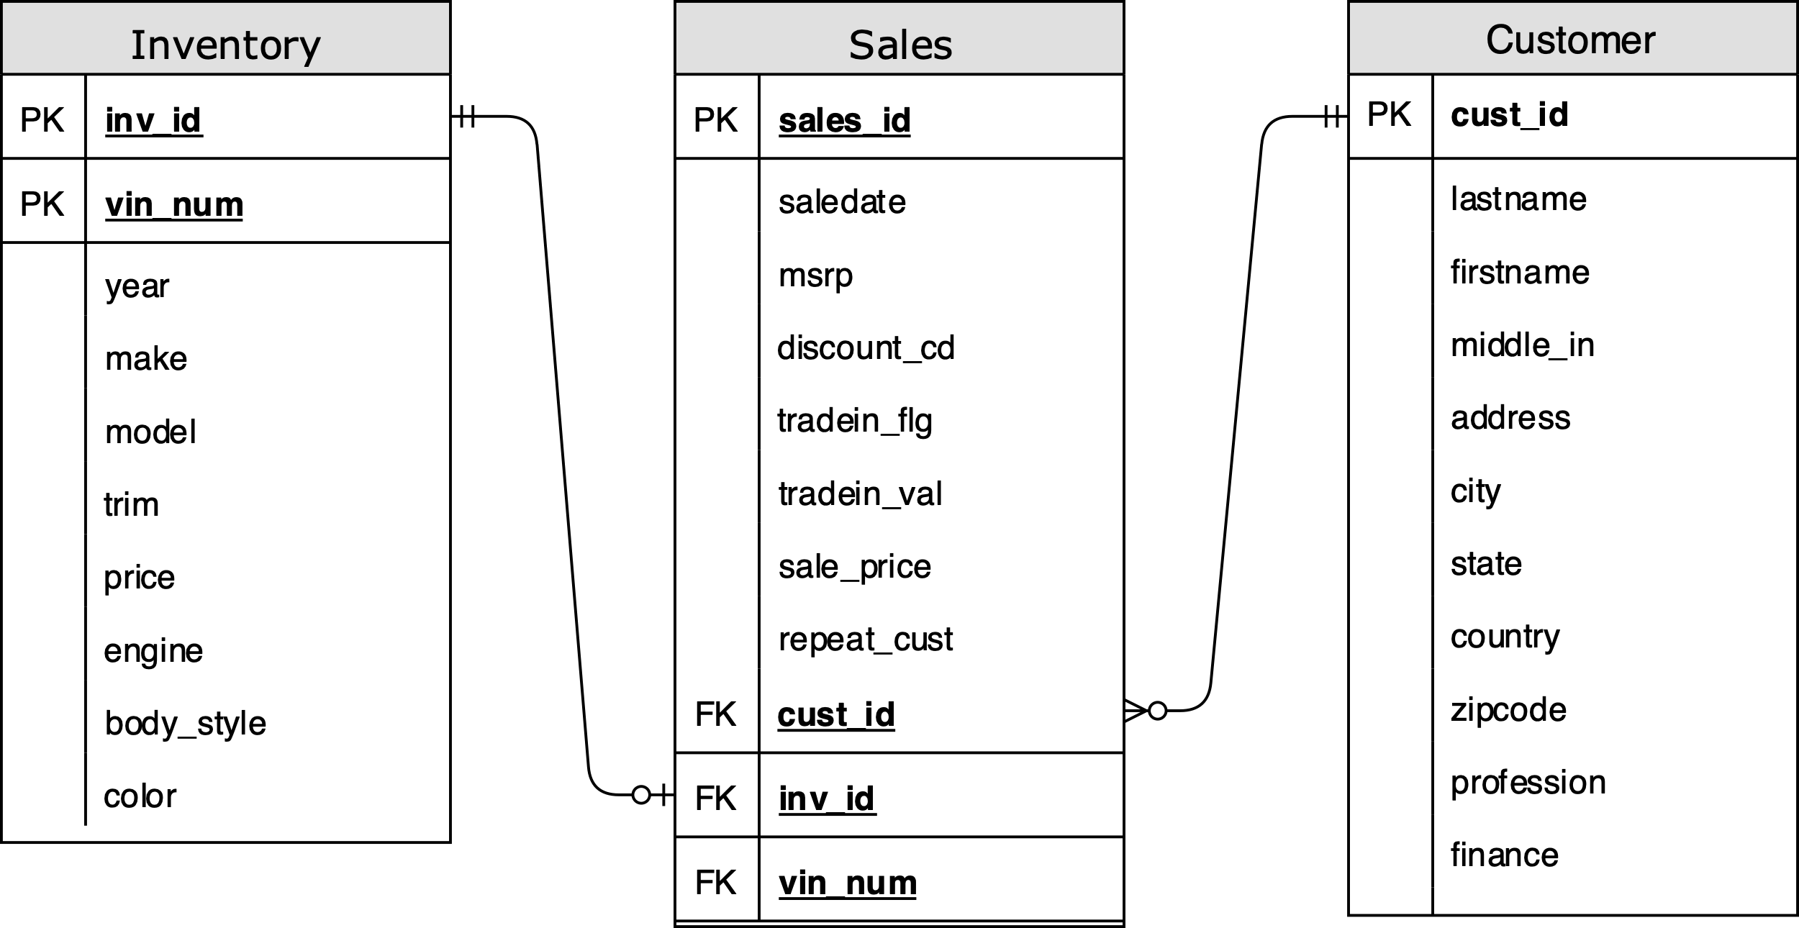

In above schema we have Crow’s foot notation used, thus helping us understand below points

1. A sale must belong(minimum) to a customer. Hence “|” added at customer end.
2. A sale can only belong to one customer. Hence “|” added at customer end.
3. A customer doesn’t have to participate in sale to exist in database. Hence “o” added at sales end.
4. And further a customer can make many sales. Hence “>” added at sales end.

Similarly, for Sales and Inventory relationship:

1. A sale must have(minimum) an inventory. Hence “|” added at inventory end.
2. A sale can only have to one inventory. Hence “|” added at inventory end.
3. An inventory doesn’t have to participate in sale to exist in database. Hence “o” added at sales end.
4. And further an inventory can be part of only one sale record. Hence “|” added at sales end.

Now the Preowned Dealer Schema

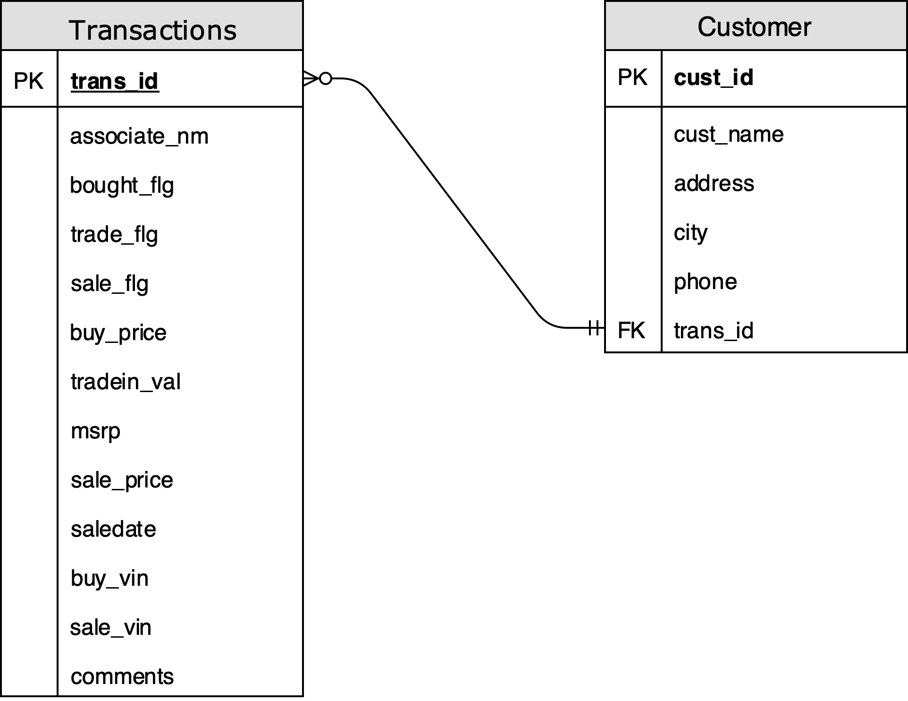

In above schema we have Crow’s foot notation used, thus helping us understand below points

1. A transaction must belong(minimum) to a customer. Hence “|” added at customer end.
2. A transaction can only belong to one customer. Hence “|” added at customer end.
3. A customer doesn’t have to participate in transaction to exist in database. Hence “o” added at sales end.
4. And further a customer can make many transactions. Hence “>” added at sales end.

Now the task in hand is to have Schema Integration. To start with here are few observations:

1. Both the schema’s have Customer table in common.
2. We have attributes which are common.
3. At first glance we see that the Sales table is ⊂ (is a kind of subset) of Transaction table.
4. And further the Inventory details are Entity in our dealer Schema, and attributes of Inventory are in Preowned Dealer Schema.

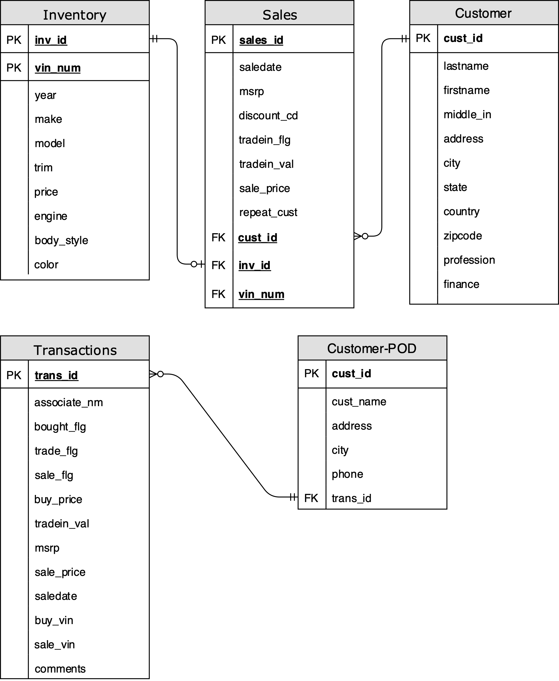

Step 1: Towards the effort to merge the customer entity, in this step we make city_master as a separate entity containing information about City/State/Country and Zipcode. Thus, below Crow’s foot notation:

1. As part of relation a Customer can have only one city associated with them.
2. A city can have multiple customers associated with it. Hence “>” notation is used. Having one to many relationships.

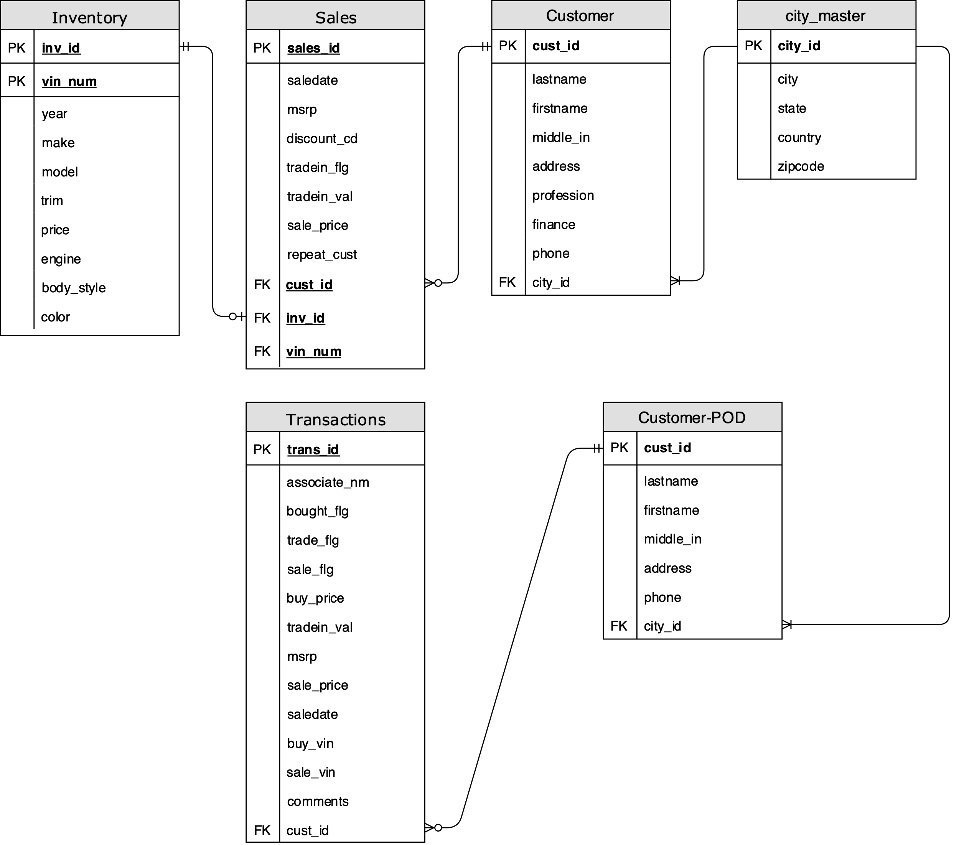

Step 2: Towards the effort to merge the customer entity, the above step of creating a city_master further helps us identify that Preowned Dealer Customer is ⊂ of Customer. Thus, we merge the two without loss of information.

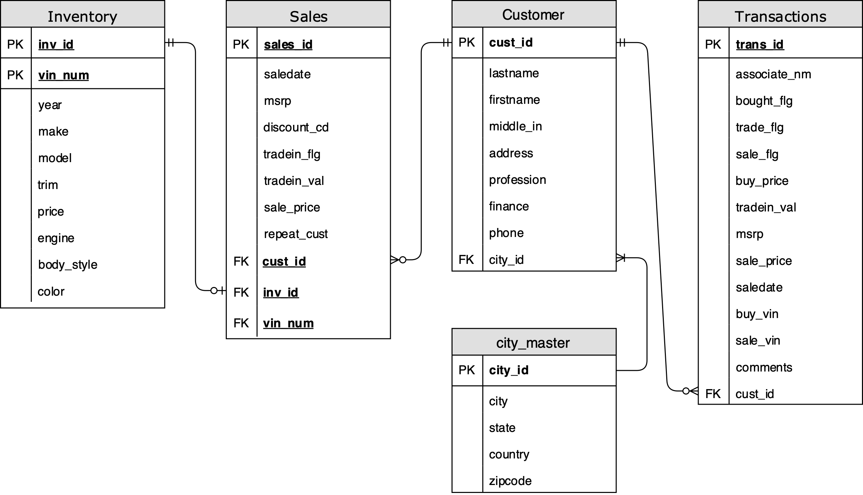

In above schema we have Crow’s foot notation used, thus helping us understand below points

1. A transaction must belong(minimum) to a customer. Hence “|” added at customer end.
2. A transaction can only belong to one customer. Hence “|” added at customer end.
3. A customer doesn’t have to participate in transaction to exist in database. Hence “o” added at sales end.
4. And further a customer can make many transactions. Hence “>” added at sales end.

We will continue with further with Step 3 on next page.

Step 3: In this step we see with reordering of Transactions table entity that the Sales table is ⊂ (is a kind of subset) of Transaction table.

And therefore, is would be safe to merge the two entities, as all Sales are a kind of transaction and thus merging the two will not lead to any information loss. So, in this step we add extra attributes to Transactions table/entity to help achieve our final merge that will be shown in Step 4.

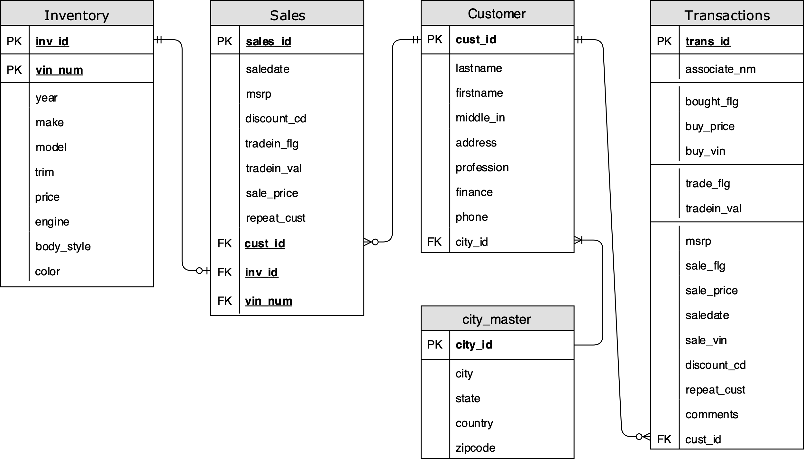

We continue with Step 4 on next page.

Step 4: In this we finally combine the schemas for the final Integrated Schema with no information lost.

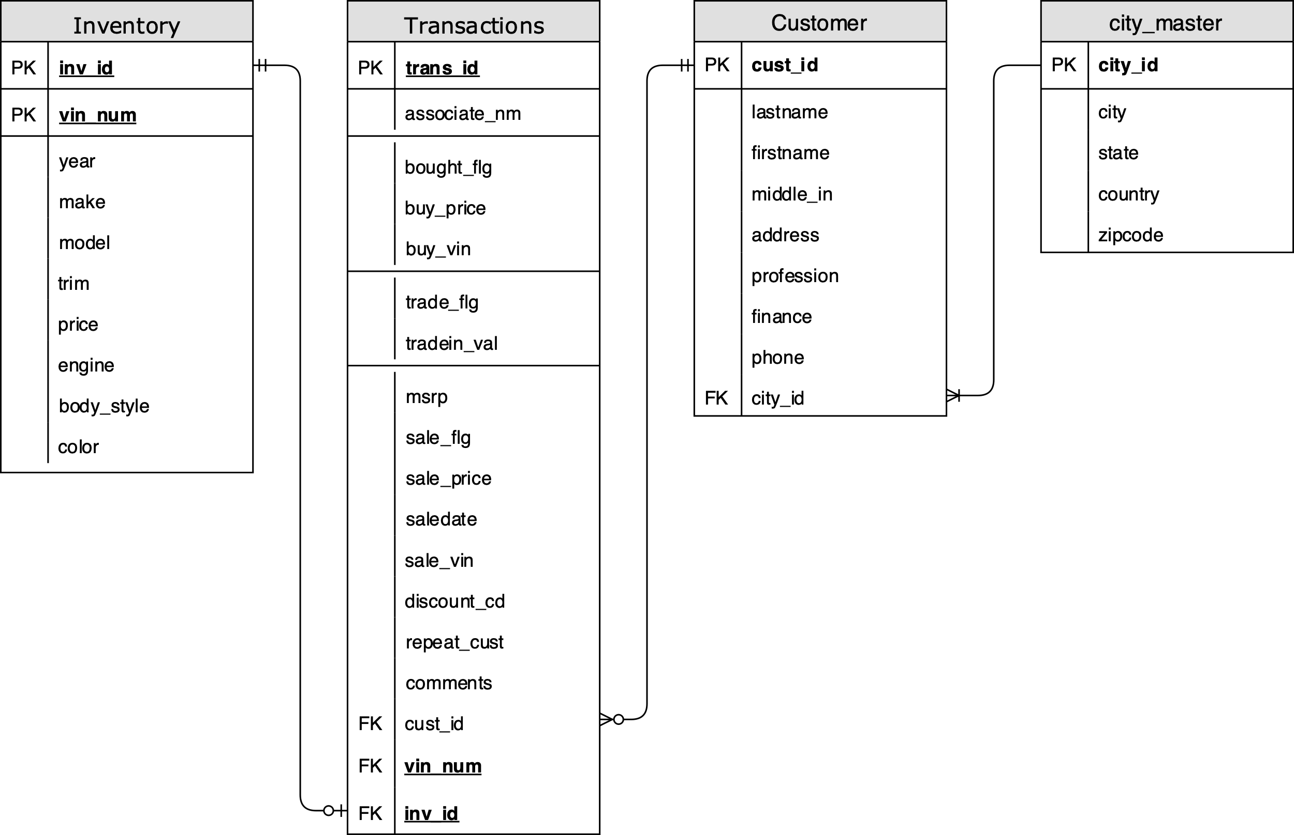

Below is the link for final merged interactive Schema:

[Schema Integration Interactive](https://tinyurl.com/y5l8rum4)