PIZZA SALES SQL

A. KPI's

1. TOTAL REVENUE :-

SELECT SUM(total_price) AS Total_revenue FROM pizza_sales;

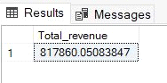

2.AVG_ORDER_VALUE:-

SELECT * FROM pizza_sales;

SELECT SUM(total_price)/ COUNT(DISTINCT order_id) as Avg_order_value FROM pizza_sales;

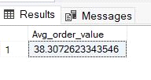

3. Total Pizzas Sold:-

SELECT * FROM pizza_sales;

SELECT SUM(quantity) as Total_Pizza_Sold FROM pizza_sales;

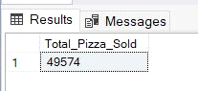

4. Total Orders:-

SELECT * FROM pizza_sales;

SELECT COUNT(DISTINCT order_id) as Total_Orders FROM pizza_sales;

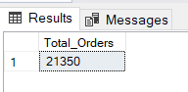

5. Avg_Pizzas_per_order:-

SELECT * FROM pizza_sales;

SELECT CAST(SUM(quantity) AS DECIMAL(10,2))

/ CAST(COUNT(DISTINCT order_id)AS DECIMAL(10,2)) as Avg_pizzas_per_order FROM pizza_sales;

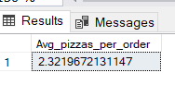

6. Daily trends for orders (order_day):-

SELECT * FROM pizza_sales;

SELECT DATENAME(DW, order_date) as order_day, COUNT(DISTINCT order_id) AS Total_orders FROM pizza_sales

GROUP BY DATENAME(DW, order_date);

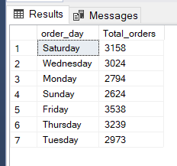

7.Total_sales_percentage:-

SELECT pizza_category, SUM(total_price) * 100 / (SELECT sum(total_price) FROM pizza_sales) AS Total_Sales

from pizza_sales

GROUP BY pizza_category;

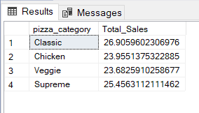

8. top 5 Pizza by revenue:-

SELECT TOP 5 pizza_name, SUM(total_price) AS TOTAL_Revenue FROM pizza_sales

GROUP BY pizza_name

ORDER BY TOTAL_Revenue

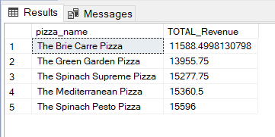

9.Top 5 orders:-

SELECT TOP 5 pizza_name, COUNT(order_id) AS Total_Orders FROM pizza_sales

GROUP BY pizza_name

ORDER BY Total_Orders asc

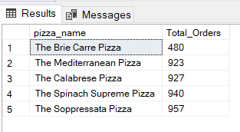

10. % sales by pizza_size:-

SELECT pizza_size, CAST(SUM(total_price) AS DECIMAL(10, 2)) AS Total_revenue,

CAST(SUM(total_price) * 100 / (SELECT SUM(total_price) FROM pizza_sales) AS DECIMAL(10, 2)) AS PCT

FROM pizza_sales

GROUP BY pizza_size

ORDER BY pizza_size;

