JFBMS32 esp32c3
ble wifi disabled
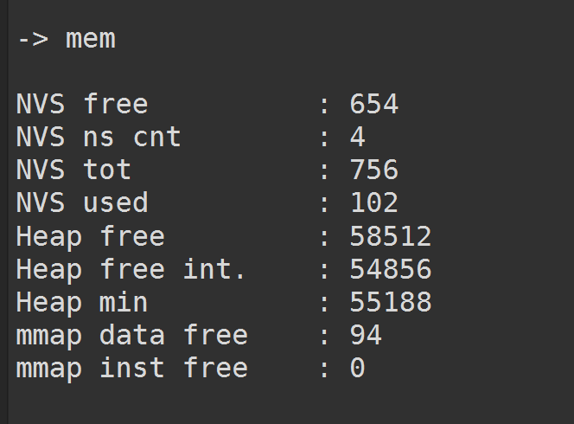
ble enabled wifi disabled
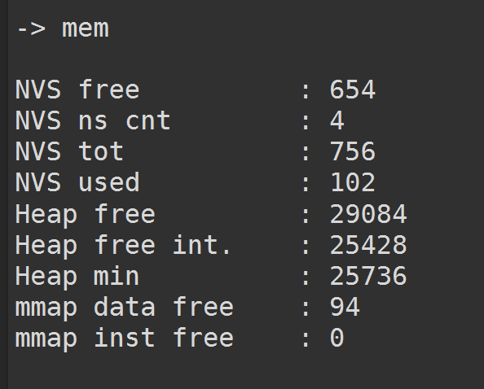
ble and wifi ap enabled
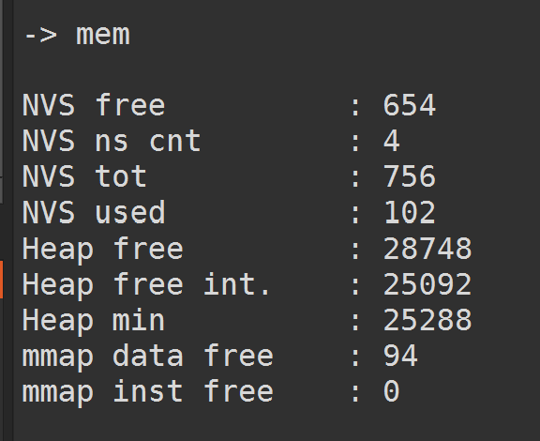
Ble wifi on and connected via ble
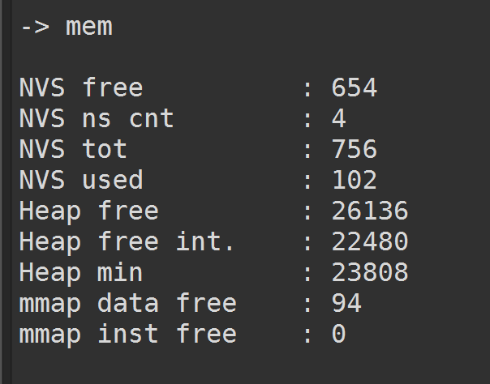
Ble wifi on and connected via wifi
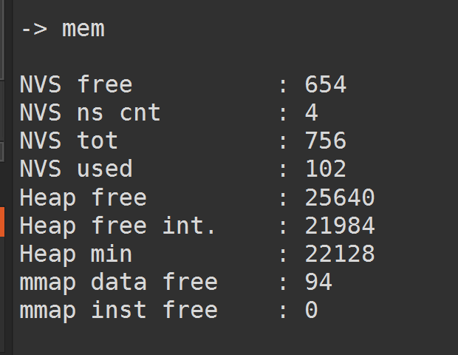

IDF 5.4.4
ble enabled wifi disabled
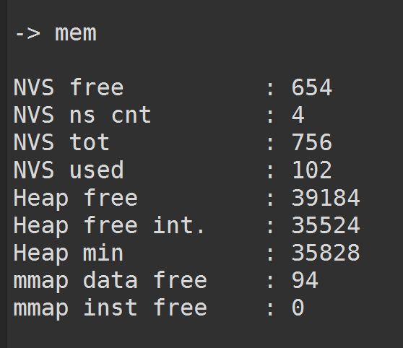
Ble on wifi off and connected to ble
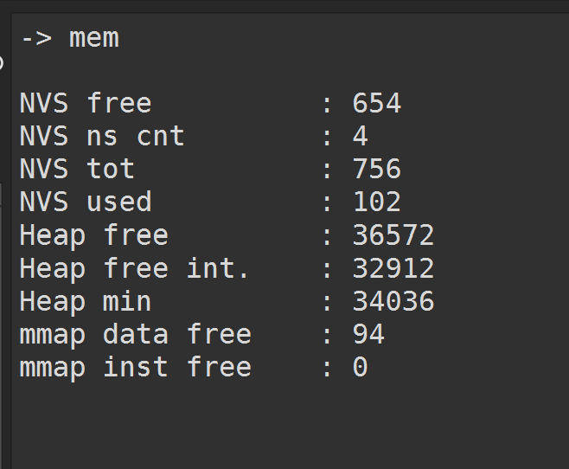

Ble and wifi ap are enabled
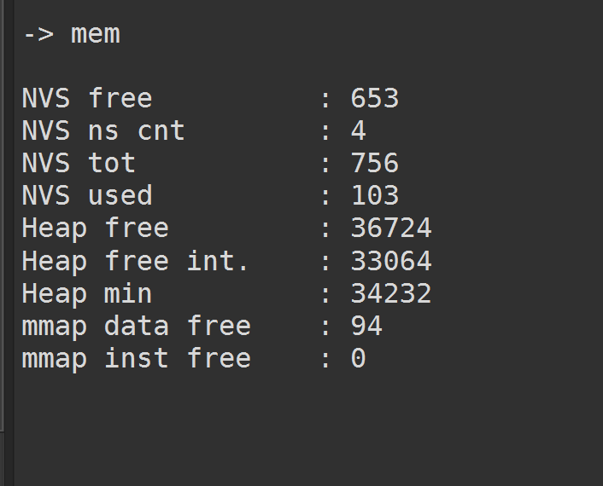
Ble and wifi app enabled and connected to wifi
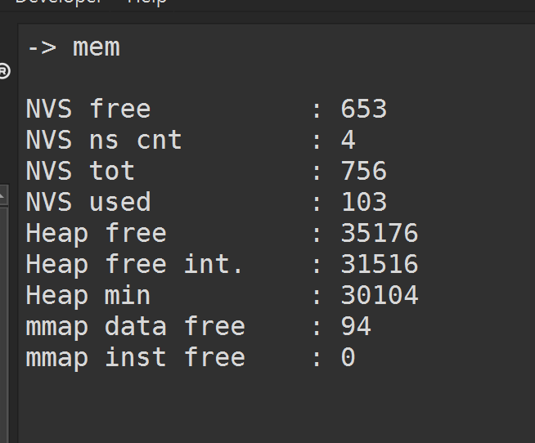

Ble wifi disabled
