**🛠 Step 1: Install MySQL NDB Cluster on All Laptops**

**🔹 For Everyone (All Machines)**

1. **Download MySQL Cluster** from the official website:  
   🔗 [Download MySQL Cluster](https://dev.mysql.com/downloads/cluster/)
   * Choose **Windows (ZIP Archive)**.
   * Extract it to: C:\mysql-cluster
2. **Add MySQL to System Path:**
   * Open **Start** → Search **"Environment Variables"** → Open it.
   * Under **System Variables**, find Path → **Edit**.
   * Click **New**, add:
   * Click **OK** to save.
3. **Verify Installation**:  
   Open **Command Prompt** (cmd) and run:

If it shows the MySQL version, installation is successful.

**🖥 Step 2: Setup the Management Node (Vedika - 10.40.2.108)**

**Vedika should follow these steps:**

1. **Create a configuration file**:
   * Open **Notepad**, save it as:

C:\mysql-cluster\config.ini

1. **Add the following content** to config.ini:

ini

CopyEdit

[ndbd default]

NoOfReplicas=2

DataMemory=80M

IndexMemory=18M

[ndb_mgmd]

Hostname=10.40.2.108

DataDir=C:\mysql-cluster

[ndbd]

Hostname=10.40.14.207

NodeId=2

DataDir=C:\mysql-cluster\data

[ndbd]

Hostname=<Amruta's IP>

NodeId=3

DataDir=C:\mysql-cluster\data

[mysqld]

Hostname=10.40.1.66

1. **Start the Management Node**:

MySQL Cluster Management Server is running.

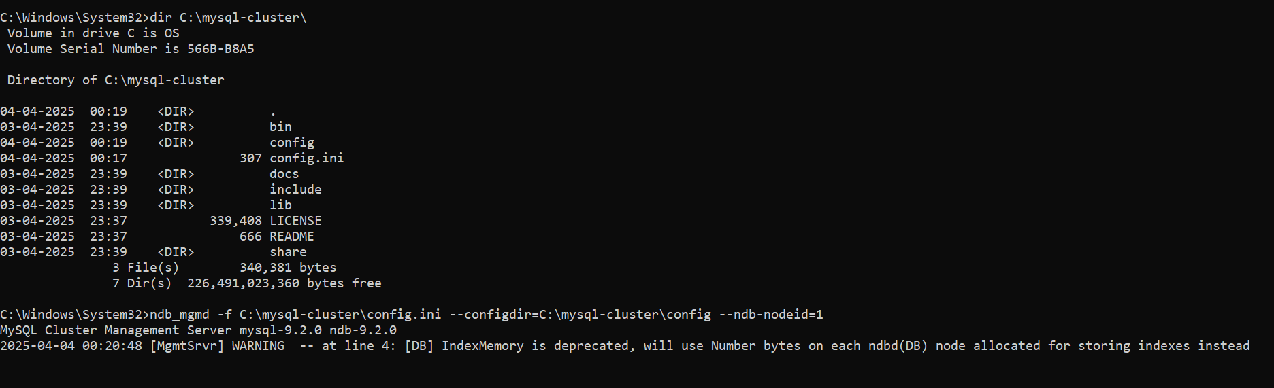

**🖥 Step 3: Setup the Data Nodes (Chetna - 10.40.14.207 & Amruta - ??)**

1. **Create a configuration file**:
   * Open **Notepad**, save it as:
2. **Add the following content** to my.ini:

ini

CopyEdit

[mysqld]

ndbcluster

[mysql_cluster]

ndb-connectstring=10.40.2.108

1. **Start the Data Node**:
   * Open **Command Prompt (Admin)**.
   * If successful, it will show:

MySQL Cluster Data Node is running.

chetna got connected to vedika

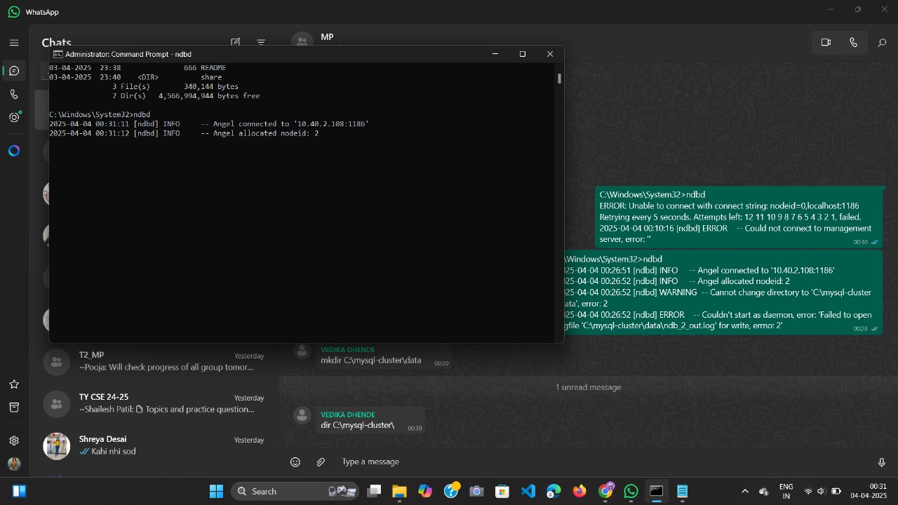

amruta got connected to vedika

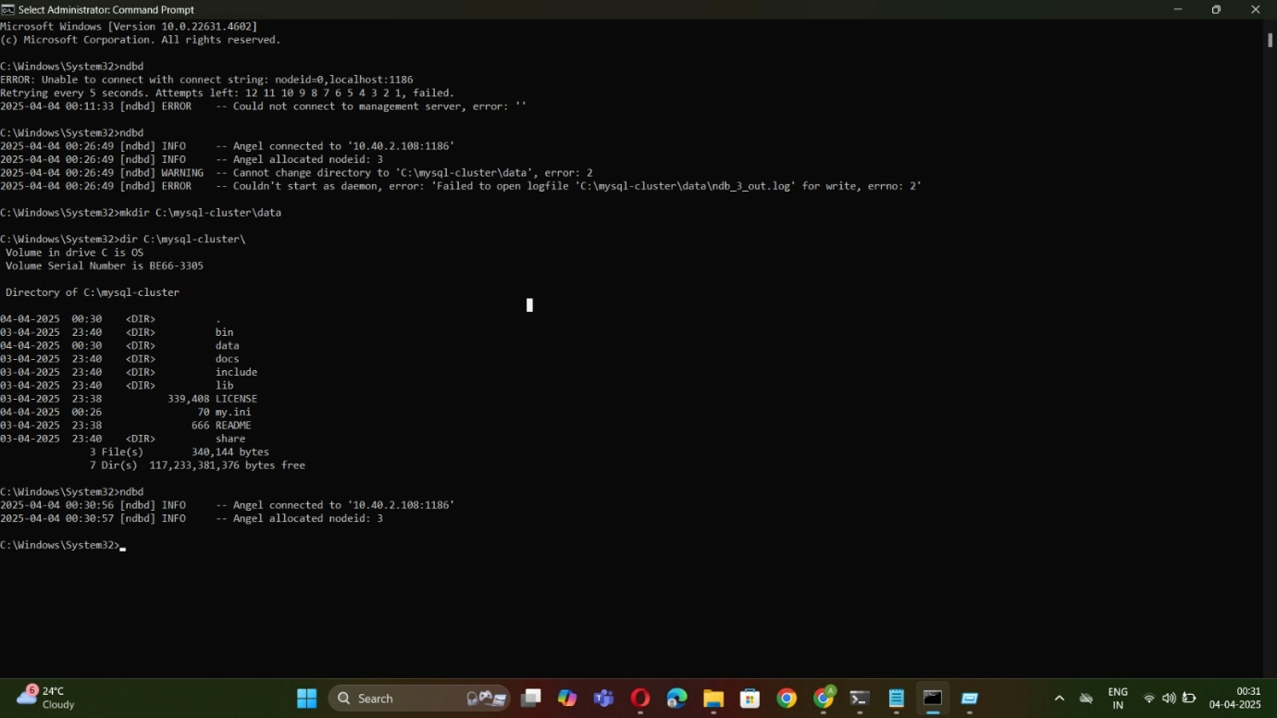

Vaish

