Walchand College of Engineering, Sangli
Department of Computer Science and Engineering
Class: Final Year (CSE) Year: 2025-26 Semester: 1

Course: High Performance Computing Lab
Practical No. 5
Exam Seat No: 22510054
Name : Vedika Uvaraj Dhende
Batch : B3

Title of practical: Implementation of OpenMP programs.
Implement following Programs using OpenMP with C:

Implementation of Matrix-Matrix Multiplication.

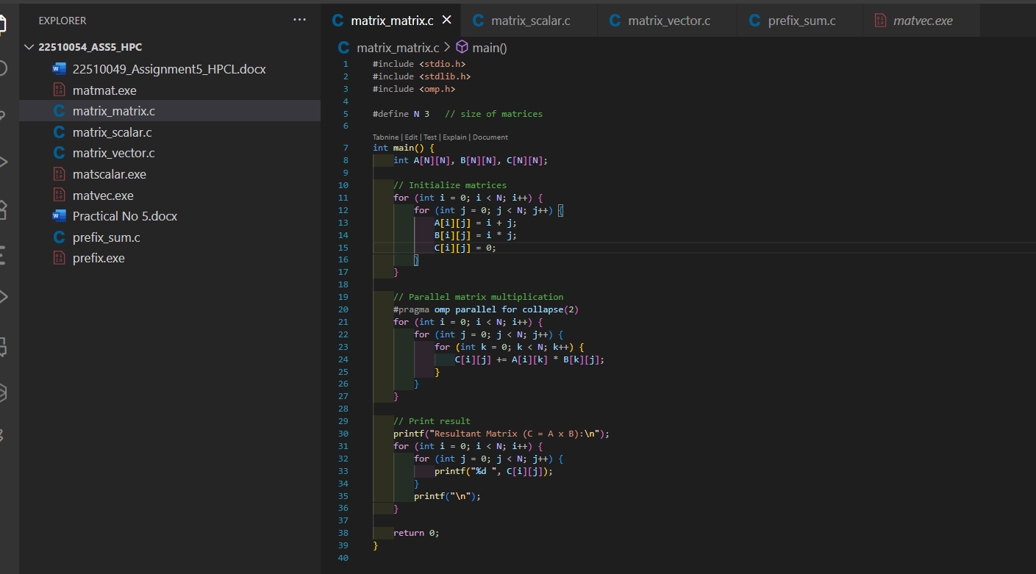
OUTPUT:
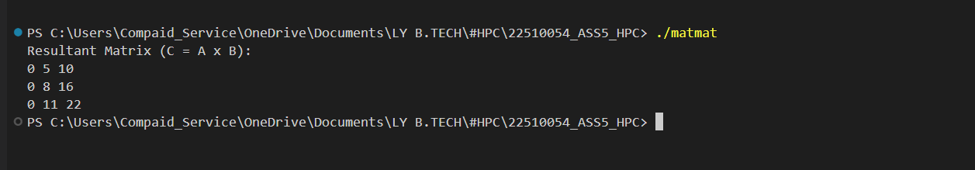

Implementation of Matrix-scalar Multiplication.
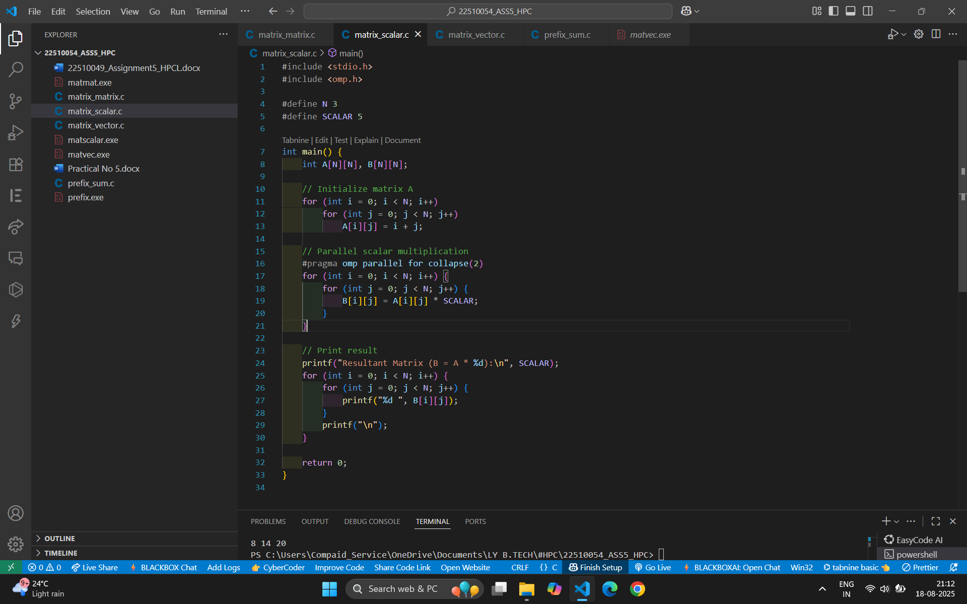

OUTPUT:
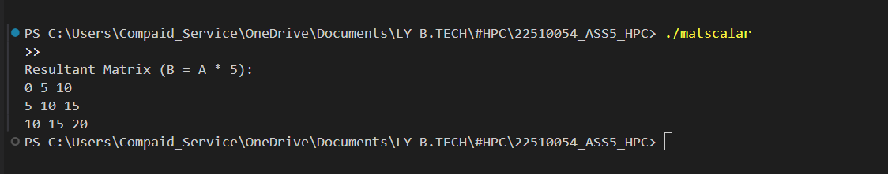

Implementation of Matrix-Vector Multiplication.
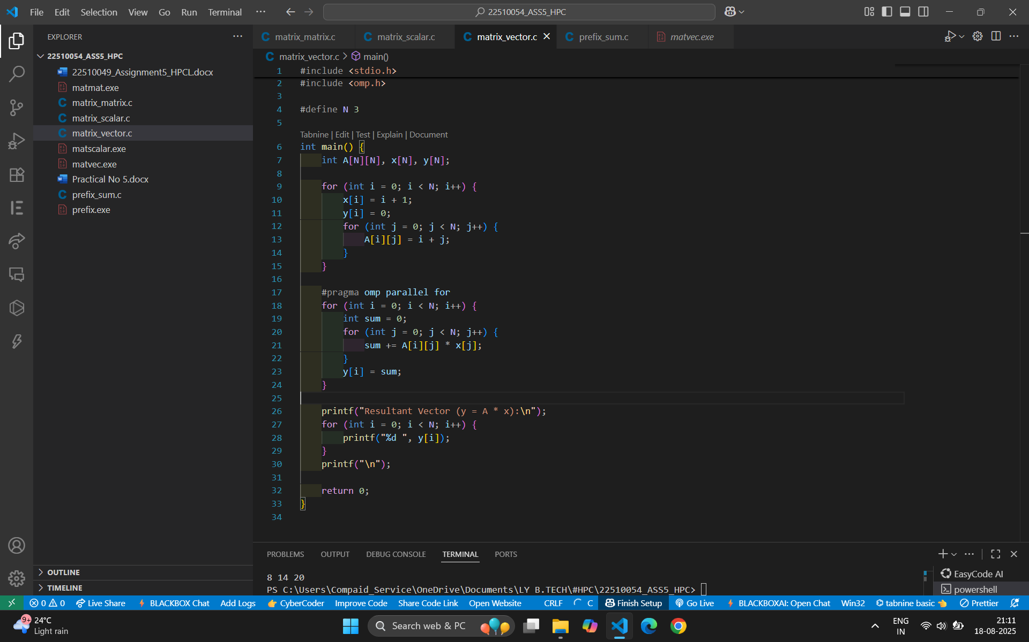

OUTPUT:
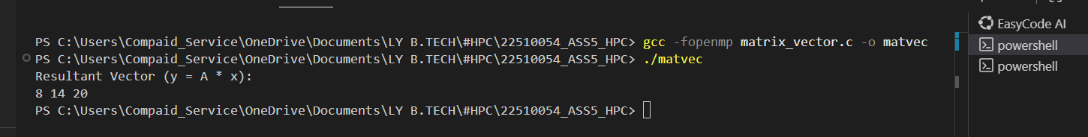

Implementation of Prefix sum

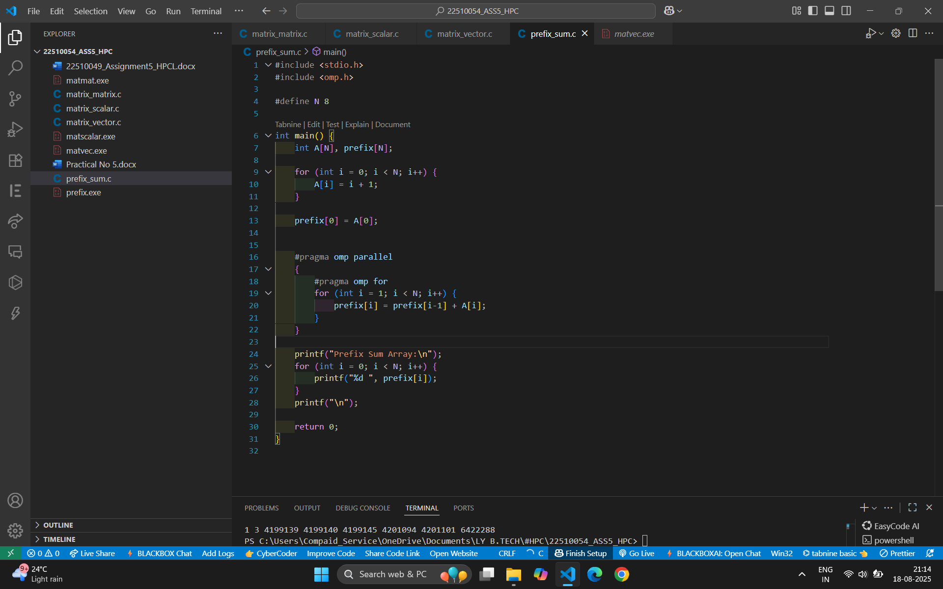
OUTPUT:

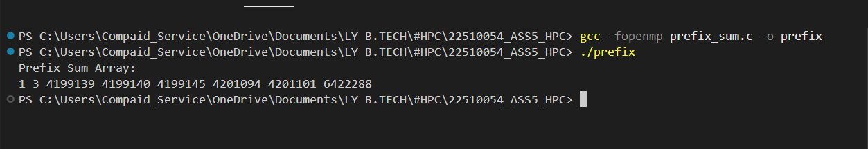

Information:

Problem Statement 1: Matrix–Matrix Multiplication
Problem Description
Matrix–Matrix multiplication is a fundamental operation in scientific computing, computer graphics, and data analysis.
If we have two matrices A of size (m × n) and B of size (n × p), their multiplication results in a matrix C of size (m × p).
Formula:

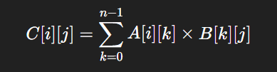

Parallelization Goal
- The calculation of each element C[i][j] is independent of others.
- Hence, rows and columns can be computed in parallel using OpenMP.
- Each thread can compute different parts of the result matrix, reducing execution time significantly.

Why Synchronization is Needed
- Since different threads write to different memory locations in C, synchronization overhead is minimal.
- However, if multiple threads try to print results simultaneously, we need synchronization (critical or ordered).

OpenMP Tools Used
- parallel for → divides iterations of loops across threads.
- collapse(2) → parallelizes nested loops for better workload distribution.
- critical / ordered → ensures correct printing order (optional).

Problem Statement 2: Matrix–Scalar Multiplication
Problem Description
Matrix–Scalar multiplication is the process of multiplying each element of a matrix by a single scalar value.
If matrix A is of size (m × n) and scalar value is k, then the result matrix B is also (m × n).
Formula:



Parallelization Goal
- Every element of the matrix can be multiplied independently.
- Perfectly parallelizable task: different threads can handle different elements simultaneously.

Why Synchronization is Needed
- Since each thread writes to different memory cells, no data races occur.
- Synchronization is only needed if threads print simultaneously.

OpenMP Tools Used
- parallel for → divides element-wise multiplication across threads.
- schedule(static/dynamic) → controls distribution of iterations.
- critical (optional) → ensures ordered printing if required.

Problem Statement 3: Matrix–Vector Multiplication
Problem Description
Matrix–Vector multiplication multiplies an (m × n) matrix with a vector of size (n × 1), producing a result vector of size (m × 1).
Formula:



Parallelization Goal
- Each row of the matrix can be multiplied with the vector in parallel.
- OpenMP can assign one row per thread or distribute work within rows.

Why Synchronization is Needed
- Each thread updates different entries of the result vector, so no race conditions.
- Synchronization required only for printing or if reduction is used.

OpenMP Tools Used
- parallel for → distributes row computations across threads.
- reduction(+:sum) → safely accumulates partial sums.
- critical/ordered → used for ordered printing if needed.

Problem Statement 4: Prefix Sum
Problem Description
The Prefix Sum (also called scan) of an array generates a new array where each element is the sum of all previous elements.
Formula:
For an array A = [a₀, a₁, a₂, …, an−1],
Prefix[i]=a0+a1+a2+…+aiPrefix[i] = a_0 + a_1 + a_2 + … + a_iPrefix[i]=a0​+a1​+a2​+…+ai​
Example:
A = [1, 2, 3, 4] → Prefix = [1, 3, 6, 10]

Parallelization Goal
- Prefix sum is not fully independent, since each element depends on previous ones.
- However, it can be parallelized using a two-step method:
  - Perform partial sums in parallel.
  - Adjust results using prefix values from previous blocks.

Why Synchronization is Needed
- Dependencies make prefix sum tricky: one thread must wait for another’s result.
- Synchronization ensures correct ordering of partial sums.

OpenMP Tools Used
- parallel for → used for partial sums.
- barrier → makes threads wait before moving to the adjustment step.
- critical (optional) → ensures ordered updates
https://github.com/veddnd/HPCprac5

