Walchand College of Engineering, Sangli
Department of Computer Science and Engineering
Class: Final Year (CSE) Year: 2025-26 Semester: 1

Course: High Performance Computing Lab
PRN: 22510054
Name: Vedika Dhende.
Batch: B3
Practical No. 6
Title of practical:
Installation of MPI & Implementation of basic functions of MPI
Problem Statement 1:
Implement a simple hello world program by setting number of processes equal to 10
Screenshots:
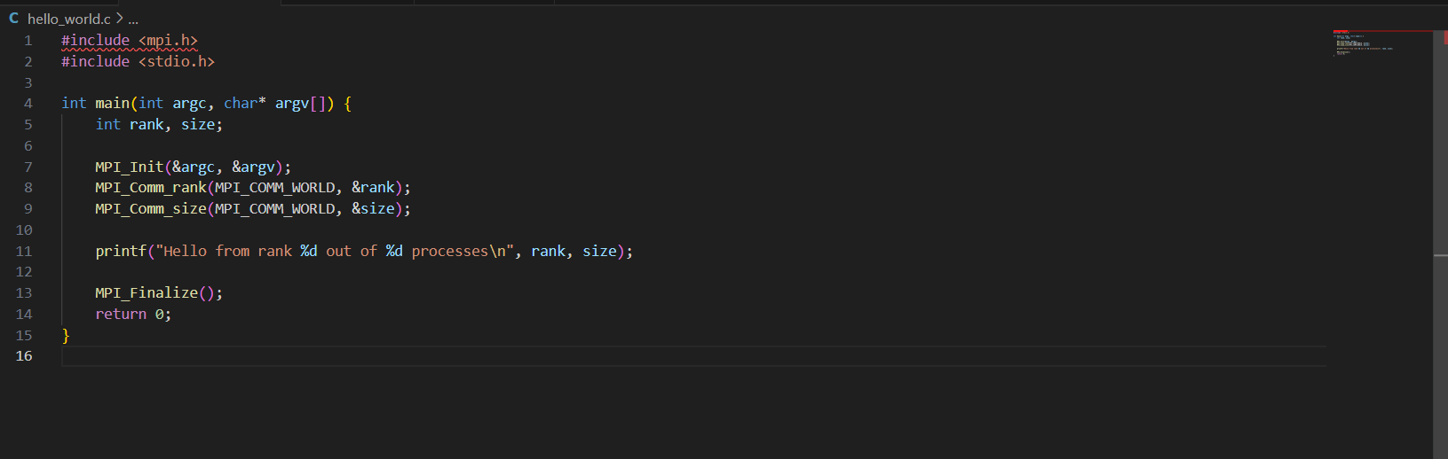
Output:

Information 1:
This program demonstrates how to run multiple processes in parallel using MPI. We start 10 processes at the same time using mpirun -np 10.
Each process executes the same program but can identify itself using its rank which is a unique ID assigned by MPI and can also know the total number of processes using MPI_Comm_size.
The program uses:
MPI_Init() → to initialize the MPI environment.
MPI_Comm_rank() → to get the rank of each process.
MPI_Comm_size() → to get the total number of processes.
MPI_Finalize() → to terminate the MPI environment.

Problem Statement 2:
Implement a program to display rank and communicator group of five processes
Screenshots:
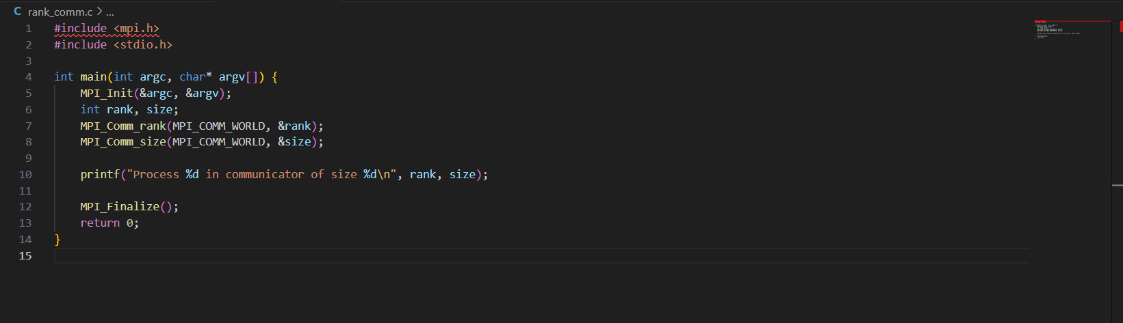
Output:
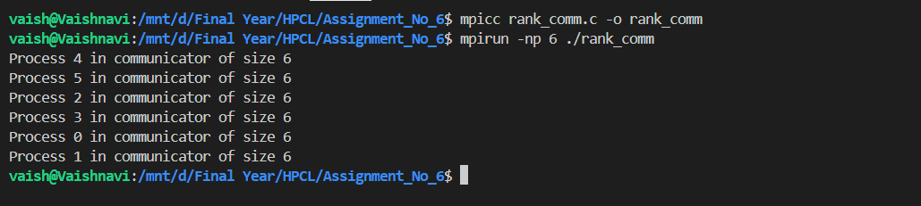
Information:
This program demonstrates how each process can identify its rank and the total number of processes in a communicator group. We start 5 processes using mpirun -np 5.
Each process uses MPI functions to determine its unique rank and the total number of processes in MPI_COMM_WORLD.
Q3: Implement a MPI program to give an example of Deadlock.
Program and screenshots
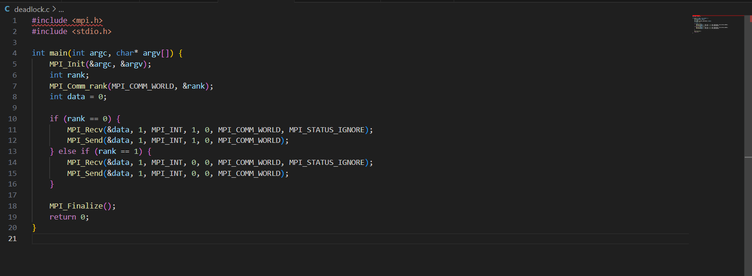
Output:
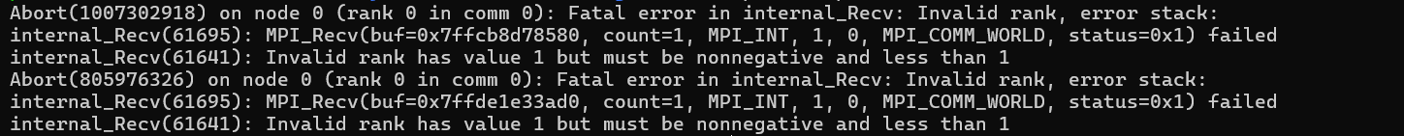
Information:
This program demonstrates a deadlock situation using MPI. We start 2 processes using mpirun -np 2.
Each process tries to send and receive messages in such a way that both processes wait indefinitely for each other, causing the program to hang.
The program uses:
MPI_Init() → to initialize the MPI environment.
MPI_Comm_rank() → to identify the rank of each process.
MPI_Send() → to send a message to another process.
MPI_Recv() → to receive a message from another process.
MPI_Finalize() → to terminate the MPI environment.
This example is used to show how blocking communication can lead to a deadlock if not handled correctly
Q4. Implement blocking MPI send & receive to demonstrate Nearest neighbor exchange of data in a ring topology.
Program and screenshots
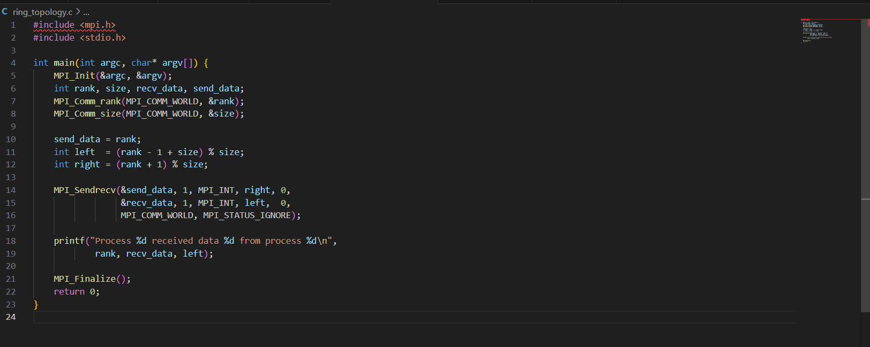
Output:

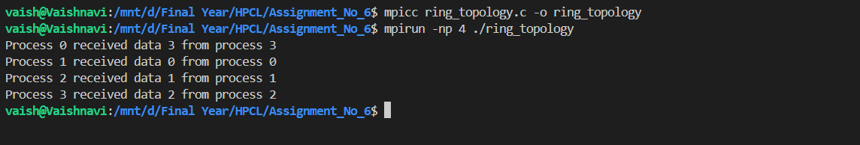
Information:
This program demonstrates data exchange between nearest neighbors in a ring topology. We start multiple processes using mpirun.
Each process sends data to its right neighbor and receives data from its left neighbor using blocking send and receive functions. The left and right neighbors are calculated using the total number of processes.
The program uses:
MPI_Init() → to initialize the MPI environment.
MPI_Comm_rank() → to get the rank of each process.
MPI_Comm_size() → to get the total number of processes.
MPI_Send() → to send data to the right neighbor.
MPI_Recv() → to receive data from the left neighbor.
MPI_Finalize() → to terminate the MPI environment.
This demonstrates communication patterns and ensures each process exchanges data correctly in a circular arrangement.

Q5. Write a MPI program to find the sum of all the elements of an array A of size n. Elements of an array can be divided into two equals groups. The first [n/2] elements are added by the first process, P0, and last [n/2] elements the by second process, P1. The two sums then are added to get the final result.
Program and screenshots
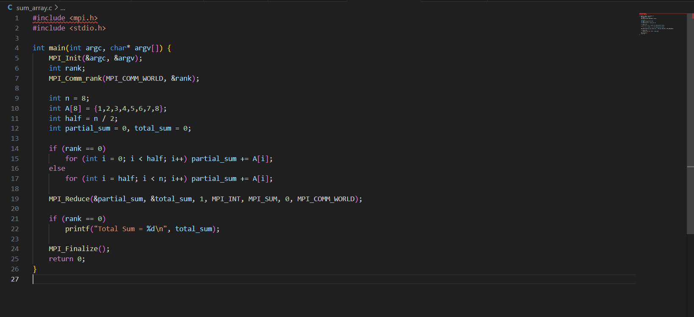
Output:
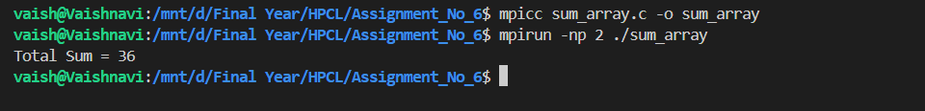
Information:
This program demonstrates parallel computation using MPI to find the sum of all elements in an array. We start 2 processes using mpirun -np 2.
The array is divided into two halves.
Process 0 sums the first half of the array.
Process 1 sums the second half of the array.
Both processes exchange their partial sums, and Process 0 calculates the final total.
The program uses:
MPI_Init() → to initialize the MPI environment.
MPI_Comm_rank() → to identify the rank of each process.
MPI_Comm_size() → to get the total number of processes.
MPI_Send() → to send partial sums between processes.
MPI_Recv() → to receive partial sums from the other process.
MPI_Finalize() → to terminate the MPI environment.
This demonstrates data parallelism, where the work is divided among multiple processes to compute results efficiently.

