Final Year B. Tech., Sem VII 2025-26

High Performance Computing Lab
Practical No. 7

Name – Vedika Dhende.
PRN – 22510054
Batch – B3

Implement Matrix-Vector Multiplication using MPI. Use different number of processes and analyze the performance.

Screenshot:

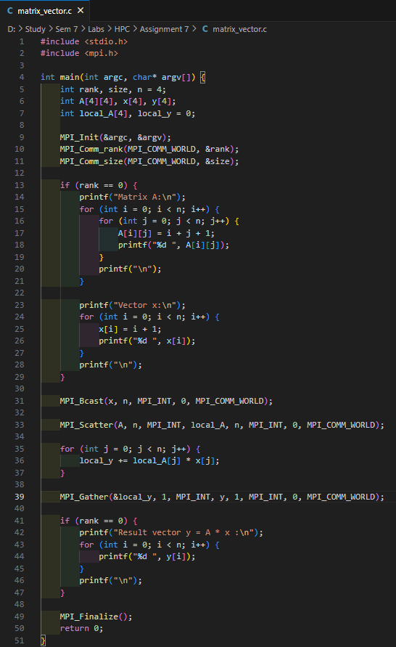

Output :
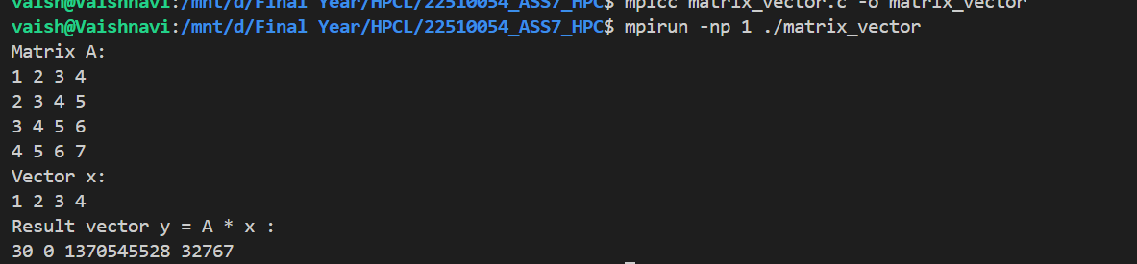
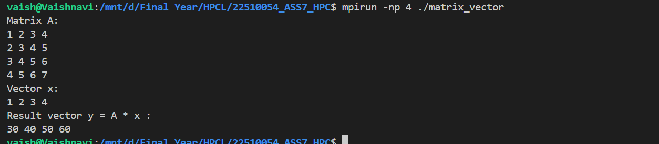

Information:
This program demonstrates parallel matrix-vector multiplication using the Message Passing Interface (MPI).
The goal is to divide the rows of a matrix among multiple processes so that each process computes part of the final result vector.
Each process receives a subset of matrix rows and multiplies them with the entire vector that is shared across all processes. The partial results from each process are then gathered by the root process to form the complete output vector.
The program uses:
- MPI_Init() → Initializes the MPI environment.
- MPI_Comm_rank() → Gets the rank (ID) of each process.
- MPI_Comm_size() → Gets the total number of processes.
- MPI_Bcast() → Broadcasts the input vector to all processes.
- MPI_Scatter() → Distributes different rows of the matrix to all processes.
- MPI_Gather() → Collects the partial results from each process.
- MPI_Finalize() → Terminates the MPI environment.

Implement Matrix-Matrix Multiplication using MPI. Use different number of processes and analyze the performance.

Screenshots :
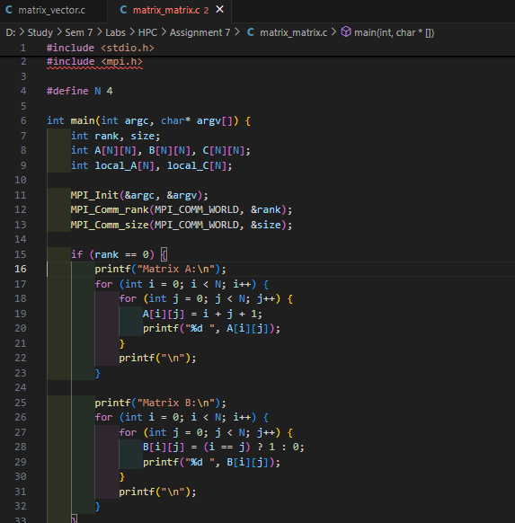
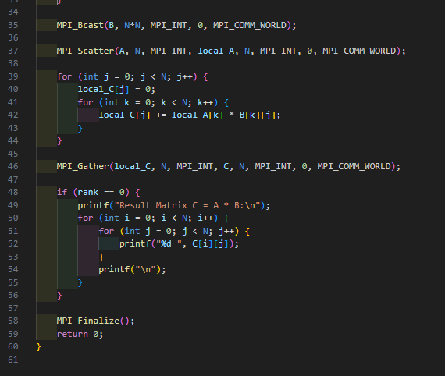

Output:
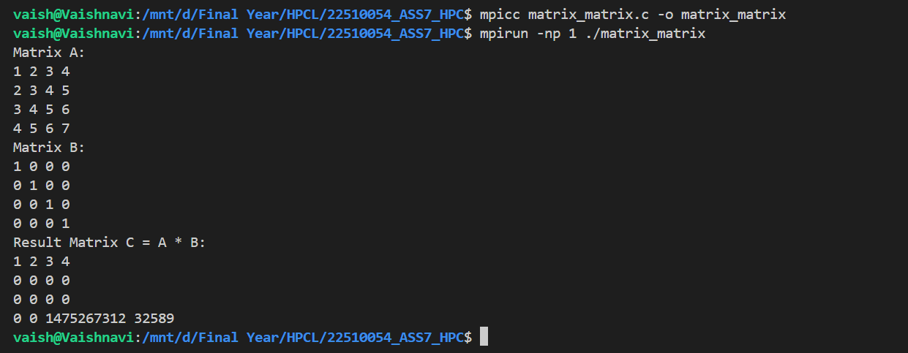

Information:
This program demonstrates parallel matrix–matrix multiplication using the Message Passing Interface (MPI). The main objective is to divide the rows of the first matrix among multiple processes so that each process can compute one or more rows of the result matrix simultaneously.
Each process receives a portion of Matrix A (rows) and the complete Matrix B (broadcasted to all processes). Each process multiplies its assigned rows of A with B to compute a part of the final Matrix C. The partial results are then gathered by the root process to form the complete result matrix.
The program uses the following MPI functions:
- MPI_Init() → Initializes the MPI environment.
- MPI_Comm_rank() → Determines the rank (ID) of each process.
- MPI_Comm_size() → Determines the total number of processes.
- MPI_Bcast() → Broadcasts Matrix B to all processes.
- MPI_Scatter() → Distributes rows of Matrix A among all processes.
- MPI_Gather() → Collects the computed rows of Matrix C from all processes.
- MPI_Finalize() → Terminates the MPI environment.

