Course: High Performance Computing Lab

Practical No 8

PRN: 22510054
Name: Vedika Dhende
Batch – B3

Problem Statement 1 – Study and implement 2D Convolution using MPI. Use a different number of processes and analyze the performance.
Screenshots:
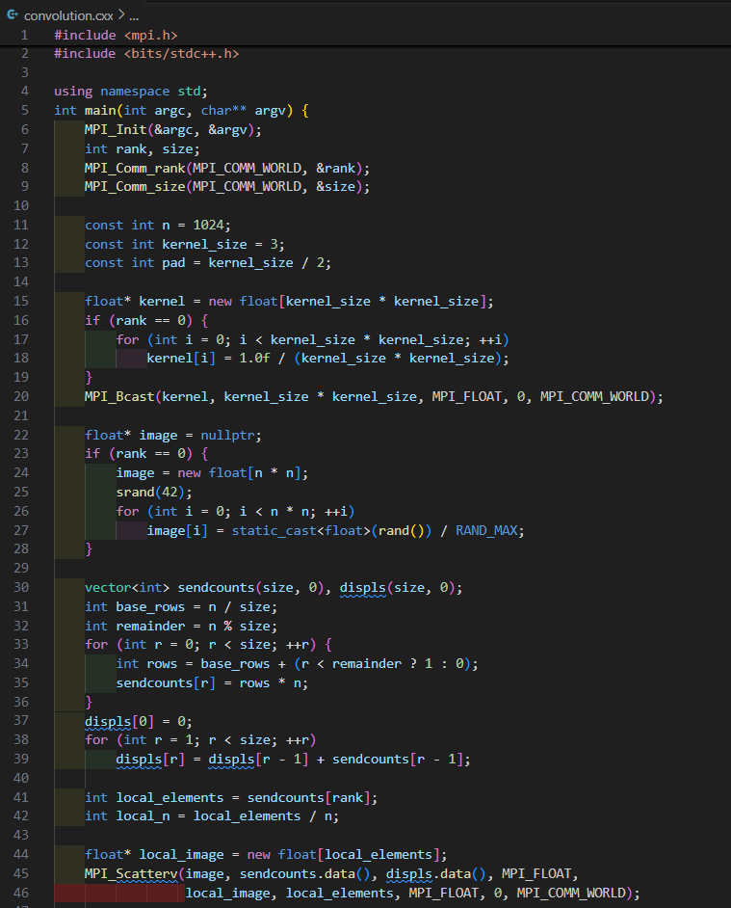
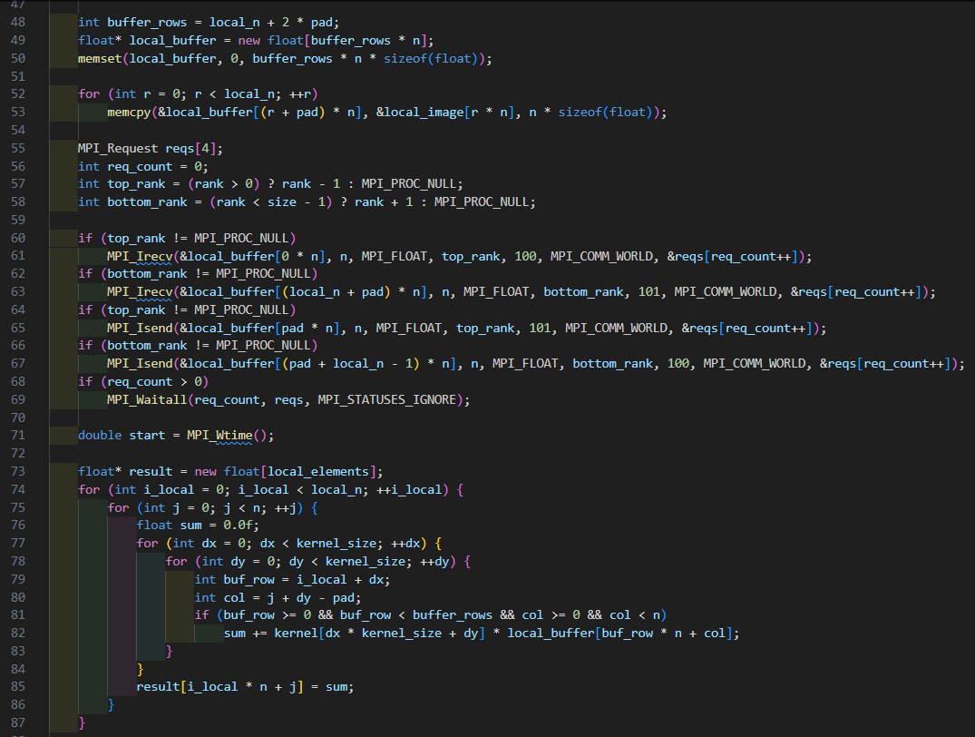
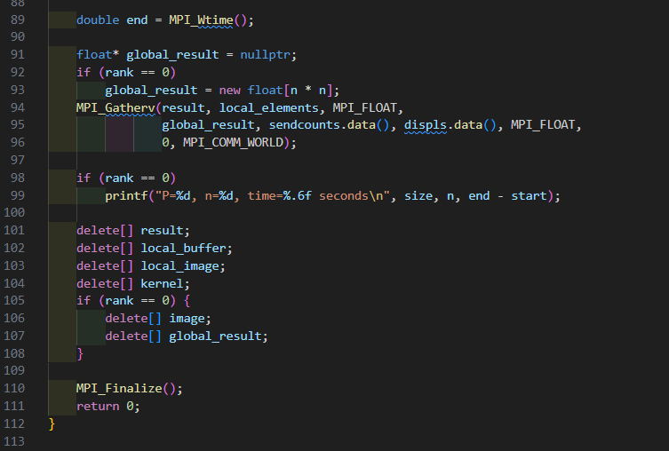

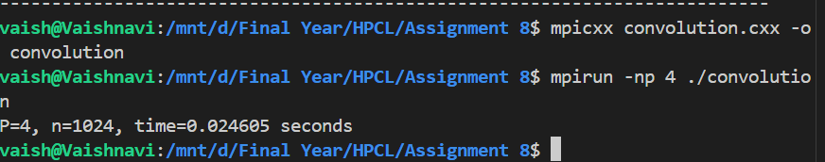
Information:
- Scalability: As the number of processes increases, the computation time per process decreases. However, communication overhead (halo exchange) becomes more significant.
- Speedup: For small numbers of processes (e.g., 2, 4), the speedup is nearly linear. Beyond a certain point (e.g., 8, 16), the communication overhead reduces the speedup, and performance may plateau or degrade due to increased communication contention.
- Observation: The time measurements for different process counts (1, 2, 4, 8, 16) will show that the optimal number of processes depends on the problem size and system architecture. For n=1024, the communication overhead becomes noticeable beyond 8 processes, leading to diminishing returns in speedup.

Problem Statement 2 – Implement dot product using MPI. Use different number of processes and analyze the performance.
Screenshots:
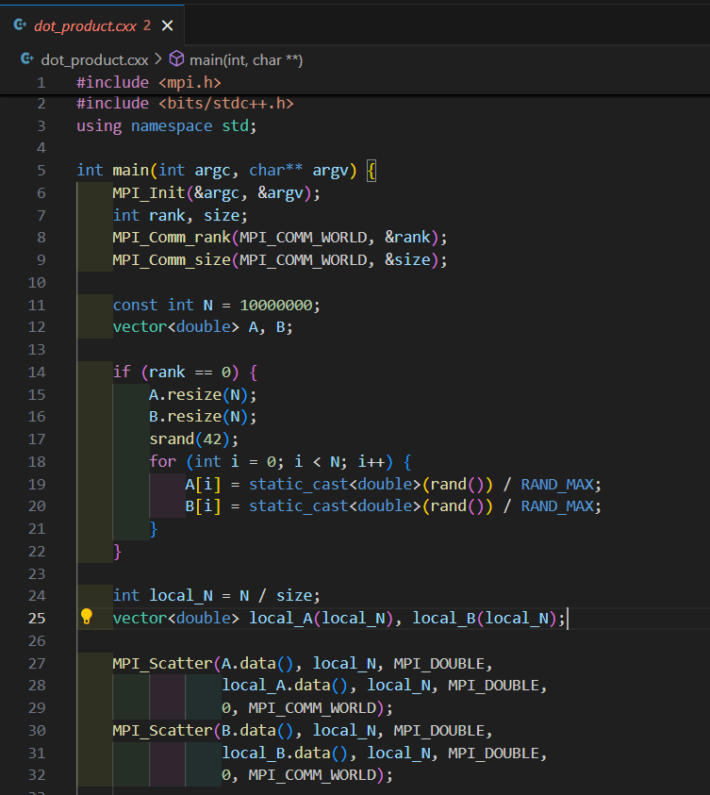
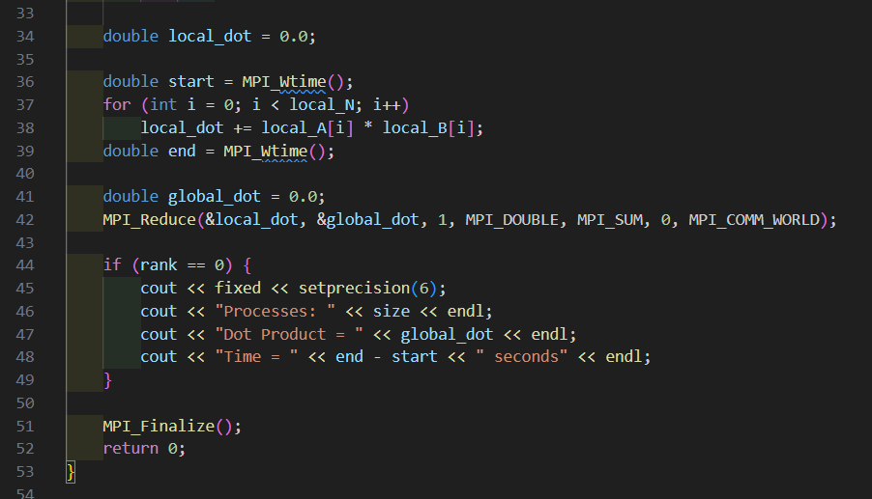

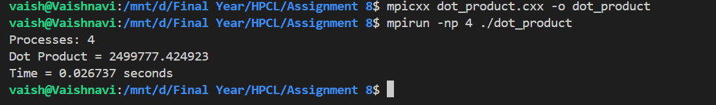
Processes | Dot Product | Time (seconds)
1 | 2499777.424923 | 0.096980
2 | 2499777.424923 | 0.103967
3 | 2499776.585728 | 0.103787
4 | 2499777.424923 | 0.106309

