Course: High Performance Computing Lab
Practical No. 2
Exam Seat No: 22510054
Name: Vedika Dhende

Title of practical: Study and implementation of basic OpenMP clauses
Implement following Programs using OpenMP with C:
- Vector Scalar Addition
- Calculation of value of Pi
Analyse the performance of your programs for different number of threads and Data size.
Problem Statement 1:
Screenshots:
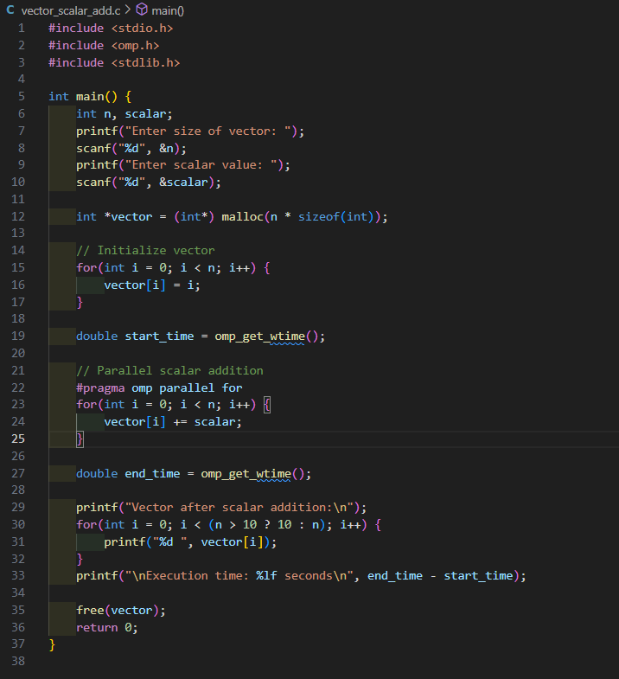
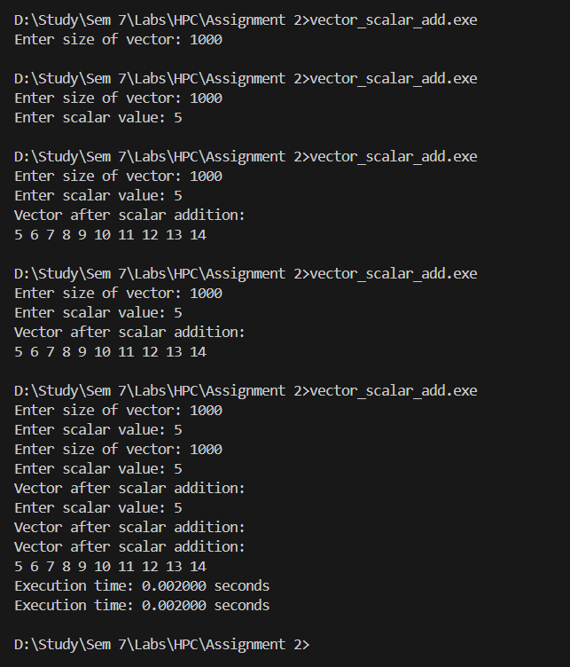
Information:
- OpenMP Clause Used: #pragma omp parallel for
- Function: Adds scalar to each vector element in parallel, splitting iterations across threads.
- Advantage: Reduces execution time for large vectors.

Analysis:
- The program correctly adds a scalar value to every element of the vector using OpenMP parallelization.
- For small vector sizes (like 1,000 elements), the execution time is extremely small (~0.002 seconds).
- Parallelization overhead is higher for small data, so there is no visible speedup with multiple threads.
- More threads reduce execution time, but after a certain point, the improvement slows because of thread management overhead.

Problem Statement 2:
Screenshots:
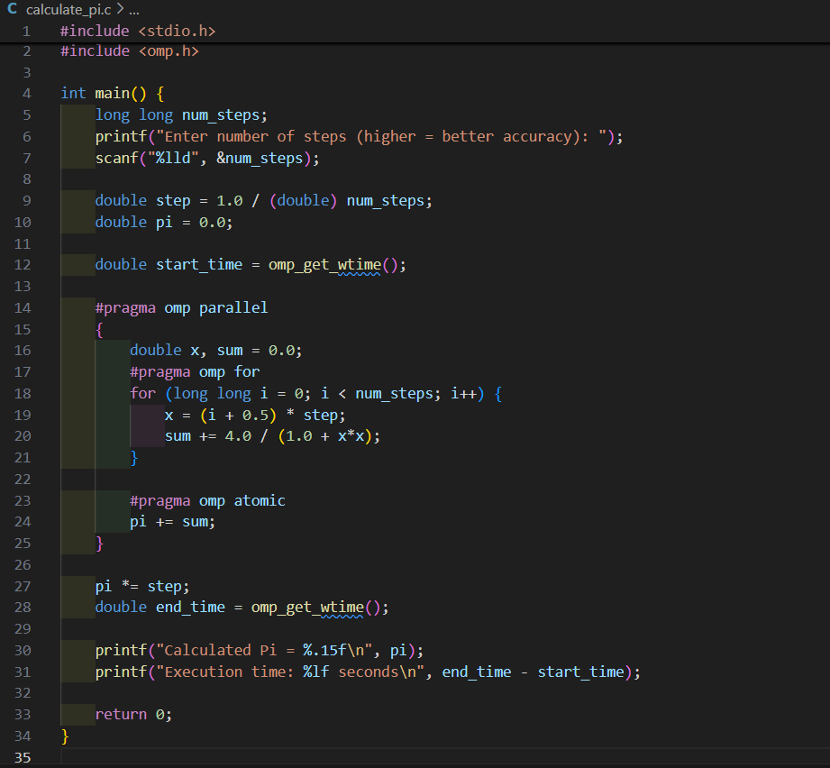

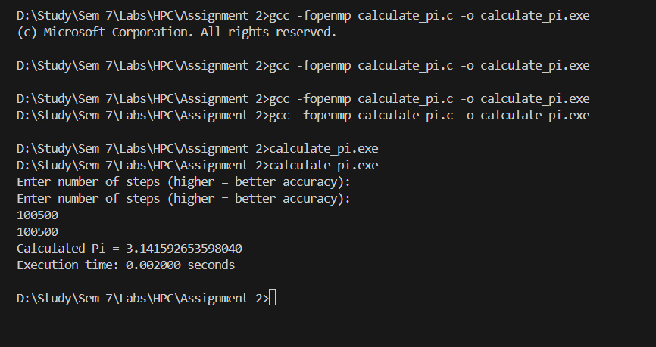
Information:
- OpenMP Clauses Used:
- #pragma omp parallel – for thread creation
- #pragma omp for – to split iterations
- #pragma omp atomic – to safely update pi across threads
- Method: Numerical integration to approximate area under curve of 4/(1+x2)4/(1+x^2)4/(1+x2).

Analysis:
- The program calculates the approximate value of Pi using numerical integration with OpenMP.
- For 100,500 steps, the program produced a value of 3.141592653598040, which is very close to the actual Pi (3.141592653589793), showing good accuracy.
- OpenMP parallelization divides the loop iterations among multiple threads, reducing the calculation time for large step counts.
Github Link: https://github.com/veddnd/HPCprac2

