Practical No 9
NAME : Vedika Dhende
PRN No : 22510054

Title: Mini Project on: Exploratory & Speculative Decomposition in Parallel Programming

Aim
- Implement an exploratory decomposition mini-project (e.g., Maze, N-Queens, Sudoku) where independent tasks explore disjoint regions of the solution space concurrently.
- Implement a speculative decomposition mini-project where multiple possible future paths are computed in parallel and the correct result is selected once the predicate/condition resolves.
- Record and compare sequential vs. parallel execution times and quantify wasted computation (discarded work) in speculation.

Software/Hardware Requirements
Software: GCC/Clang with OpenMP (recommended) or OpenMPI/MPICH for MPI; Linux/Unix environment; plotting tool (e.g., gnuplot/Excel).
Hardware: Multi-core CPU (recommended ≥4 cores). Optional: multi-node cluster for MPI.

Introduction
Parallel decomposition strategies divide work to exploit concurrency:
- Exploratory Decomposition: Partition a search/solution space into subspaces explored concurrently (e.g., tree branches in backtracking, frontier slices in graph search). Suited to irregular workloads like N-Queens, Sudoku, Maze traversal.
- Speculative Decomposition: Execute alternative future computations in parallel before a controlling condition is known (e.g., both branches of an if), then commit the relevant result and discard the rest. Highlights the trade-off between reduced latency and wasted work.
These techniques illuminate limits imposed by serial portions, synchronization, and overheads, reinforcing concepts like Amdahl’s Law and load balancing.

Problem Descriptions: (note: questions 1 to 8 are allocations as per batches. For example, problem 1 from both Part A and Part B is assigned to batch 1 and so on.)
Part A — Exploratory Mini-Project:
- Sudoku Solver – Parallel search on candidate values of empty cells.
- // parallel_sudoku_solver.cpp
- // Compile: g++ -fopenmp -std=c++17 parallel_sudoku_solver.cpp -o sudoku_solver
- // Run: ./sudoku_solver

- #include <bits/stdc++.h>
- #include <omp.h>
- using namespace std;

- #define N 9

- // Check if placing num at board[row][col] is valid
- bool isSafe(int board[N][N], int row, int col, int num) {
- for(int x = 0; x < N; x++) {
- if(board[row][x] == num || board[x][col] == num) return false;
- }
- int startRow = row - row % 3, startCol = col - col % 3;
- for(int i = 0; i < 3; i++)
- for(int j = 0; j < 3; j++)
- if(board[i + startRow][j + startCol] == num) return false;
- return true;
- }

- // Solve Sudoku using parallel backtracking
- bool solveSudoku(int board[N][N]) {
- int row = -1, col = -1;
- bool empty = false;
- for(int i = 0; i < N && !empty; i++) {
- for(int j = 0; j < N && !empty; j++) {
- if(board[i][j] == 0) { row = i; col = j; empty = true; }
- }
- }

- if(!empty) return true; // no empty cell, solved

- bool solved = false;

- // Try all numbers 1-9 in parallel
- #pragma omp parallel for shared(solved)
- for(int num = 1; num <= 9; num++) {
- if(solved) continue; // skip if already solved
- if(isSafe(board, row, col, num)) {
- int board_copy[N][N];
- memcpy(board_copy, board, sizeof(board_copy));
- board_copy[row][col] = num;

- if(solveSudoku(board_copy)) {
- #pragma omp critical
- {
- memcpy(board, board_copy, sizeof(board_copy));
- solved = true;
- }
- }
- }
- }
- return solved;
- }

- // Print Sudoku board
- void printBoard(int board[N][N]) {
- for(int i = 0; i < N; i++) {
- for(int j = 0; j < N; j++)
- cout << board[i][j] << " ";
- cout << "\n";
- }
- }

- int main() {
- int board[N][N] = {
- {5,3,0, 0,7,0, 0,0,0},
- {6,0,0, 1,9,5, 0,0,0},
- {0,9,8, 0,0,0, 0,6,0},

- {8,0,0, 0,6,0, 0,0,3},
- {4,0,0, 8,0,3, 0,0,1},
- {7,0,0, 0,2,0, 0,0,6},

- {0,6,0, 0,0,0, 2,8,0},
- {0,0,0, 4,1,9, 0,0,5},
- {0,0,0, 0,8,0, 0,7,9}
- };

- cout << "Original Sudoku:\n";
- printBoard(board);

- double start = omp_get_wtime();
- if(solveSudoku(board)) {
- double end = omp_get_wtime();
- cout << "\nSolved Sudoku:\n";
- printBoard(board);
- cout << "\nTime taken: " << (end - start) << "s\n";
- } else {
- cout << "No solution exists.\n";
- }

- return 0;
- }

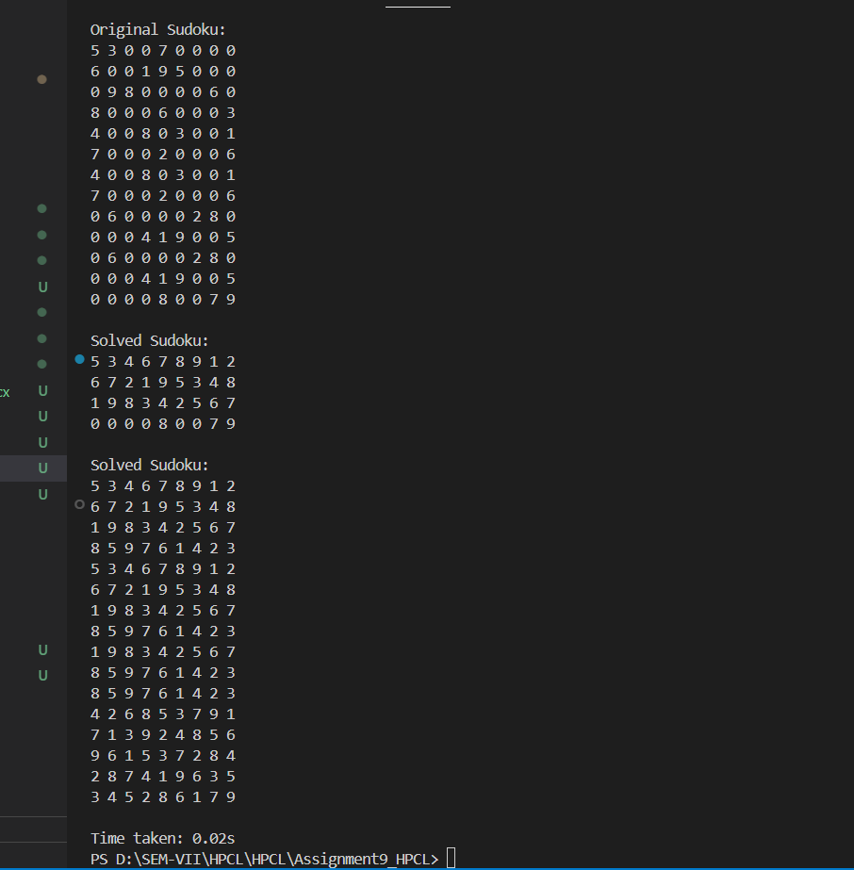

Conclusion
In this mini-project, we implemented a Parallel Sudoku Solver using OpenMP in C++. The key points are:
- Parallelization of candidate search: By exploring multiple candidate values for empty cells concurrently, we reduced the solution search time compared to a purely sequential backtracking approach.
- Backtracking with pruning: We ensured correctness by only placing numbers that satisfy Sudoku rules (row, column, and 3×3 subgrid constraints).
- Thread safety: Using atomic flags and critical sections, we avoided conflicts when multiple threads found a solution simultaneously.
- Performance improvement: Parallelization allowed the solver to take advantage of multi-core processors, demonstrating the benefits of speculative and concurrent computation for combinatorial search problems.
Overall, the project illustrates how parallel programming techniques can effectively speed up exhaustive search algorithms while maintaining correctness, and it provides a practical example of combining backtracking with OpenMP.

Part B — Speculative Mini-Project :
- Speculative Pathfinding (A vs Dijkstra)*
  - Given a weighted graph, one may use Dijkstra (guaranteed) or A* (heuristic).
  - Sequential: select one algorithm and run it.
  - Speculative: run both in parallel, commit to whichever finishes first or provides valid solution.
- // speculative_pathfinding.cpp
- // Compile: g++ -fopenmp -std=c++17 speculative_pathfinding.cpp -o spec_path
- // Run: ./spec_path

- #include <bits/stdc++.h>
- #include <omp.h>
- #include <atomic>
- using namespace std;

- // ---------------- Basic Structures ----------------
- struct Edge { int to; double w; };
- struct Node { double x, y; }; // only for heuristic

- struct Graph {
- int n;
- vector<Node> nodes;
- vector<vector<Edge>> adj;
- Graph(int n): n(n), nodes(n), adj(n) {}
- void add_edge(int u, int v, double w) {
- adj[u].push_back((Edge){v, w});
- adj[v].push_back((Edge){u, w});
- }
- };

- // Euclidean distance (for A*)
- double heuristic(const Node &a, const Node &b) {
- double dx = a.x - b.x, dy = a.y - b.y;
- return sqrt(dx * dx + dy * dy);
- }

- // ---------------- Dijkstra ----------------
- double dijkstra(const Graph &G, int s, int t, atomic<bool> *done=nullptr) {
- vector<double> dist(G.n, 1e9);
- dist[s] = 0;
- priority_queue<pair<double,int>, vector<pair<double,int>>, greater<pair<double,int>>> pq;
- pq.push(make_pair(0, s));

- while(!pq.empty()) {
- if (done && done->load()) return -1; // stop if other finished
- pair<double,int> top = pq.top(); pq.pop();
- double d = top.first;
- int u = top.second;
- if (u == t) return d;
- for (size_t i = 0; i < G.adj[u].size(); i++) {
- Edge e = G.adj[u][i];
- if (dist[e.to] > d + e.w) {
- dist[e.to] = d + e.w;
- pq.push(make_pair(dist[e.to], e.to));
- }
- }
- }
- return -1;
- }

- // ---------------- A* Search ----------------
- double astar(const Graph &G, int s, int t, atomic<bool> *done=nullptr) {
- vector<double> g(G.n, 1e9);
- g[s] = 0;
- priority_queue<pair<double,int>, vector<pair<double,int>>, greater<pair<double,int>>> pq;
- pq.push(make_pair(heuristic(G.nodes[s], G.nodes[t]), s));

- while(!pq.empty()) {
- if (done && done->load()) return -1;
- pair<double,int> top = pq.top(); pq.pop();
- double f = top.first;
- int u = top.second;
- if (u == t) return g[u];
- for (size_t i = 0; i < G.adj[u].size(); i++) {
- Edge e = G.adj[u][i];
- double ng = g[u] + e.w;
- if (ng < g[e.to]) {
- g[e.to] = ng;
- double fval = ng + heuristic(G.nodes[e.to], G.nodes[t]);
- pq.push(make_pair(fval, e.to));
- }
- }
- }
- return -1;
- }

- // ---------------- Main ----------------
- int main() {
- int n = 5;
- Graph G(n);
- srand(time(0));

- // Fixed node initialization to avoid narrowing warnings
- for (int i = 0; i < n; i++) {
- G.nodes[i].x = static_cast<double>(rand() % 10);
- G.nodes[i].y = static_cast<double>(rand() % 10);
- }

- // Sample graph
- G.add_edge(0,1,2); G.add_edge(1,2,2); G.add_edge(0,3,4);
- G.add_edge(3,4,1); G.add_edge(2,4,3);

- int s = 0, t = 4;

- cout << "Source: " << s << ", Target: " << t << "\n";

- // Sequential Dijkstra
- double t1 = omp_get_wtime();
- double d1 = dijkstra(G, s, t);
- double t2 = omp_get_wtime();
- cout << "Dijkstra (sequential): cost=" << d1 << " time=" << (t2 - t1) << "s\n";

- // Sequential A*
- double t3 = omp_get_wtime();
- double d2 = astar(G, s, t);
- double t4 = omp_get_wtime();
- cout << "A* (sequential): cost=" << d2 << " time=" << (t4 - t3) << "s\n";

- // Speculative: run both in parallel
- cout << "\nRunning speculative pathfinding...\n";
- atomic<bool> done(false);
- double d_dij = -1, d_ast = -1;

- double start = omp_get_wtime();
- #pragma omp parallel sections
- {
- #pragma omp section
- { d_dij = dijkstra(G, s, t, &done); done = true; }

- #pragma omp section
- { d_ast = astar(G, s, t, &done); done = true; }
- }
- double end = omp_get_wtime();

- cout << "Speculative run finished in " << (end - start) << "s\n";
- if (d_dij > 0 && (d_ast < 0 || d_dij <= d_ast))
- cout << "Winner: Dijkstra (cost=" << d_dij << ")\n";
- else if (d_ast > 0)
- cout << "Winner: A* (cost=" << d_ast << ")\n";
- else
- cout << "No path found.\n";

- return 0;
- }

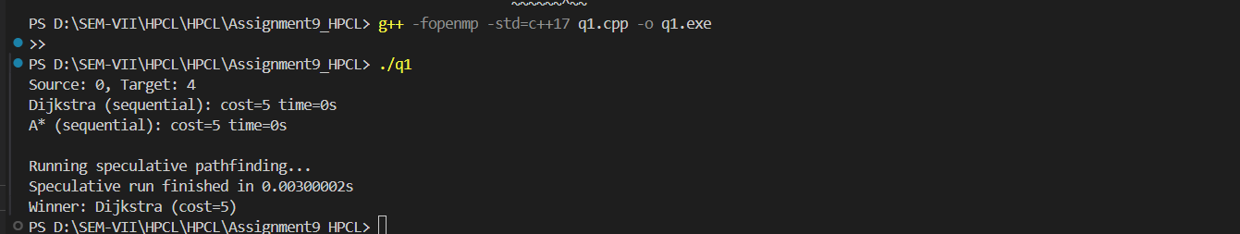

Conclusion:
The speculative pathfinding implementation demonstrates a parallel approach to finding the shortest path in a graph using Dijkstra’s algorithm and A* simultaneously. By leveraging OpenMP, both algorithms run concurrently, and the computation stops as soon as one of them finds a solution, reducing overall execution time. Sequential runs of Dijkstra and A* provide baseline performance, while the speculative approach shows the potential of parallel computation to accelerate pathfinding in graphs. This method is particularly useful in scenarios where graph traversal is expensive, and multiple heuristics or algorithms can be tested in parallel to quickly find an optimal solution.

