1.Git-HOL

Setting up Git Configuration



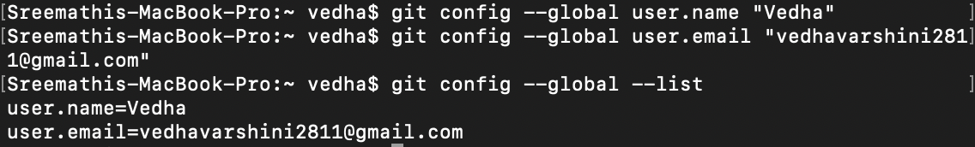

Integrating nano notepad



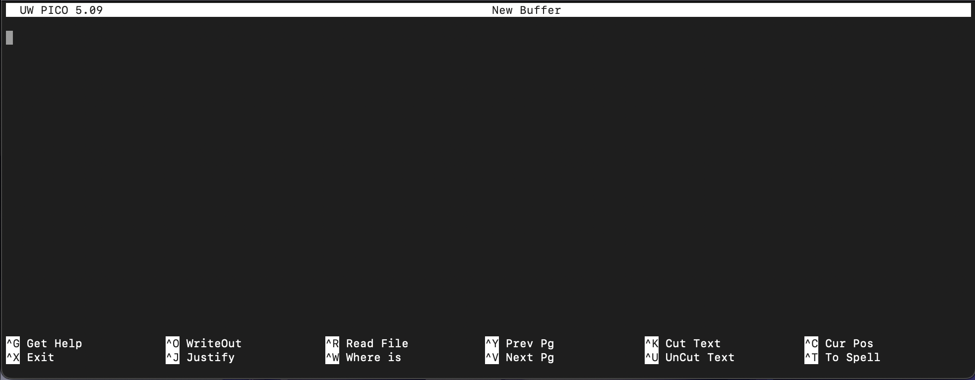

Add file to source code repository

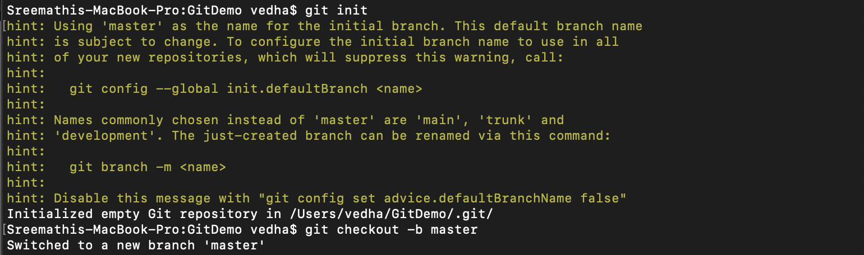

Creating file welcome.txt

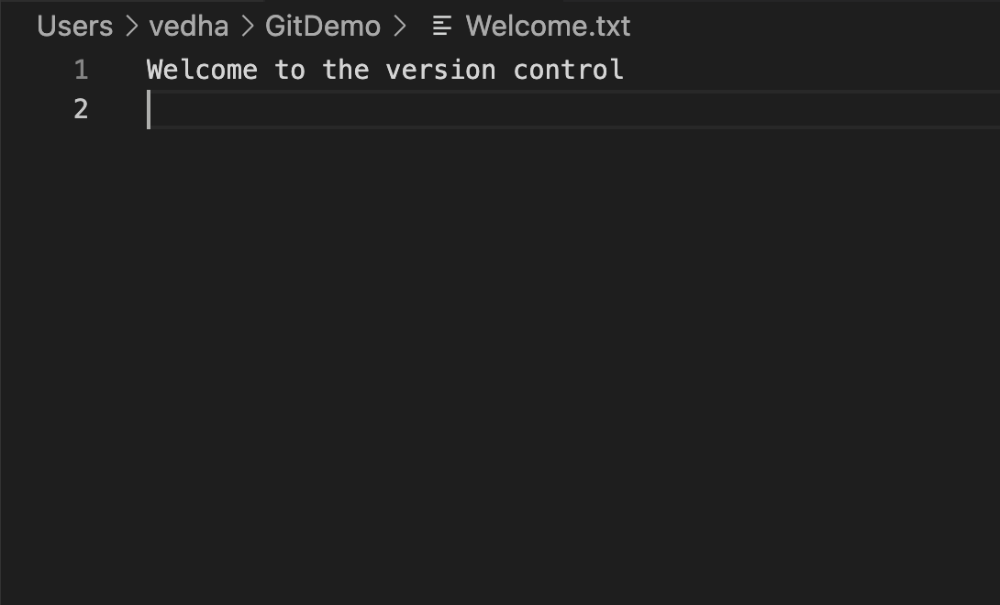

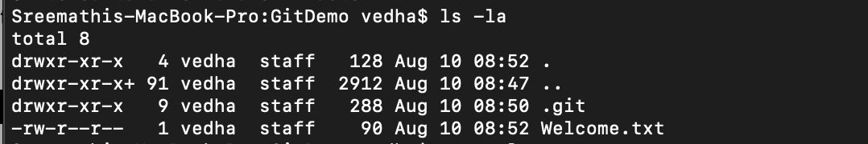



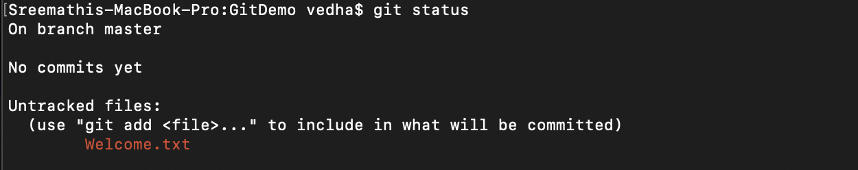

Adding to git

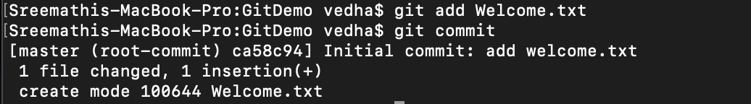

Pushing and pulling from git

