2.Git-HOL

Creating log files



Checking the files

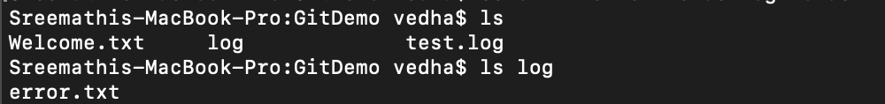

Opening .gitignore



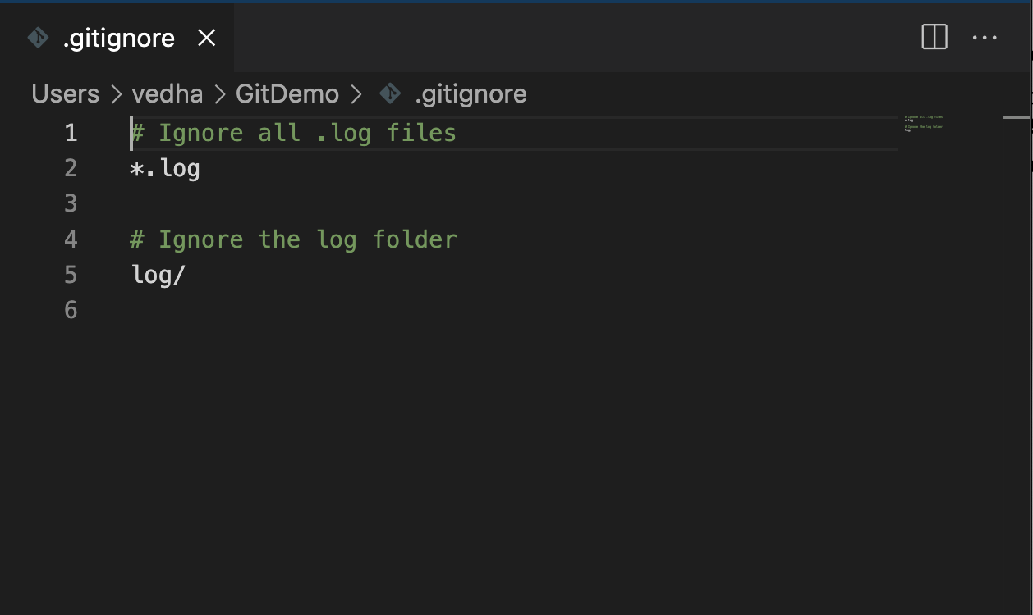

Adding to git



Pushing to git

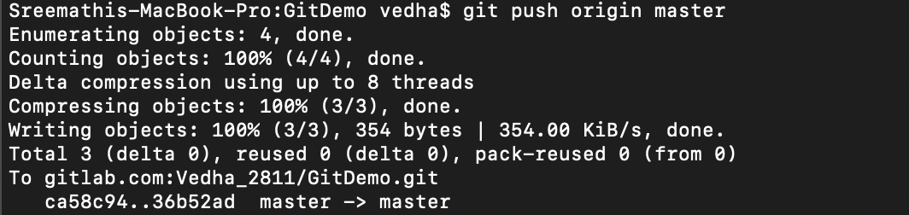

Verifying if logs are being ignored

