3.Git-HOL

Branching:

Creating a new branch

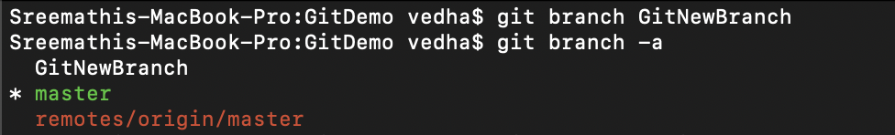

Switching to new branch

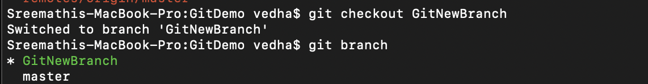

Creating new files and committing them

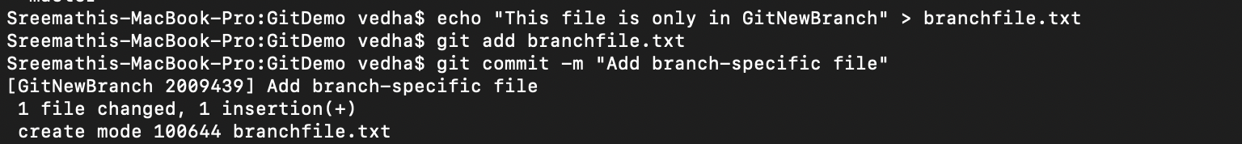

Checking the status



Merging:

Switching to master

Listing differences

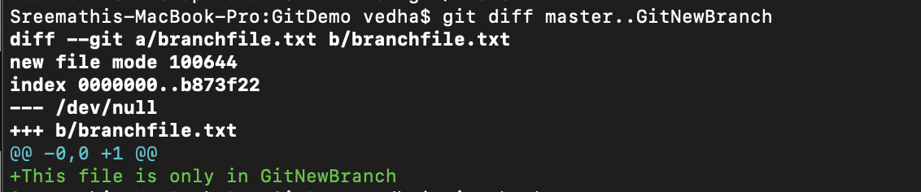

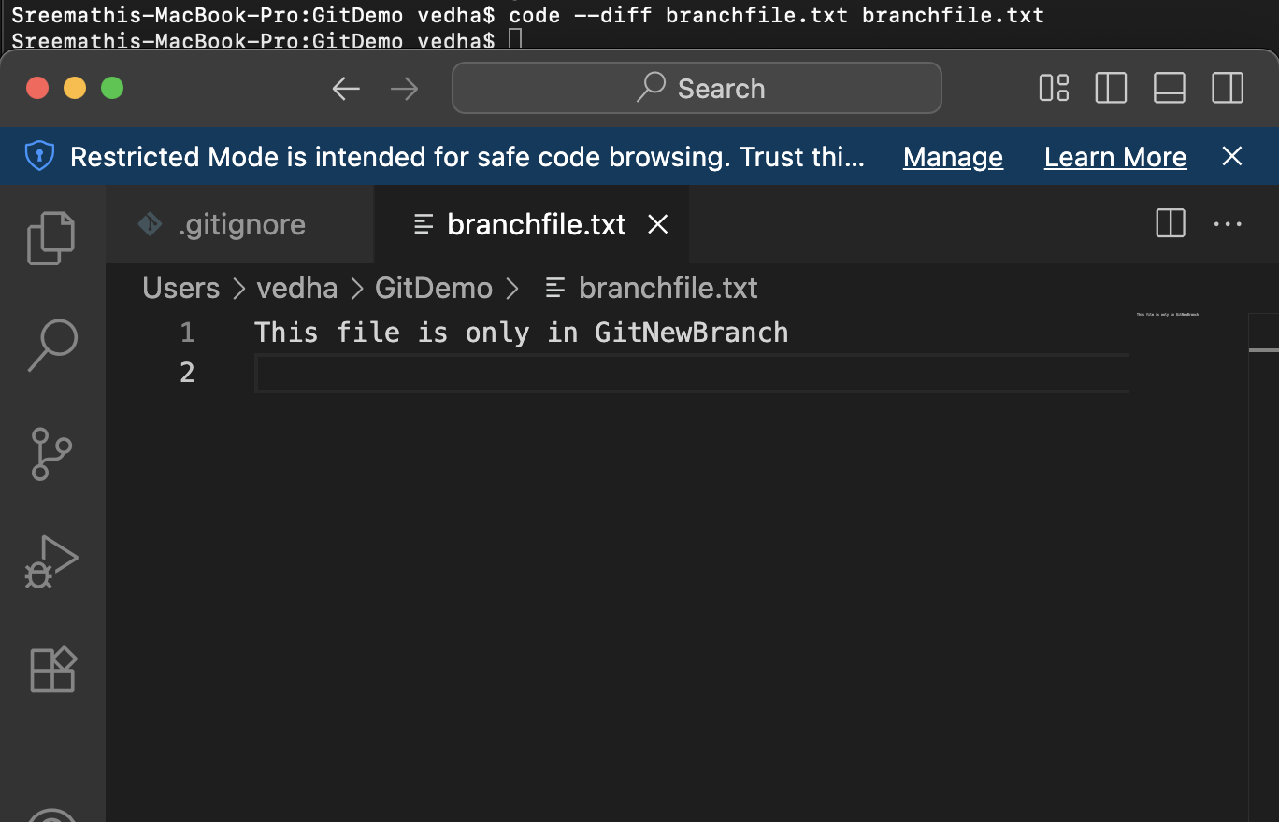

Merging source branch

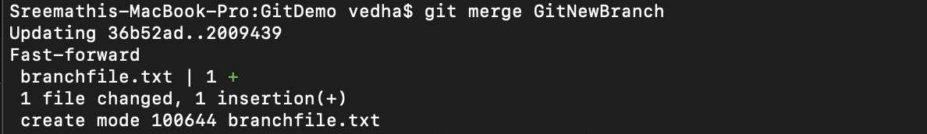

Observing the logging

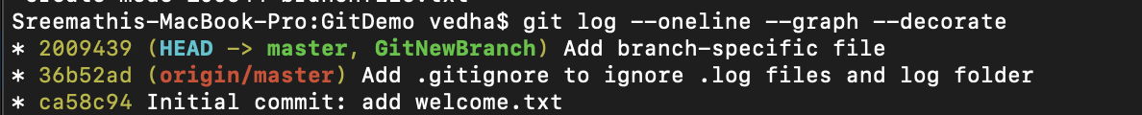

Deleting the branch after merge 

Observing git status

