4.Git-HOL

Creating new branch



Adding and committing hello.xml

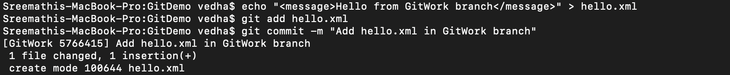

Switching back to master



Adding a different hello.xml

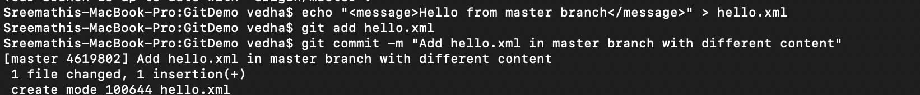

Viewing commit history

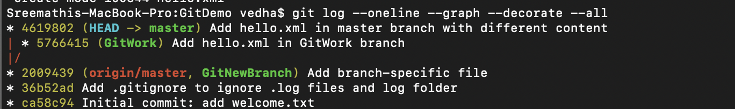

Seeing differences before merging

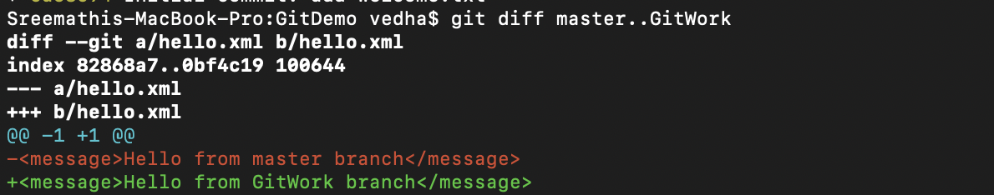

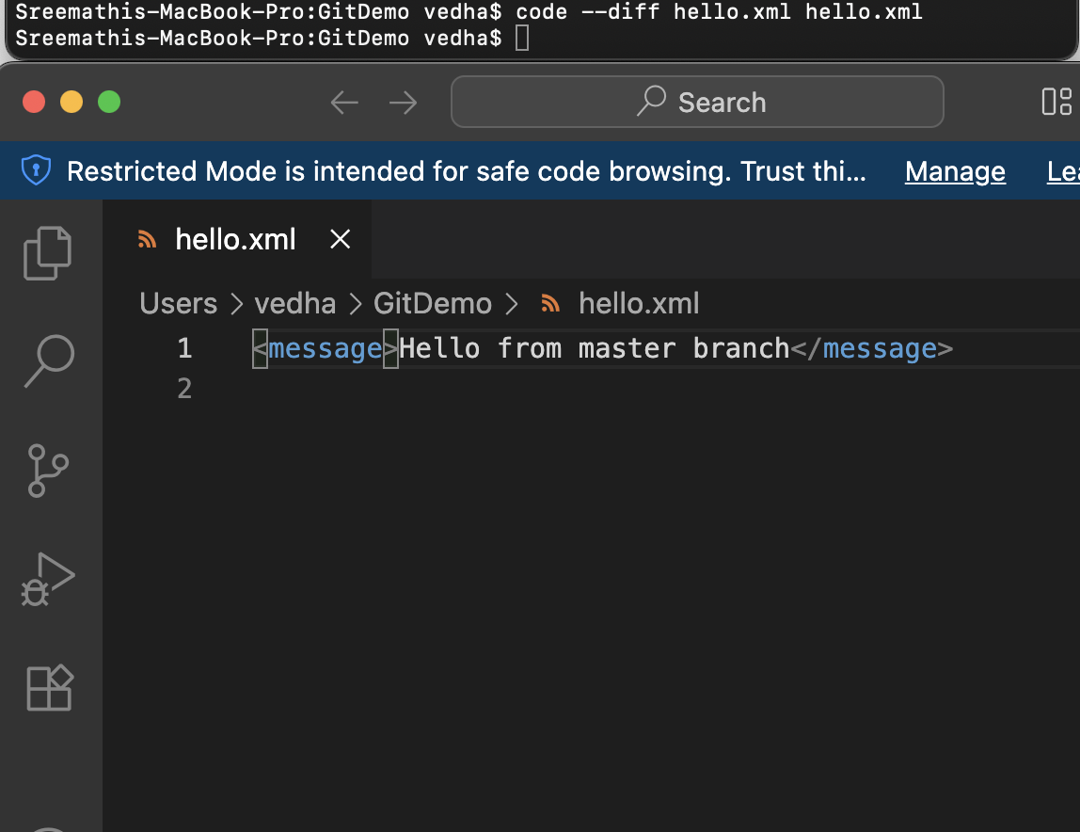

Merging gitwork to master

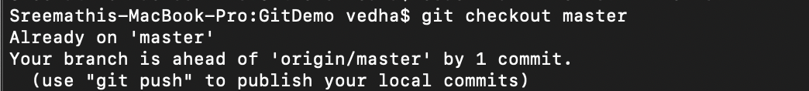

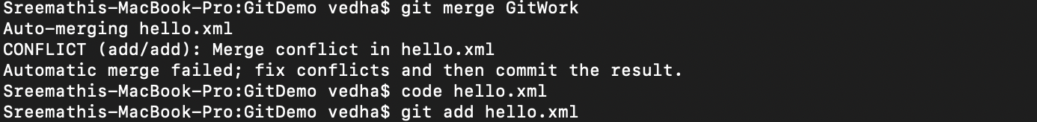

Resolving conflict

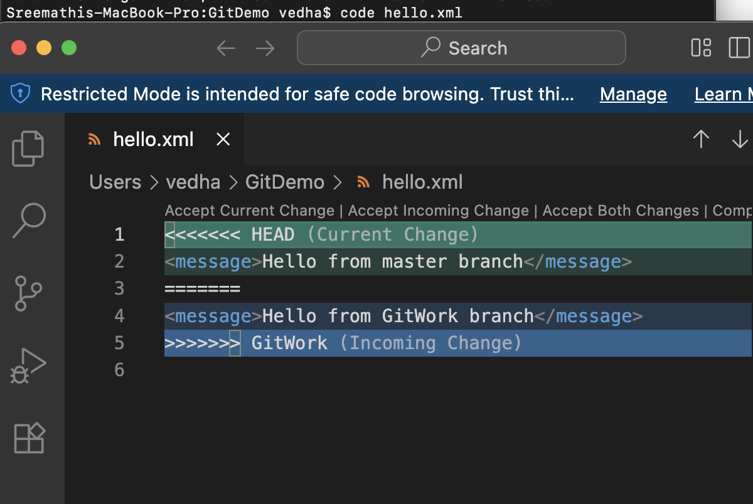

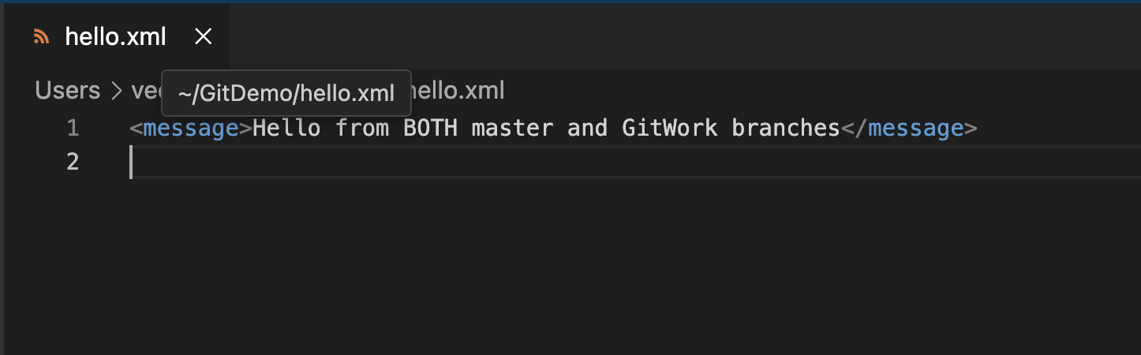

Then adding and committing again 



Adding backup files to .gitignore

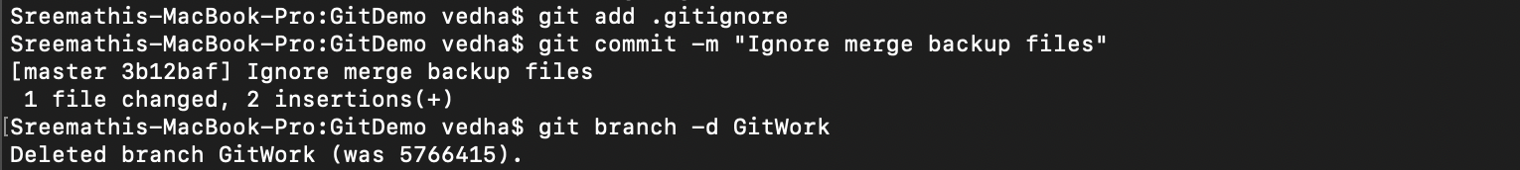

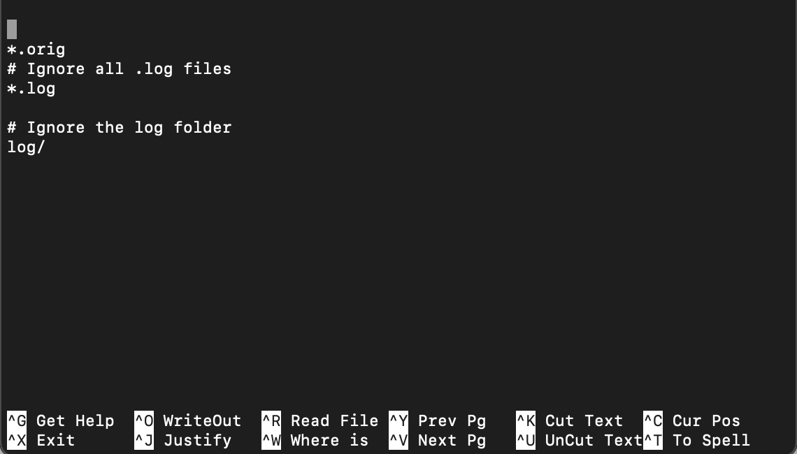

Then deleting the merged branch



Viewing final log

