5.Git-HOL

Switching to master branch

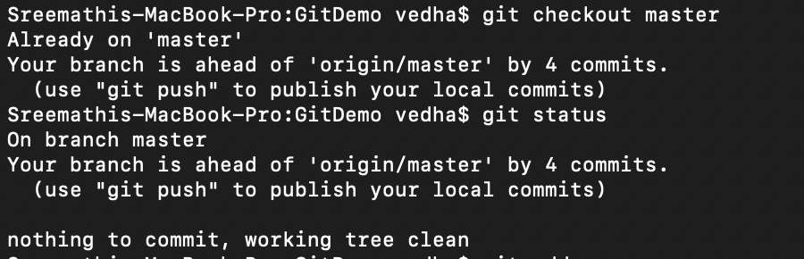

Committing all changes

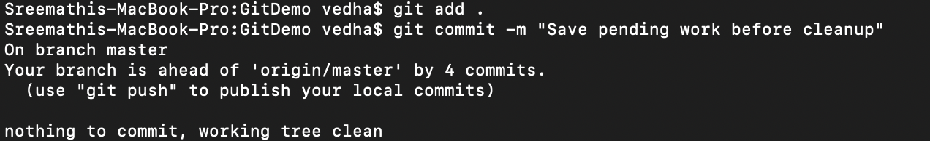

Seeing all branches

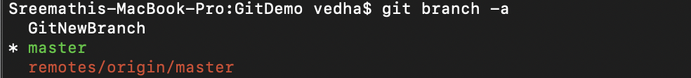

Pulling from remote

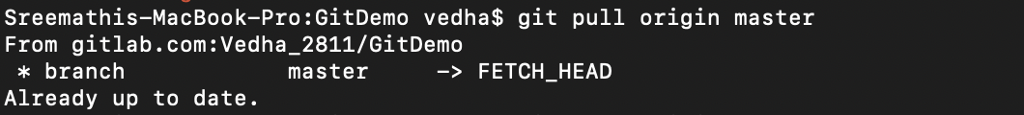

Pushing to remote

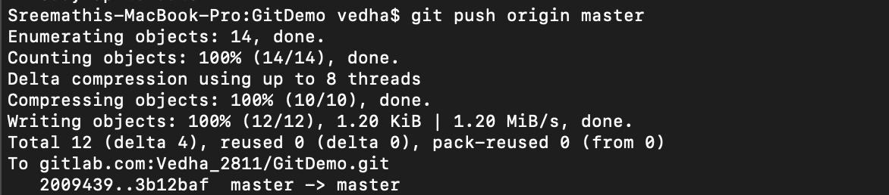

Verifying

