*DEPLOY WORDPRESS USING RDS AND ALLOCATE ELASTIC IP*

STEP-1: *Create MySQL Database: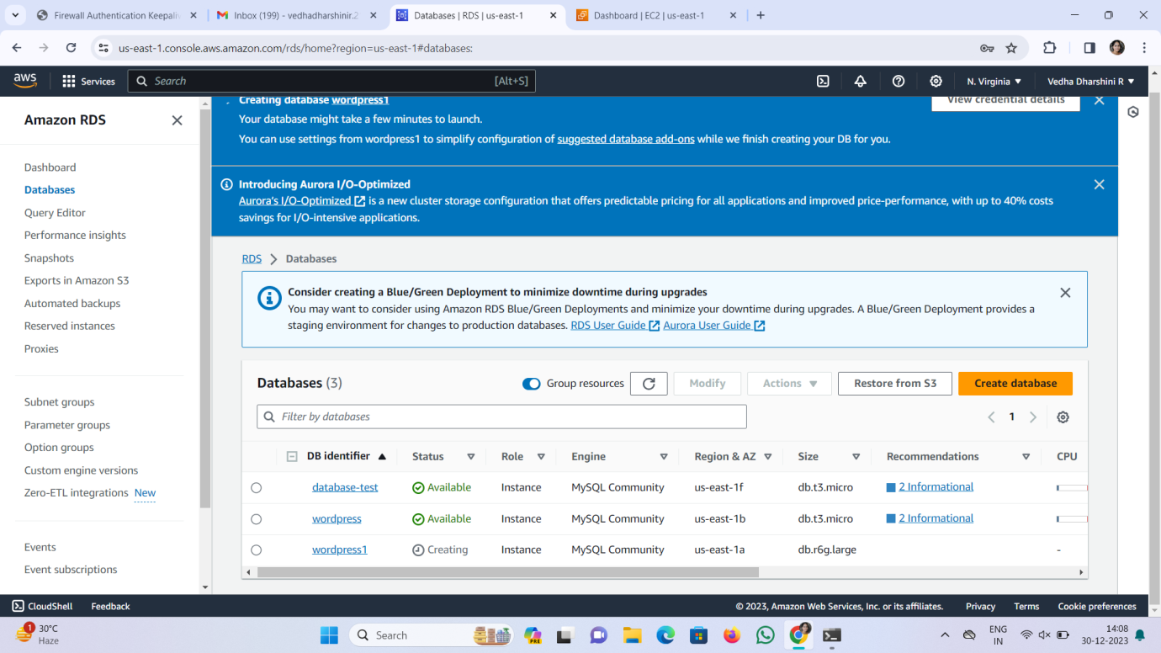*

*Description:* *In this module, created a fully managed MySQL*

Database using Amazon RDS.

*Step-2: Creating Instance with EC2*

*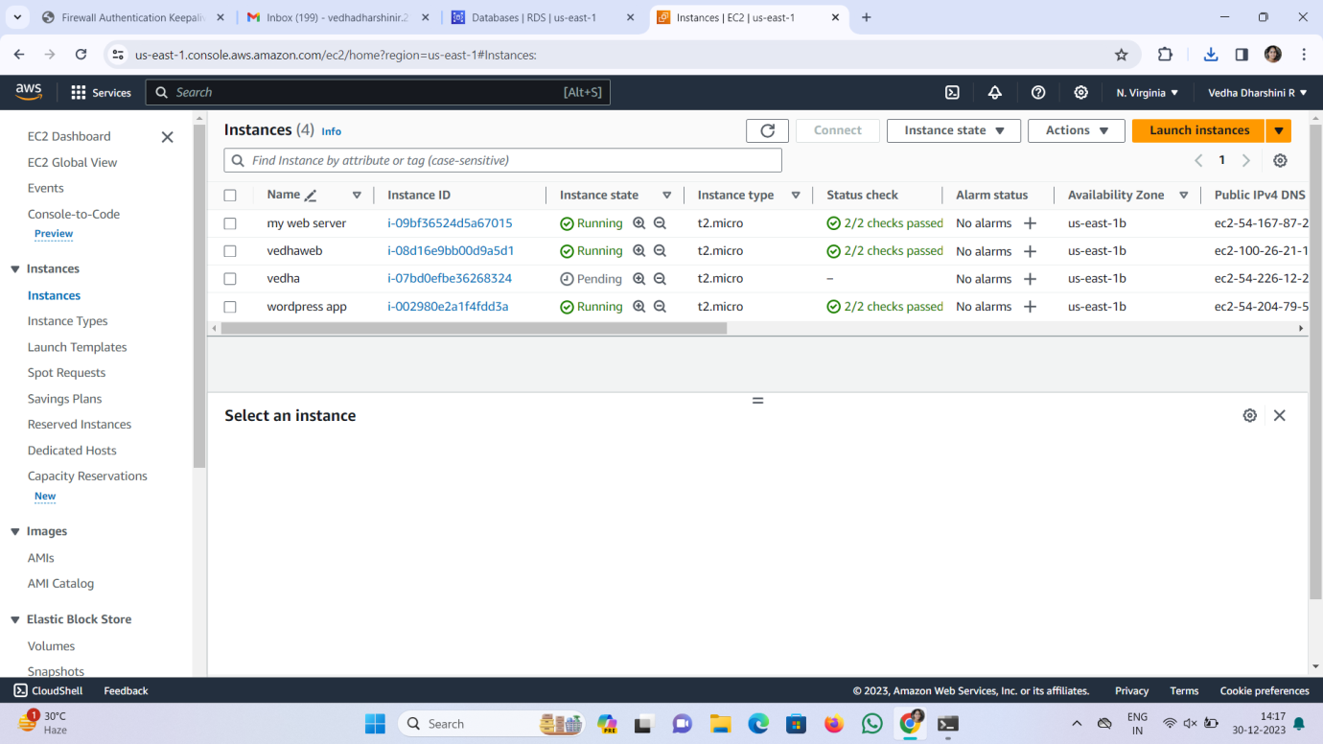*

*Description:* Successfully launched EC2 instance.

*Step -3: Allocate Elastic IP Address:*

*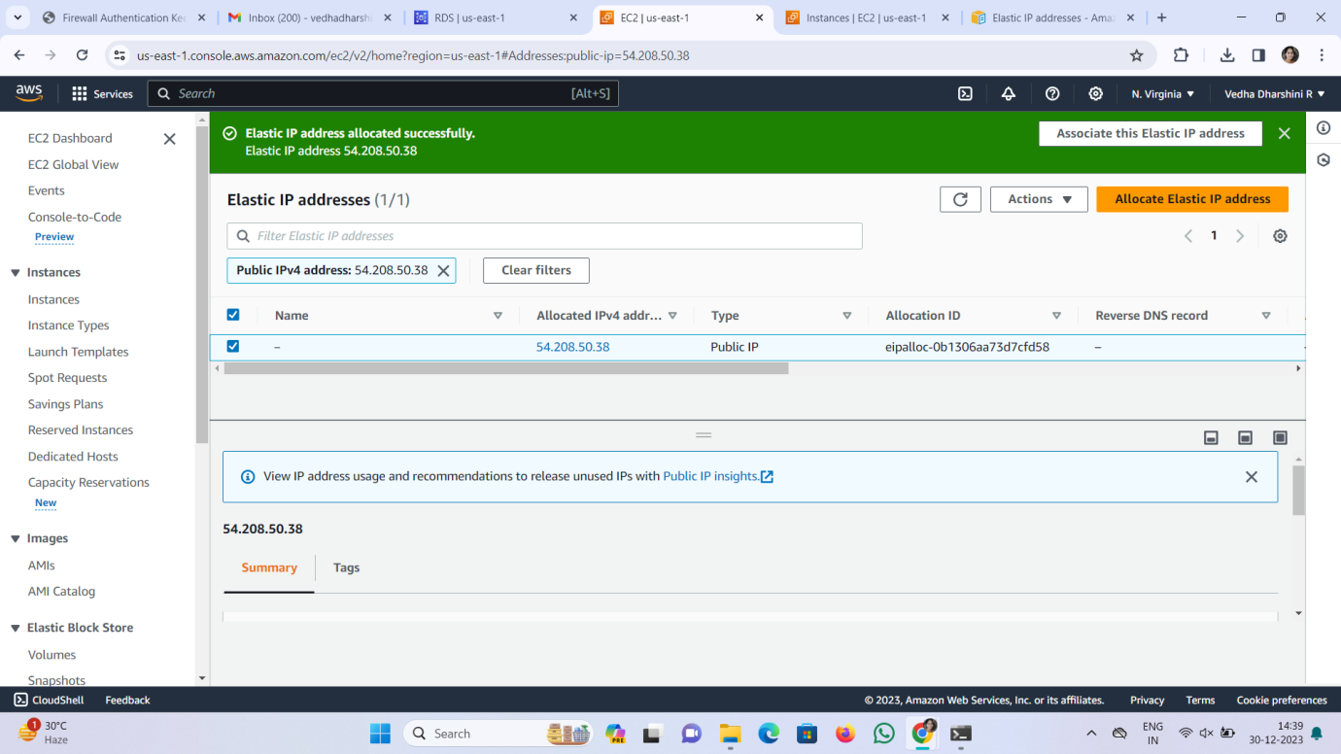*

*Description:* Allocating Elastic IP Address to the running instance

Successfully allocated.

Step-4: Connect the EC2 Instance:

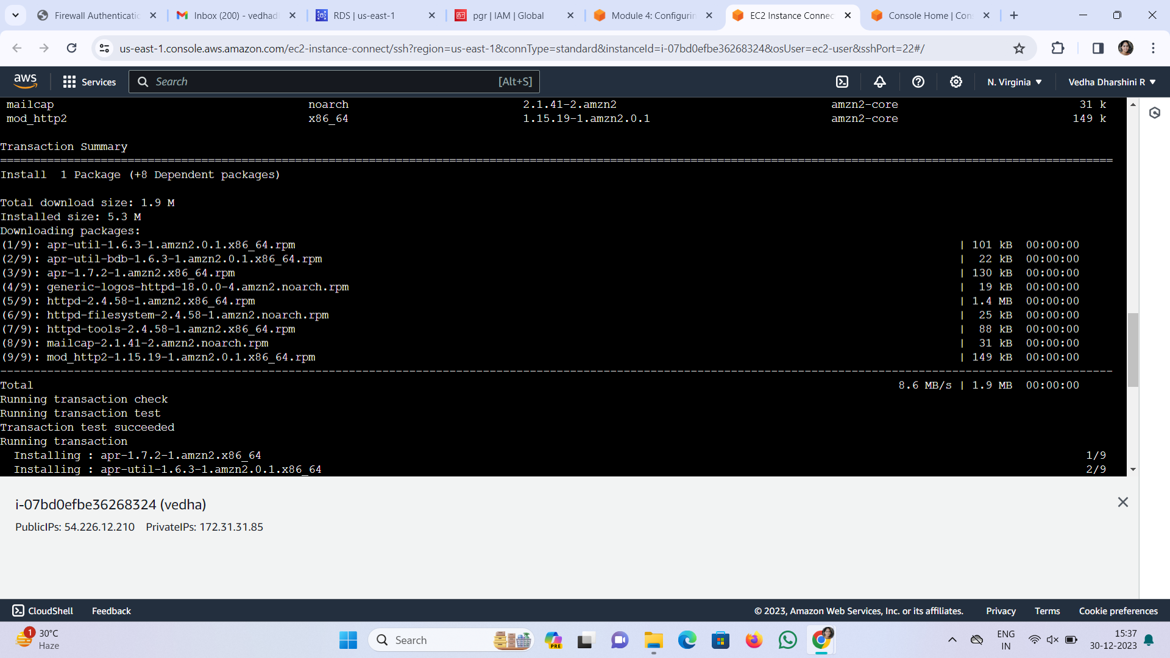

Description: Connection has been established.

Step-5: Installation of Apache Web Server

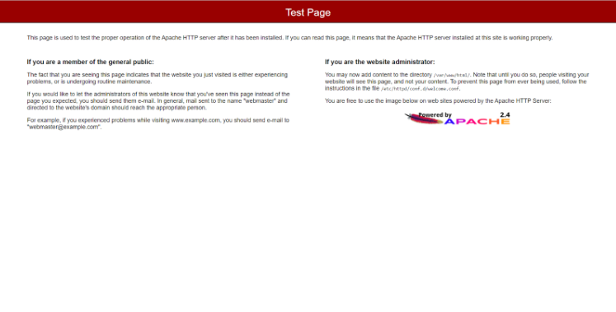

Step-6: Deploying Word press.

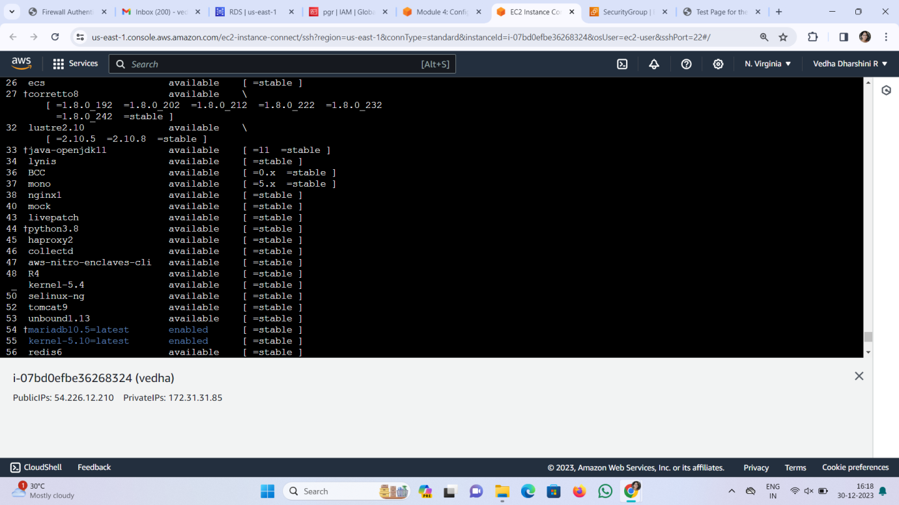

Step-7: Installing a word press 