from google.colab import files

uploaded=files.upload()

**Q1.**

import pandas as pd

import numpy as np

def equal_width_binning(data, num_bins):

"""Performs equal-width binning on a pandas Series.

Args:

data: pandas Series containing the data to be binned.

num_bins: The desired number of bins.

Returns:

A pandas Series with the binned data.

"""

# Calculate bin edges

min_val = data.min()

max_val = data.max()

bin_width = (max_val - min_val) / num_bins

bin_edges = [min_val + i * bin_width for i in range(num_bins + 1)]

# Bin the data

binned_data = pd.cut(data, bins=bin_edges, labels=False, include_lowest=True, duplicates='drop')

return binned_data

def calculate_entropy(data):

"""Calculates the entropy of a pandas Series.

Args:

data: pandas Series containing the data.

Returns:

The entropy of the data.

"""

# Calculate probabilities of each unique value

value_counts = data.value_counts(normalize=True)

probabilities = value_counts.values

# Calculate entropy

entropy = -np.sum(probabilities * np.log2(probabilities))

return entropy

# --- Main part to read from CSV and calculate entropy ---

# Replace 'your_csv_file.csv' with the actual path to your CSV file

# Replace 'outcome_column' with the name of the column containing your outcome variable

csv_file_path = 'Heart_disease_statlog.csv'

df = pd.read_csv(csv_file_path)

outcome_column = 'target'

# Bin the outcome column if it's continuous:

df['binned_outcome'] = equal_width_binning(df[outcome_column], num_bins=4)

# Calculate entropy:

entropy = calculate_entropy(df['binned_outcome'])

# Print the result

print(f"Entropy: {entropy}")

**OUTPUT**: Entropy: 0.9910760598382222

**Q2.**

import pandas as pd

import numpy as np

def calculate_gini_index(data, target_column):

"""Calculates the Gini index for a dataset.

Args:

data: pandas DataFrame containing the data.

target_column: The name of the column containing the target variable.

Returns:

The Gini index value.

"""

# Get the target variable values

target_values = data[target_column].unique()

# Calculate the total number of samples

total_samples = len(data)

# Initialize Gini index to 0

gini_index = 0

# Iterate through each target value

for value in target_values:

# Calculate the proportion of samples with the current target value

proportion = len(data[data[target_column] == value]) / total_samples

# Update the Gini index

gini_index += proportion * (1 - proportion)

return gini_index

# Assuming 'df' is your pandas DataFrame and 'target' is the name of the target column

gini_index = calculate_gini_index(df, 'target')

# Print the result

print(f"Gini Index: {gini_index}")

**OUTPUT:** Gini Index: 0.49382716049382713

**Q3.**

import pandas as pd

import numpy as np

def calculate_entropy(data):

"""Calculates the entropy of a pandas Series."""

value_counts = data.value_counts(normalize=True)

probabilities = value_counts.values

entropy = -np.sum(probabilities * np.log2(probabilities))

return entropy

def calculate_information_gain(data, feature_column, target_column):

"""Calculates the information gain for a given feature."""

total_entropy = calculate_entropy(data[target_column])

# Calculate weighted average entropy for each feature value

weighted_entropy = 0

for value in data[feature_column].unique():

subset = data[data[feature_column] == value]

weighted_entropy += (len(subset) / len(data)) * calculate_entropy(subset[target_column])

# Calculate information gain

information_gain = total_entropy - weighted_entropy

return information_gain

def find_best_root_node(data, features, target_column):

"""Finds the best feature for the root node using Information Gain."""

best_feature = None

max_information_gain = -1 # Initialize with a negative value

for feature in features:

information_gain = calculate_information_gain(data, feature, target_column)

if information_gain > max_information_gain:

max_information_gain = information_gain

best_feature = feature

return best_feature

# Example Usage:

# Assuming 'df' is your pandas DataFrame, 'features' is a list of feature column names,

# and 'target_column' is the name of the target variable column.

features = ['sex', 'cp', 'chol'] # Replace with your feature names

target_column = 'target' # Replace with your target column name

best_root_feature = find_best_root_node(df, features, target_column)

print(f"Best Root Node Feature: {best_root_feature}")

**Q4.**

import pandas as pd

import numpy as np

import warnings

def binning(data, num_bins=4, binning_type='equal_width'):

"""

Performs binning on a pandas Series.

Args:

data: pandas Series containing the data to be binned.

num_bins: The desired number of bins (default is 4).

binning_type: The type of binning to perform ('equal_width' or 'equal_frequency', default is 'equal_width').

Returns:

A pandas Series with the binned data.

"""

if binning_type == 'equal_width':

# Calculate bin edges

min_val = data.min()

max_val = data.max()

bin_width = (max_val - min_val) / num_bins

bin_edges = [min_val + i * bin_width for i in range(num_bins + 1)]

# Bin the data

binned_data = pd.cut(data, bins=bin_edges, labels=False, include_lowest=True, duplicates='drop')

elif binning_type == 'equal_frequency':

# Bin the data using quantiles

binned_data = pd.qcut(data, q=num_bins, labels=False, duplicates='drop')

else:

raise ValueError("Invalid binning_type. Choose 'equal_width' or 'equal_frequency'.")

return binned_data

def calculate_entropy(data):

"""Calculates the entropy of a pandas Series."""

value_counts = data.value_counts(normalize=True)

probabilities = value_counts.values

entropy = -np.sum(probabilities * np.log2(probabilities))

return entropy

def calculate_information_gain(data, feature_column, target_column):

"""Calculates the information gain for a given feature."""

total_entropy = calculate_entropy(data[target_column])

# Calculate weighted average entropy for each feature value

weighted_entropy = 0

for value in data[feature_column].unique():

subset = data[data[feature_column] == value]

weighted_entropy += (len(subset) / len(data)) * calculate_entropy(subset[target_column])

# Calculate information gain

information_gain = total_entropy - weighted_entropy

return information_gain

def find_best_root_node(data, features, target_column):

"""Finds the best feature for the root node using Information Gain."""

best_feature = None

max_information_gain = -1 # Initialize with a negative value

# Suppress DeprecationWarning

with warnings.catch_warnings():

warnings.filterwarnings("ignore", category=DeprecationWarning)

for feature in features:

# Bin the feature if it's continuous

if data[feature].dtype == np.number:

data[feature] = binning(data[feature]) # Use default binning parameters

information_gain = calculate_information_gain(data, feature, target_column)

if information_gain > max_information_gain:

max_information_gain = information_gain

best_feature = feature

return best_feature

# Example Usage:

# Assuming 'df' is your pandas DataFrame, 'features' is a list of feature column names,

# and 'target_column' is the name of the target variable column.

features = ['trestbps', 'chol', 'thalach'] # Replace with your feature names

target_column = 'target' # Replace with your target column name

best_root_feature = find_best_root_node(df, features, target_column)

print(f"Best Root Node Feature: {best_root_feature}")

**Q5.**

import pandas as pd

import numpy as np

import warnings

def binning(data, num_bins=4, binning_type='equal_width'):

"""Performs binning on a pandas Series."""

if binning_type == 'equal_width':

min_val = data.min()

max_val = data.max()

bin_width = (max_val - min_val) / num_bins

bin_edges = [min_val + i * bin_width for i in range(num_bins + 1)]

binned_data = pd.cut(data, bins=bin_edges, labels=False, include_lowest=True, duplicates='drop')

elif binning_type == 'equal_frequency':

binned_data = pd.qcut(data, q=num_bins, labels=False, duplicates='drop')

else:

raise ValueError("Invalid binning_type. Choose 'equal_width' or 'equal_frequency'.")

return binned_data

csv_file_path = 'Heart_disease_statlog.csv'

df = pd.read_csv(csv_file_path)

outcome_column = 'target'

def calculate_entropy(data):

"""Calculates the entropy of a pandas Series."""

value_counts = data.value_counts(normalize=True)

probabilities = value_counts.values

entropy = -np.sum(probabilities * np.log2(probabilities))

return entropy

def calculate_information_gain(data, feature_column, target_column):

"""Calculates the information gain for a given feature."""

total_entropy = calculate_entropy(data[target_column])

weighted_entropy = 0

for value in data[feature_column].unique():

subset = data[data[feature_column] == value]

weighted_entropy += (len(subset) / len(data)) * calculate_entropy(subset[target_column])

information_gain = total_entropy - weighted_entropy

return information_gain

def find_best_root_node(data, features, target_column):

"""Finds the best feature for the root node using Information Gain."""

best_feature = None

max_information_gain = -1 # Initialize with a negative value

# Create a copy of the DataFrame to avoid modifying the original

data_copy = data.copy()

with warnings.catch_warnings():

warnings.filterwarnings("ignore", category=DeprecationWarning)

for feature in features:

# Check if the feature is numerical

if np.issubdtype(data_copy[feature].dtype, np.number):

data_copy[feature] = data_copy[feature].astype(np.int64) # Keep as np.int64

information_gain = calculate_information_gain(data_copy, feature, target_column)

if information_gain > max_information_gain:

max_information_gain = information_gain

best_feature = feature

return best_feature

def build_decision_tree(data, features, target_column):

"""Builds the decision tree recursively."""

# Base case: If all target values are the same, return the target value

if len(data[target_column].unique()) == 1:

return np.int64(data[target_column].iloc[0]) # Ensure it's stored as np.int64

# Base case: If no features left, return the most common target value

if len(features) == 0:

return np.int64(data[target_column].mode()[0])

# Find the best feature to split on

best_feature = find_best_root_node(data, features, target_column)

# Create a tree node

tree = {best_feature: {}}

# Recursively build subtrees for each feature value

for value in sorted(data[best_feature].unique()): # Sort for consistency

subset = data[data[best_feature] == value]

remaining_features = [f for f in features if f != best_feature]

subtree = build_decision_tree(subset, remaining_features, target_column)

tree[best_feature][np.int64(value)] = subtree # Ensure keys are np.int64

return tree

# Example usage:

# Assuming 'df' is your pandas DataFrame, 'features' is a list of feature column names,

# and 'target_column' is the name of the target variable column.

features = ['sex', 'cp', 'chol'] # Replace with your feature names

target_column = 'target' # Replace with your target column name

decision_tree = build_decision_tree(df, features, target_column)

print(decision_tree)

**Q6.**

import pandas as pd

import numpy as np

import warnings

from sklearn.tree import DecisionTreeClassifier, plot_tree

import matplotlib.pyplot as plt

# ... (binning, calculate_entropy, calculate_information_gain, find_best_root_node, build_decision_tree functions remain the same) ...

# Assuming 'df' is your pandas DataFrame, 'features' is a list of feature column names,

# and 'target_column' is the name of the target variable column.

features = ['sex', 'cp', 'chol'] # Replace with your feature names

target_column = 'target' # Replace with your target column name

# Convert continuous features to categorical using binning if needed

for feature in features:

if pd.api.types.is_numeric_dtype(df[feature]): # Check if the feature is numeric

df[feature] = binning(df[feature])

# Create a DecisionTreeClassifier object

clf = DecisionTreeClassifier()

# Train the decision tree using your data

clf.fit(df[features], df[target_column])

# Plot the decision tree

plt.figure(figsize=(12, 8)) # Adjust figure size as needed

plot_tree(clf, feature_names=features, class_names=['0', '1'], filled=True, rounded=True)

plt.show()

plt.show()

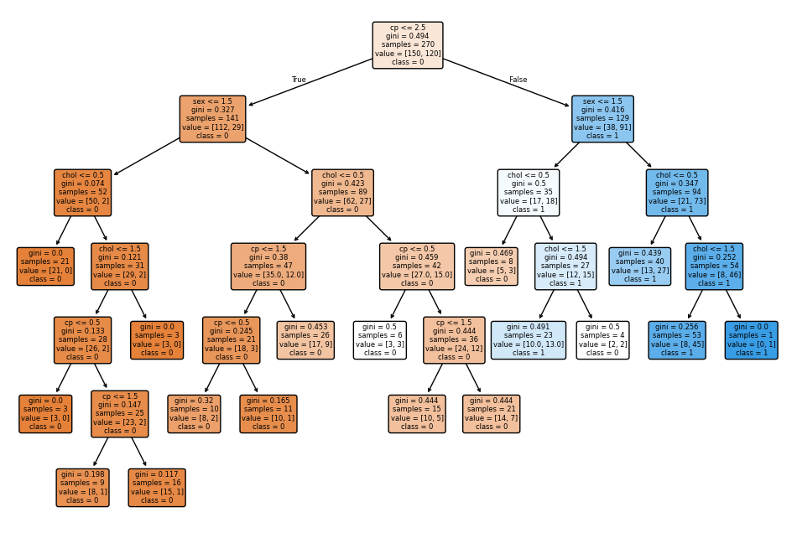

**Q7.**

import pandas as pd

import numpy as np

import matplotlib.pyplot as plt

from sklearn.tree import DecisionTreeClassifier

from sklearn.inspection import DecisionBoundaryDisplay

# Assuming 'df' is your pandas DataFrame

# Select two features for visualization (e.g., 'feature1' and 'feature2')

feature1 = 'chol' # Replace with your first feature name

feature2 = 'cp' # Replace with your second feature name

features = [feature1, feature2]

target_column = 'target' # Replace with your target column name

# Create a DecisionTreeClassifier object

clf = DecisionTreeClassifier()

# Train the decision tree using the selected features and target

clf.fit(df[features], df[target_column])

# Create a meshgrid for visualization

x_min, x_max = df[feature1].min() - 1, df[feature1].max() + 1

y_min, y_max = df[feature2].min() - 1, df[feature2].max() + 1

xx, yy = np.meshgrid(np.arange(x_min, x_max, 0.1), np.arange(y_min, y_max, 0.1))

# Plot the decision boundary

disp = DecisionBoundaryDisplay.from_estimator(

clf,

df[features],

response_method="predict",

xlabel=feature1,

ylabel=feature2,

alpha=0.8,

cmap=plt.cm.RdYlBu,

)

# Plot the training points

disp.ax_.scatter(

df[feature1], df[feature2], c=df[target_column], edgecolor="k", cmap=plt.cm.RdYlBu

)

plt.title("Decision Boundary of Decision Tree")

plt.show()

