Design Thinking Project Workbook

Don't find customers for your product but find products for your customers
1. Team

Team Name: Credit Card Fraud Detection Using Machine Learning

Team Members:
- P N Vedha Sree-2320030269
- A.Abhiram-2320030077
- Suchitra Rout-2320030383

2. Problem/Opportunity Domain

Domain of Interest: Fraud Detection in Credit Card Transactions Using Machine Learning

Description of the Domain:
Fraud detection in financial transactions is the process of identifying and preventing fraudulent activities, such as unauthorized payments and identity theft, using machine learning models.
How It Works:
- Data Collection – Transaction data includes features like Time, Amount, and anonymized variables (V1 to V28).
- Model Training – A machine learning model (e.g., Random Forest) is trained on historical transaction data to classify transactions as fraudulent (1) or legitimate (0).
- Prediction – When a user enters transaction details, the trained model predicts whether it is fraud or not.
- Deployment – The model is integrated into a web application (Flask) for real-time fraud detection.
Why Machine Learning?
- Detects complex fraud patterns beyond simple rule-based checks.
- Adapts to evolving fraud techniques.
- Reduces false positives, ensuring real transactions aren’t blocked unnecessarily.
Applications: Used in banking, e-commerce, and online payments for fraud prevention

Why did you choose this domain?:

- Real-World Impact – Fraud detection is crucial in banking, e-commerce, and finance to prevent financial losses and protect users.
- This domain was chosen due to its real-world impact and the opportunity to apply advanced AI techniques to solve critical financial security challenges.
- Challenging & Dynamic – Fraud techniques constantly evolve, making it an exciting and high-demand field for AI solutions.

3. Problem/Opportunity Statement

Problem Statement:
Financial fraud is a critical challenge in digital transactions, requiring accurate detection methods. Traditional rule-based systems fail to adapt to evolving fraud tactics. This project aims to develop a machine learning-based fraud detection model using a subset of key transaction features (4-5) to classify transactions as fraudulent or legitimate. The model will be deployed in a Flask web application for real-time predictions
Problem Description:
There is a growing issue of disorganization and poor time management when it comes to managing deadlines, tasks, and schedules. Many customers struggle with using traditional tools or basic digital solutions, which fail to effectively meet their needs for efficient task management and time tracking.

Context (When does the problem occur):

- When there are multiple deadlines or projects to manage at once.
- When the customer needs to prioritize tasks and track progress.

Alternatives (What does the customer do to fix the problem):

- Use manual methods like spreadsheets, paper lists, or sticky notes – Customers rely on physical or basic digital methods, which can easily get lost, disorganized, or become time-consuming to update.
- Rely on basic calendar applications for deadline reminders – While these tools offer reminders, they lack detailed task tracking and prioritization features.
- Use specialized task management apps – Some customers might use apps like Trello or Asana, but they often find them too complicated or difficult to use consistently.
Customers (Who has the problem most often):
1. Project managers and team leaders.
2. Freelancers and remote workers.
3. Students and researchers

Emotional Impact (How does the customer feel):
- Overwhelmed by the volume of tasks.
- Stressed about missing deadlines or overlooking important details.
- Frustrated by the lack of clarity and control over their workload.
.

Quantifiable Impact (What is the measurable impact):
- Reduced Productivity and Efficiency:
- Fraudulent transactions require additional manual verification and investigation.
- A machine learning model can automate fraud detection, reducing time spent on manual reviews.
- Increased Project Delays and Missed Deadlines:
- Fraudulent activities cause disruptions in business operations.
- Implementing an AI-driven fraud detection system minimizes these delays by flagging fraud in real-time.
- Higher Error Rates and Rework:
- Traditional fraud detection methods have high false positives, leading to incorrect transaction blocking.
- A well-trained ML model improves accuracy, reducing errors and unnecessary rework.
- Increased Employee Burnout and Turnover:
- Fraud analysts handling excessive manual reviews experience stress and burnout.
- Automation through machine learning alleviates workload, improving job satisfaction.

Alternative Shortcomings (What are the disadvantages of the alternatives):
  - Manual Methods:
- Disadvantage: Error-prone, time-consuming, and difficult to scale.
- Why ML is Better: Automates fraud detection, reducing human error and processing time.
  - Calendars & Basic Tracking Tools:
- Disadvantage: Not designed for fraud detection, lacks analytical capabilities.
- Why ML is Better: Uses historical patterns and real-time analytics for decision-making.
  - Generic Tools (Rule-based Systems):
- Disadvantage: Require constant updates, and struggle with evolving fraud techniques.
- Why ML is Better: Learns and adapts to new fraud patterns without manual rule updates.
  - Generic AI Models:
- Disadvantage: May not be tailored to fraud detection, leading to false positives or privacy risks.
- Why ML is Better: A domain-specific ML model is trained on financial transaction data for high accuracy and better fraud detection
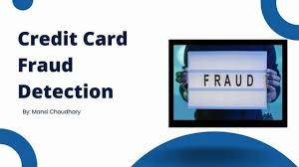
3. Addressing SDGs

Relevant Sustainable Development Goals (SDGs):
SDG 8 (Decent Work):
- AI streamlines tasks, leading to more efficient work and less wasted time.
- Automation and intelligent prioritization reduce stress and burnout.
SDG 9 (Innovation):
- AI implementation fosters technological advancement in workflow optimization.
- It improves the digital infrastructure of task management.
SDG 12 (Responsible Consumption):
- AI enables better resource allocation, minimizing waste.
- Less time wasted on unorganized work, reduces overall energy use.

How does your problem/opportunity address these SDGs?:
Improved forecasting can mitigate climate-related disasters.
AI-driven solutions enhance technological innovation in meteorology.
4. Stakeholders
1. Who are the key stakeholders involved in or affected by this project?
The primary stakeholders for "Task-Flow" include individual users who need task management, teams and project managers coordinating work, developers building and maintaining the AI system, businesses implementing it for efficiency, investors funding its development, and data security experts ensuring user privacy and compliance.
2. What roles do the stakeholders play in the success of the innovation?
Users are crucial for adoption and feedback, developers ensure the system's functionality, businesses drive implementation and usage, investors provide financial support, and security experts guarantee data protection. Each stakeholder's role is essential for the successful development and widespread adoption of the "Task-Flow" system.
3. What are the main interests and concerns of each stakeholder?
Users prioritize ease of use and increased productivity, teams need seamless collaboration tools, developers focus on technical feasibility and innovation, businesses seek improved efficiency and ROI, investors desire financial returns, and security experts are concerned with data privacy and compliance.

4. How much influence does each stakeholder have on the outcome of the project?
Users and businesses have high influence through adoption and implementation decisions, developers control the system's functionality, investors dictate resource allocation, and security experts ensure compliance, all playing significant roles in the project's success.
5 . What is the level of engagement or support expected from each stakeholder?
Users are expected to provide feedback and actively use the system, developers should offer continuous support and updates, businesses need to implement and promote the system, investors should provide financial and strategic guidance, and security experts must conduct audits and ensure compliance.
6. How will you communicate and collaborate with stakeholders throughout the project?
Communication will occur through user feedback channels, regular developer meetings, business progress reports, investor updates, and security consultations, ensuring all stakeholders are informed and engaged throughout the project's lifecycle.

5. Power Interest Matrix of Stakeholders

High Power, High Interest:
- Banking Executives/Fraud Prevention Teams: They have the power to implement the system and a strong interest in reducing fraudulent transactions and protecting customers.
- AI/ML Engineers/Data Scientists: They shape the system’s development and have a high interest in its accuracy and performance.
High Power, Low Interest:
- Regulatory Bodies (e.g., Financial Conduct Authority, Data Protection Authorities): They have the power to enforce compliance with financial regulations but may have limited interest in the daily operation of the fraud detection system.
- Investors/Stakeholders: They fund the project and care about its ROI but aren’t deeply involved in the technical details.

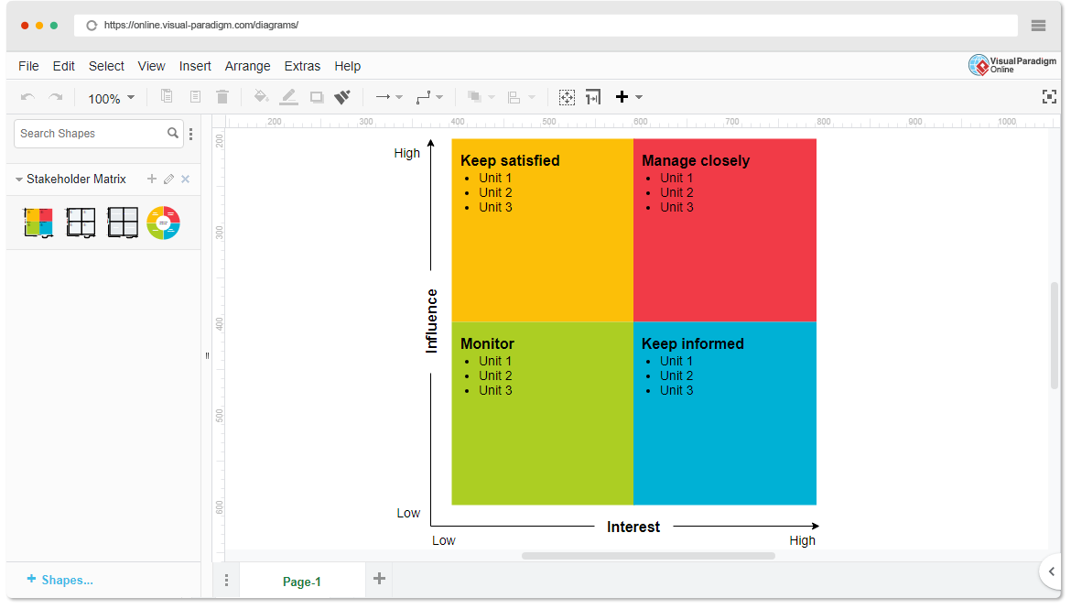
Low Power, Low Interest:
- General Public: Unless directly affected by fraud or using services from institutions adopting the system, they have little power and interest in its development.

- High Power, High Interest: [Banking executives/Fraud Prevention Teams]
- High Power, Low Interest: [Regulatory Bodies]
- Low Power, High Interest: [Credit Card Holders/Customers Support Teams]
- Low Power, Low Interest: [General Public]

- Empathetic Interviews

Conduct Skilled interviews with at least 30 citizens/Users by asking open-ended questions (What, why/How etc) and list the insights as per the format below

I need to know  (thoughts, feelings, actions) | Questions I will ask  (open questions) | Insights I hope to gain
Thoughts about initial expectations | What are your key expectations from this project? | What are their primary goals for credit card fraud detection?
Thoughts about success | What performance metrics do you consider essential for measuring project success? | What key indicators define success for them?
Thoughts about technical support | What regulatory or compliance factors should we consider while developing this system? | What level of financial and technical support will they provide?
Strategic planning | How do you see AI fraud detection aligning with your strategic objectives? | What policies must the AI model adhere to?
Ethical considerations | How can we ensure transparency and accountability in AI-generated credit card transactions? | What legal, financial, or reputational risks need to be managed?
Perceptions about risks involved | What potential risks or concerns should we proactively address? | What would make them prioritise this project over others?
actions to take to enhance accuracy | What datasets or research insights could help enhance our AI model’s accuracy? | How do common people and bank employees want to use the system?
Actions to take in regard to testing | How would you like to be involved in testing and validating the AI model? | What factors would improve confidence in our project?
Voicing concerns | What concerns, if any, do you have about AI-generated credit card fraud detection? | What partnerships can be leveraged for further development?

SKILLED INTERVIEW REPORT
(Examples are given. Erase them and fill with your user information.)

User/Interviewee | Questions Asked | Insights gained (NOT THEIR ANSWERS)
Bank Customer | How do you feel about the security of your credit card transactions? | Many customers feel insecure about their online transactions and worry about their credit card information being stolen
Small business owner | How do you detect fraud in transactions for your business? | Small business owners often rely on manual checks or alerts from banks, but find it difficult to spot fraud in real-time due to the volume of transactions
Professional | Have you ever experienced any unauthorized charges on your credit card? | Some professionals have faced unauthorized charges, often noticing them too late due to delayed notifications or ineffective fraud detection systems.
Freelancer | What steps do you take to prevent fraud when using your credit card online? | Freelancers often use basic security measures like strong passwords or two-factor authentication but are still concerned about sophisticated fraud schemes.
Fraud analyst | How do you identify fraudulent transactions in real time? | Fraud analysts rely on patterns and historical data but find it challenging to identify new fraud tactics without advanced machine learning or AI-based tools

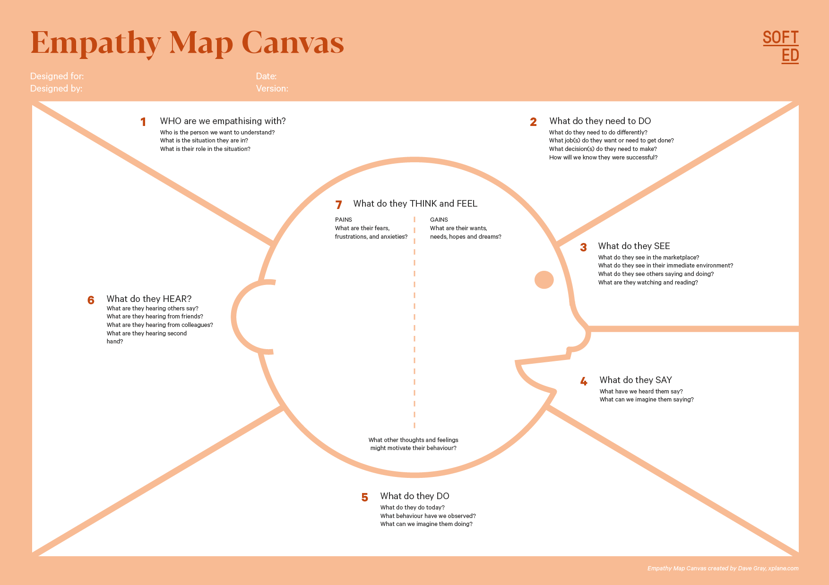
Empathy Map

Issues of new age transaction crime
Credit Card Holder
Who is your Customer Segment:Banks and Financial institutions
Idea/Innovation Title:Credit Card Fraud Detection Using AIML

Designed By:Sophie, Chetan and Swathi
Date of Submission: 16.02.2025
Losing money and reputation
To provide security
Their livelihood
Monitor and Respond:
Common crime in transactions:
Words of reassurance to their customers
They follow old retaliating methods

- Empathy Map

- Who is your Customer?
1. Banks and Financial Institutions
2. Payment Processors (e.g., Visa, Mastercard)
3 . Fintech Companies
b. Who are we empathising with?
1. Credit Card Holders (End Users):
- They’re the ones directly impacted by fraud.
- Situation: They might receive unexpected fraud alerts, notice unauthorized transactions, or feel anxious about the safety of their finances.
- Role: Victim of fraud, relying on the system to protect their money and identity.
2. Fraud Prevention Teams/Analysts:
- They use the system daily to monitor transactions and respond to alerts.
- Situation: They’re under pressure to minimize false positives while catching real fraud quickly.
- Role: Investigate flagged transactions and refine detection strategies.
c. What do they need to do?

1. Credit Card Holders:
- Monitor Transactions: Keep an eye on statements and app notifications for suspicious activity.
- Respond to Alerts: Confirm whether flagged transactions are legitimate or fraudulent.
- Report Fraud: Contact the bank immediately when unauthorized activity is detected.
- Secure Their Account: Change passwords, freeze the card, or enable additional security measures if fraud occurs.
- Stay Informed: Understand fraud risks and recognize potential scams.

2. Fraud Prevention Teams/Analysts:
- Analyze Alerts: Review flagged transactions to distinguish real fraud from false positives.
- Investigate Patterns: Identify new fraud techniques and update detection models.
- Optimize the System: Work with AI/ML engineers to fine-tune algorithms and reduce errors.
- Communicate with Customers: Support affected customers, guiding them through dispute resolution.
- Report Findings: Provide insights to improve fraud prevention strategies.
d. What do they see?

Credit Card Holders:
- Alerts and Notifications:
  - "Suspicious transaction detected. Was this you?"
  - "Your card has been temporarily blocked for your security."
- Bank App/Website Interface:
  - Transaction history with flagged entries.
  - Options to dispute charges or report fraud.
- Account Changes:
  - Account lockouts or card deactivation notices.
  - Updates on dispute resolution progress.
- News and Social Media:
  - Stories about rising cybercrime and new fraud tactics.
- Emotional Cues:
  - Anxiety from seeing unauthorized charges or unfamiliar transaction locations.

Fraud Prevention Teams/Analysts:
- Monitoring Dashboards:
  - Real-time transaction data.
  - Alerts highlighting suspicious activity.
- Fraud Patterns and Reports:
  - Visualizations of transaction trends and flagged anomalies.
- Case Management System:
  - Workflow for handling reported fraud cases.
  - Communication logs with affected customers.
- Performance Metrics:
  - Accuracy rates, false positives, and detection efficiency reports.
e. What do they say?

Credit Card Holders:
- When receiving an alert:
  - "I don’t recognize this transaction — was my card hacked?"
- When reporting fraud:
  - "I need help disputing these charges."

Fraud Prevention Teams/Analysts:
- When analyzing alerts:
  - "This pattern looks suspicious — let’s flag it."
- When discussing system performance:
  - "The model is flagging too many legitimate transactions — we need to fine-tune it."
f. What do they do?

Credit Card Holders:
- Monitor Transactions:
  - Regularly check statements and app notifications.
- Respond to Alerts:
  - Confirm whether transactions are legitimate or report suspicious activity.
- Report Fraud:
  - Contact the bank to dispute charges and freeze their card.

Fraud Prevention Teams/Analysts:
- Monitor Transactions:
  - Review flagged transactions in real time.
- Investigate Alerts:
  - Analyze suspicious patterns and identify emerging fraud tactics.
- Take Action:
  - Freeze accounts, block suspicious transactions, and contact affected customers.
g. What do they hear?

Credit Card Holders:
- From the Bank/App Notifications:
  - “Unusual activity detected on your account. Please verify this transaction.”
- From Customer Support:
  - “We’re investigating the suspicious transaction on your account.”
- From Media and Social Circles:
  - “Card fraud is on the rise — stay vigilant!’
Fraud Prevention Teams/Analysts:
- From the System:
  - “New alert: Unusual transaction detected.”
- From Colleagues:
  - “We’re seeing a new fraud pattern emerging.”
- From Management:
  - “We need to reduce false positives without missing real fraud.”

h.What do they think and feel?

Credit Card Holders:
- Thoughts:
  - “How did someone get my card details?”
  - “Is my money safe?”
  - “I hope this doesn’t affect my credit score.”
  - “Why did my legitimate transaction get blocked?”
- Feelings:
  - Anxiety: Worried about financial loss and identity theft.
  - Frustration: Annoyed if legitimate transactions get flagged or if resolution takes too long.
  - Relief: When fraud is caught early or resolved quickly.
  - Distrust: Skeptical about the security of digital payments after an incident.

Fraud Prevention Teams/Analysts:
- Thoughts:
  - “Did the system catch real fraud or another false positive?”
  - “Are we missing new fraud tactics?”
  - “How can we improve detection without overwhelming ourselves?”
- Feelings:
  - Pressure: To catch fraud quickly and accurately.
  - Frustration: When the system generates too many false positives or misses real fraud.
  - Satisfaction: When they successfully identify and stop fraudulent activity.
  - Responsibility: Feeling accountable for protecting users and the organization.

8. Persona of Stakeholders
Stakeholder Name: Sravani
Demographics: 45 years old, urban area, works in banking/finance
Goals: Detect and prevent credit card fraud in real-time to minimize financial losses
Challenges: Complex fraud patterns, delayed detection, false positives
Aspiration: Build a secure and trustworthy financial system with AI-powered fraud detection
Needs: Real-time fraud alerts and automated detection
Pain Points: Loss of trust and financial damage due to fraudulent transactions
Stakeholder Name: Rahul
Demographics: 32 years old, small business owner, urban area
Goals: Protect business transactions and customer data from fraud
Challenges: Lack of secure payment systems, high processing fees
Aspiration: Secure business payments with an AI-based fraud detection system
Needs: Secure payment gateway and real-time fraud alerts
Pain Points: Business losses due to chargebacks and fraud
Stakeholder Name: Priya
Demographics: 28 years old, frequent online shopper
Goals: Ensure safe and secure online shopping
Challenges: Identity theft and unauthorized transactions
Aspiration: Confidence in secure online transactions
Needs: Secure and encrypted payment processing
Pain Points: Unauthorized purchases on her credit card
Stakeholder Name: Arjun
Demographics: 50 years old, financial institution manager
Goals: Improve fraud detection and reduce losses for the bank
Challenges: False alarms, limited scalability
Aspiration: Streamline fraud detection using AI-based solutions
Needs: AI-driven fraud prevention dashboard
Pain Points: Increasing fraud cases and customer dissatisfaction
10. Look for Common Themes, Behaviors, Needs, and Pain Points among the Users

Analyse the data from your affinity diagram to uncover recurring patterns among your users, helping you better understand their expectations and challenges.
Common Themes:
Users frequently encounter false positives or missed fraud cases with existing fraud detection tools.
Financial institutions and businesses make critical decisions based on fraud risk assessments.

Common Behaviors:
Users tend to rely on manual reviews or basic rule-based systems to detect fraud.
They prefer tools that are easy to use, accurate, and provide quick feedback.
Common Needs:
AI-driven fraud detection models that are highly accurate and customizable.
A solution that’s easy to integrate with existing transaction systems
Common Pain Points:
High false positive rates lead to unnecessary investigations and customer dissatisfaction.
Inability to detect evolving fraud patterns due to outdated models.
Lack of automation, causing delays in fraud detection and response.

12. Define the Needs and Insights of Your Users

User Needs:
Accurate and Real-Time Fraud Detection – Users need fast and precise identification of fraudulent transactions to avoid financial loss and ensure security.
Clear Alerts and Notifications – Immediate alerts for suspicious activity to allow quick action and minimize damage.
User-Friendly Dashboard – An intuitive interface that clearly shows transaction status, risk levels, and suggested actions.
User Insights:
Decision-Making is Transaction-Dependent – Financial institutions and users make decisions based on the security of their transactions.
Concerns About False Positives – Users are wary of AI-generated fraud warnings due to past false alarms, seeking more reliable detection.
High Demand for Fast Detection and Resolution – Users prioritize systems that can detect and resolve issues in real time without disrupting business operations
13. POV Statements

POV Statements:

PoV Statements  (At least ten) | Role-based or Situation-Based | Benefit, Way to Benefit,  Job TBD,  Need (more/less) | PoV Questions  (At least one per statement)
A credit card holder who worries about unauthorized charges needs real-time fraud alerts because delayed detection can lead to financial loss. | A credit card holder who worries about unauthorized charges | Prevent unauthorized charges and reduce financial loss | How might we create a fraud detection system that alerts users instantly without false positives?
A bank’s fraud analyst who monitors large transaction volumes needs an AI-powered detection system because manual monitoring is slow and error-prone. | A bank's fraud analyst who monitors thousands of transactions daily | Identify suspicious activities faster | How might we make fraud detection more accurate and scalable for analysts?
An online business owner who accepts multiple payment methods needs a secure payment gateway because fraud can lead to chargebacks and revenue loss. | An online business owner who accepts multiple payment methods | Reduce chargebacks and revenue loss | How might we integrate fraud detection into payment gateways without slowing down processing?
An elderly customer who is less familiar with online banking needs a simplified fraud alert system because complex notifications may cause confusion and inaction | An elderly customer who is less familiar with online banking | Reduce confusion and improve action | How might we design a clear and accessible fraud alert system for older users?
A bank’s customer service agent who handles fraud disputes needs detailed fraud analysis reports because a lack of insights delays resolution. | A bank’s customer service agent who handles fraud disputes | Speed up dispute resolution | How might we provide agents with actionable fraud insights to speed up resolutions?
A small business owner who processes high volumes of small transactions needs adaptive fraud detection because different transaction sizes require different detection strategies. | A small business owner who processes high volumes of small transactions | Detect small fraud attempts | How might we tailor fraud detection models for different transaction sizes?
An online shopper who makes frequent purchases from multiple platforms needs consistent fraud detection because false positives disrupt the shopping experience | An online shopper who makes frequent purchases from multiple platforms | Reduce false positives without missing fraud | How might we reduce false positives without compromising fraud detection accuracy?
A high-net-worth individual who conducts large financial transactions needs enhanced fraud monitoring because high-value transactions are more vulnerable to targeted fraud. | A high-net-worth individual who conducts large financial transactions | Protect against targeted fraud | How might we design specialized fraud protection for high-value transactions?
14. Develop POV/How Might We (HMW) Questions to Transform Insights/Needs into Opportunities for Design

User Need/Insight | "How Might We" Question
Users need real-time fraud detection to prevent unauthorized transactions. | How might we develop an AI system that detects and blocks fraudulent transactions in real-time?
Financial institutions need to reduce false positives in fraud detection. | How might we improve the accuracy of our fraud detection model to minimize false alarms in our systems?
Users need to feel secure while making online transactions. | How might we create a secure and user-friendly payment experience?
Customers are frustrated when legitimate transactions are flagged as fraud. | How might we train the model to differentiate between legitimate and fraudulent transactions more accurately?

16. Crafting a Balanced and Actionable Design Challenge
"Develop an AI-powered credit card fraud detection system that provides real-time, accurate, and adaptive fraud prevention to protect users and financial institutions from unauthorized transactions while ensuring a seamless user experience.

17. Validating the Problem Statement with Stakeholders for Alignment
Validation Plan:
Goal: Ensure the problem statement and solution approach align with stakeholder needs, industry requirements, and user expectations.

Stakeholder/User | Role | Feedback on the Problem Statement | Suggestions for Improvement
Banking Institutions | Ensure financial security and minimize fraudulent losses | Ensure the problem statement clearly outlines how AI will enhance fraud detection accuracy and reduce false positives. | Focus on improving real-time detection and seamless user experience to prevent transaction disruption.
Fraud Analysts | Monitor and analyze fraudulent activities | Clarify how AI models will adapt to evolving fraud patterns. | Improve the adaptability of the system to identify new fraud patterns without manual intervention.
Credit Card Holders | End users affected by fraud | Highlight how the solution will improve user trust and security. | Include user-friendly notifications and quick dispute-resolution mechanisms.
AI/ML Engineers | Develop and maintain AI model | Specify the AI algorithms used and how they will enhance predictive accuracy. | Optimize the model for faster real-time processing and lower computational costs.
18. Ideation
Ideation Process:
Idea Number | Proposed Solution | Key Features/Benefits | Challenges/Concerns
Idea 1 | AI-Driven Fraud Detection Model | High accuracy in detecting fraudulent transactions using historical data and real-time analysis. | False positives and model bias.
Idea 2 | Real-Time Transaction Monitoring | Immediate flagging of suspicious transactions based on behavioural patterns. | Computational Complexity
Idea 3 | User Behavior Analysis | Tracks user behaviour to differentiate legitimate transactions from fraud | Privacy concerns and user consent.
Idea 4 | Multi-Layer Security System | Combines AI with rule-based detection and user authentication. | Complexity in system integration and maintenance.
Idea 5 | Adaptive Learning Model | Continuously learns from new fraud patterns and user feedback. | Overfitting and model drift over time.

Solution Concept Form
1. Problem Statement:
- Traditional fraud detection systems fail to identify complex fraud patterns and adapt to evolving tactics, leading to financial losses and compromised user security.

2. Target Audience:
- Banks, financial institutions, payment processors, and credit card users..

3. Solution Overview:
- AI-driven credit card fraud detection system using machine learning to analyze real-time transaction data and detect suspicious patterns with high accuracy, improving user security and reducing financial loss.

4. Key Features:
Feature | Description
Feature 1 | AI-based fraud detection with high accuracy using machine learning to identify suspicious patterns and anomalies in real time.
Feature 2 | Mobile and web-based accessibility.
Feature 3 | Seamless integration with existing banking and payment systems to enable real-time decision-making and prevent fraudulent transactions.

5. Benefits:
Benefit | Description
Benefit 1 | Faster and more accurate fraud detection using AI.
Benefit 2 | Reduced financial losses by preventing unauthorized transactions.
Benefit 3 | Improved customer trust and Satisfaction through secure transactio

6. Unique Value Proposition (UVP):
- AI-powered, real-time fraud detection system with high accuracy and minimal false positives.

7. Key Metrics:
Detection Accuracy – Percentage of correctly identified fraudulent transactions.
False Positive Rate – Percentage of legitimate transactions wrongly flagged as fraud.
Response Time – Time taken to detect and respond to a fraudulent activity.
8. Feasibility Assessment:
Availability of real-time transaction data from payment gateways and financial institutions.
Infrastructure needs, such as cloud computing resources and secure data storage.
Regulatory compliance and data privacy requirements.

9. Next Steps:
- Train AI models on large transaction datasets.
- Integrate the fraud detection system with payment gateways.
- Test and validate the model through pilot implementation.
- Refine the model based on real-world performance.

