VII. Comparison of Proposed Work and Existing Work with Table and Graph
Project: India Road Accident Risk Analysis

Comparison Method
Existing work is represented by baseline models trained without feature engineering. Proposed work is represented by the same models trained with engineered features such as fatality rate, city-level totals, and cause-based risk indicators.
Model | F1 (Proposed) | F1 (Existing) | Delta F1 | AUC (Proposed) | AUC (Existing)
Logistic Regression | 2.93% | 2.44% | +0.49% | 70.82% | 61.90%
Decision Tree | 15.35% | 14.17% | +1.18% | 68.68% | 58.20%
Gradient Boosting | 18.06% | 12.11% | +5.95% | 72.12% | 62.79%
K-Nearest Neighbors | 0.96% | 0.49% | +0.47% | 33.28% | 33.27%
Naive Bayes | 41.60% | 17.79% | +23.81% | 70.82% | 61.87%
LinearSVC | 1.98% | 1.00% | +0.98% | 70.41% | 60.39%

Key Findings
- Best proposed model in the comparison study: Naive Bayes with 41.60% F1.
- Best baseline model: Naive Bayes with 17.79% F1.
- Average F1 gain from feature engineering: +4.7 percentage points.
- Average AUC gain from feature engineering: +6.8 percentage points.

Comparison Graphs
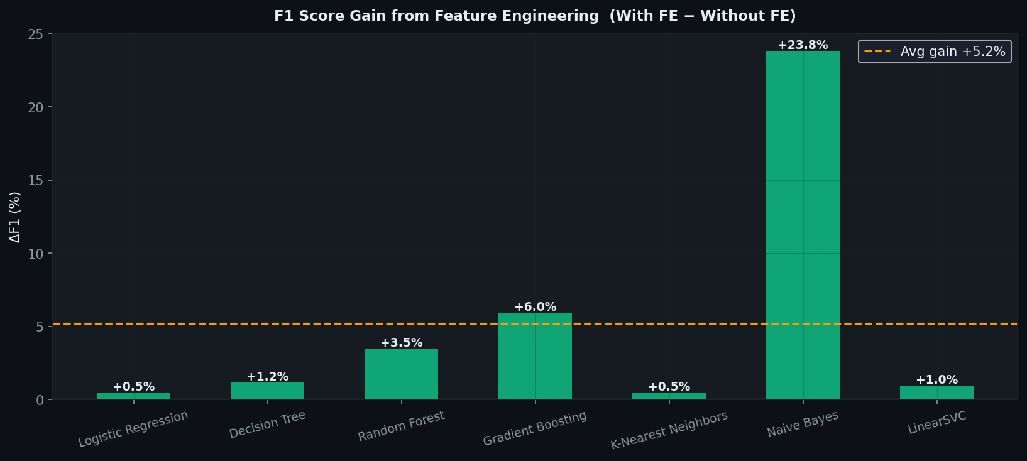
Figure 7.1: F1-score gain from feature engineering.
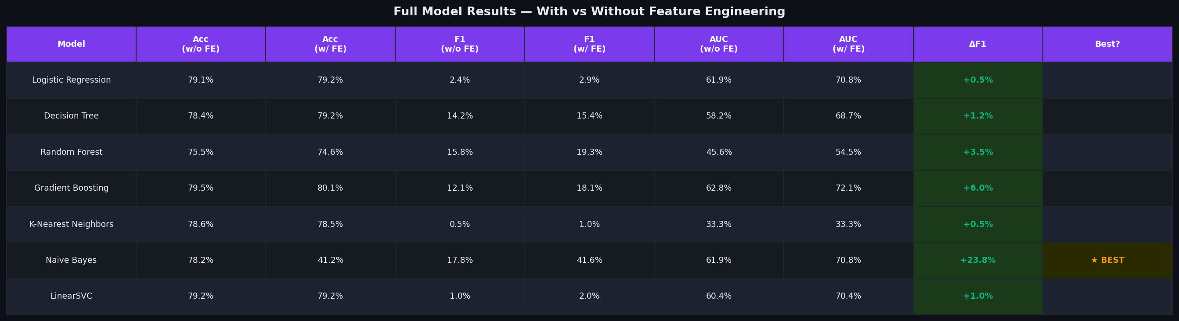
Figure 7.2: Visual comparison table of all evaluated models.
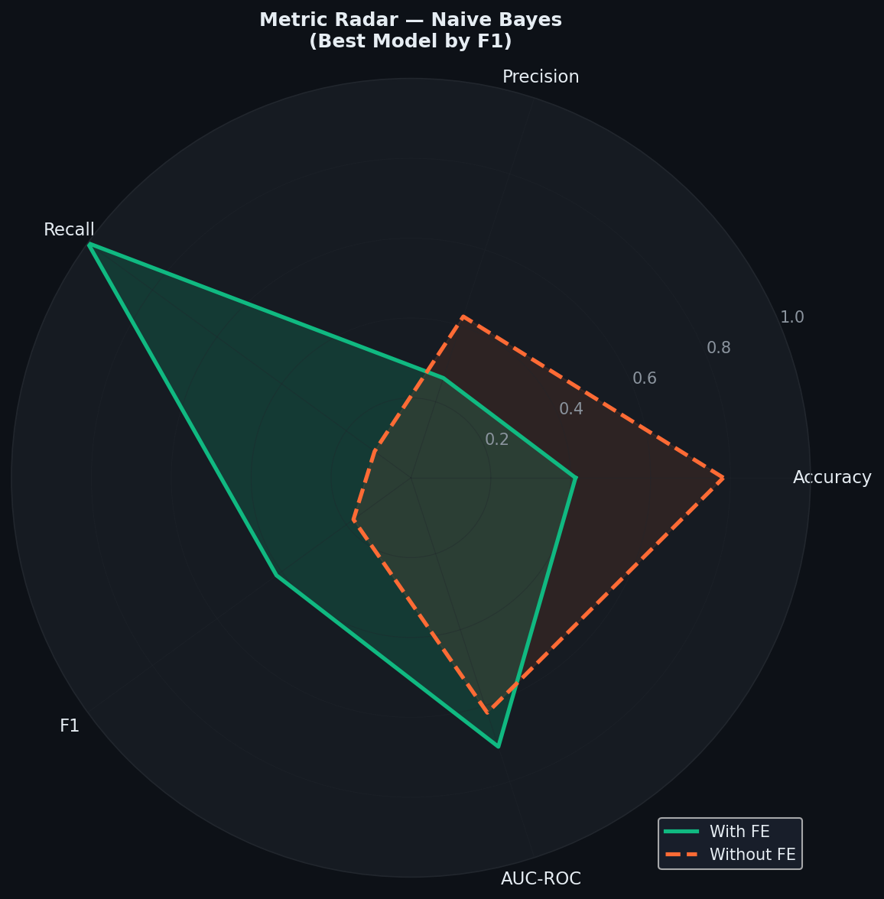
Figure 7.3: Radar chart for the best-performing proposed model.

Discussion
The proposed approach consistently improves model quality by enriching the feature space with domain-relevant variables. In particular, Naive Bayes benefits substantially from the additional accident severity indicators. Random Forest was excluded from the written comparison summary because the run in main.py encountered a Windows permission issue during parallel execution.

