IV. EDA Visual Output (All)
Project: India Road Accident Risk Analysis

Overview
This document compiles the exploratory data analysis visuals generated from the accident dataset. It includes raw descriptive visualizations and preprocessed feature-engineering visualizations used to support later machine learning experiments.

Dataset Highlights
- Total rows: 9,550
- Cities covered: 50
- Cause categories: 6
- Cause subcategories: 35
- Total accidents: 352,416
- Persons killed: 81,252
- Total injured: 252,575
- Fatality rate: 23.1%

Raw EDA Figures
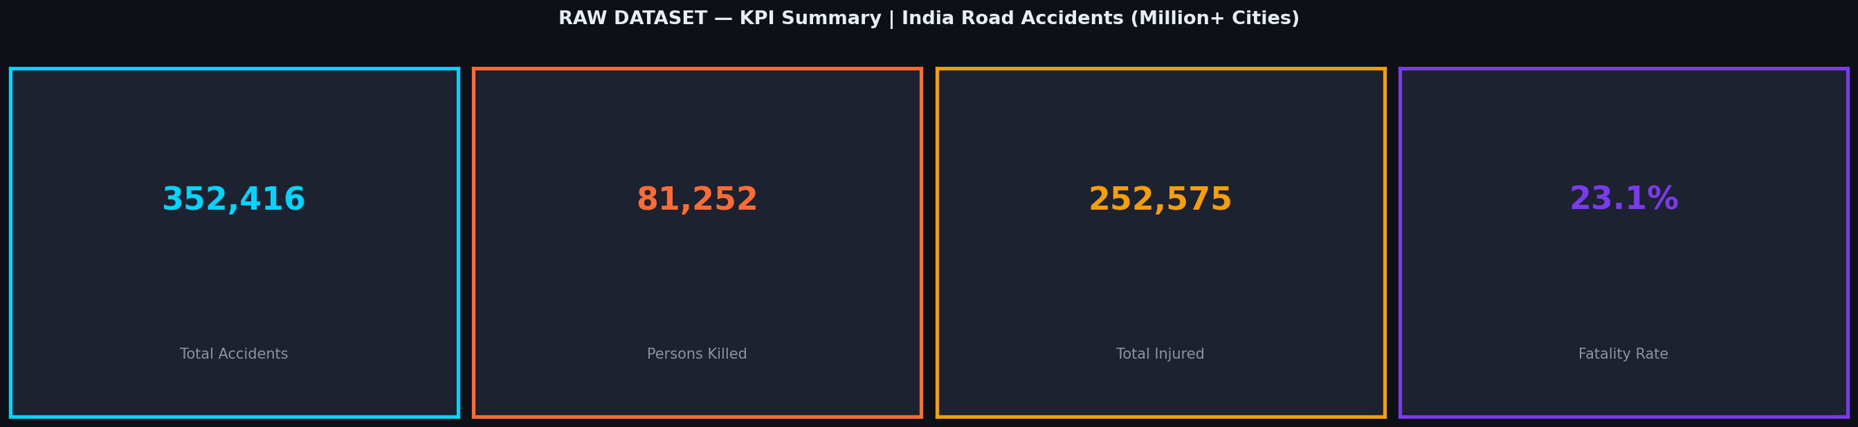
Figure 4.1: KPI summary of the raw accident dataset.
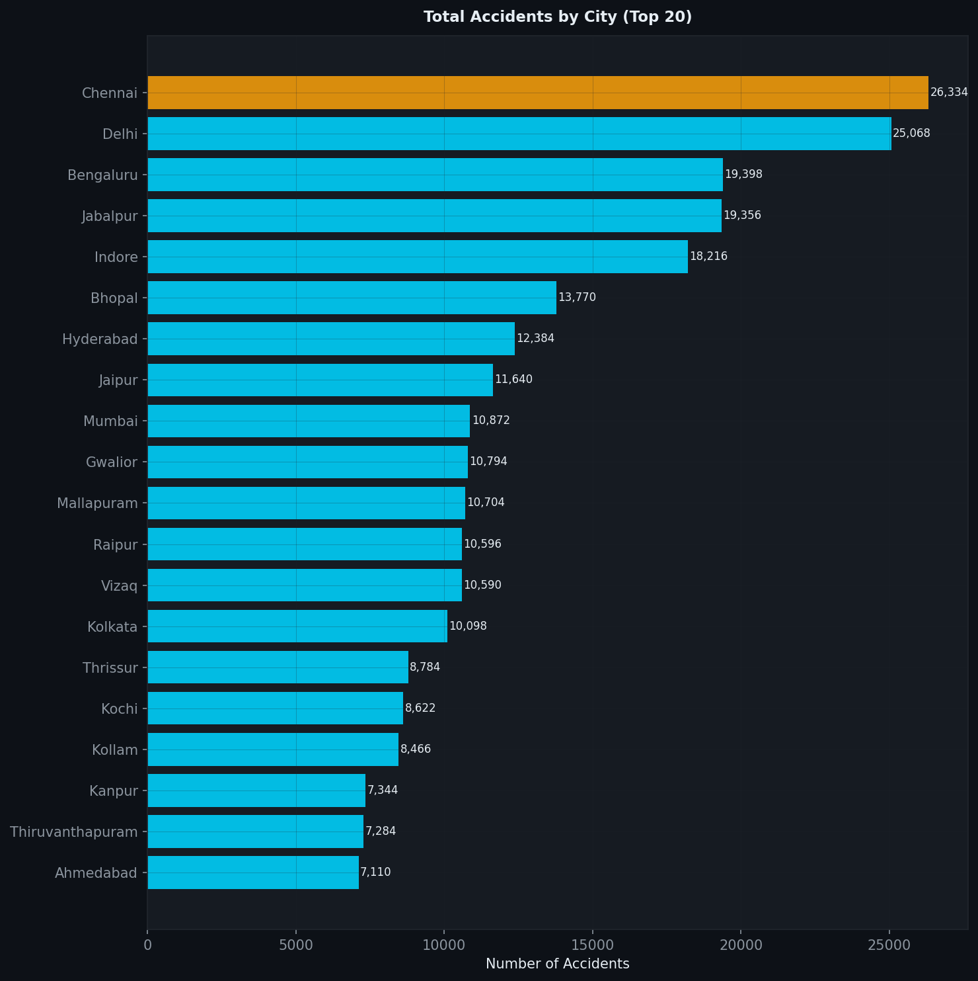
Figure 4.2: Top 20 cities by total accident count.
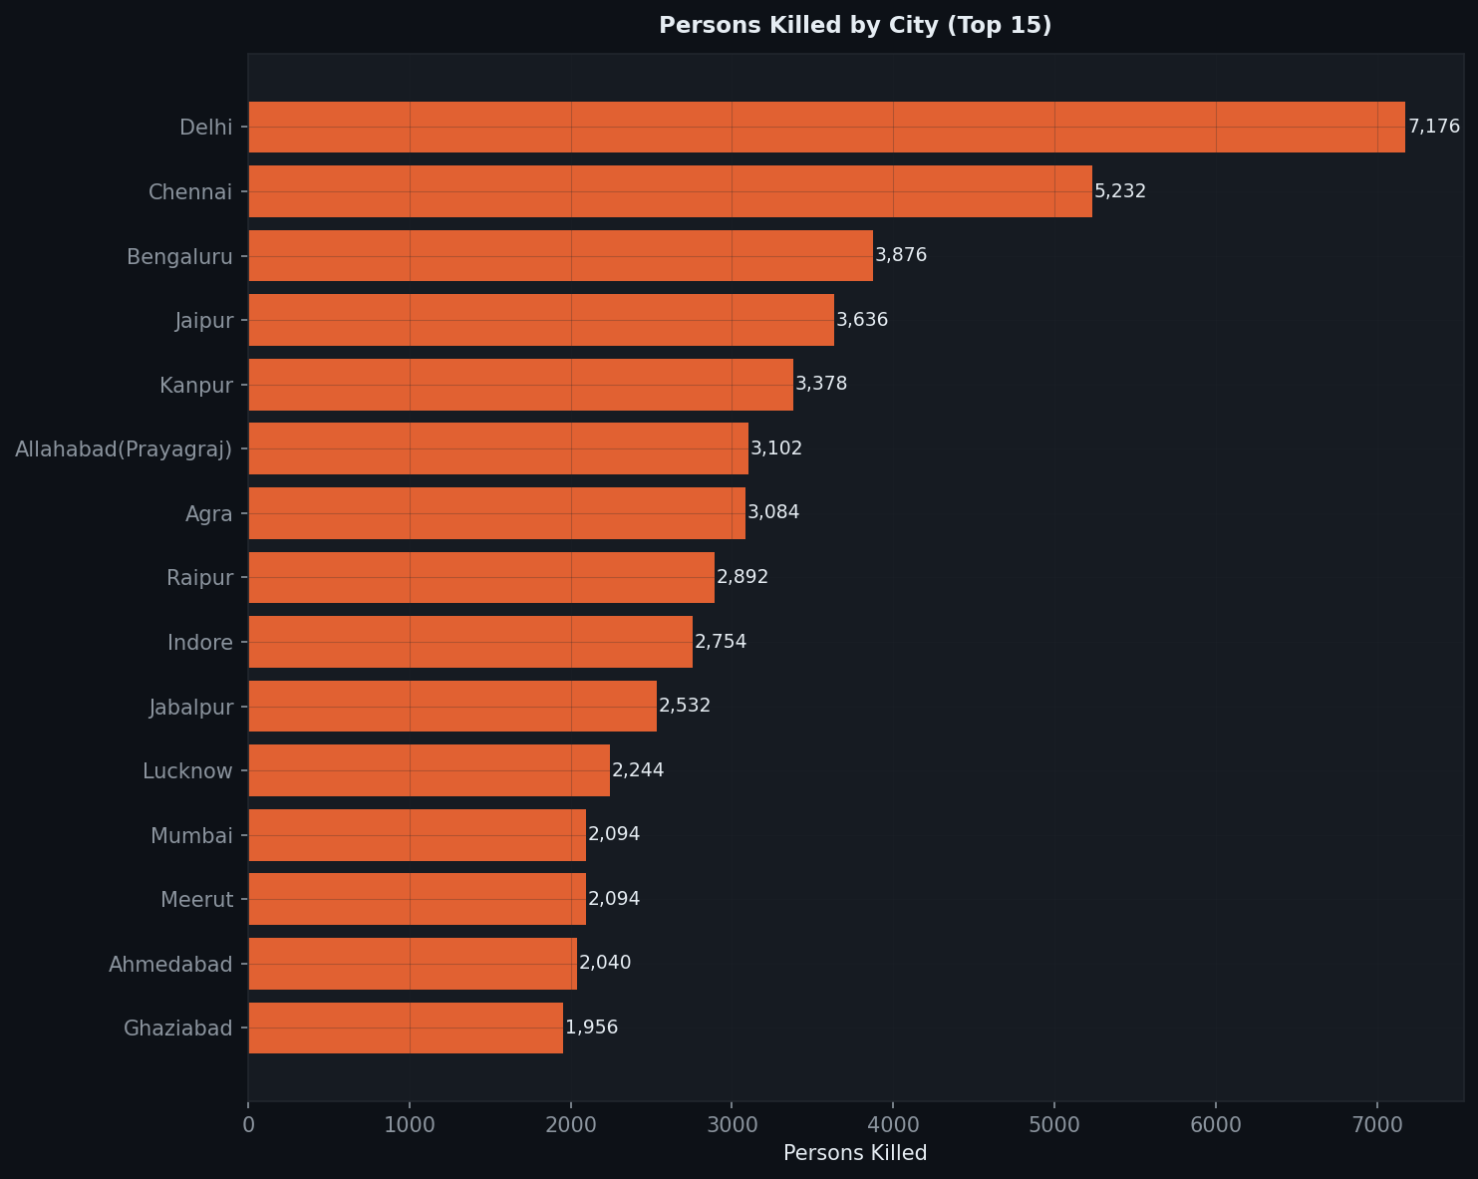
Figure 4.3: Top cities by persons killed.
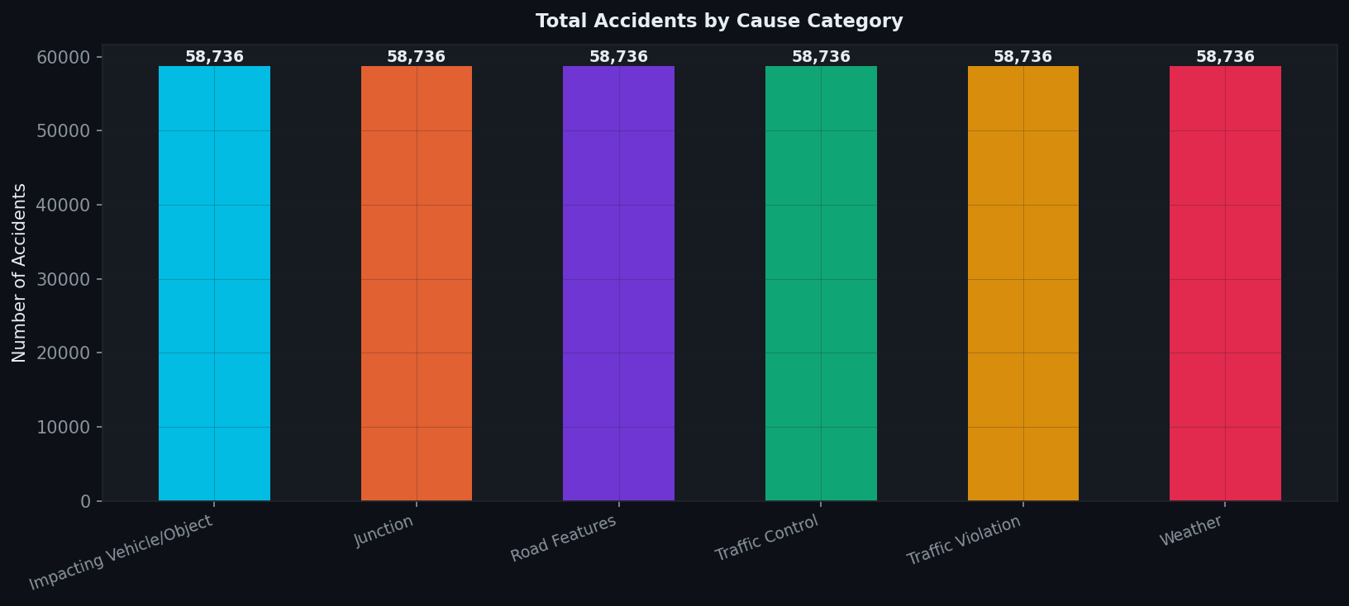
Figure 4.4: Accident counts by cause category.
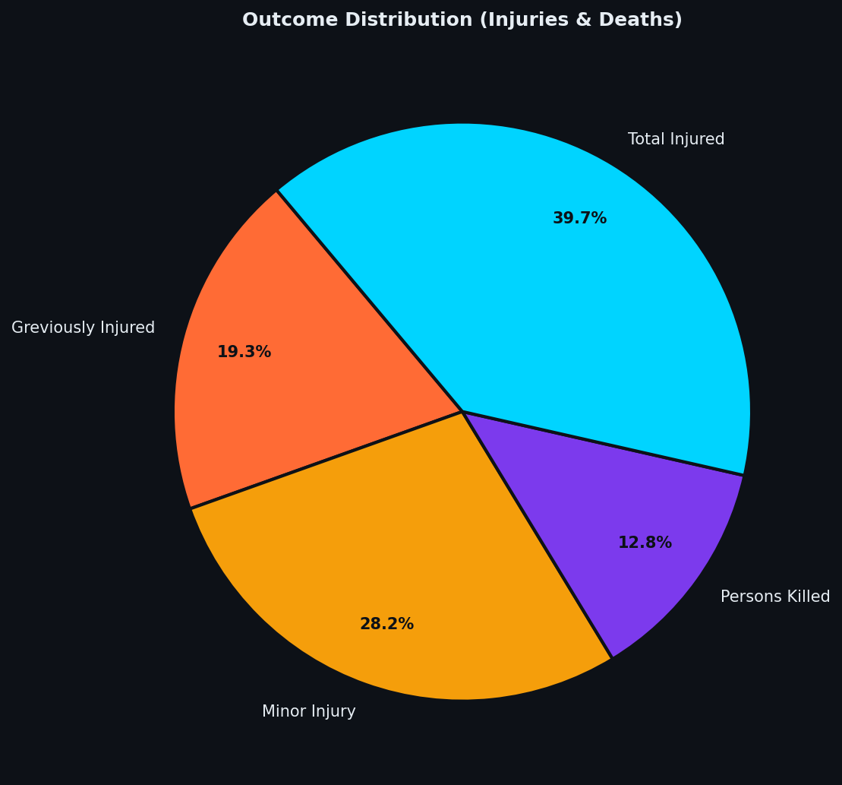
Figure 4.5: Distribution of injury and fatal outcomes.
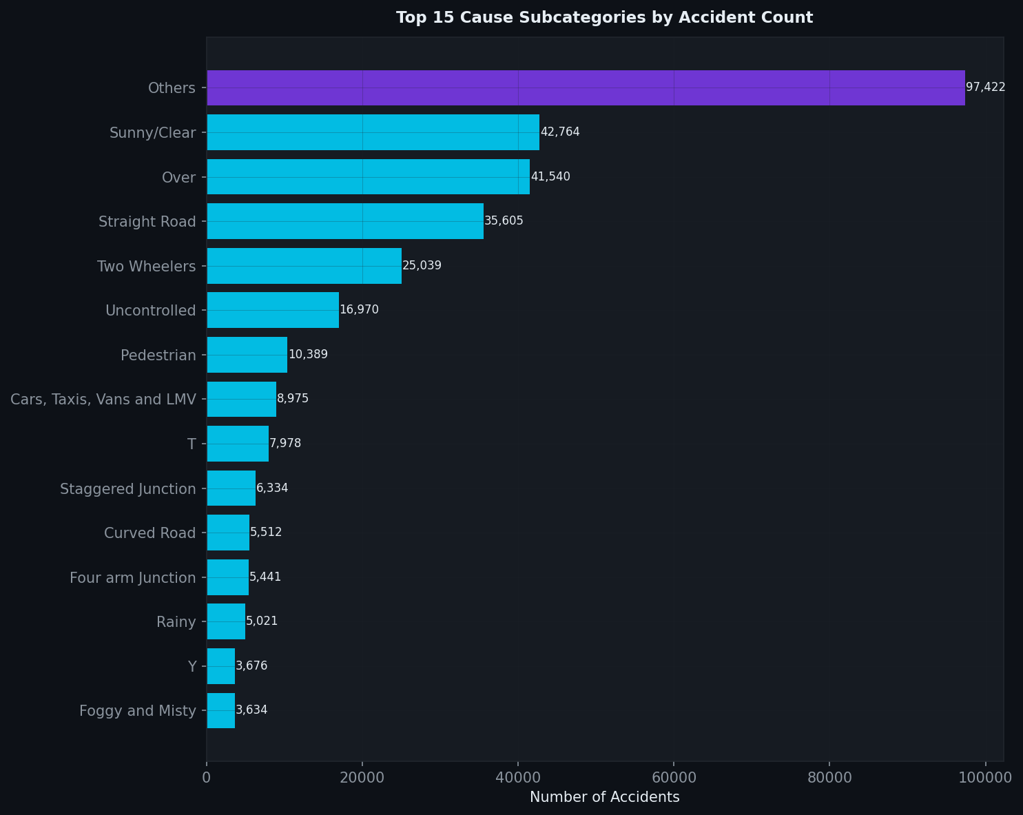
Figure 4.6: Top cause subcategories by accident count.
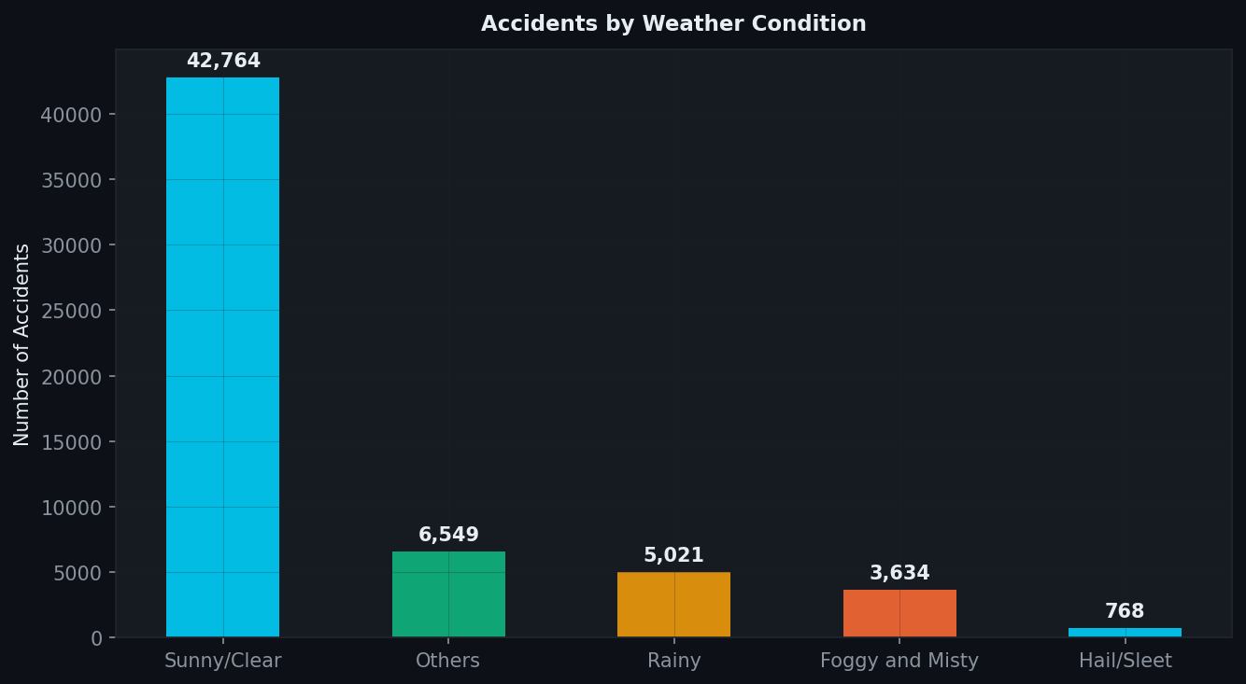
Figure 4.7: Weather-condition-wise accident distribution.
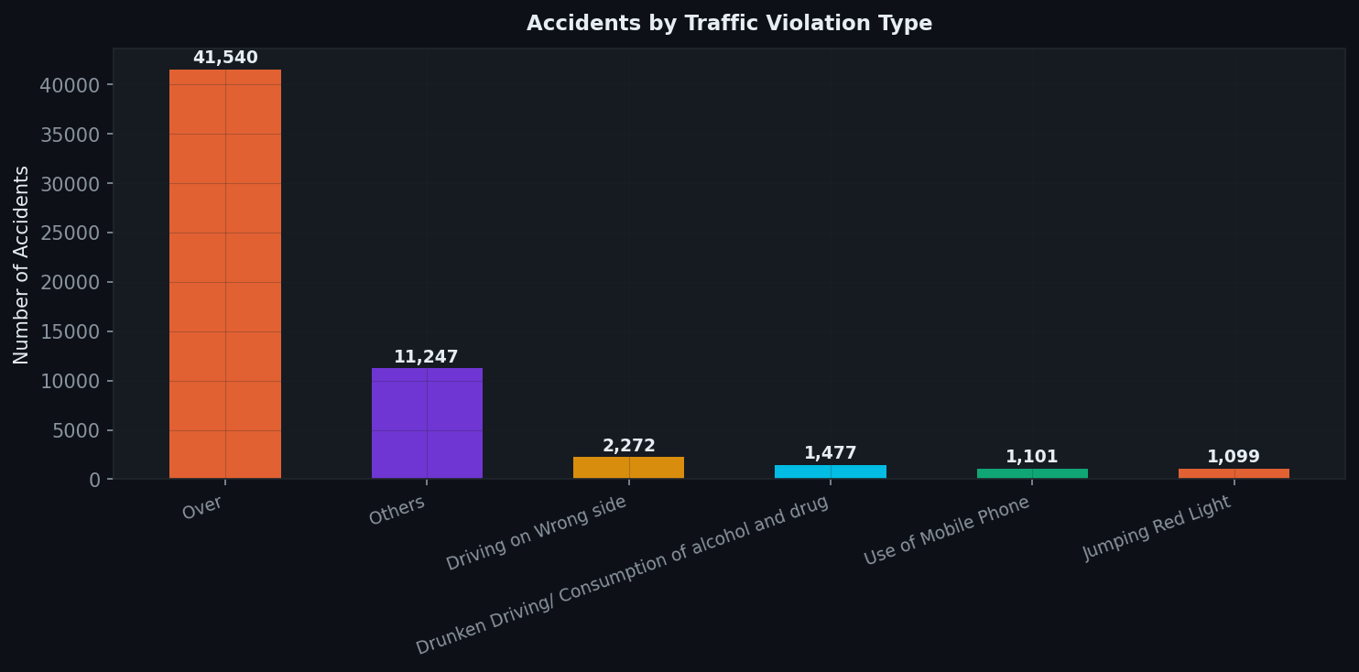
Figure 4.8: Traffic-violation-wise accident distribution.
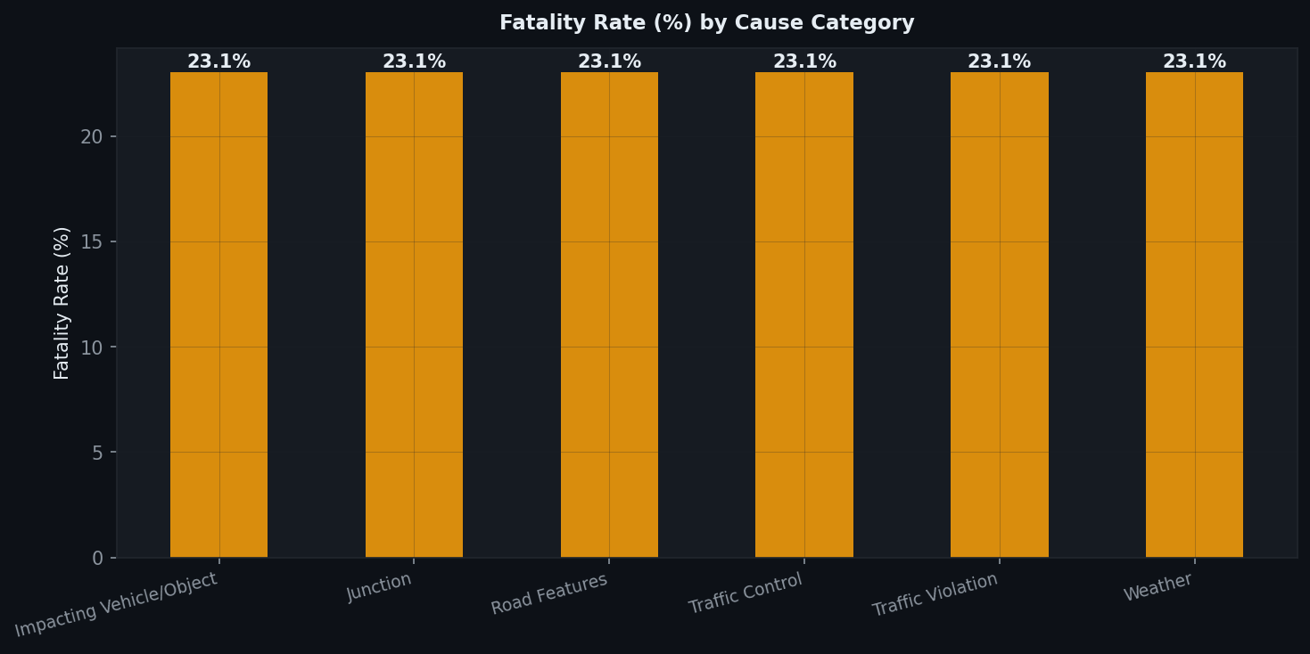
Figure 4.9: Fatality rate by cause category.
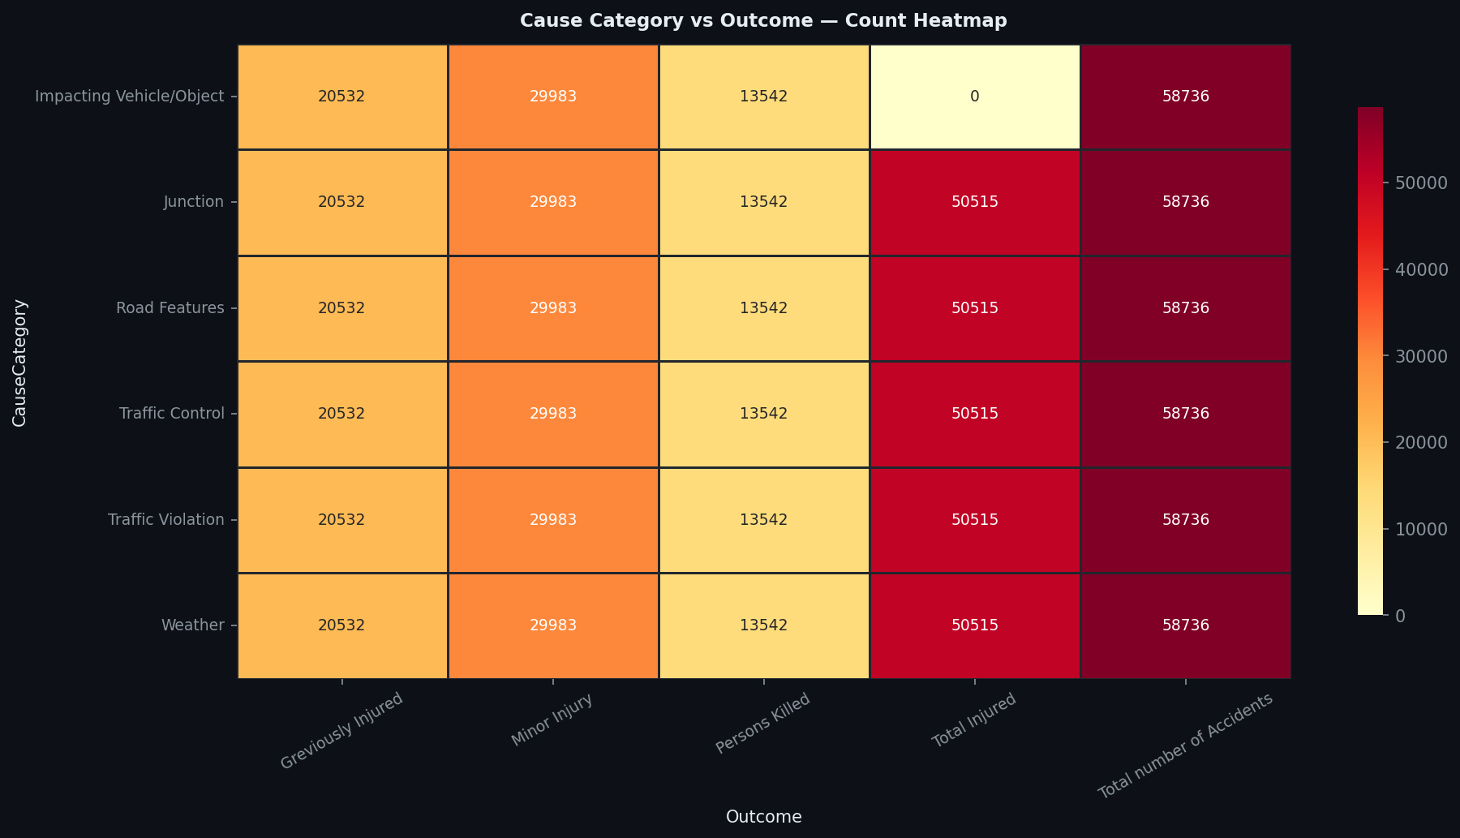
Figure 4.10: Heatmap of cause category versus outcome count.
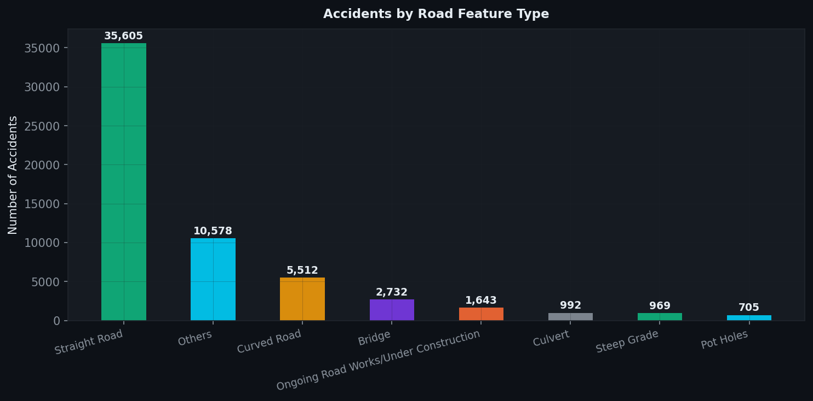
Figure 4.11: Road feature wise accident counts.

Preprocessed and Feature-Engineered Figures

Figure 4.12: KPI summary after preprocessing.
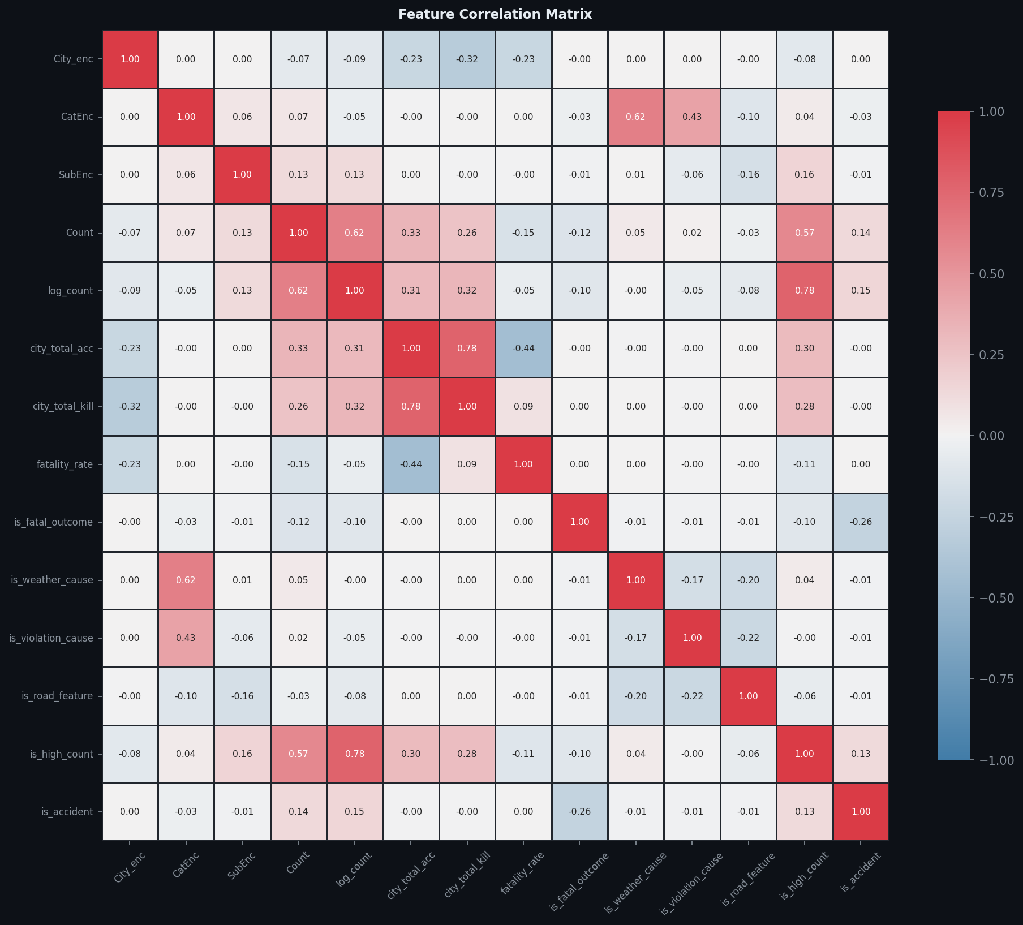
Figure 4.13: Correlation matrix of encoded and engineered variables.
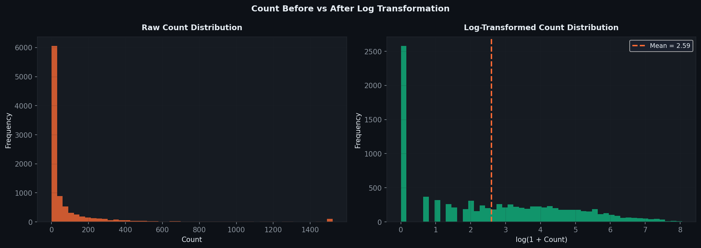
Figure 4.14: Count distribution before and after log transformation.
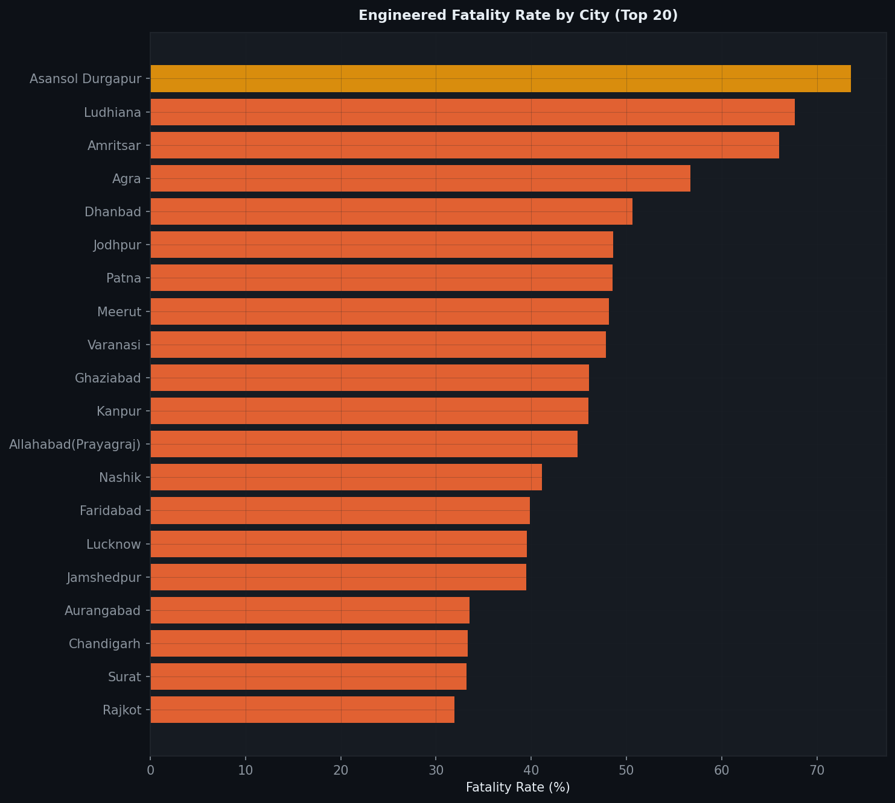
Figure 4.15: Engineered fatality rate by city.
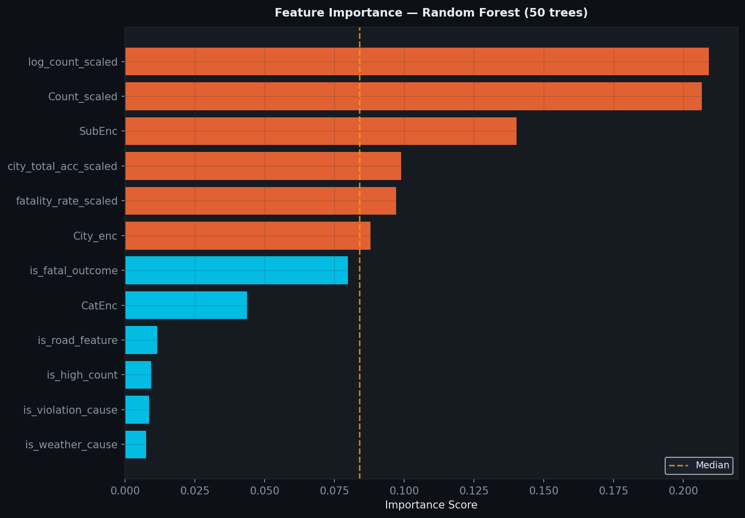
Figure 4.16: Random forest feature importance plot.
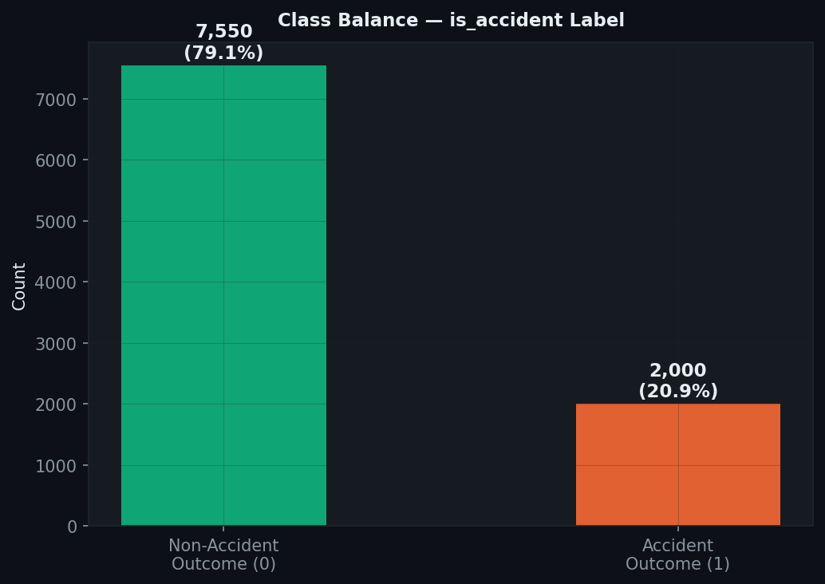
Figure 4.17: Class balance of the target variable.
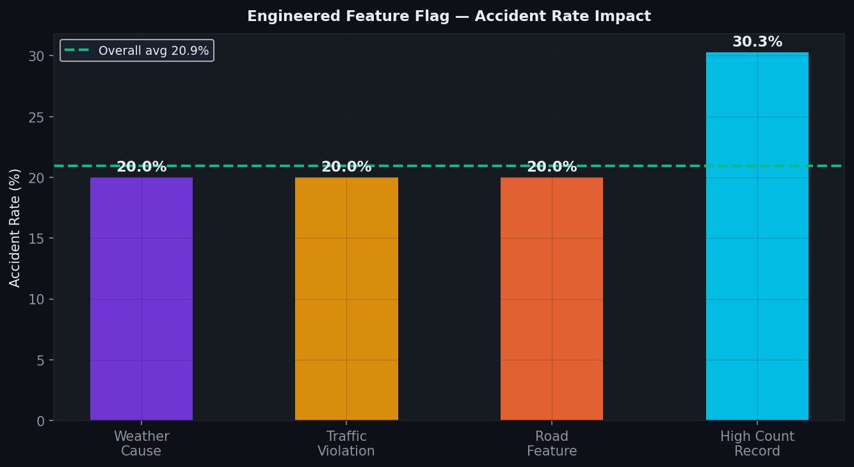
Figure 4.18: Impact of engineered binary risk indicators.

EDA Summary
- Chennai and Delhi have the highest accident counts in the dataset.
- Feature engineering enriches the dataset with severity-related variables and contextual flags.
- The preprocessed views show useful separability for downstream classification tasks.

