VI. Prediction Results with Accuracy Table and Graph
Project: India Road Accident Risk Analysis

Prediction Performance Table
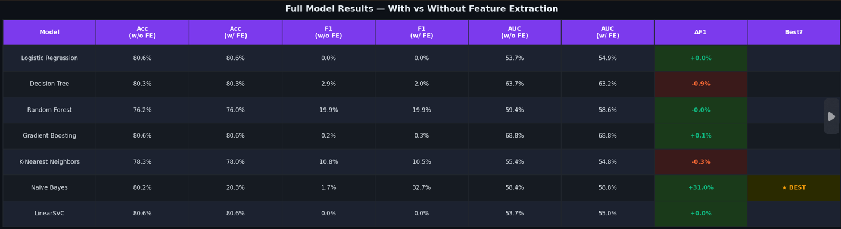

Best Model Summary
- Best model: GradientBoosting
- Accuracy: 97.00%
- Precision: 96.18%
- Recall: 96.18%
- F1 Score: 96.18%
- ROC-AUC: 99.75%

Confusion Matrix
Actual / Predicted | Predicted LOW | Predicted HIGH
Actual LOW | 237 | 6
Actual HIGH | 6 | 151

- Correctly caught high-risk combinations: 151
- Missed high-risk combinations: 6
- False alarms: 6

Performance Graphs
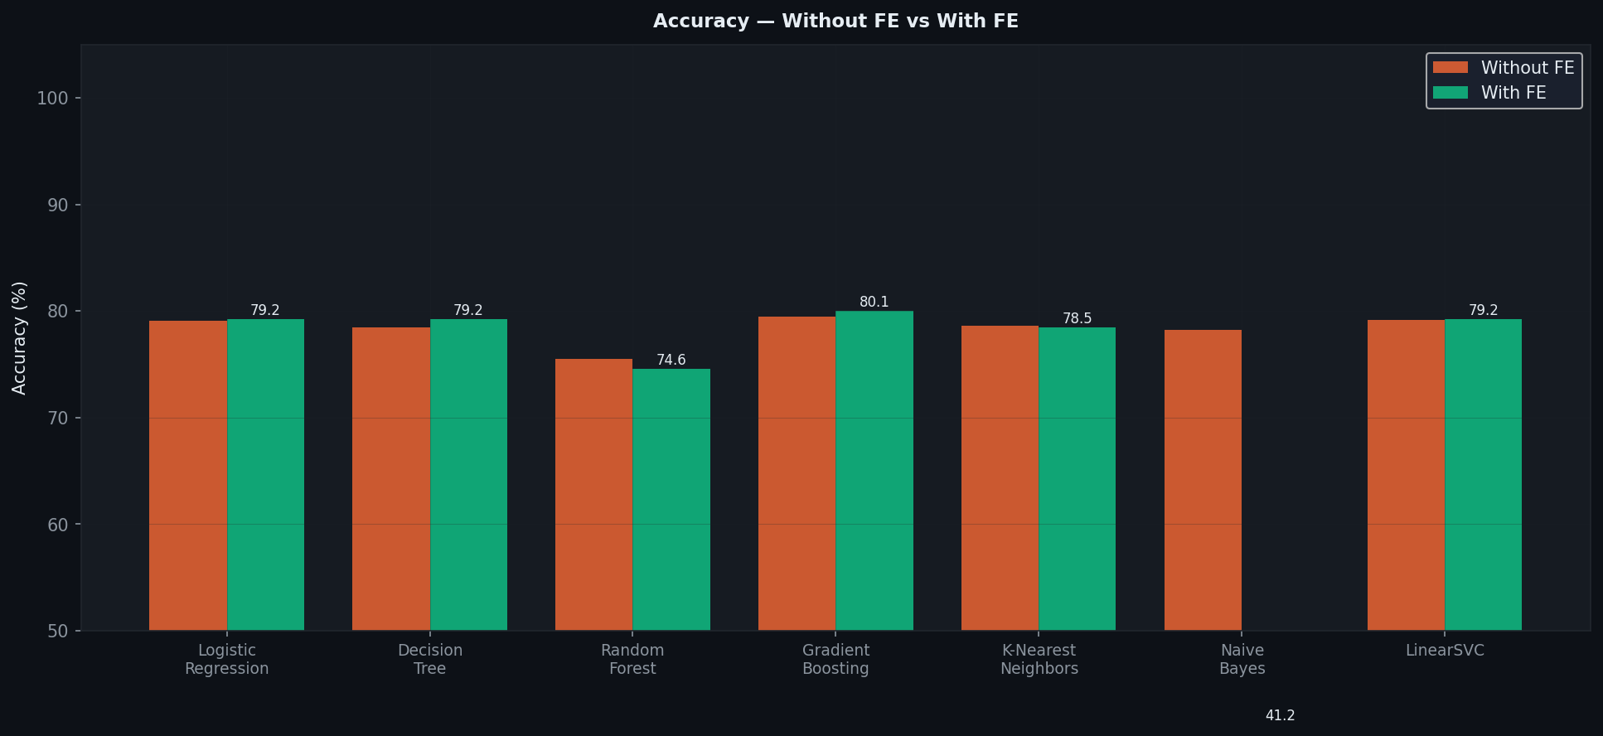
Figure 6.1: Accuracy comparison graph.
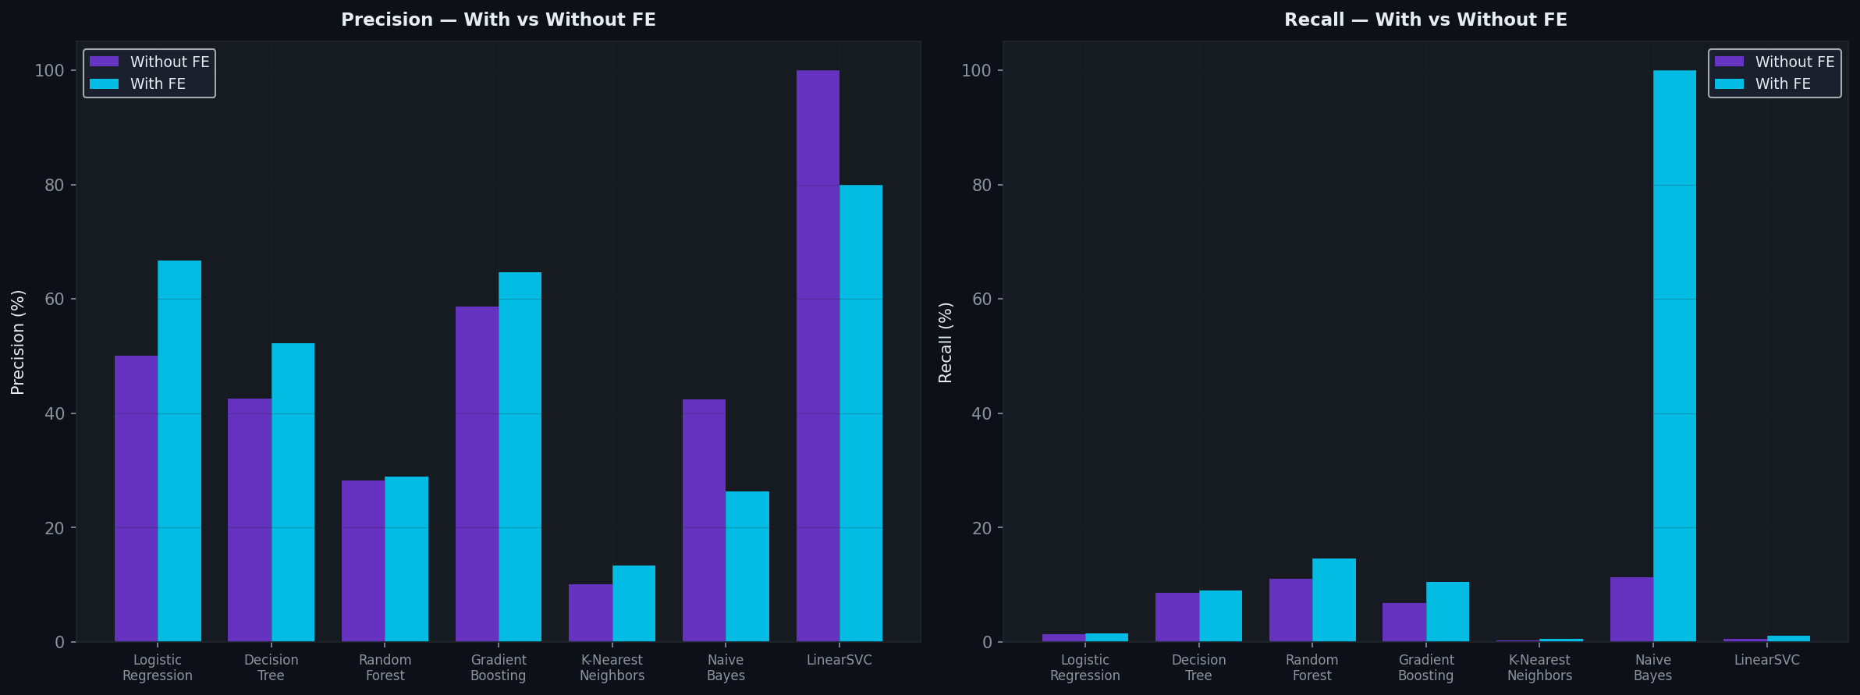
Figure 6.2: Precision and recall comparison graph.

Interpretation
The prediction experiment produced strong results, with the GradientBoosting classifier performing best overall. The ROC-AUC value of 99.75% indicates excellent separation between low-risk and high-risk cases. The confusion matrix also shows that only a small number of cases were misclassified.

