Issue - 1:

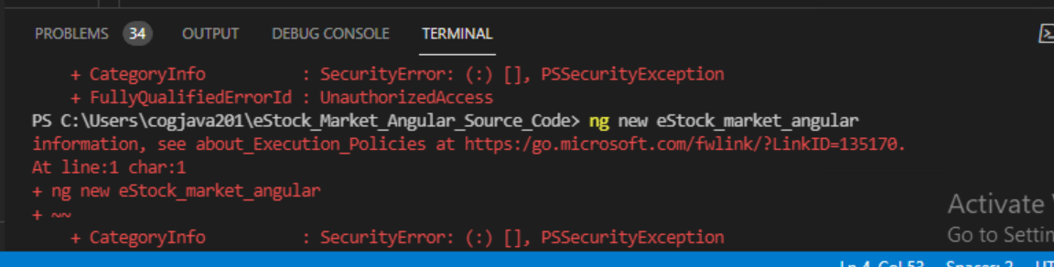

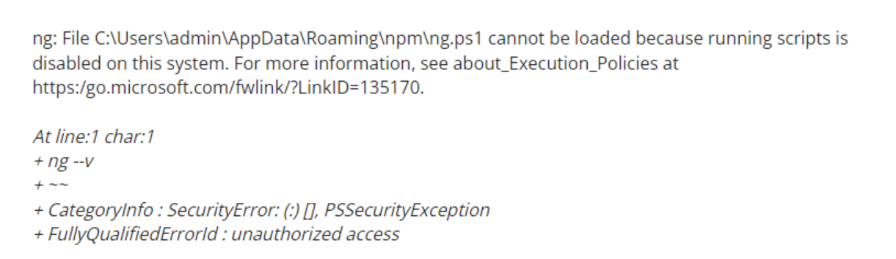

Solution:

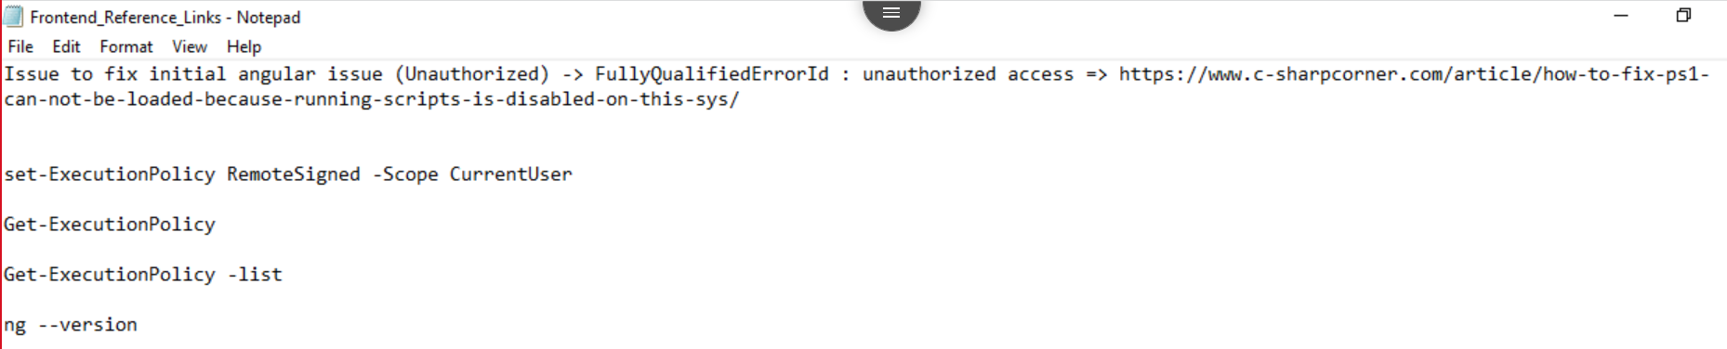

Issue – 2:



Solution -> Navigate to angular project

Issue – 3:

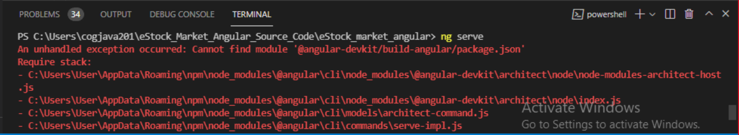

Solution:

Issue – 4:

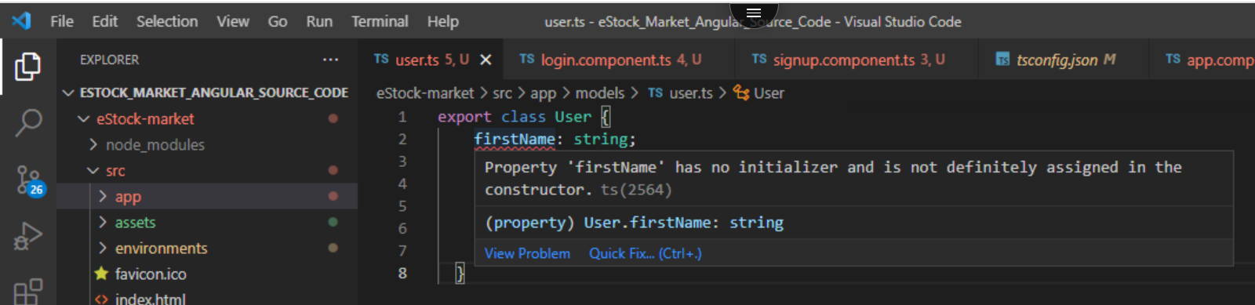

Solution:

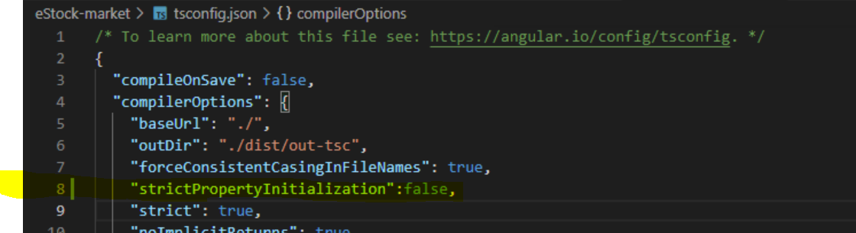

Issue – 5: